Assignment 3

Code:
Bubble sort
code = """#include <omp.h>
#include <stdio.h>
#include <stdlib.h>

void swap(int *,int *);

int main (int argc, char *argv[]) {
int SIZE =100000;
int A[SIZE],B[SIZE];
for(int i=0;i<SIZE;i++)
{
A[i]=rand()%SIZE;
B[i]=A[i];
printf(" %d",A[i]);
}
printf("\\n");
//int A[5] = {6,9,1,3,7};
int N = SIZE;
int i=0, j=0;
int first;
double start,end;
start = omp_get_wtime();
for (int i = 0; i < N-1; i++) {
for (int j = 0; j < N-i-1; j++) {
if (B[j] > B[j+1])
{
// swap arr[j+1] and arr[i]
int temp = B[j];
B[j] = B[j+1];
B[j+1] = temp;
}
}
}
end = omp_get_wtime();
double temptime = end -start;

start=omp_get_wtime();
for( i = 0; i < N-1; i++ )
{
first = i % 2;
#pragma omp parallel for default(none),shared(A,first,N)
for( j = first; j < N-1; j += 1 )
{
if( A[ j ] > A[ j+1 ] )
{
swap( &A[ j ], &A[ j+1 ] );
}
}
}
end=omp_get_wtime();
for(i=0;i<N;i++)
{
printf(" %d",B[i]);
}

printf("\\n-------------------------\\n Time Serial= %f",(temptime));
printf("\\n-------------------------\\n Time Parallel= %f",(end-start));
}

void swap(int *num1, int *num2)
{

int temp = *num1;
*num1 = *num2;
*num2 = temp;
}

"""
text_file = open("code.cpp", "w")
text_file.write(code)
text_file.close()
!g++ -fopenmp code.cpp
!./a.out

Output
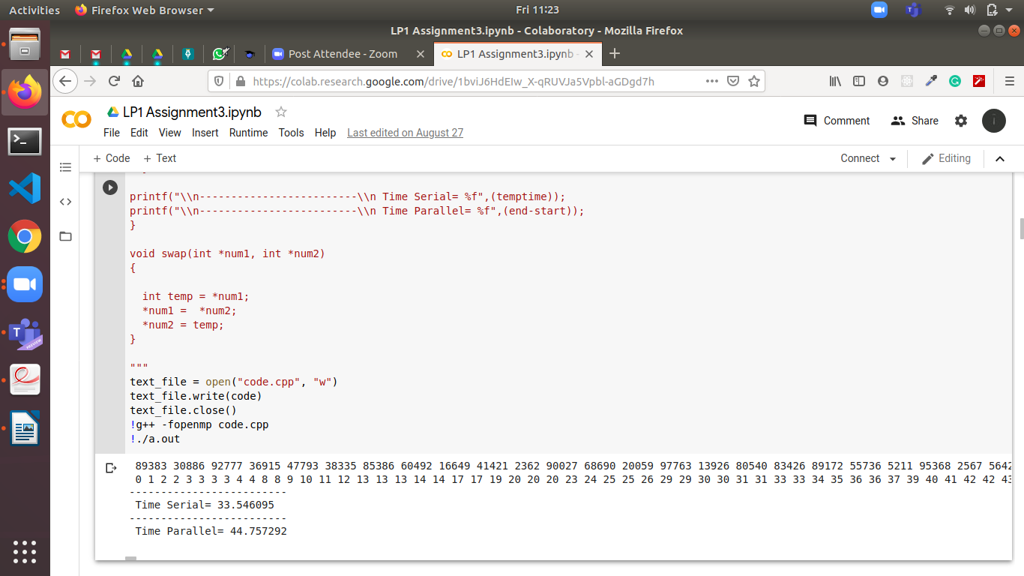

Merge Sort:

Code
code = """
#include <stdio.h>
#include <string.h>
#include <stdlib.h>
#include "omp.h"

#define MAX_SIZE 1000

void generate_list(int * x, int n) {
int i,j,t;
for (i = 0; i < n; i++)
x[i] = i;
for (i = 0; i < n; i++) {
j = rand() % n;
t = x[i];
x[i] = x[j];
x[j] = t;
}
}

void print_list(int * x, int n) {
int i;
for (i = 0; i < n; i++) {
printf("%d ",x[i]);
}
}

void merge(int * X, int n, int * tmp) {
int i = 0;
int j = n/2;
int ti = 0;

while (i<n/2 && j<n) {
if (X[i] < X[j]) {
tmp[ti] = X[i];
ti++; i++;
} else {
tmp[ti] = X[j];
ti++; j++;
}
}
while (i<n/2) { /* finish up lower half */
tmp[ti] = X[i];
ti++; i++;
}
while (j<n) { /* finish up upper half */
tmp[ti] = X[j];
ti++; j++;
}
memcpy(X, tmp, n*sizeof(int));

} // end of merge()

void mergesort(int * X, int n, int * tmp)
{
if (n < 2) return;

#pragma omp task firstprivate (X, n, tmp)
mergesort(X, n/2, tmp);

#pragma omp task firstprivate (X, n, tmp)
mergesort(X+(n/2), n-(n/2), tmp);
#pragma omp taskwait

/* merge sorted halves into sorted list */
merge(X, n, tmp);
}

void smerge(int arr[], int l, int m, int r)
{
int i, j, k;
int n1 = m - l + 1;
int n2 = r - m;
/* create temp arrays */
int L[n1], R[n2];
/* Copy data to temp arrays L[] and R[] */
for (i = 0; i < n1; i++)
L[i] = arr[l + i];
for (j = 0; j < n2; j++)
R[j] = arr[m + 1 + j];
/* Merge the temp arrays back into arr[l..r]*/
i = 0; // Initial index of first subarray
j = 0; // Initial index of second subarray
k = l; // Initial index of merged subarray
while (i < n1 && j < n2) {
if (L[i] <= R[j]) {
arr[k] = L[i];
i++;
}
else {
arr[k] = R[j];
j++;
}
k++;
}
/* Copy the remaining elements of L[], if there
are any */
while (i < n1) {
arr[k] = L[i];
i++;
k++;
}
/* Copy the remaining elements of R[], if there
are any */
while (j < n2) {
arr[k] = R[j];
j++;
k++;
}
}
void smergeSort(int arr[], int l, int r)
{
if (l < r) {
// Same as (l+r)/2, but avoids overflow for
// large l and h
int m = l + (r - l) / 2;
// Sort first and second halves
smergeSort(arr, l, m);
smergeSort(arr, m + 1, r);
smerge(arr, l, m, r);
}
}

int main()
{
int n = 10;
double start, stop, temptime;;

int data[MAX_SIZE], tmp[MAX_SIZE], datas[MAX_SIZE], temp[MAX_SIZE];

generate_list(data, n);
for(int i=0;i<n;i++){
datas[i]=data[i];
}
printf("List Before Sorting... \\n ");
print_list(data, n);

start = omp_get_wtime();
smergeSort(datas, 0, n-1);
stop = omp_get_wtime();
temptime = stop-start;
start = omp_get_wtime();
#pragma omp parallel
{
#pragma omp single
mergesort(data, n, tmp);
}
stop = omp_get_wtime();
printf("\\nList After Sorting Serially\\n");
print_list(datas, n);
printf("\\nList After Sorting Parallelly\\n");
print_list(data, n);

printf("\\nTime serially: %g", temptime);
printf("\\nTime parallely: %g \\n",stop-start);
}

"""
text_file = open("code.cpp", "w")
text_file.write(code)
text_file.close()
!g++ -fopenmp code.cpp
!./a.out

Output (For 10 elements)
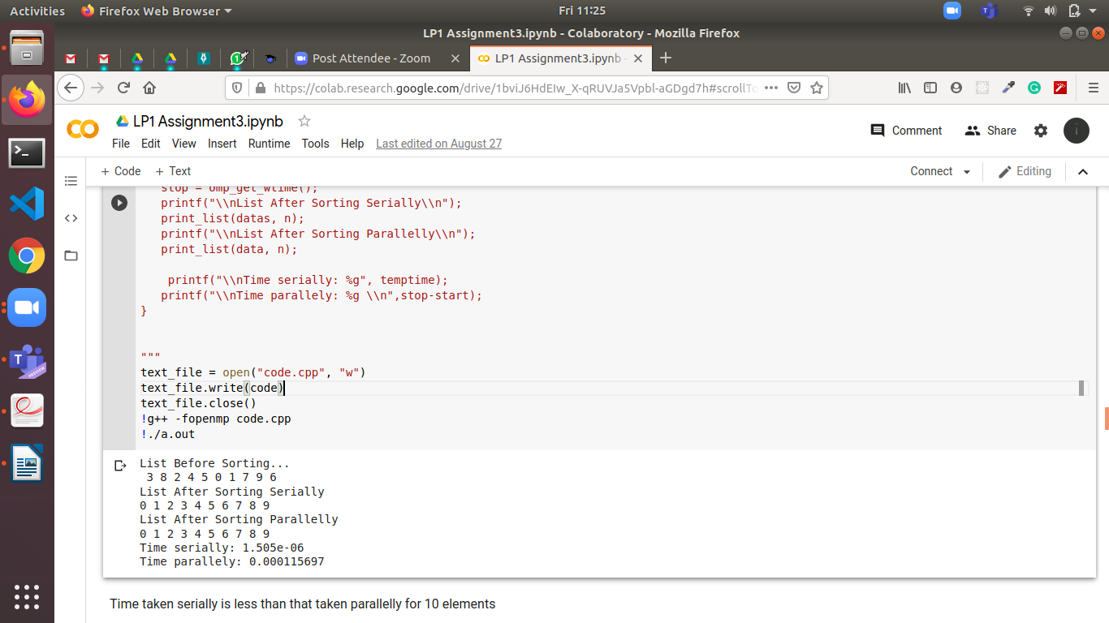

(For 1000 elements)
