Assignment 3

1) Merge Sort
CODE:

code = """
#include<iostream>
#include<omp.h>

using namespace std;

void printArray(int *arr, int size) {
for(int i=0; i<size; i++) {
cout<<arr[i]<<" ";
}
cout<<endl;
}

void merge(int* arr, int start, int mid, int end) {
int len = (end - start) + 1;
int temp[len];
int cur = 0;
int i = start;
int j = mid + 1;
while(i <= mid && j <= end){
if(arr[i] < arr[j]) {
temp[cur] = arr[i];
cur++;
i++;
}
else {
temp[cur] = arr[j];
cur++;
j++;
}
}
if(i <= mid) {
while(i <= mid) {
temp[cur] = arr[i];
i++;
cur++;
}
}
else if(j <= end) {
while(j <= end) {
temp[cur] = arr[j];
j++;
cur++;
}
}
cur = 0;
for(i=start; i<=end; i++) {
arr[i] = temp[cur];
cur++;
}

}

void mergeSort(int *arr, int start, int end) {
if(start < end) {
int mid = (start+end) / 2;
#pragma omp parallel sections
{
#pragma omp section
mergeSort(arr, start, mid);
#pragma omp section
mergeSort(arr, mid+1, end);
}
merge(arr, start, mid, end);
}
}

int main(int argc, char *argv[]) {
int size = 100;
int a[size];
double start, end;
omp_set_num_threads(2);
for(int i=0; i<size; i++) {
a[i] = rand()% 100;
}
//int a[]= {7,33,5,5,23,111,75,34,77,121,120};
for(int i=0; i<size; i++)
cout<<" "<<a[i];
cout<<endl;
start = omp_get_wtime();
mergeSort(a, 0, size-1);
printArray(a, size);
end = omp_get_wtime();
cout<<"Time parallel = "<<(end-start)<<endl;
return 0;
}

"""

text_file = open("code.cpp", "w")
text_file.write(code)
text_file.close()
!g++ -fopenmp code.cpp
!./a.out

OUTPUT:
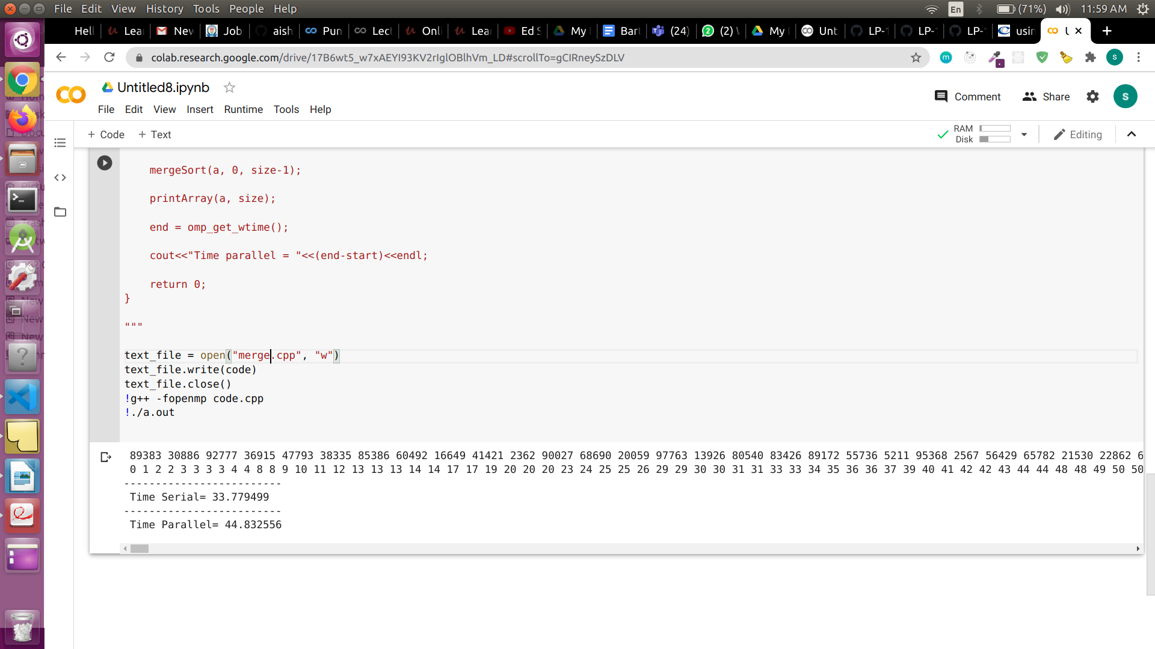

2) Bubble sort
CODE:
code = """#include <omp.h>
#include <stdio.h>
#include <stdlib.h>
void swap(int *,int *);
int main (int argc, char *argv[]) {
int SIZE =1000;
int A[SIZE],B[SIZE];
for(int i=0;i<SIZE;i++)
{
A[i]=rand()%SIZE;
B[i]=A[i];
printf(" %d",A[i]);
}
printf("\\n");
//int A[5] = {6,9,1,3,7};
int N = SIZE;
int i=0, j=0;
int first;
double start,end;
start = omp_get_wtime();
for (int i = 0; i < N-1; i++) {
for (int j = 0; j < N-i-1; j++) {
if (B[j] > B[j+1])
{
// swap arr[j+1] and arr[i]
int temp = B[j];
B[j] = B[j+1];
B[j+1] = temp;
}
}
}
end = omp_get_wtime();
double temptime = end -start;
start=omp_get_wtime();
for( i = 0; i < N-1; i++ )
{
first = i % 2;
#pragma omp parallel for default(none),shared(A,first,N)
for( j = first; j < N-1; j += 1 )
{
if( A[ j ] > A[ j+1 ] )
{
swap( &A[ j ], &A[ j+1 ] );
}
}
}
end=omp_get_wtime();
for(i=0;i<N;i++)
{
printf(" %d",B[i]);
}
printf("\\n-------------------------\\n Time Serial= %f",(temptime));
printf("\\n-------------------------\\n Time Parallel= %f",(end-start));
}
void swap(int *num1, int *num2)
{
int temp = *num1;
*num1 = *num2;
*num2 = temp;}"""
text_file = open("code.cpp", "w")
text_file.write(code)
text_file.close()
!g++ -fopenmp code.cpp
!./a.out

OUTPUT:

