Assignment 4
1) Binary Search

CODE:
code = """
#include<mpi.h>
#include<stdio.h>

#define n 12

#define key 55

int a[] = {1,2,3,4,7,9,13,24,55,56,67,88};

int a2[20];

int binarySearch(int *array, int start, int end, int value) {
int mid;
while(start <= end) {
mid = (start + end) / 2;
if(array[mid] == value)
return mid;
else if(array[mid] > value)
end = mid - 1;
else
start = mid + 1;
}
return -1;
}

int main(int argc, char* argv[]) {
int pid, np, elements_per_process, n_elements_received;
MPI_Status status;
MPI_Init(&argc, &argv);
MPI_Comm_rank(MPI_COMM_WORLD, &pid);
MPI_Comm_size(MPI_COMM_WORLD, &np);
if(pid == 0) {
int index, i;
if(np > 1) {
for(i=1; i<np-1; i++) {
index = i * elements_per_process;
//element count
MPI_Send(&elements_per_process, 1, MPI_INT, i, 0, MPI_COMM_WORLD);

MPI_Send(&a[index], elements_per_process, MPI_INT, i, 0, MPI_COMM_WORLD);
}
index = i* elements_per_process;
int elements_left = n - index;
MPI_Send(&elements_left, 1, MPI_INT, i, 0, MPI_COMM_WORLD);
MPI_Send(&a[index], elements_left, MPI_INT, i, 0, MPI_COMM_WORLD);
}
int position = binarySearch(a, 0, elements_per_process-1, key);
if(position != -1)
printf("Found at: %d", position);
int temp;
for(i=1; i<np; i++) {
MPI_Recv(&temp, 1, MPI_INT, MPI_ANY_SOURCE, 0, MPI_COMM_WORLD, &status);
int sender = status.MPI_SOURCE;
if(temp != -1)
printf("Found at: %d by %d", (sender*elements_per_process)+temp, sender);
}
}
else {
MPI_Recv(&n_elements_received, 1, MPI_INT, 0, 0, MPI_COMM_WORLD, &status);
MPI_Recv(&a2, n_elements_received, MPI_INT, 0, 0, MPI_COMM_WORLD, &status);
int position = binarySearch(a2, 0, n_elements_received-1, key);
MPI_Send(&position, 1, MPI_INT, 0, 0, MPI_COMM_WORLD);
}
MPI_Finalize();
return 0;
}
"""

text_file = open("Binary.c", "w");
text_file.write(code);
text_file.close();
!mpiCC Binary.c
!mpirun --allow-run-as-root -np 4 ./a.out

OUTPUT:
KEY TO FIND = 55
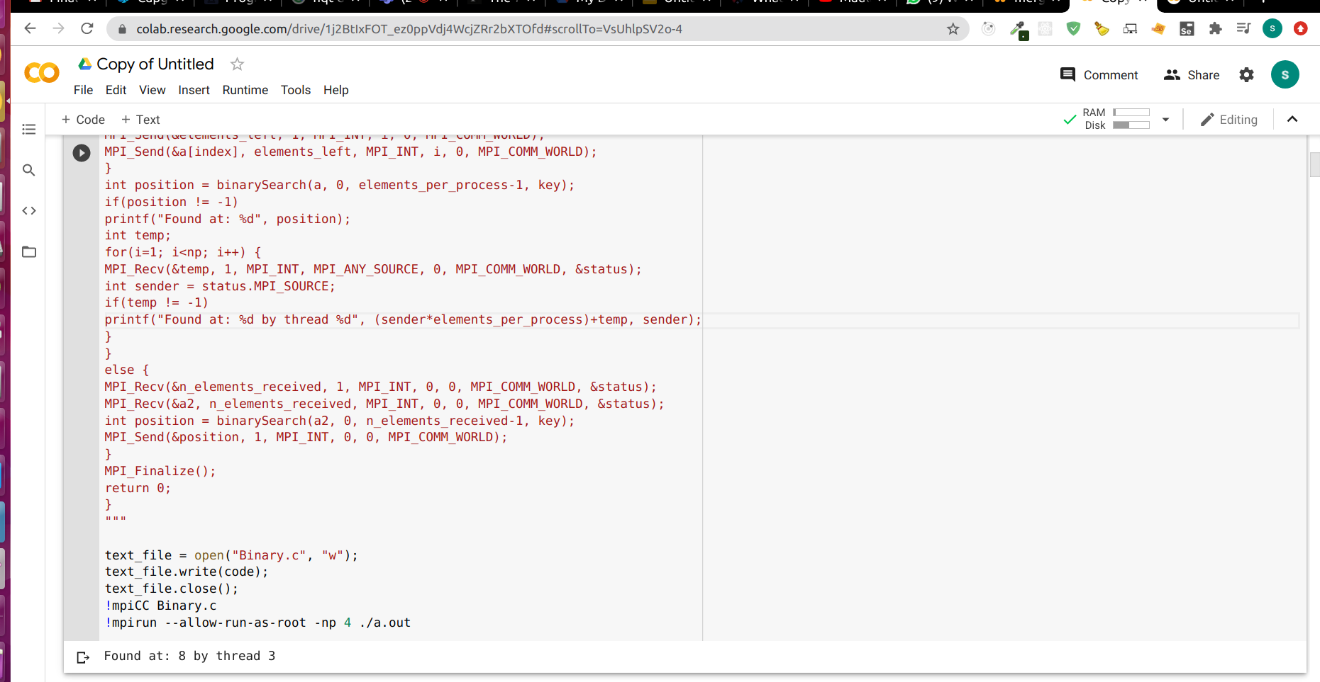
2)Best-First Search

CODE:
code = """
#include<iostream>
#include<omp.h>

using namespace std;
int q[100];
int visited[7];
int local_q;

void bfs(int adj_matrix[7][7], int first, int last, int q[], int n_nodes) {
if(first==last)
return;
int cur_node = q[first++];
cout<<" "<<cur_node;
omp_set_num_threads(3);
#pragma omp parallel for shared(visited)
for(int i=0; i<n_nodes; i++) {
if(adj_matrix[cur_node][i] == 1 && visited[i] == 0){
q[last++] = i;
visited[i] = 1;
}
}
bfs(adj_matrix, first, last, q, n_nodes);
}

int main() {
int first = -1;
int last = 0;
int n_nodes = 7;
for(int i=0; i<n_nodes; i++) {
visited[i] = 0;
}
int adj_matrix[7][7] = {
{0, 0, 1, 0, 0, 1, 0},
{1, 0, 1, 1, 0, 1, 0},
{1, 1, 0, 0, 1, 0, 0},
{0, 1, 0, 0, 0, 1, 0},
{1, 0, 1, 1, 0, 1, 0},
{0, 1, 0, 0, 1, 0, 1},
{0, 0, 0, 1, 0, 1, 0}
};
int start_node = 3;
q[last++] = start_node;
first++;
visited[start_node] = 1;
bfs(adj_matrix, first, last, q, n_nodes);
return 0;
}
"""

text_file = open("bfs.cpp", "w")
text_file.write(code)
text_file.close()
!g++ -fopenmp bfs.cpp
!./a.out

OUTPUT:
