.NET TECHNOLOGIES (01CE1523)
Lab Manual

Name: Srushti Pambhar
Enrolment No: 92400103260
Class: 5EC2
Batch: A

INDEX

Lab | Program | CO | Date | Marks |  |  |  | Total | Signature
 |  |  |  | R1(4) | R2(2) | R3(2) | R4(2) | (10)
1. | Develop Student Admission Management Module using OOP Concepts (Class, Object, Constructor, Access Modifiers). | CO1
2. | Design Employee Payroll System using Inheritance, Interface & Polymorphism | CO1
3. | Develop Expense Tracking Module with Exception Handling | CO1
4. | Build Online Event Registration Portal using ASP.NET Controls & Validation | CO2
5. | Develop Academic Calendar & Leave Management System using Rich Controls, Session & Cookies | CO2
6. | Create Product Catalog Application using ASP.NET MVC Architecture. (Controllers, Models, Views, Routing) | CO3
7. | Develop Feedback Management Module using MVC Layout, Partial View & Validation. (HTML Helpers, Validation, Layouts) | CO3
8. | Develop Inventory Management Module using ADO.NET & CRUD Operations | CO4
9. | Create Placement Dashboard using Data Controls & Crystal Reports | CO4
10. | Build Student Management REST API using ASP.NET Core  (Middleware, API, Project Structure) | CO5
11. | Develop Smart Campus Service Portal – Feature Extension  (Integrate MVC + Database + API) | CO1,  CO2,  CO3,  CO4,  CO5

R1 | Practical Performance
R2 | Timely Submission
R3 | Neatness & Documentation
R4 | Uploaded on Git

Experiment 1
AIM: Develop Student Admission Management Module using OOP Concepts (Class, Object, Constructor, Access Modifiers).
Source: Main.cs
Code:
using System;

namespace StudentAdmissionManagement
{
class Student
{

private int studentId;
private string studentName;
private int age;
private string gender;
private string course;
private double percentage;

public Student(int id, string name, int age, string gender, string course, double percentage)
{
studentId = id;
studentName = name;
this.age = age;
this.gender = gender;
this.course = course;
this.percentage = percentage;
}

public void DisplayStudent()
{
Console.WriteLine("\nStudent Details:-");
Console.WriteLine("Student ID : " + studentId);
Console.WriteLine("Student Name : " + studentName);
Console.WriteLine("Age : " + age);
Console.WriteLine("Gender : " + gender);
Console.WriteLine("Course : " + course);
Console.WriteLine("Percentage : " + percentage + "%");
}

public void CheckAdmission()
{
Console.WriteLine("\nAdmission Status:-");

if (percentage >= 60)
{
Console.WriteLine("Admission Approved");
}
else
{
Console.WriteLine("Admission Rejected");
}
}
}

class Program
{
static void Main(string[] args)
{
int id, age;
string name, gender, course;
double percentage;

Console.WriteLine("Student Admission Management Module:-");

Console.Write("Enter Student ID: ");
id = int.Parse(Console.ReadLine());

Console.Write("Enter Student Name: ");
name = Console.ReadLine();

Console.Write("Enter Age: ");
age = int.Parse(Console.ReadLine());

Console.Write("Enter Gender: ");
gender = Console.ReadLine();

Console.Write("Enter Course: ");
course = Console.ReadLine();

Console.Write("Enter Percentage: ");
percentage = double.Parse(Console.ReadLine());

Student s1 = new Student(id, name, age, gender, course, percentage);

s1.DisplayStudent();
s1.CheckAdmission();
Console.ReadKey();
}
}
}

Output: Screenshot:

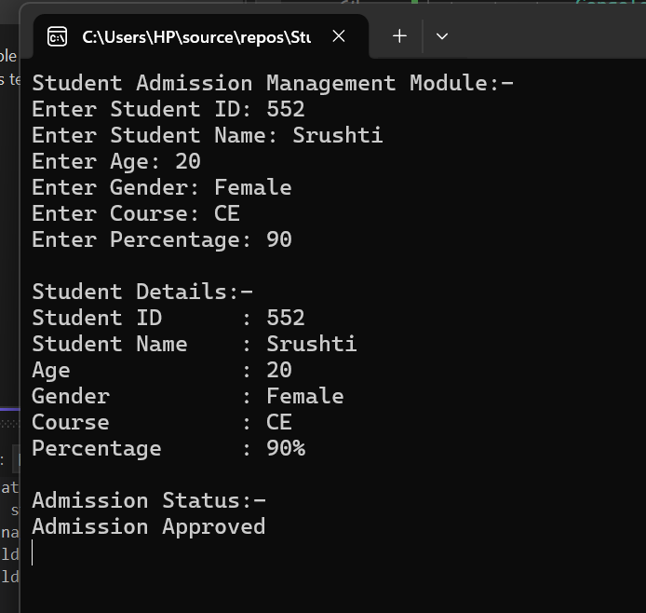

Github Link: https://github.com/Srushti-7745/Student-Management-Portal.git

