DON BOSCO INSTITUTE OF TECHNOLOGY KURLA , MUMABI

A PROJECT REPORT ON

“ML-BASED FLOOD ANALYSIS”


SUBMITTEDBY:

ATIF SAYAD (45)
SOHAM RAHATWAL (48)
MRUDULA SONWANE (58)
SRUSHTI THOMBRE (61)

UNDER THE GUIDENCES OF:

DR. VAISHALI KAVATHEKAR

DEPARTMENT OF INFORMATION TECHNOLOGY

(2025 - 2026)

CERTIFICATE

This is to certify that the project entitled “ML Based Flood Analysis” is a bonafide work submitted to the University of Mumbai in partial fulfillment of the requirements for the award of the degree of Bachelor of Engineering in Information Technology.

(GUIDE SIGNATURE)

Dissertation Approval Certificate

This project report entitled “ML Based Flood Analysis” is approved for the degree of Bachelor of Engineering in Information Technology.

Examiners

1. ---------------------------------------------

2. ---------------------------------------------

Name: -

Date: -

Place: -

Declaration

I declare that this written submission represents my ideas in my own words and that all external ideas, data, software, and sources have been adequately cited and referenced. I also declare that I have adhered to the principles of academic honesty and integrity and have not misrepresented or falsified any idea, data, fact, or source in this submission.

--------------------------------------
(Project Team)

Date:

CONTENTS
1 Introduction

1.1 Problem Statement
1.2 Scope of the Project
1.3 Current Scenario
1.4 Need for the Proposed System

2 Review of Literature

2.1 Geospatial flood-risk assessment and machine-learning methods

3 Analysis and Design

3.1 Methodology and analysis
3.2 System architecture and design

4 Implementation

5 Results and Discussion

6 Conclusion

7 References
ABSTRACT
This project presents a geospatial machine-learning workflow for assessing building-level flood vulnerability in Kurla, Mumbai. OpenStreetMap building and waterway data are combined with a digital elevation model to derive elevation, river and drainage distances, slope, local relief, major-waterway distance, and waterway-density features. The engineered features are standardized and grouped using three-cluster K-Means modelling. The resulting High Risk, Medium Risk, and Low Risk categories are exported as geospatial data and presented through static maps, interactive maps, a dashboard, and formal reports.
Keywords: flood risk, GIS, K-Means, DEM, OpenStreetMap, Kurla, Mumbai
1 INTRODUCTION
1.1 Problem Statement
Urban flooding can affect buildings, roads, drainage systems, and communities within a short period. A repeatable building-level assessment helps compare locations using consistent terrain and waterway features.
1.2 Scope of the Project
The project focuses on Kurla, Mumbai. It loads OpenStreetMap buildings and waterways, reads the Kurla digital elevation model, engineers’ terrain and hydrological features, applies three-cluster K-Means classification, and produces geospatial exports and visual outputs.
1.3 Current Scenario
Flood-related information is often distributed across maps, spreadsheets, remote-sensing products, and local observations. A unified workflow helps organize these inputs and communicate relative risk clearly.
1.4 Need for the Proposed System
The system provides a repeatable way to rank buildings using measurable spatial features and supplies maps, CSV and GeoPackage outputs, an interactive dashboard, and report-ready summaries.
2 REVIEW OF LITERATURE
2.1 Geospatial flood-risk assessment and machine-learning methods
Geospatial flood-risk studies commonly combine elevation, slope, distance to rivers or drains, rainfall, land cover, and other environmental variables. Digital elevation models support terrain derivatives, while OpenStreetMap provides detailed building and waterway geometries. Unsupervised clustering is useful when labelled building-level flood outcomes are unavailable because it groups locations with similar feature profiles.
3 ANALYSIS AND DESIGN
3.1 Methodology and analysis
The ordered pipeline is: load OSM buildings and waterways; load the DEM; calculate elevation; calculate distance to river; calculate slope and local relief; calculate major-waterway distance and waterway density; calculate drainage distance; cluster the engineered feature matrix; assign the three risk classes; generate maps; and export the final results.
3.2 System architecture and design
The package is divided into data, features, models, visualization, utilities, reporting, and pipeline layers. Data loaders provide geospatial inputs. Feature modules add columns while preserving source geometries. The clustering module consumes the feature table, and visualization and reporting modules write outputs.
[ IMAGE SPACE: System architecture diagram ]
[ IMAGE SPACE: Pipeline workflow diagram ]
4 IMPLEMENTATION
4.1 Data loading
The OSM loader retrieves building and waterway geometries for the selected place. The DEM loader reads the raster and exposes the data and transform required for zonal statistics and terrain calculations. Pathlib is used for filesystem paths and output locations.
4.2 Feature engineering
Each building receives elevation, dist_to_river, slope_deg, local_relief_m, dist_to_major_waterway, waterway_density_300m, and dist_to_drainage_m values. CRS transformations are performed where required for distance and raster operations.
4.3 Modelling and outputs
Missing feature values are handled before standardization, and K-Means is configured for three clusters with a fixed random state. The resulting labels are mapped to the three risk classes and passed to the exporters.
5 RESULTS AND DISCUSSION
The exported feature report contains 2285 building records. The current distribution is High Risk: 1514, Medium Risk: 82, and Low Risk: 689. These categories describe relative similarity within the engineered feature space and should be interpreted alongside local knowledge, rainfall observations, drainage capacity, and field verification.
The static risk map provides a compact overview, while the interactive dashboard supports filtering by risk category. The GeoPackage preserves geometry and attributes for GIS software, and the CSV provides a tabular form for analysis.
[ IMAGE SPACE: Dashboard screenshot ]
[ IMAGE SPACE: Historical comparison chart ]
Figure 1. Building-level flood vulnerability map
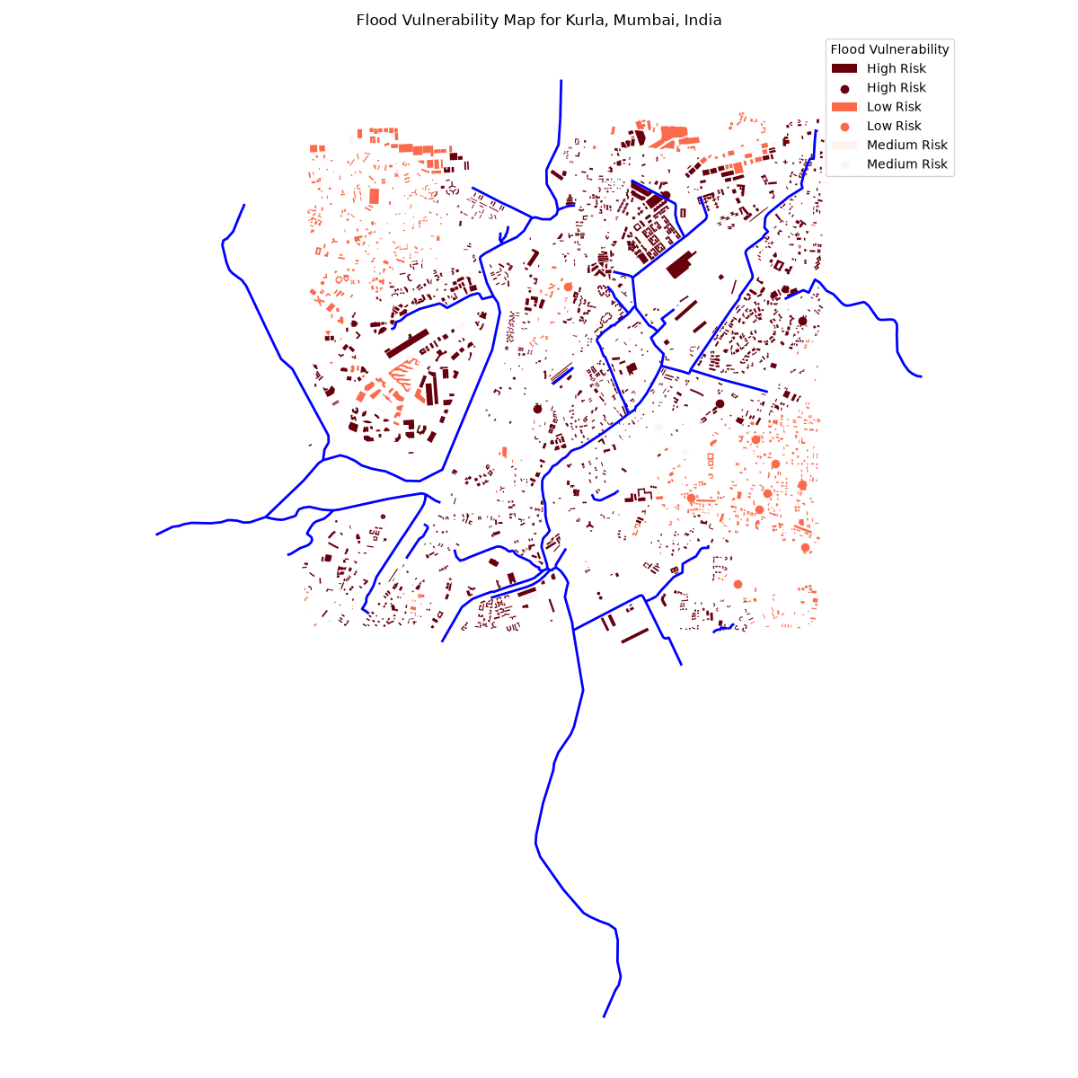
6 CONCLUSION
The modular flood-analysis package converts the original notebook workflow into a reusable, ordered geospatial pipeline. It preserves the feature calculations and CRS-aware processing while making the data loading, feature engineering, clustering, visualization, and export stages easier to maintain.
Future extensions may include validated multi-year observations, rainfall and tide time series, field-verified labels, hydrodynamic simulation, uncertainty estimates, and additional study areas.
7 REFERENCES
[1] OpenStreetMap contributors, OpenStreetMap data and documentation.
[2] U.S. Geological Survey, Digital Elevation Models and terrain analysis guidance.
[3] Pedregosa, F. et al., Scikit-learn: Machine Learning in Python, Journal of Machine Learning Research.
[4] GeoPandas, Rasterio, and Folium documentation.

