**TEAM – 4**

**DIGITAL LOCKER**

Under the guidance of

**Dr Saroja v Siddamal**

|  |  |  |
| --- | --- | --- |
| Name | USN | Roll no. |
| **Srushti Shettar** | **01FE20BEC042** | **139** |
| **Khushi Talli** | **01FE20BEC027** | **124** |

**Problem Statement:**

Digital lock with a four-bit password

**Introduction:**

We are designing a digital lock which takes four bit input password from the user and compares with the original set password.

**Explaination:**

* A four-bit digital lock uses four digital inputs to enter a password, and provides an output indicating whether or not the correct password has been entered.
* The design of a four-bit digital lock typically involves a finite state machine that controls the operation of the lock.
* The lock operates on a clock signal, and uses a set of internal registers to store the current state and password information.
* When a user enters a password, it is compared with the set password, and if it matches, the lock is unlocked.
* If the password is entered incorrectly a three times, an alarm may be sounded to indicate a potential security breach.

**Flow chart:**

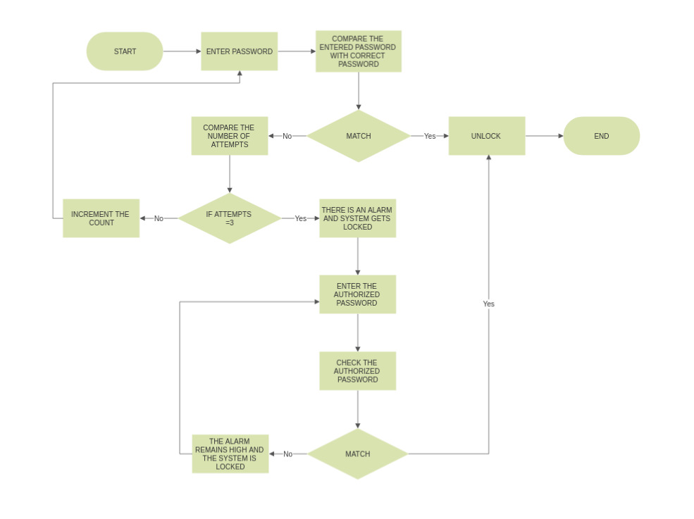

**Signals used:**

* clk: The clock signal used to trigger the state transitions and operations in the code.
* reset: The reset signal used to initialize the lock's state and outputs.
* password: A 4-bit input representing the correct password. input_pass: A 4-bit input representing the password entered by the user.
* unlocked: A 1-bit output indicating whether the lock is currently unlocked (1) or locked (0).
* alarm: A 1-bit output indicating whether the alarm is active (1) or inactive (0). authorized: A 1-bit output indicating whether the entered password is authorized (1) or unauthorized (0).
* state: A 3-bit register representing the current state of the lock.
* count: A 2-bit register used to keep track of the number of incorrect password attempts. correct_pass: A wire indicating whether the entered password matches the correct password or meets the condition for a master code (count == 2'b11 and input_pass == 4'b1111).

**States Used:**

These states are defined using a 3-bit register called "state" in the code:

* IDLE is represented by the value 3'b000.
* CHECK_PASS is represented by the value 3'b001.
* ALARM is represented by the value 3'b010.
* UNLOCKED is represented by the value 3'b011.

The state transitions occur based on the current state and the correctness of the entered password, and they determine the behavior of the digital lock.

**Results:**

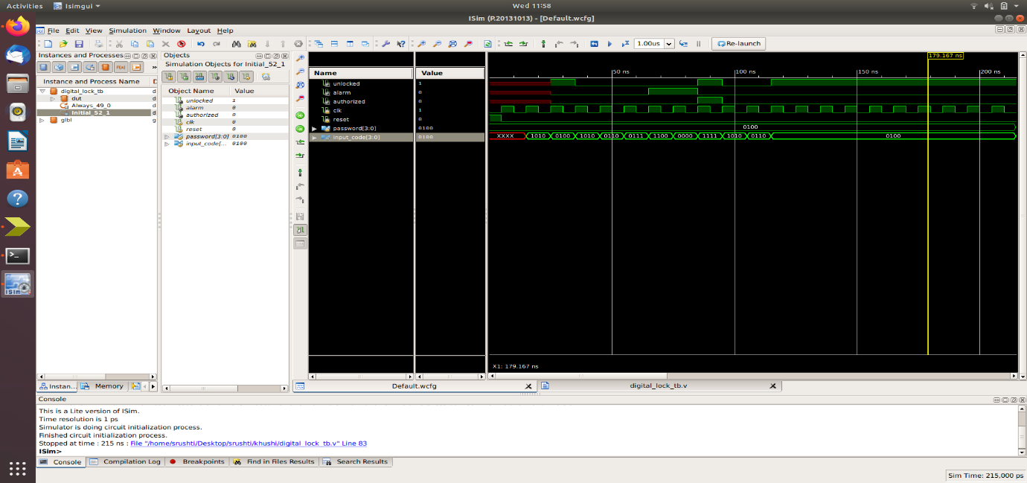

**Conclusion:**

The digital lock has a password set as 0100. User has 3 chances to unlock the lock, after 3 chances an alarm rings and the system is locked completely which is only opened through an authorized password set as 1111.