WEEK 2 TASK
Data Collection, Cleaning, and Preprocessing
for Logistics Analysis
Logistics Data Analyst Internship
Dataset: Olist Brazilian E-Commerce Public Dataset
Tools: Python, Pandas, NumPy, Matplotlib, Seaborn and Scikit-learn

1. Objective
This task implements a simulated logistics data-preprocessing pipeline using a publicly available e-commerce logistics dataset. The work covers data inspection, missing-value analysis, duplicate detection, timestamp conversion, logical validation, outlier detection and treatment, feature engineering, normalization and standardization.
The purpose of preprocessing is to convert raw operational records into reliable, consistent and analysis-ready data. High-quality data is essential for accurate logistics KPIs, delivery analysis and later predictive modelling.

2. Data Collection Simulation
Two CSV files were used as the reference logistics data:
- olist_orders_dataset.csv – order-level records containing order status and purchase, approval, carrier-delivery, customer-delivery and estimated-delivery timestamps.
- olist_order_items_dataset.csv – item-level records containing order item, product, seller, shipping-limit date, price and freight information.
The orders dataset contained 99,441 records and 8 columns. The order-items dataset contained 112,650 records and 7 columns.
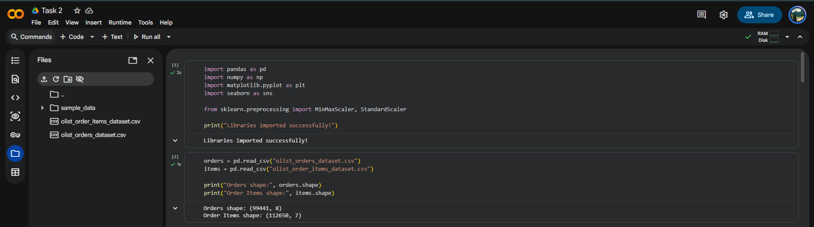
Figure 1. Loading the two logistics datasets.
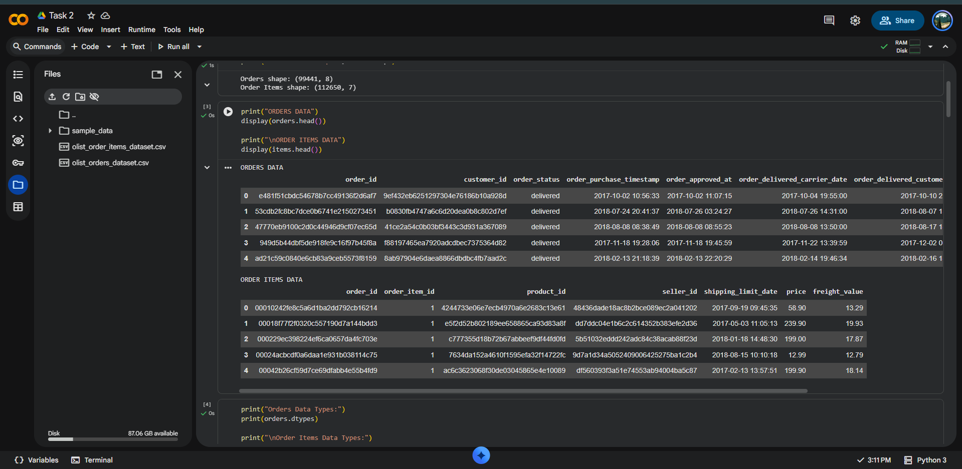
Figure 2. Initial inspection of orders and order-items records.

3. Preprocessing Methodology
- Inspect dataset dimensions, sample records and data types.
- Measure missing values for every field.
- Check for exact duplicate rows.
- Convert timestamp fields to Pandas datetime format.
- Create delivery_days, delay_days and late_flag logistics features.
- Check for impossible negative delivery, freight and price values.
- Detect extreme delivery times using the Interquartile Range (IQR) method.
- Cap extreme delivery times at the calculated IQR boundary.
- Remove records missing critical delivery dates from the analysis-ready dataset.
- Apply Min-Max normalization and StandardScaler standardization.
- Perform final validation of dimensions, missing values and data types.

4. Initial Data Inspection

4.1 Dataset Dimensions
The initial dataset dimensions were 99,441 × 8 for orders and 112,650 × 7 for order items.

4.2 Data Types
The order timestamp columns were initially stored as object/string values. Numeric fields such as price and freight_value were numeric. Timestamp conversion was required before date arithmetic.
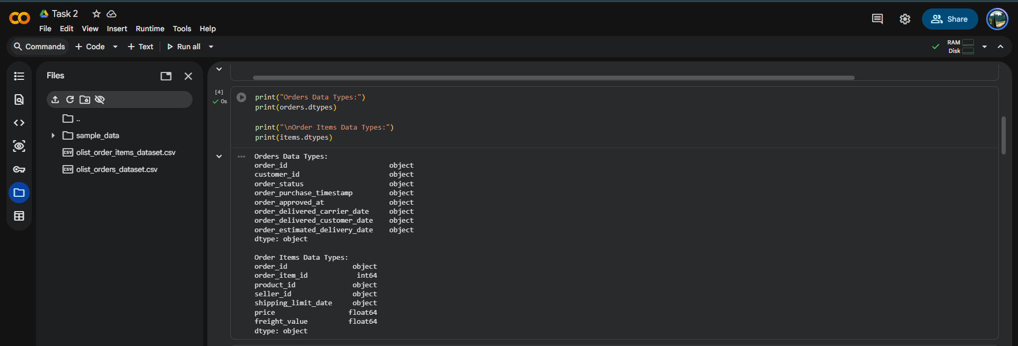
Figure 3. Initial data types.

5. Missing-Value Analysis and Treatment
The orders dataset contained 160 missing order_approved_at values, 1,783 missing order_delivered_carrier_date values and 2,965 missing order_delivered_customer_date values. The displayed order-items fields contained no missing values.
For delivery-time analysis, purchase time, customer delivery time and estimated delivery time are critical. Instead of inventing missing delivery dates, records missing these critical fields were excluded from the analysis-ready dataset.
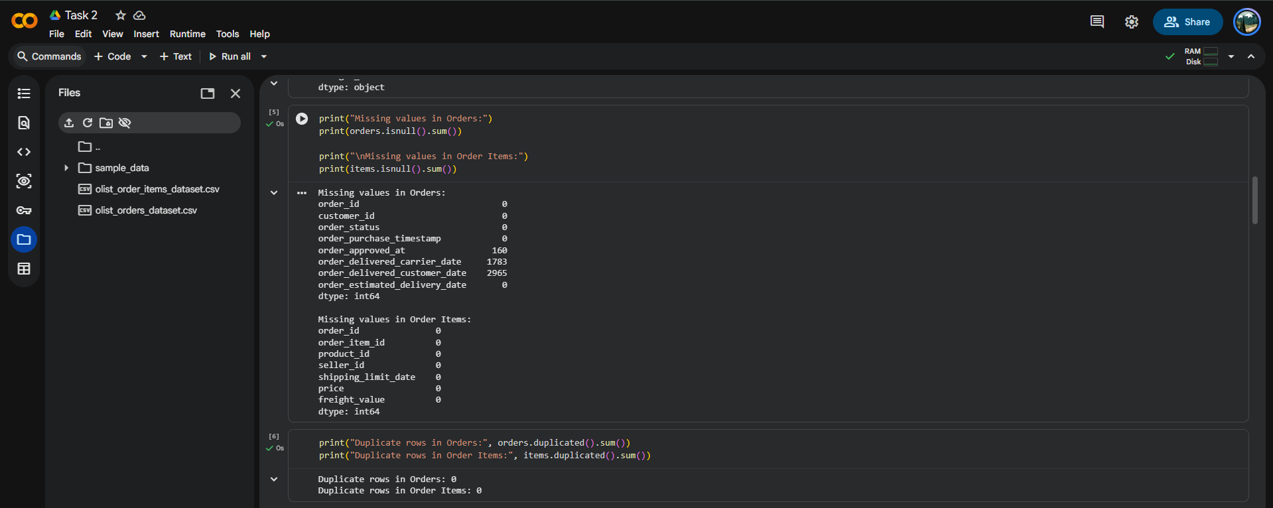
Figure 4. Missing-value counts.

6. Duplicate Detection
Exact duplicate rows were checked in both datasets. The results showed zero duplicate rows in the orders dataset and zero duplicate rows in the order-items dataset.
orders = orders.drop_duplicates()
items = items.drop_duplicates()

7. Date and Time Preprocessing
The five order timestamp fields were converted from object/string representation to datetime64. This enables reliable time arithmetic and duration calculations.
date_columns = [
"order_purchase_timestamp",
"order_approved_at",
"order_delivered_carrier_date",
"order_delivered_customer_date",
"order_estimated_delivery_date"
]
for col in date_columns:
orders[col] = pd.to_datetime(orders[col], errors="coerce")
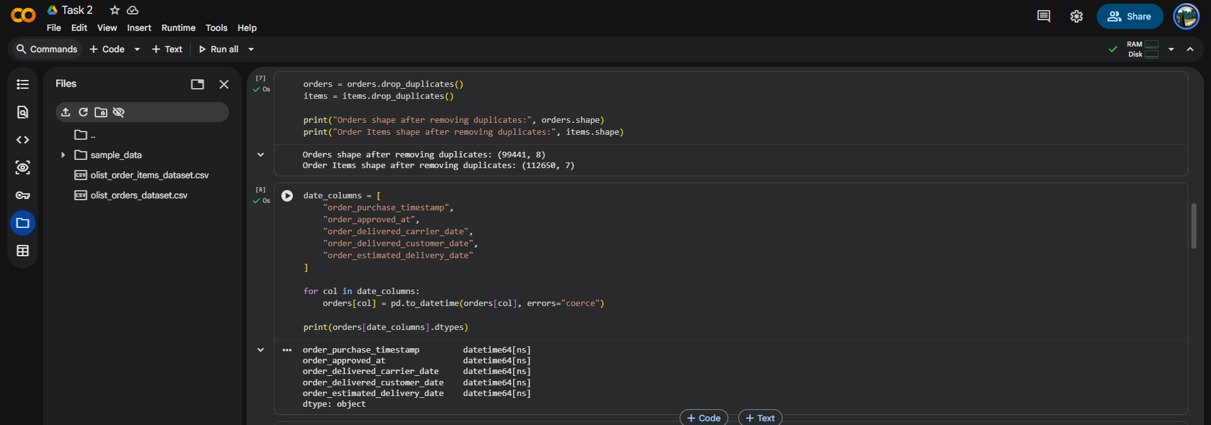
Figure 5. Timestamp columns converted to datetime64.

8. Logistics Feature Engineering
Three useful logistics indicators were derived:
- delivery_days – actual elapsed time between order purchase and customer delivery.
- delay_days – difference between actual customer delivery and estimated delivery.
- late_flag – 1 when delay_days is greater than zero; otherwise 0.
orders["delivery_days"] = (
orders["order_delivered_customer_date"]
- orders["order_purchase_timestamp"]
).dt.total_seconds() / 86400
orders["delay_days"] = (
orders["order_delivered_customer_date"]
- orders["order_estimated_delivery_date"]
).dt.total_seconds() / 86400
orders["late_flag"] = (orders["delay_days"] > 0).astype(int)

9. Invalid-Value Checks
Logical validation returned zero negative delivery days, zero negative freight values and zero negative product prices. Therefore, no impossible negative values required correction.
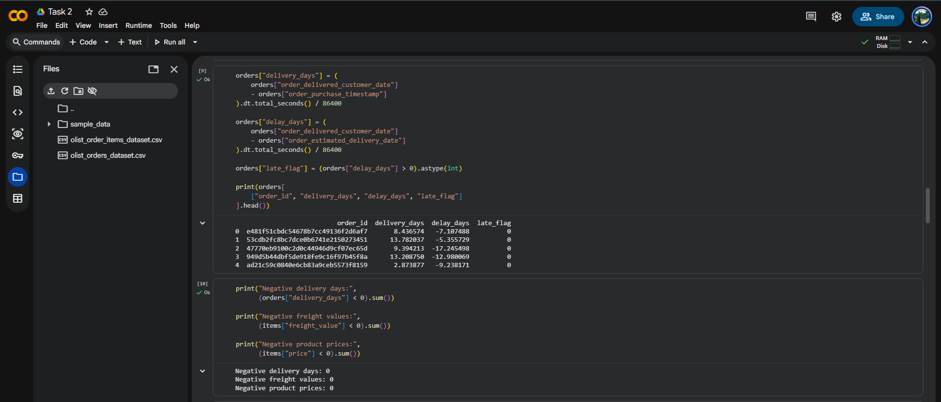
Figure 6. Invalid-value validation results.

10. Outlier Detection Using IQR
Delivery time had a long right tail. The IQR method was used to identify unusually high delivery times. The observed statistics were Q1 = 6.7664 days, Q3 = 15.7203 days and IQR = 8.9539 days. The upper bound was 29.1512 days, and 4,899 delivery-time observations were identified as outliers.
Q1 = orders["delivery_days"].quantile(0.25)
Q3 = orders["delivery_days"].quantile(0.75)
IQR = Q3 - Q1
lower_bound = Q1 - 1.5 * IQR
upper_bound = Q3 + 1.5 * IQR
outliers = orders[
(orders["delivery_days"] < lower_bound) |
(orders["delivery_days"] > upper_bound)
]
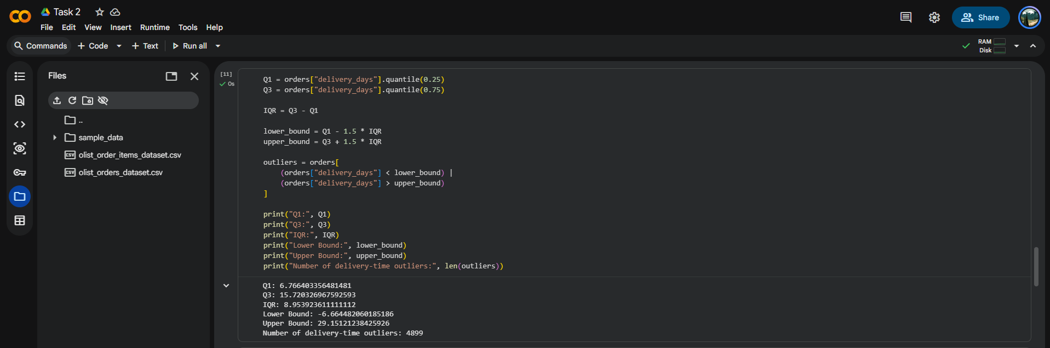
Figure 7. IQR statistics and detected outliers.
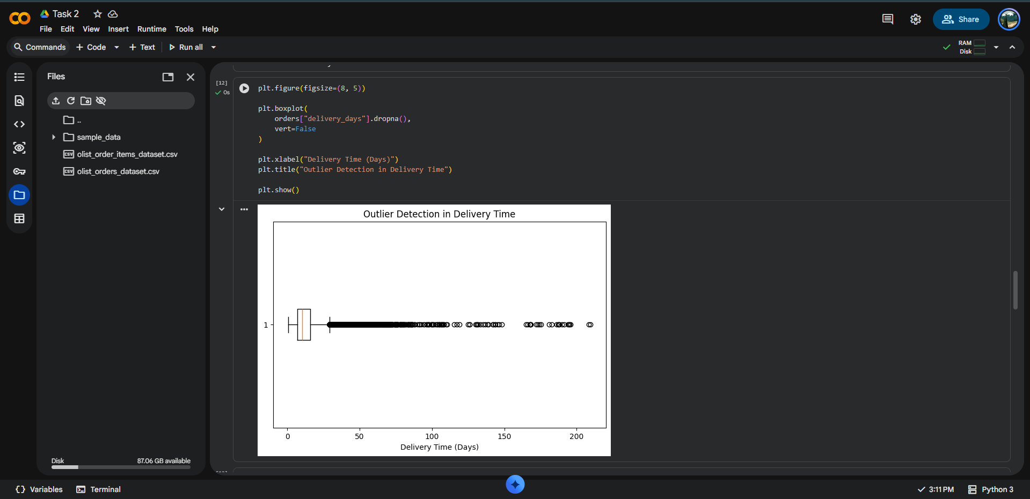
Figure 8. Boxplot showing delivery-time outliers.

11. Outlier Treatment
The original maximum delivery time was approximately 209.63 days. Instead of deleting every extreme observation, IQR-based capping was used. The resulting maximum capped delivery time was approximately 29.15 days.
Capping preserves the observations while reducing the influence of extreme values on summary statistics and machine-learning algorithms. This is preferable when extreme delivery times may represent genuine logistics incidents.
orders["delivery_days_capped"] = orders["delivery_days"].clip(
lower=lower_bound,
upper=upper_bound
)
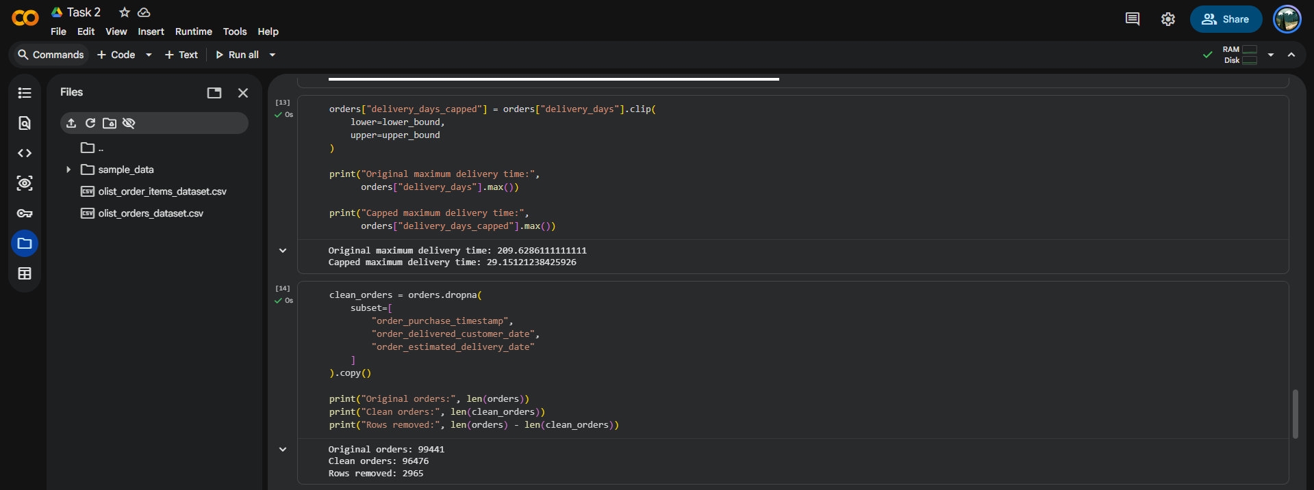
Figure 9. Original and capped maximum delivery time.

12. Analysis-Ready Dataset
Records missing purchase time, customer delivery time or estimated delivery time were excluded. The original 99,441 orders were reduced by 2,965 records, producing 96,476 analysis-ready orders.
clean_orders = orders.dropna(
subset=[
"order_purchase_timestamp",
"order_delivered_customer_date",
"order_estimated_delivery_date"
]
).copy()
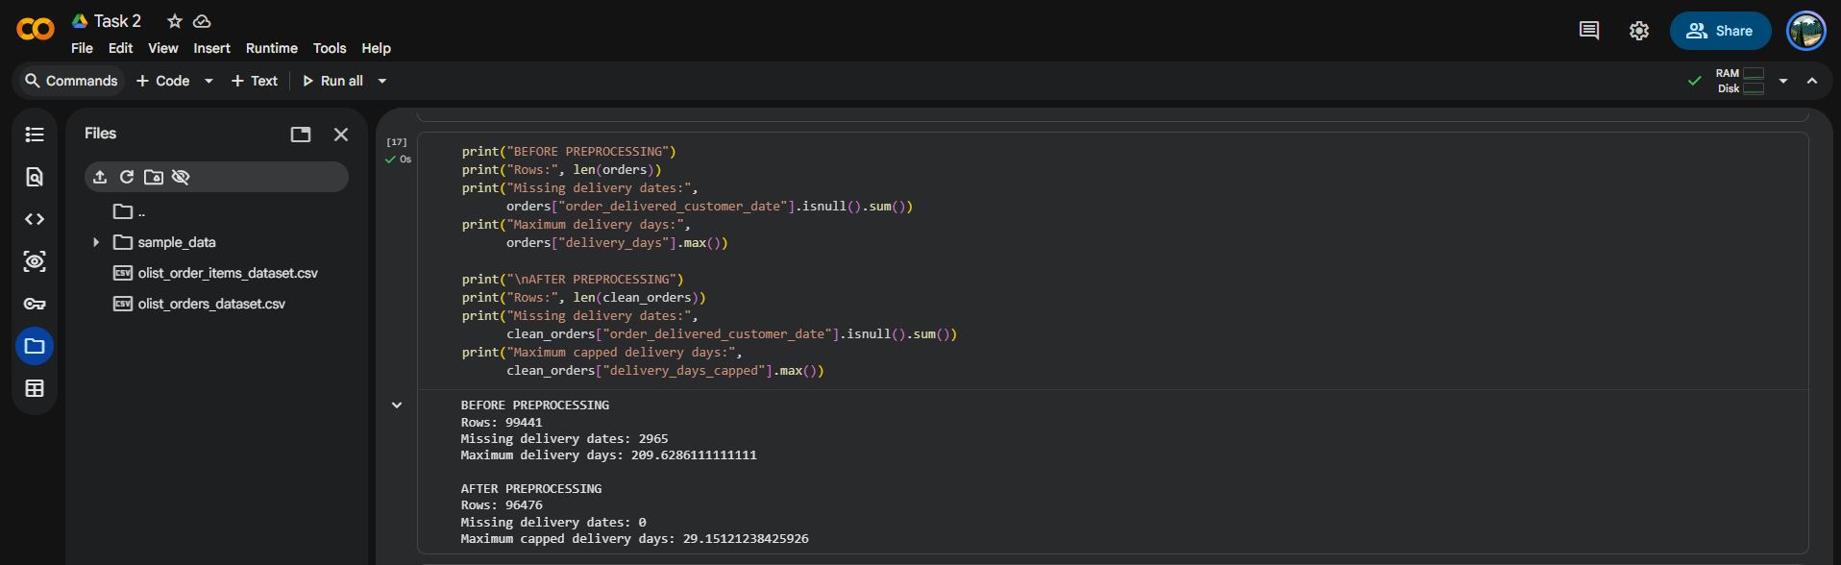
Figure 10. Before-and-after preprocessing comparison.

13. Normalization and Standardization

13.1 Min-Max Normalization
Min-Max scaling transforms a numerical feature to a common 0–1 range. It is useful when the magnitude of a variable should be constrained to a consistent scale.
scaler = MinMaxScaler()
clean_orders["delivery_days_normalized"] = scaler.fit_transform(
clean_orders[["delivery_days_capped"]]
)

13.2 Standardization
StandardScaler converts a feature to a z-score representation, centering it around zero and scaling by standard deviation.
standard_scaler = StandardScaler()
clean_orders["delivery_days_standardized"] = standard_scaler.fit_transform(
clean_orders[["delivery_days_capped"]]
)
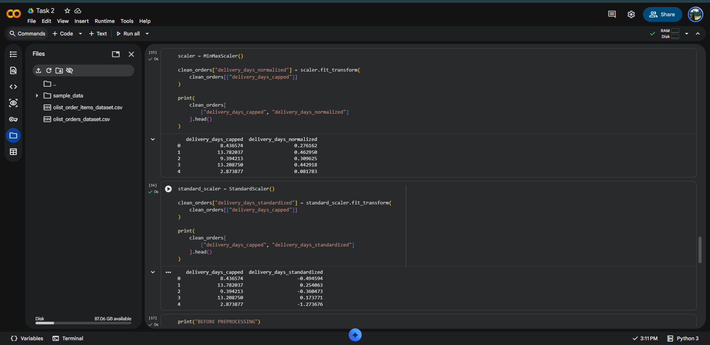
Figure 11. Normalized and standardized delivery-time values.

14. Final Data Quality Validation
The final analysis-ready dataset contained 96,476 rows and 14 columns. The final validation output showed zero remaining missing values in the retained analysis-ready records for the displayed fields. Timestamp fields were datetime64, delivery and delay measures were float64, and late_flag was int64.
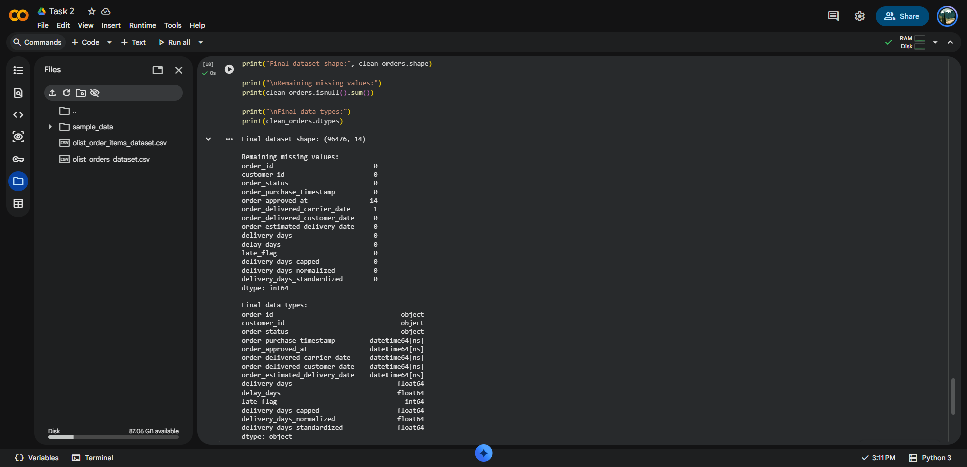
Figure 12. Final dataset dimensions, missing-value check and data types.

15. Consolidated Python Pipeline
import pandas as pd
import numpy as np
from sklearn.preprocessing import MinMaxScaler, StandardScaler
orders = pd.read_csv("olist_orders_dataset.csv")
items = pd.read_csv("olist_order_items_dataset.csv")
orders = orders.drop_duplicates()
items = items.drop_duplicates()
date_columns = [
"order_purchase_timestamp",
"order_approved_at",
"order_delivered_carrier_date",
"order_delivered_customer_date",
"order_estimated_delivery_date"
]
for col in date_columns:
orders[col] = pd.to_datetime(orders[col], errors="coerce")
orders["delivery_days"] = (
orders["order_delivered_customer_date"]
- orders["order_purchase_timestamp"]
).dt.total_seconds() / 86400
orders["delay_days"] = (
orders["order_delivered_customer_date"]
- orders["order_estimated_delivery_date"]
).dt.total_seconds() / 86400
orders["late_flag"] = (orders["delay_days"] > 0).astype(int)
Q1 = orders["delivery_days"].quantile(0.25)
Q3 = orders["delivery_days"].quantile(0.75)
IQR = Q3 - Q1
lower_bound = Q1 - 1.5 * IQR
upper_bound = Q3 + 1.5 * IQR
orders["delivery_days_capped"] = orders["delivery_days"].clip(
lower_bound, upper_bound
)
clean_orders = orders.dropna(
subset=[
"order_purchase_timestamp",
"order_delivered_customer_date",
"order_estimated_delivery_date"
]
).copy()
minmax = MinMaxScaler()
clean_orders["delivery_days_normalized"] = minmax.fit_transform(
clean_orders[["delivery_days_capped"]]
)
standard = StandardScaler()
clean_orders["delivery_days_standardized"] = standard.fit_transform(
clean_orders[["delivery_days_capped"]]
)
print(clean_orders.shape)
print(clean_orders.isnull().sum())

16. Reflection
Data quality directly affects logistics analytics and operational decisions. Missing delivery dates can make delivery KPIs incomplete, incorrect data types can prevent accurate date calculations, duplicates can inflate volumes, and extreme delivery times can distort averages and models.
The preprocessing pipeline converts raw order data into an analysis-ready dataset. The engineered delivery_days, delay_days and late_flag variables can support later logistics KPI analysis, visualization and predictive modelling. Normalized and standardized variables can also be used as inputs to machine-learning methods.

17. Key Results Summary
Metric | Result | Meaning
Orders dataset | 99,441 × 8 | Initial order-level records
Order-items dataset | 112,650 × 7 | Initial item-level records
Duplicate rows | 0 in both | No exact duplicates found
Missing customer delivery dates | 2,965 | Critical missing delivery field
Negative delivery/freight/price | 0 | No logical negative values
IQR upper bound | 29.1512 days | Outlier treatment threshold
Delivery-time outliers | 4,899 | High delivery-time observations
Original maximum | 209.6286 days | Extreme raw observation
Capped maximum | 29.1512 days | IQR-capped value
Final dataset | 96,476 × 14 | Analysis-ready dataset

18. Conclusion
The Week 2 task successfully implemented a complete logistics data collection and preprocessing workflow in Python. The Olist datasets were inspected, cleaned and transformed. Missing critical delivery records were handled, duplicate and invalid-value checks were performed, delivery-time outliers were detected using IQR and capped, and Min-Max normalization and standardization were demonstrated.
The resulting analysis-ready dataset provides a reliable foundation for subsequent logistics analysis, KPI evaluation, visualization and predictive modelling.

