YUVINTERN – LOGISTICS DATA ANALYST
WEEK 3 TASK
Advanced Data Analysis and Visualization in Logistics
Prepared by: Srushti Titarmare
Role: Data Analyst Intern
Tools: Python, Pandas, NumPy, Matplotlib, Seaborn, Google Colab

Objective
To explore logistics order data, perform EDA, visualize key performance metrics, identify bottlenecks and outliers, and derive actionable logistics insights.

1. Objective
This task focuses on advanced exploratory data analysis and visualization of logistics data using Python. The analysis covers delivery performance, delays, freight costs, product prices, distributions, outliers and correlations.
The workflow includes data loading, cleaning, date conversion, feature engineering, descriptive statistics, visualization, correlation analysis, interpretation and recommendations.

2. Dataset and Structure
Two logistics CSV files were analyzed: an orders dataset and an order-items dataset.
Dataset | Rows | Columns
Orders | 99,441 | 8
Order Items | 112,650 | 7
The analysis created delivery_days, delay_days and late_flag to measure delivery performance.

3. Tools Used
- Python
- Pandas
- NumPy
- Matplotlib
- Seaborn
- Google Colab

4. Data Loading and Cleaning
import pandas as pd
import numpy as np
import matplotlib.pyplot as plt
import seaborn as sns
orders = pd.read_csv("olist_orders_dataset.csv")
items = pd.read_csv("olist_order_items_dataset.csv",
on_bad_lines="skip", quoting=3)
print("Orders:", orders.shape)
print("Order Items:", items.shape)
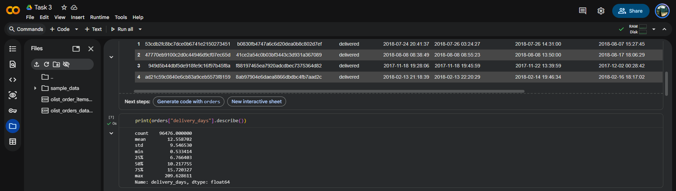
Figure 1. Loading Python libraries and logistics datasets.
Column names in the order-items data were cleaned by removing quotation marks and extra whitespace.
items.columns = items.columns.str.replace('"','').str.strip()
print("Cleaned columns:", items.columns.tolist())
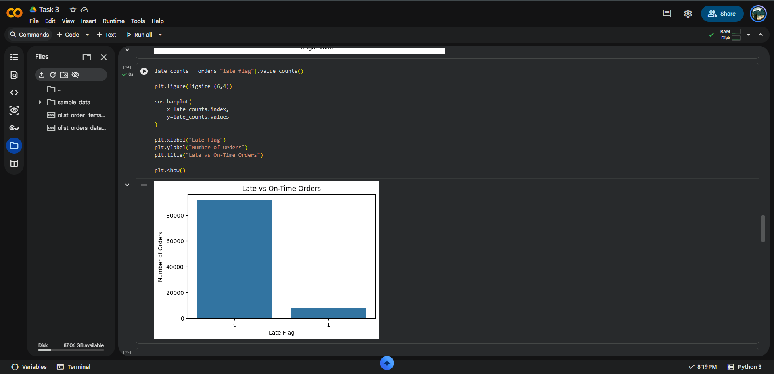
Figure 7. Cleaning column names.

5. Feature Engineering
Date fields were converted to datetime format. Delivery duration was calculated from purchase to customer delivery. Delay was calculated from actual delivery against estimated delivery. A binary late_flag was then created.
date_columns = [
"order_purchase_timestamp",
"order_delivered_customer_date",
"order_estimated_delivery_date"
]
for col in date_columns:
orders[col] = pd.to_datetime(orders[col], errors="coerce")
orders["delivery_days"] = (
orders["order_delivered_customer_date"]
- orders["order_purchase_timestamp"]
).dt.total_seconds() / 86400
orders["delay_days"] = (
orders["order_delivered_customer_date"]
- orders["order_estimated_delivery_date"]
).dt.total_seconds() / 86400
orders["late_flag"] = (orders["delay_days"] > 0).astype(int)
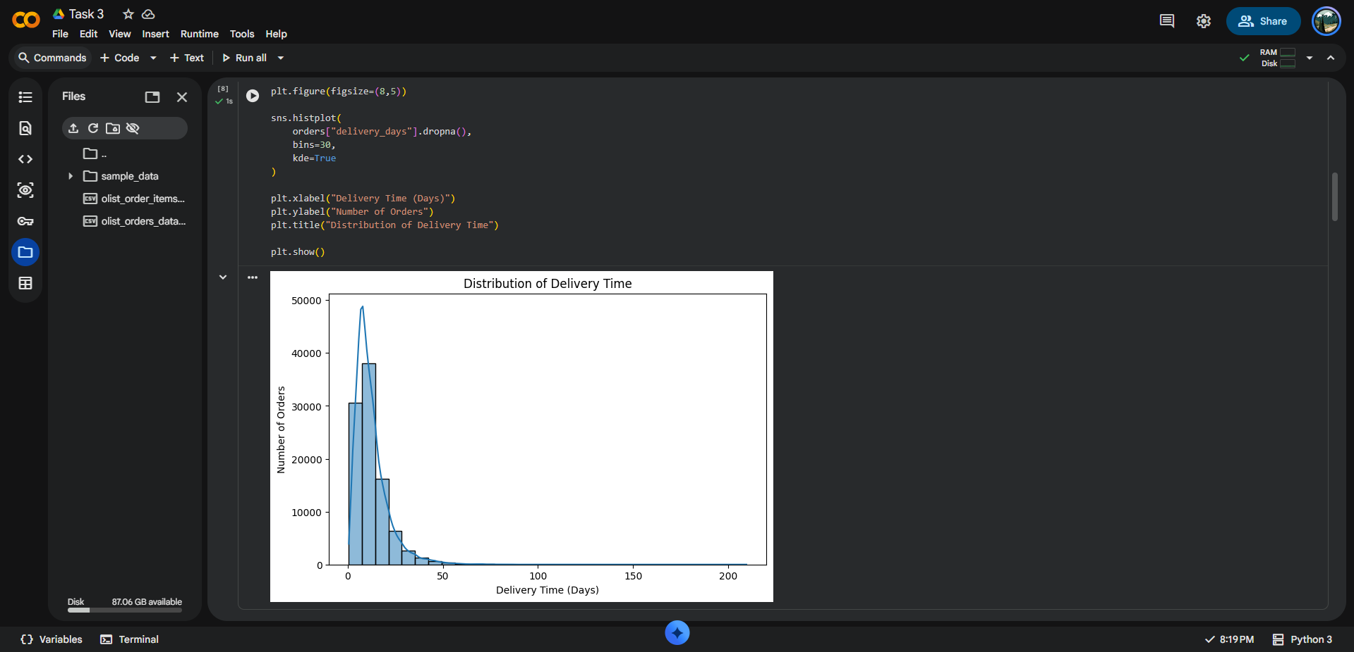
Figure 2. Date conversion and creation of delivery and delay metrics.

6. Exploratory Data Analysis
Descriptive statistics for delivery time show a right-skewed distribution.
Metric | Value
Count | 94,476
Mean | 12.5587 days
Std. deviation | 9.5465 days
Minimum | 0.5334 days
25% | 6.7664 days
Median | 10.2178 days
75% | 15.7203 days
Maximum | 209.6286 days
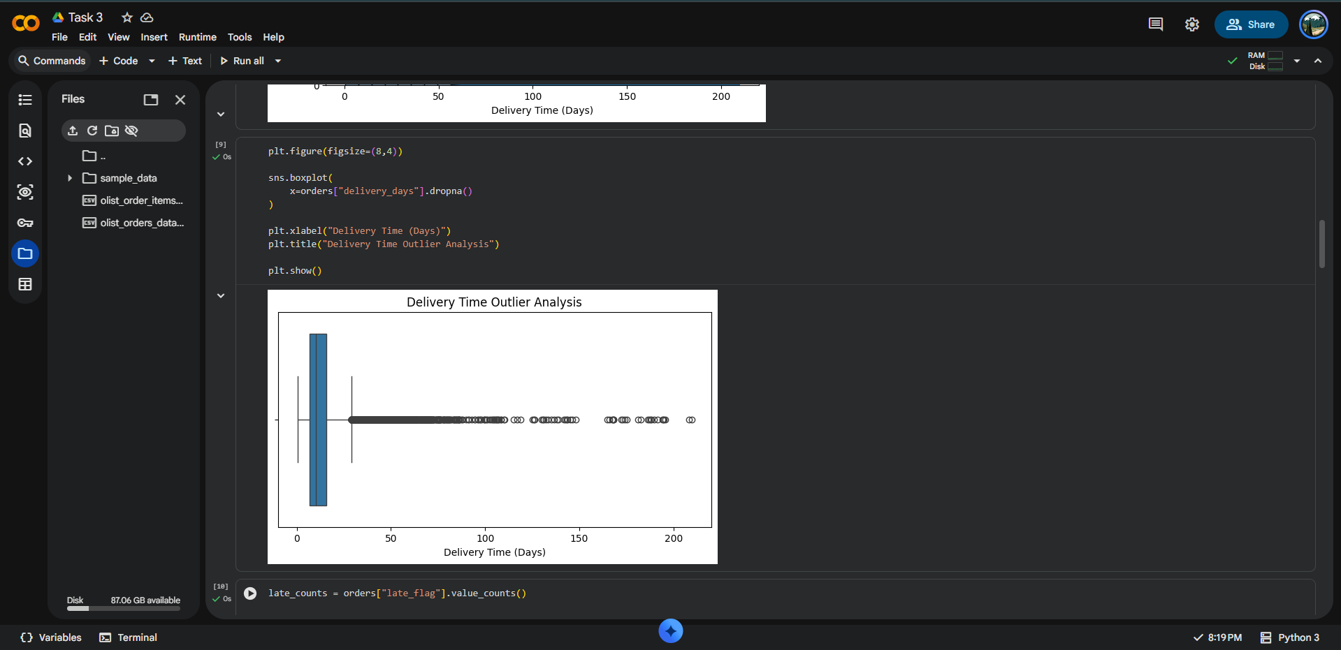
Figure 3. Descriptive statistics for delivery time.

7. Visualizations and Interpretation

7.1 Distribution of Delivery Time
A histogram with KDE was selected because it shows frequency and distribution shape.
sns.histplot(orders["delivery_days"].dropna(), bins=30, kde=True)
plt.xlabel("Delivery Time (Days)")
plt.ylabel("Number of Orders")
plt.title("Distribution of Delivery Time")
plt.show()
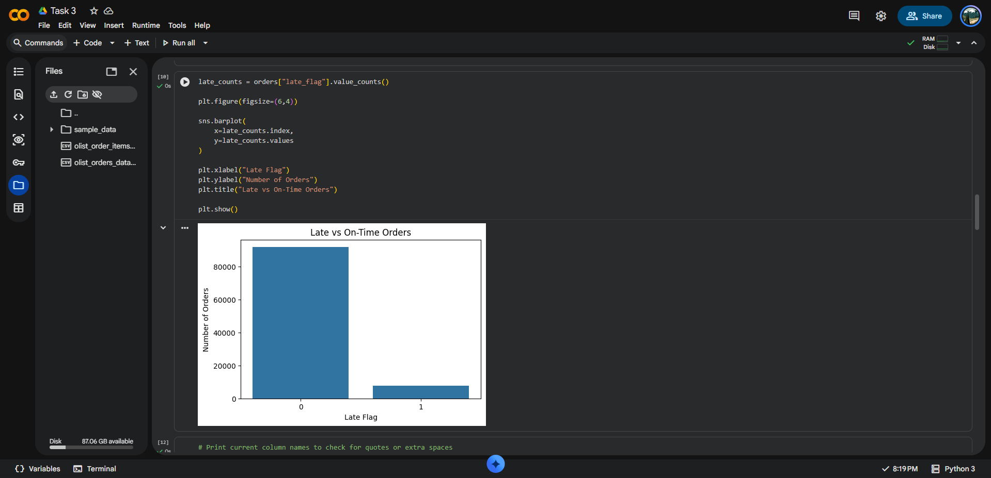
Figure 4. Distribution of delivery time.
Interpretation: Most deliveries are concentrated at lower delivery times, while the long right tail indicates a smaller number of very slow deliveries.

7.2 Delivery Time Outlier Analysis
A box plot was selected because it summarizes spread and highlights outliers.
sns.boxplot(x=orders["delivery_days"].dropna())
plt.xlabel("Delivery Time (Days)")
plt.title("Delivery Time Outlier Analysis")
plt.show()
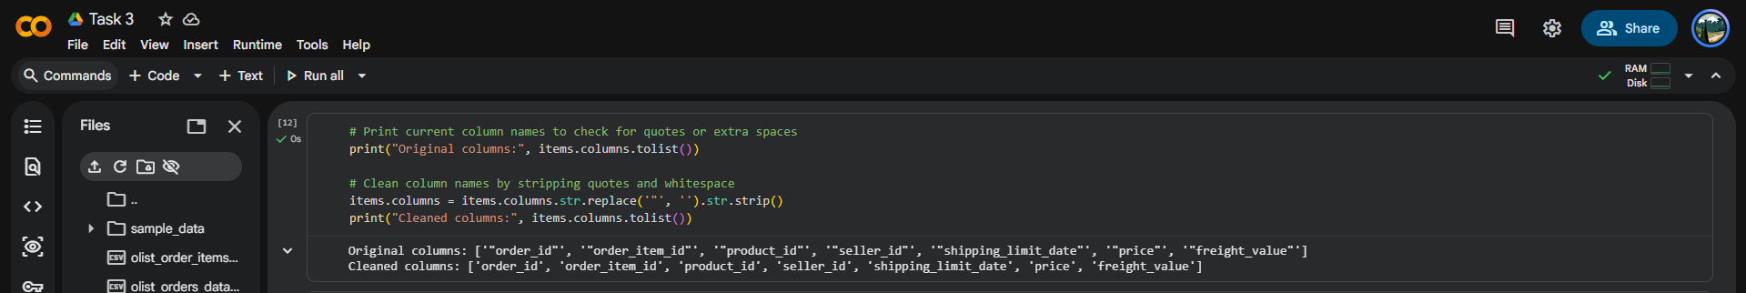
Figure 5. Delivery time outlier analysis.
Interpretation: The box plot reveals many high delivery-time outliers. These may represent operational delays, unusual routes, disruptions or data-quality cases.

7.3 Late vs On-Time Orders
A bar chart was selected to compare counts of categorical delivery outcomes.
late_counts = orders["late_flag"].value_counts()
sns.barplot(x=late_counts.index, y=late_counts.values)
plt.xlabel("Late Flag")
plt.ylabel("Number of Orders")
plt.title("Late vs On-Time Orders")
plt.show()
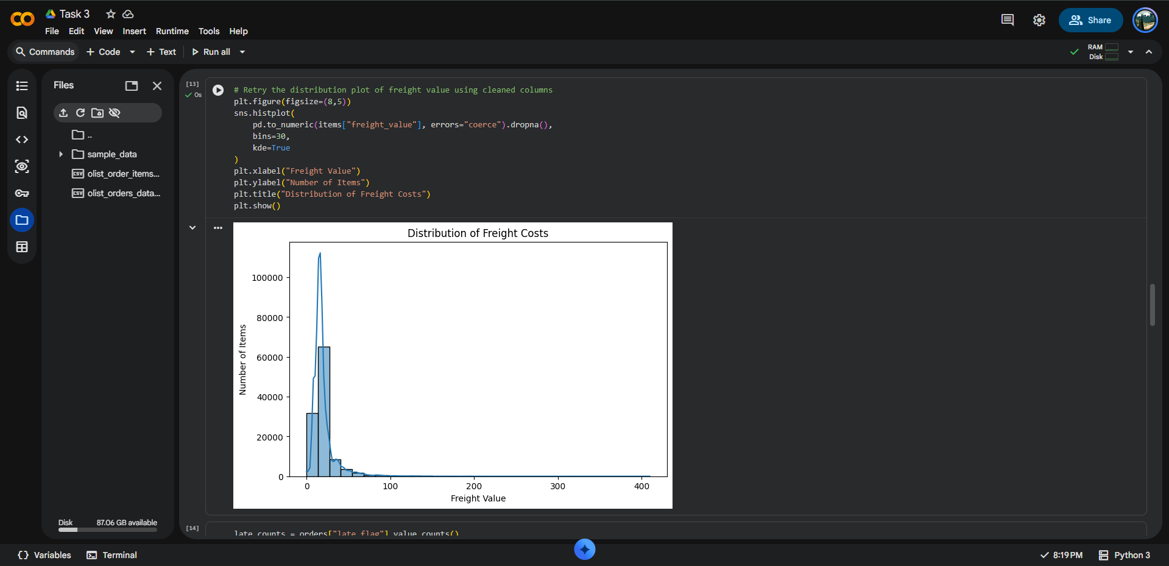
Figure 6. Late vs On-Time Orders.
Interpretation: On-time orders form the majority, while late orders form a smaller but operationally important group.

7.4 Distribution of Freight Costs
A histogram with KDE was selected to examine freight-cost concentration and skewness.
sns.histplot(items["freight_value"], bins=30, kde=True)
plt.xlabel("Freight Value")
plt.ylabel("Number of Items")
plt.title("Distribution of Freight Costs")
plt.show()
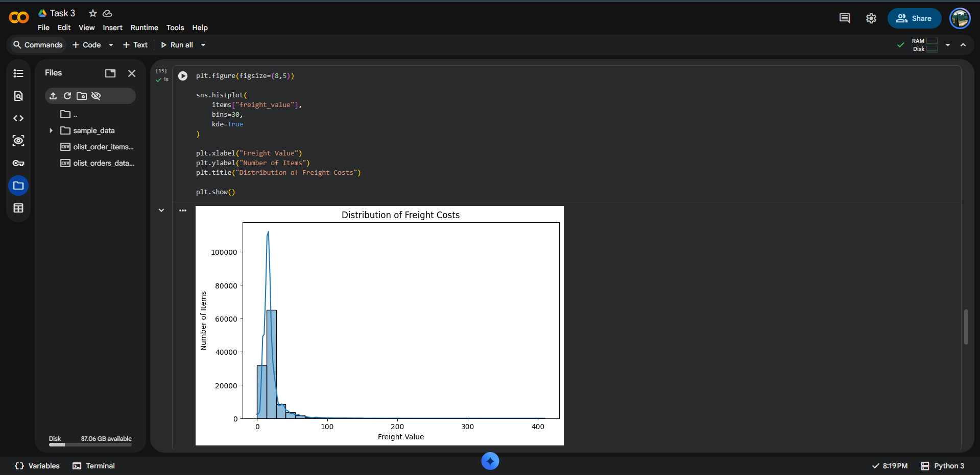
Figure 8. Distribution of freight costs.
Interpretation: Freight values are heavily concentrated at lower levels with a long right tail, indicating a smaller number of high-cost shipments.

7.5 Product Price vs Freight Cost
A scatter plot was selected to examine the relationship between two continuous variables.
sns.scatterplot(
data=items.sample(min(10000, len(items))),
x="price", y="freight_value", alpha=0.5
)
plt.xlabel("Product Price")
plt.ylabel("Freight Value")
plt.title("Relationship Between Product Price and Freight Cost")
plt.show()
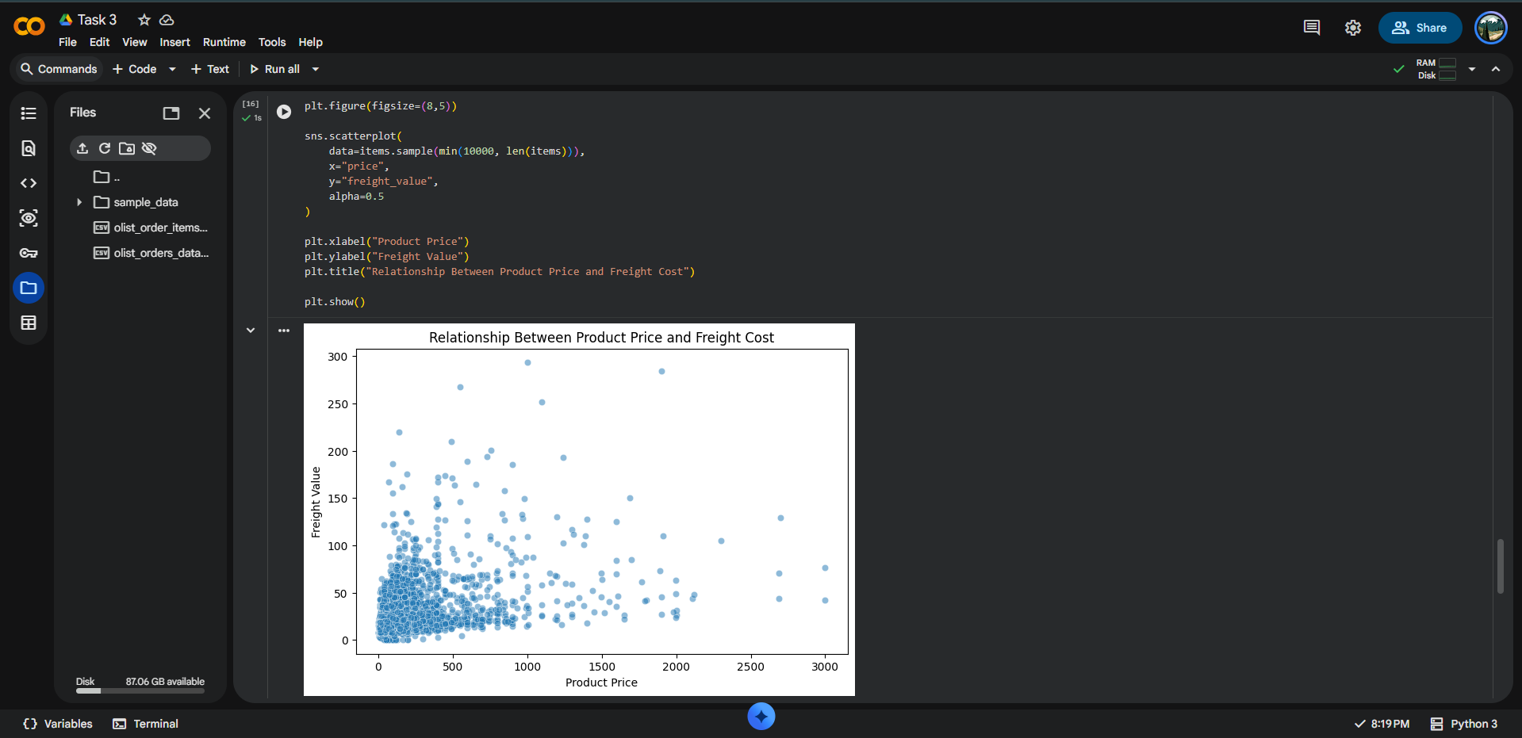
Figure 9. Product price vs freight cost.
Interpretation: The scatter plot shows a moderate positive tendency but substantial variation, meaning product price alone does not explain freight cost.

7.6 Correlation Analysis
A correlation heatmap was selected to quantify and visually summarize linear relationships.
numeric_data = items[["price", "freight_value"]]
correlation = numeric_data.corr()
print(correlation)
sns.heatmap(correlation, annot=True, cmap="coolwarm")
plt.title("Correlation Between Logistics Cost Variables")
plt.show()
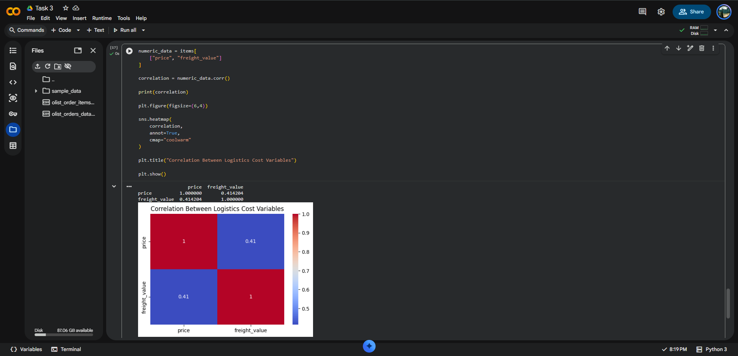
Figure 10. Correlation heatmap.
Interpretation: The price–freight correlation is approximately 0.41, indicating a moderate positive linear relationship.

8. Key Findings
- Average delivery time is approximately 12.56 days; median delivery time is approximately 10.22 days.
- Mean delivery time is greater than the median, confirming right skewness.
- Maximum observed delivery time is approximately 209.63 days, indicating extreme outliers.
- Most orders are on time, but late orders remain an important operational improvement area.
- Freight costs are strongly right-skewed, with most shipments having relatively low freight values.
- Price and freight value have a moderate positive correlation of approximately 0.41.
- Other factors such as destination, distance, package characteristics, carrier and product category likely influence freight cost.

9. Potential Bottlenecks
- Extreme delivery-time outliers may indicate delayed processing, transportation disruption or destination-specific issues.
- High late-order rates may be concentrated among particular sellers, regions, carriers or product categories.
- High freight-value outliers may indicate inefficient routes, oversized shipments or expensive destinations.
- The moderate price–freight relationship indicates that freight optimization requires additional explanatory variables.

10. Recommendations
- Track late-delivery percentage as a core logistics KPI.
- Investigate sellers, regions and routes with consistently high delay rates.
- Analyze extreme delivery-time and freight-cost outliers separately.
- Use distance, destination, package characteristics and carrier information for better freight-cost prediction.
- Build a logistics dashboard covering delivery time, late orders, freight cost and seller performance.
- Develop predictive models to identify orders at high risk of late delivery.

11. Visualization Method Justification
Visualization | Purpose | Why suitable
Histogram + KDE | Distribution | Shows frequency, concentration and skewness.
Box Plot | Outliers | Shows quartiles, spread and extreme observations.
Bar Chart | Category comparison | Clearly compares late and on-time counts.
Scatter Plot | Relationship | Shows association, variation and clusters.
Correlation Heatmap | Correlation | Summarizes linear relationships numerically and visually.

12. Conclusion
The analysis demonstrates how EDA and visualization can support data-driven logistics decisions. Delivery time, delays, freight costs and product prices were examined using descriptive statistics and multiple visualization techniques.
The results highlight right-skewed delivery and freight distributions, significant delivery-time outliers, a majority of on-time orders, and a moderate positive relationship between product price and freight value. Further analysis using destination, seller, carrier, route and product characteristics can provide deeper operational insights.

13. GitHub Submission Structure
YuvaIntern-Logistics-Data-Analyst/
├── Week-1/
├── Week-2/
│ ├── Task_2.ipynb
│ └── Week_2_Logistics_Data_Analyst_Report.docx
└── Week-3/
├── Task_3.ipynb
└── Week_3_Logistics_Advanced_Data_Analysis_Report.docx

