WEEK 1 INTERNSHIP REPORT
Strategic Planning and Data Exploration in Logistics
Logistics Data Analyst Intern
YuvaIntern / Henry Harvin Education
Student Name | Srushti Titarmare
Program | B.Tech – Data Science
Internship Role | Logistics Data Analyst Intern
Task | Week 1 – Strategic Planning and Data Exploration
Project | E-Commerce Delivery Performance Analysis
Submission Deliverable: Strategic Planning Report with Actual Python Data Exploration

1. Executive Summary
This Week 1 project presents a data-driven approach to analyzing e-commerce logistics performance. The objective is to understand delivery reliability, delivery duration and freight cost, and to establish a roadmap for predictive analytics and logistics optimization.
The Brazilian E-Commerce Public Dataset by Olist was used for the initial exploration. Python and Pandas were used to load, inspect and preprocess the order data. Delivery duration and delay were derived from timestamp fields, and logistics KPIs were calculated. The analysis found an on-time delivery rate of 91.89%, a late-delivery rate of 8.11%, an average delivery time of 12.56 days and an average freight value of 19.99.

2. Project Definition

2.1 Logistics Scenario
The scenario is an e-commerce delivery operation in which customers place orders with sellers located in different regions. Orders must be transported through a logistics network and delivered within an estimated delivery date. Management wants to identify causes and patterns associated with delivery delays and logistics cost so that transportation resources can be allocated more efficiently.

2.2 Business Questions
- What percentage of completed orders are delivered on time?
- How long does a typical order take to reach the customer?
- How frequently do orders exceed their estimated delivery date?
- What is the typical freight value associated with shipped items?
- Which operational, geographic or product factors could be investigated to explain delivery delays and cost?

3. Project Objectives
- Measure logistics performance using clearly defined KPIs.
- Explore delivery-time and freight-cost patterns using Python.
- Identify data-quality issues before analytical modeling.
- Establish a foundation for predictive modeling of late-delivery risk.
- Explore clustering for identifying similar logistics segments.
- Propose an optimization approach for transportation and route planning.
- Translate analytical results into practical logistics recommendations.

4. Background Research and Data
The project uses the Brazilian E-Commerce Public Dataset by Olist, a public dataset containing approximately 100,000 orders from a Brazilian e-commerce operation. It includes order timestamps and status, customer and seller information, products, order items, prices, freight values and geolocation-related information. These attributes make it appropriate for studying delivery performance and logistics cost.

4.1 Main Tables Used
Dataset | Relevant Fields | Purpose
olist_orders_dataset.csv | Order status, purchase date, delivery date, estimated date | Delivery KPIs
olist_order_items_dataset.csv | Price, freight value, seller and product | Freight-cost analysis
Customer/Seller datasets | Location and ZIP-prefix information | Future geographic analysis
Geolocation dataset | Latitude/longitude information | Future distance/route analysis

5. Key Performance Indicators
The following KPIs were selected because they directly represent delivery reliability, speed and logistics cost.
KPI | Actual Result | Definition | Interpretation
On-Time Delivery Rate | 91.89% | On-time completed orders / eligible completed orders | Higher indicates better delivery reliability.
Late Delivery Rate | 8.11% | Late completed orders / eligible completed orders | Lower indicates fewer service failures.
Average Delivery Time | 12.56 days | Mean(actual delivery − purchase time) | Measures average end-to-end delivery duration.
Average Freight Value | 19.99 | Mean freight_value from order items | Baseline indicator of transportation cost.

6. Actual Data Exploration

6.1 Dataset Size and Structure
The orders dataset contains 99,441 records and 8 columns. The fields include order identifiers, customer identifiers, order status and multiple order/delivery timestamps.
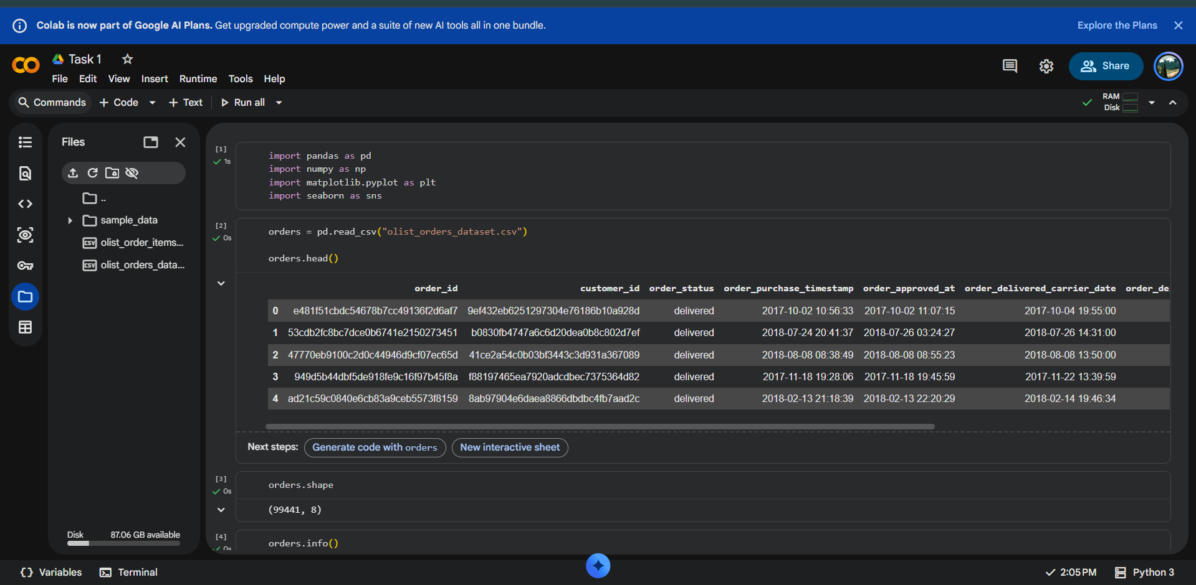
Dataset loading, sample records and dataset shape
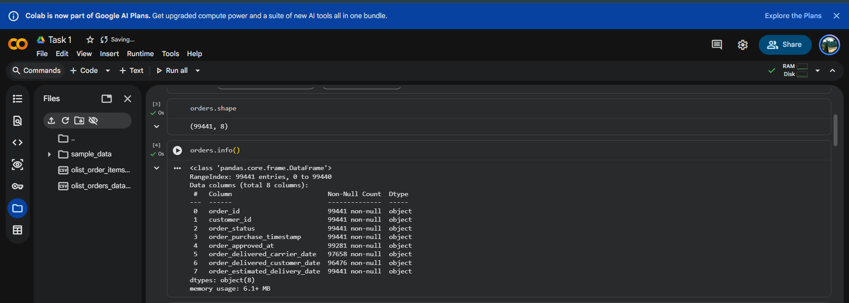
Dataset structure and data types
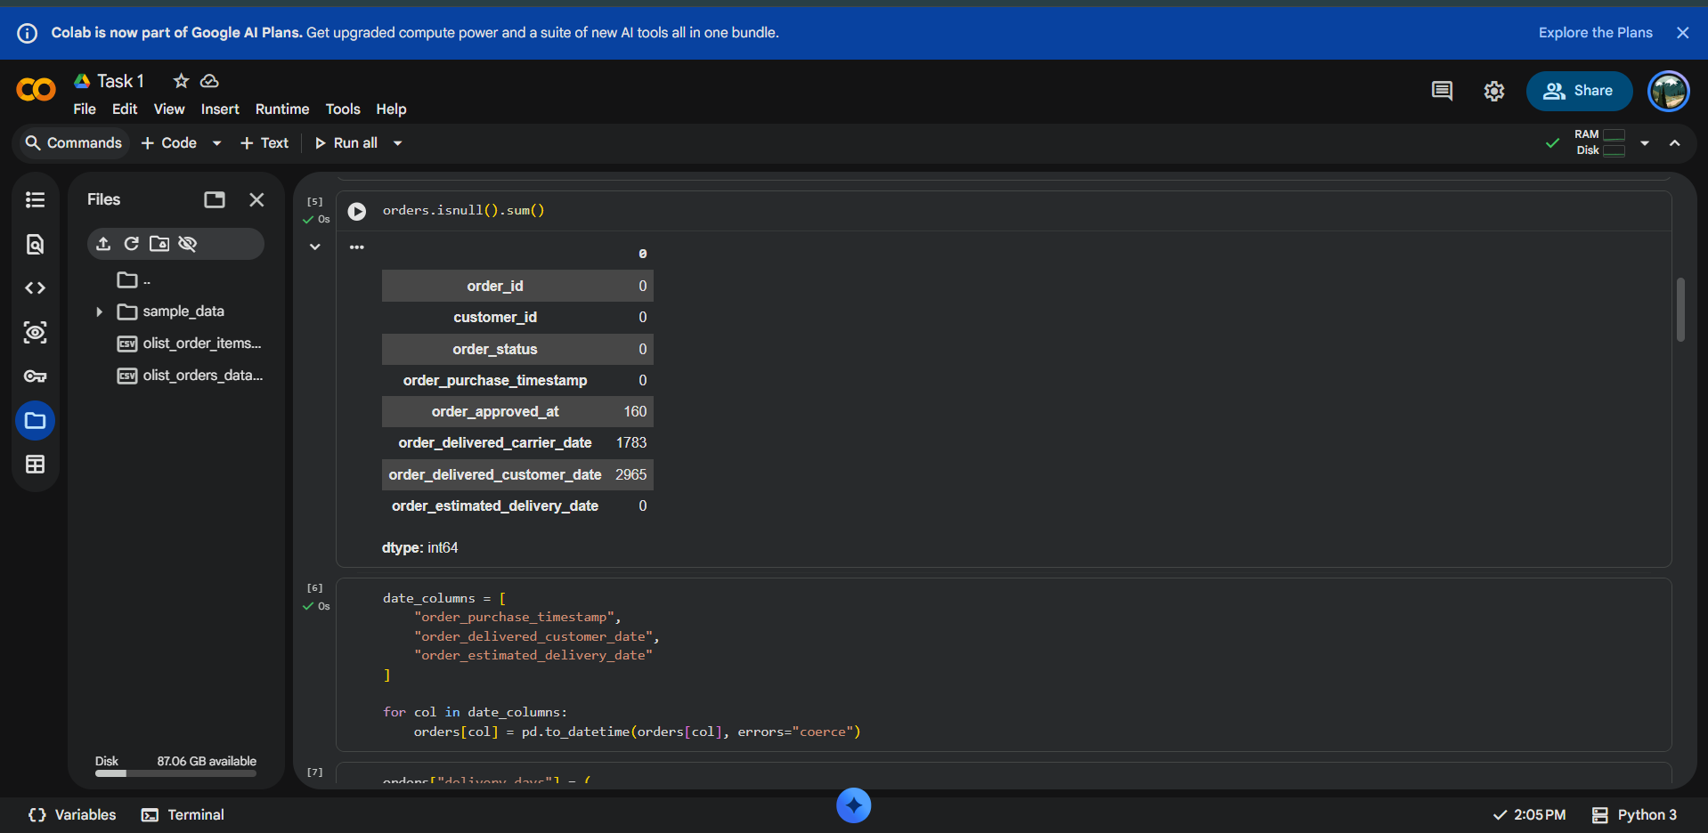
Missing-value analysis

6.2 Data Quality Findings
The missing-value check identified missing timestamps in some operational fields. The most important missing field for delivery analysis was order_delivered_customer_date, with 2,965 missing values. The analysis therefore restricted delivery-performance KPIs to records containing both actual and estimated delivery dates.
- order_approved_at: 160 missing values.
- order_delivered_carrier_date: 1,783 missing values.
- order_delivered_customer_date: 2,965 missing values.
- order_estimated_delivery_date: 0 missing values.

6.3 Feature Engineering
The following analytical variables were created from the raw timestamps:
- delivery_days = actual customer delivery timestamp − purchase timestamp.
- delay_days = actual customer delivery timestamp − estimated delivery timestamp.
- late_flag = 1 when delay_days is greater than 0; otherwise 0.

7. Exploratory Analysis Results

7.1 Delivery-Time Distribution
The delivery-time histogram is strongly right-skewed. Most completed orders are concentrated in the lower delivery-time range, while a smaller number of orders take substantially longer. The mean delivery time is 12.56 days and the median delivery time is 10.22 days, showing that extreme long-duration shipments increase the mean.
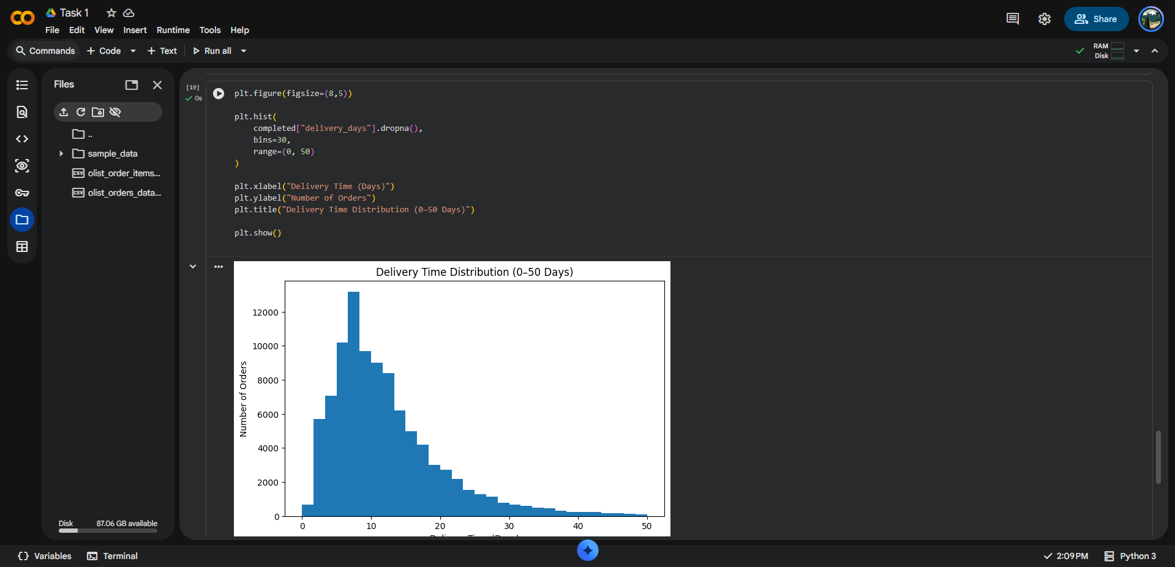
Delivery-time distribution restricted to 0–50 days

7.2 Delivery Reliability
The analysis classified completed orders as on-time or late by comparing actual customer delivery dates with estimated delivery dates. The resulting on-time delivery rate was 91.89%, while 8.11% of eligible completed deliveries were late.
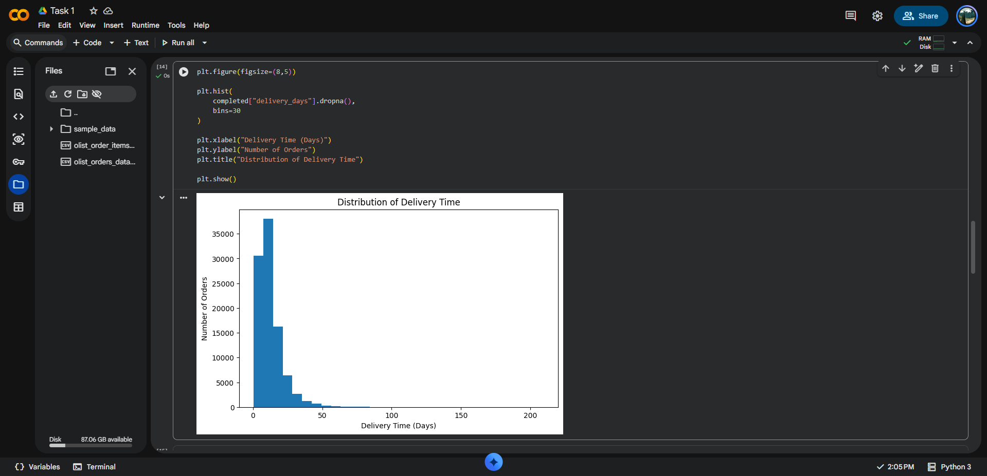
On-time versus late deliveries

7.3 Freight Cost Distribution
The order-item analysis produced an average freight value of 19.99. The freight distribution is also right-skewed, with most observations concentrated at lower values and a smaller number of items having substantially higher freight values.
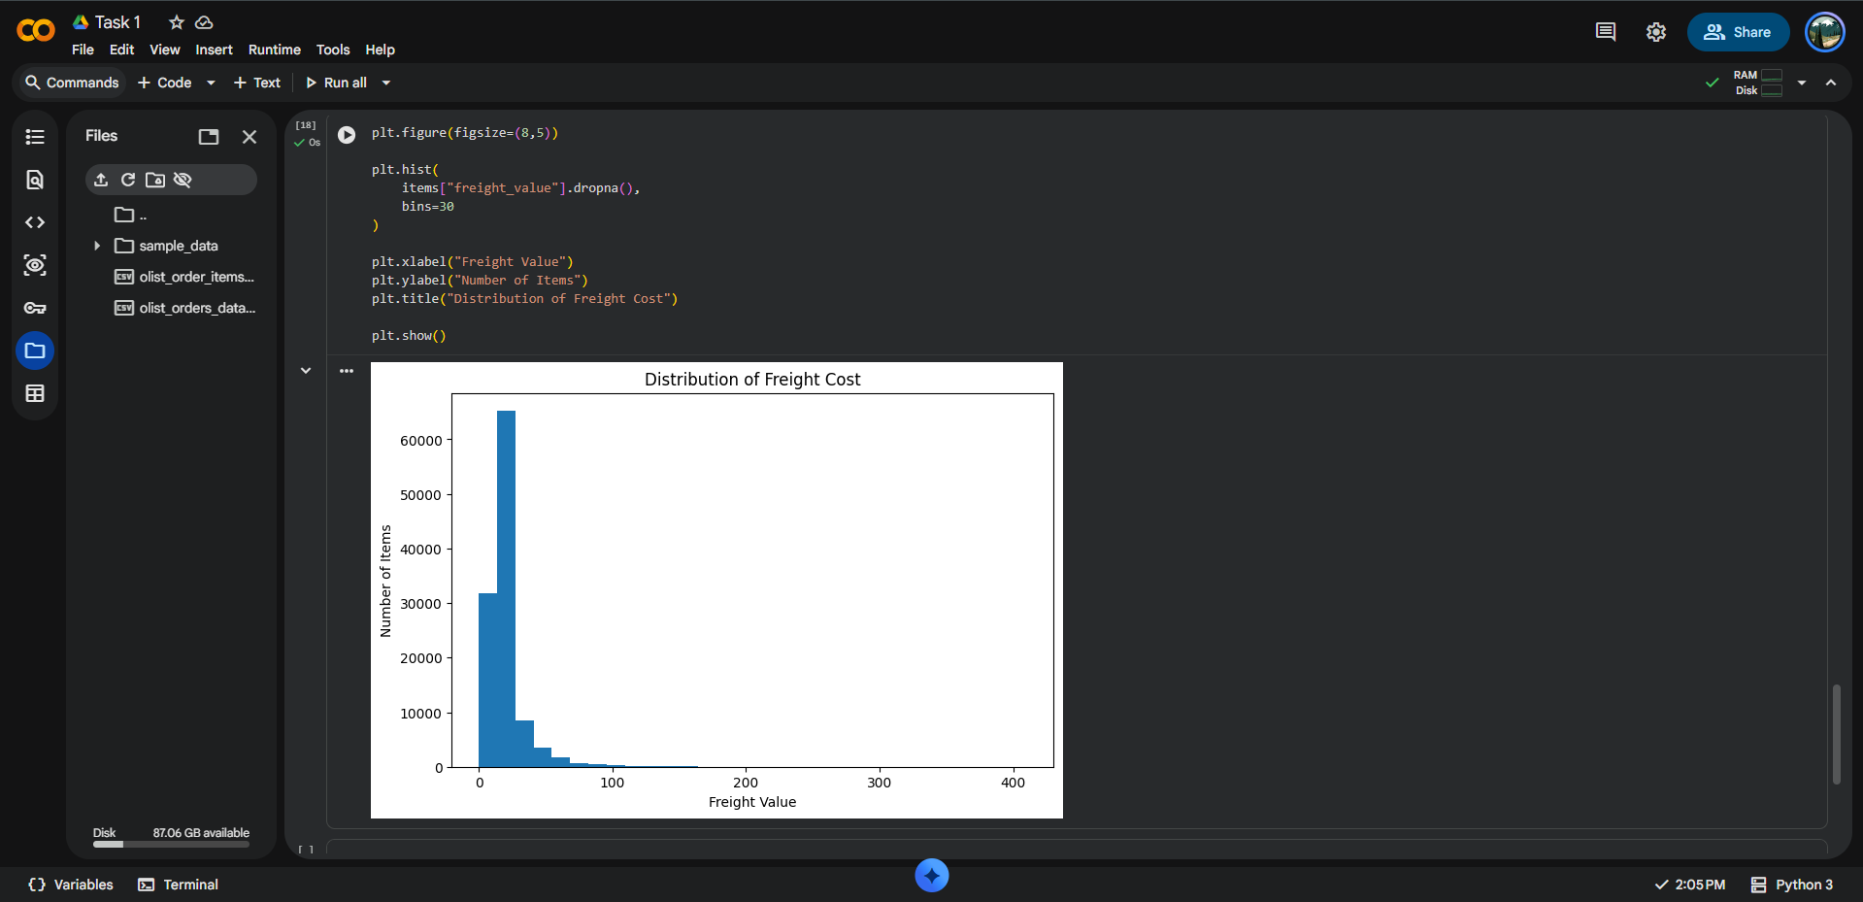
Distribution of freight value

7.4 Summary Statistics
Metric | Result
Minimum delivery time | 0.53 days
Median delivery time | 10.22 days
Average delivery time | 12.56 days
Maximum delivery time | 209.63 days

8. Data Science Methodologies

8.1 Exploratory Data Analysis
EDA will be used to understand distributions, missing values, outliers, correlations, time patterns and geographic differences.

8.2 Regression and Classification
Regression can estimate delivery duration, while classification can predict whether an order is likely to be late. Baseline models can include Linear Regression or Logistic Regression, followed by tree-based models such as Random Forest.

8.3 Clustering
K-Means or DBSCAN can be used to group sellers, customers or regions with similar delivery time, freight cost and late-delivery characteristics. Such segmentation can support differentiated logistics strategies.

8.4 Optimization
A future routing prototype can use the Vehicle Routing Problem (VRP). An optimization model can minimize distance, travel time or logistics cost while considering vehicle capacity and delivery time windows.

9. Strategic Roadmap
- Define the business problem, scope and KPIs.
- Collect and document the public logistics dataset.
- Integrate order, item, seller, customer, product and geolocation tables.
- Clean timestamps, missing values and incomplete records.
- Engineer delivery duration, delay, late flag, time and geographic features.
- Perform KPI analysis and exploratory visualization.
- Build a baseline predictive model for delivery time or late-delivery risk.
- Apply clustering to identify operational segments.
- Prototype route optimization using realistic constraints.
- Translate model results into operational recommendations.
- Document results, limitations and future improvements.

10. Python Code Illustrations
import pandas as pd
import numpy as np
import matplotlib.pyplot as plt

orders = pd.read_csv("olist_orders_dataset.csv")
items = pd.read_csv("olist_order_items_dataset.csv")

print(orders.shape)
print(orders.info())
print(orders.isnull().sum())
date_columns = [
"order_purchase_timestamp",
"order_delivered_customer_date",
"order_estimated_delivery_date"
]

for col in date_columns:
orders[col] = pd.to_datetime(orders[col], errors="coerce")

orders["delivery_days"] = (
orders["order_delivered_customer_date"]
- orders["order_purchase_timestamp"]
).dt.total_seconds() / 86400

orders["delay_days"] = (
orders["order_delivered_customer_date"]
- orders["order_estimated_delivery_date"]
).dt.total_seconds() / 86400

orders["late_flag"] = (orders["delay_days"] > 0).astype(int)
completed = orders[
orders["order_delivered_customer_date"].notna()
& orders["order_estimated_delivery_date"].notna()
].copy()

on_time_rate = (completed["late_flag"] == 0).mean() * 100
late_rate = completed["late_flag"].mean() * 100
avg_delivery_time = completed["delivery_days"].mean()
average_freight = items["freight_value"].mean()

print(f"On-Time Delivery Rate: {on_time_rate:.2f}%")
print(f"Late Delivery Rate: {late_rate:.2f}%")
print(f"Average Delivery Time: {avg_delivery_time:.2f} days")
print(f"Average Freight Cost: {average_freight:.2f}")

11. Key Findings
- The dataset contains 99,441 orders and provides sufficient information for an initial logistics performance study.
- The on-time delivery rate is 91.89%, meaning that most eligible completed orders were delivered by the estimated date.
- The late-delivery rate is 8.11%, representing a measurable opportunity for operational improvement.
- The average delivery time is 12.56 days, while the median is 10.22 days, indicating a right-skewed delivery-time distribution.
- The maximum observed delivery duration is 209.63 days, showing the presence of extreme long-duration shipments that should be investigated as potential operational outliers.
- The average freight value is 19.99, providing a baseline for future analysis by seller, product, region and order characteristics.
- Future modeling should investigate which factors are associated with late deliveries and high freight values rather than assuming that correlation proves causation.

12. Expected Business Impact
- Identify high-risk orders or regions before delivery failure occurs.
- Improve delivery-time estimation using historical data.
- Identify sellers or geographic segments with recurring performance issues.
- Compare freight cost against delivery performance.
- Support better allocation of transportation resources.
- Evaluate route alternatives using optimization techniques.

13. Assumptions and Limitations
- The public dataset represents historical operations and may not represent a current logistics network.
- The dataset does not provide every real-time operational variable, such as live traffic, vehicle availability or driver schedules.
- Missing delivery timestamps were excluded from completed-delivery KPI calculations.
- Extreme delivery durations may reflect unusual operational cases and require further investigation.
- The optimization component is a proposed prototype; a production routing system would require validated road-network distances and operational constraints.

14. Conclusion
The Week 1 analysis demonstrates how a logistics problem can be translated into measurable KPIs and a structured data-science workflow. The initial Python exploration established a baseline on-time delivery rate of 91.89%, a late-delivery rate of 8.11%, an average delivery time of 12.56 days and an average freight value of 19.99.
The next stages of the proposed project can extend this foundation through predictive modeling, clustering and vehicle-routing optimization. The overall goal is to connect analytical results with logistics decisions and improve delivery reliability, cost control and resource allocation.

15. References
- Olist Brazilian E-Commerce Public Dataset, Kaggle: https://www.kaggle.com/datasets/olistbr/brazilian-ecommerce
- UCI Machine Learning Repository – Online Retail: https://archive.ics.uci.edu/dataset/352/online+retail
- Google OR-Tools – Vehicle Routing: https://developers.google.com/optimization/routing
- Scikit-learn – Clustering: https://scikit-learn.org/stable/modules/clustering.html
- Pandas Documentation: https://pandas.pydata.org/docs/
- Matplotlib Documentation: https://matplotlib.org/stable/

16. Week 1 Deliverable Checklist
- ✓ Logistics scenario defined
- ✓ Project objectives stated
- ✓ At least three KPIs identified
- ✓ Public dataset research included
- ✓ Actual data exploration performed
- ✓ Data-quality analysis included
- ✓ Python code illustrations included
- ✓ Charts and actual KPI results included
- ✓ Data-science roadmap included
- ✓ Expected business impact and conclusion included
- ✓ References included

