WEEK 4

Predictive Modeling and Optimization
in Logistics Systems
Logistics Data Analyst Internship
Forecasting Delivery Time using Machine Learning
and deriving operational optimization recommendations

Dataset | Brazilian E-Commerce / Olist logistics dataset
Prediction Target | Delivery time in days
Models | Linear Regression, Decision Tree, Random Forest
Primary Model | Random Forest Regressor

Prepared from the completed Google Colab Task 4 analysis

1. Objective
The objective of Week 4 is to apply predictive modeling techniques to a logistics problem and use the model outputs to support operational optimization. In this task, delivery time is treated as the key logistics metric to forecast. Historical order, price, freight and purchase-time information is transformed into machine-learning features.
The analysis compares three regression approaches, evaluates them using MAE, RMSE and R², identifies the most influential features, predicts delivery time for a hypothetical order, and identifies potentially high-risk orders that may require operational attention.

2. Problem Definition
Logistics companies need reliable estimates of how long an order will take to reach the customer. Large variations in delivery time can affect customer satisfaction, transportation planning, resource allocation and delivery commitments.
The prediction problem is therefore formulated as a supervised regression problem:
Target variable: delivery_days
Target definition: the number of days between the order purchase timestamp and the customer delivery timestamp.

3. Dataset and Data Preparation
The analysis uses the Olist order and order-item datasets already used in the earlier logistics tasks. The order dataset contains approximately 99,441 orders, while the order-item dataset contains 112,650 item-level records.
The order-item data was aggregated at order level and merged with the order table. Price and freight values were converted to numeric values, and date fields were converted to datetime format.

3.1 Feature Engineering
Feature | Description
total_price | Total price of items in the order
total_freight | Total freight value associated with the order
number_of_items | Number of items in the order
purchase_hour | Hour at which the order was purchased
purchase_day | Day of the month of purchase
purchase_month | Month of purchase
purchase_weekday | Day of week represented numerically
After removing rows with missing values in the selected modeling fields, the final modeling dataset contained 96,476 records and 8 columns: seven predictor variables and one target variable.

3.2 Data Split
The data was divided into 80% training data and 20% testing data using train_test_split with random_state = 42. The resulting training set contained 77,180 observations and the testing set contained 19,296 observations.

3.3 Evidence from Colab Notebook
The following screenshots document the executed data-loading and feature-engineering steps.
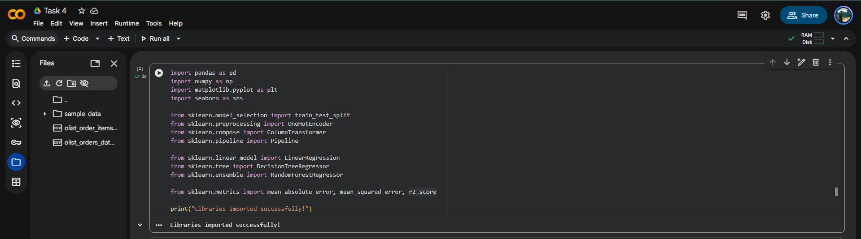
Figure 1. Executed Task 4 notebook step.
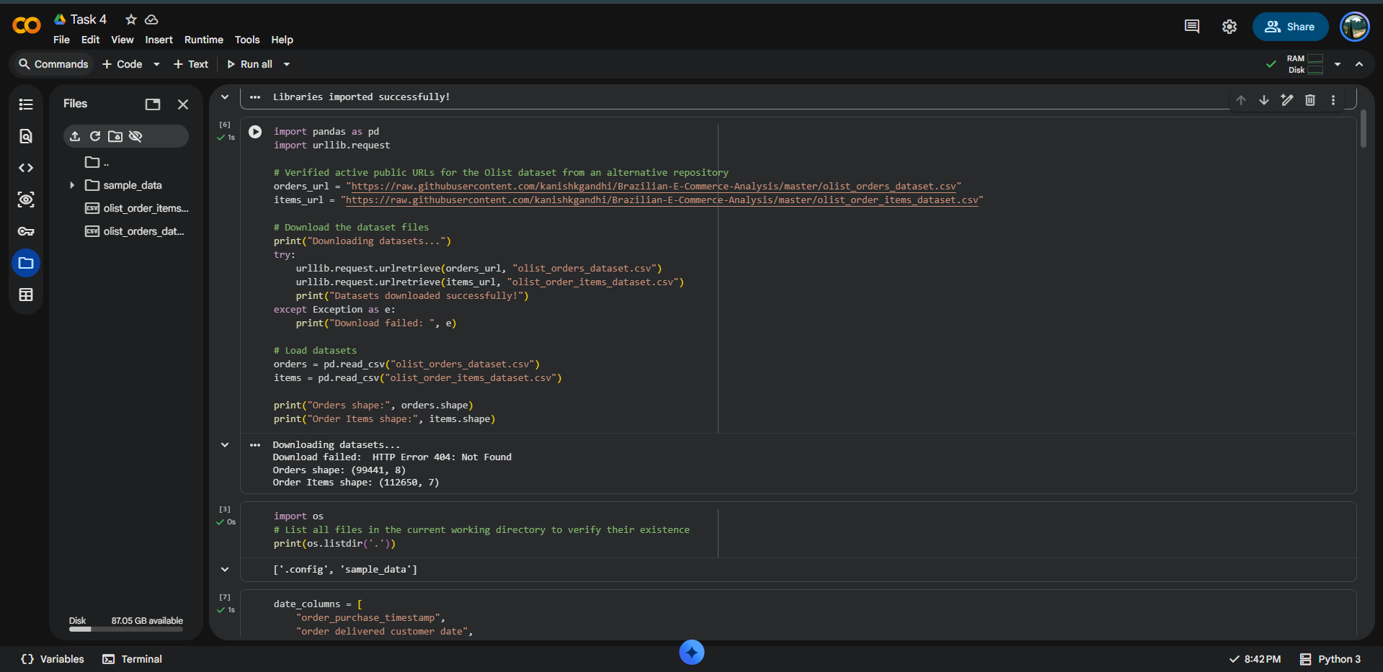
Figure 2. Executed Task 4 notebook step.
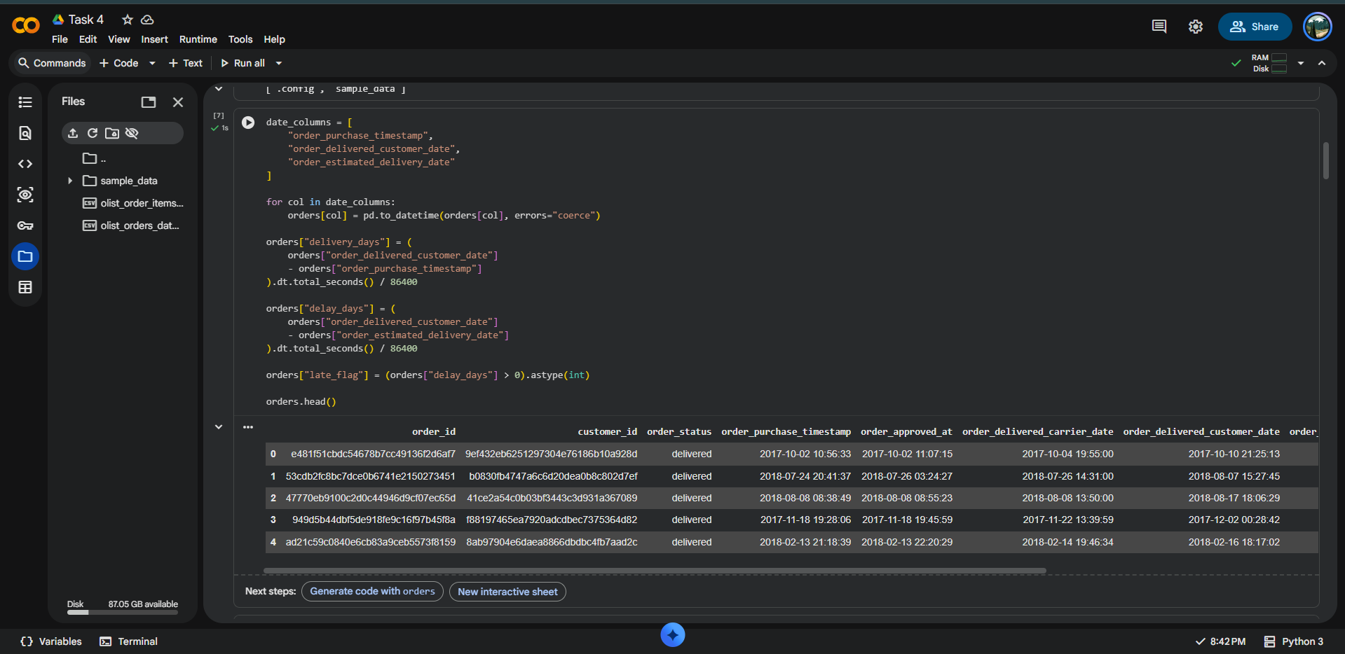
Figure 3. Executed Task 4 notebook step.
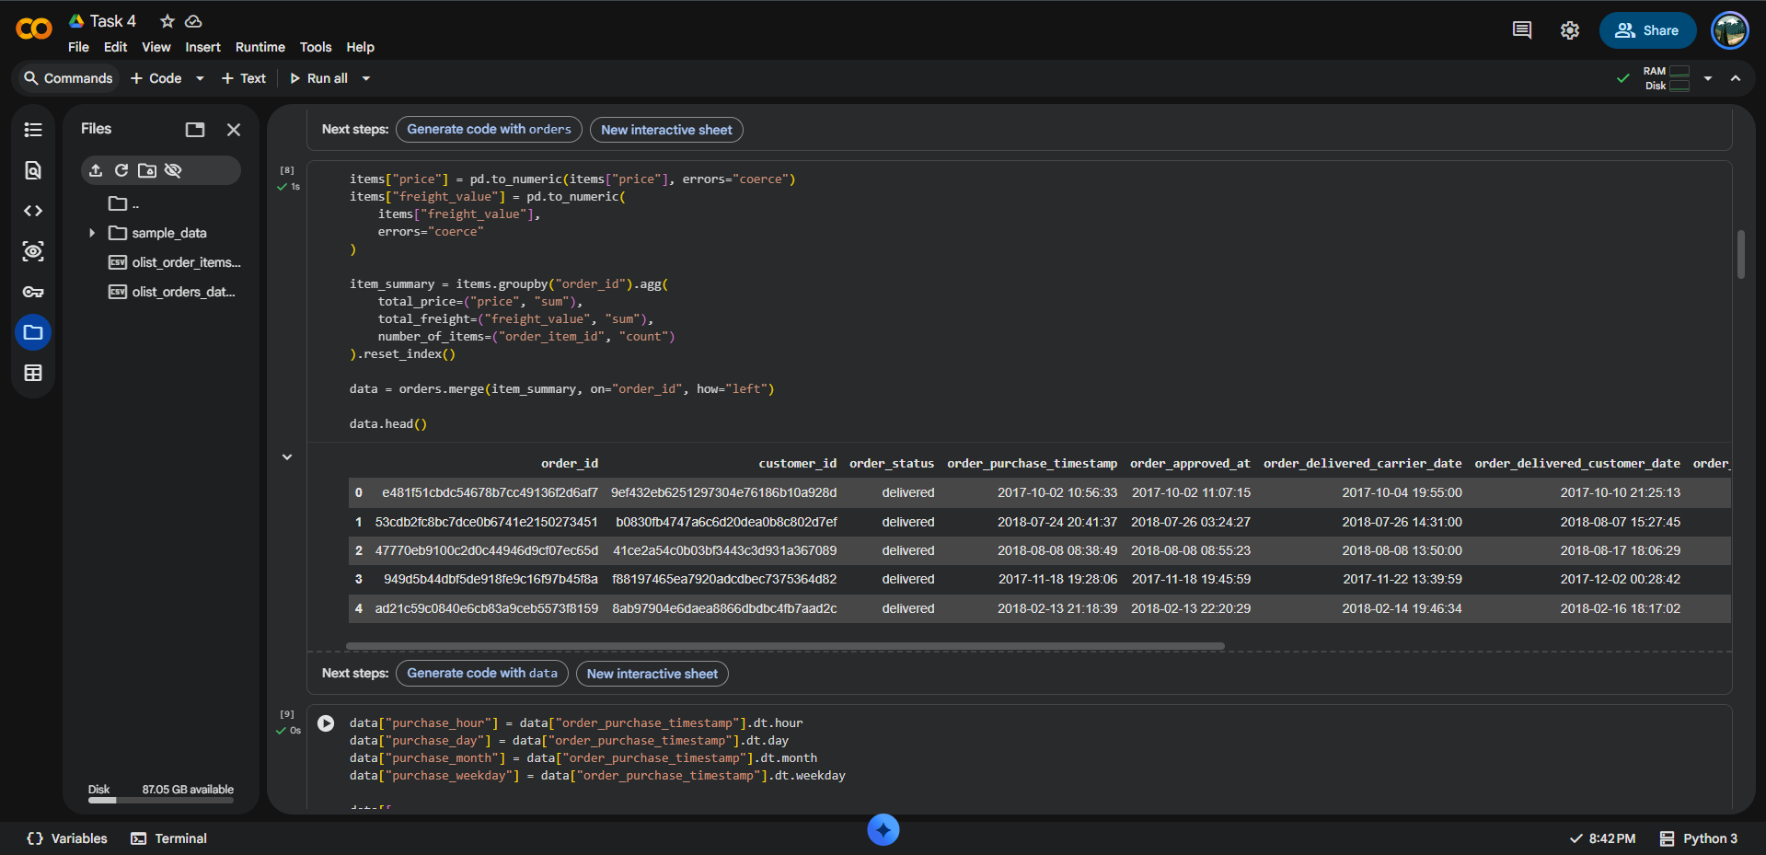
Figure 4. Executed Task 4 notebook step.
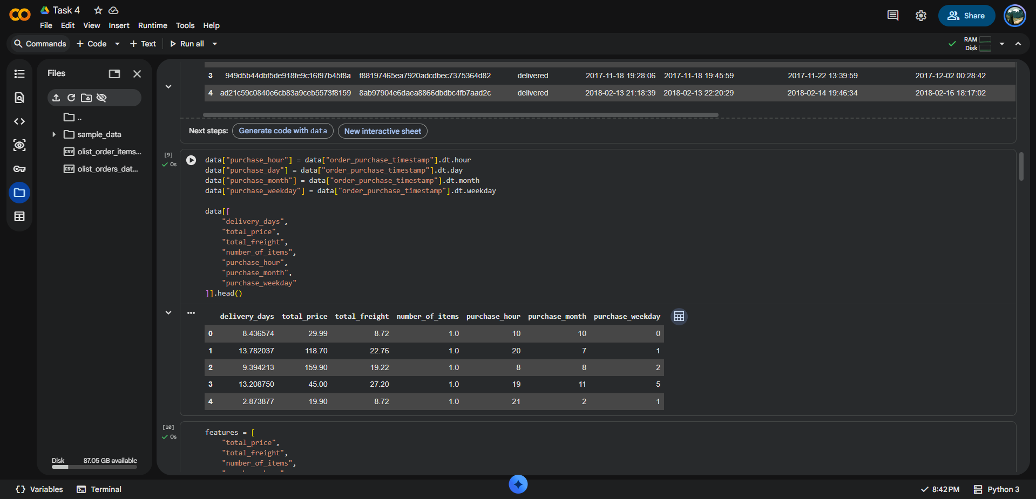
Figure 5. Executed Task 4 notebook step.

4. Model Selection and Implementation
Three regression models were selected to provide a simple baseline, a non-linear tree model, and an ensemble model. This comparison helps determine whether the relationships between logistics features and delivery time are better represented by a flexible non-linear model.

4.1 Linear Regression
Linear Regression was used as the baseline. It assumes that the target can be approximated by a linear combination of the input features. It is simple, fast and easy to interpret.

4.2 Decision Tree Regressor
A Decision Tree Regressor was used to capture non-linear relationships and feature interactions. The model was configured with max_depth = 10 and random_state = 42.

4.3 Random Forest Regressor
Random Forest combines multiple decision trees and averages their predictions. It was selected as the primary model because ensemble trees can model non-linear logistics relationships while generally being more robust than a single decision tree. The implementation used 100 trees, max_depth = 15, random_state = 42 and n_jobs = -1.

4.4 Core Python Code
# Split data
X_train, X_test, y_train, y_test = train_test_split(
X, y, test_size=0.20, random_state=42
)
# Random Forest model
rf_model = RandomForestRegressor(
n_estimators=100,
max_depth=15,
random_state=42,
n_jobs=-1
)
rf_model.fit(X_train, y_train)
rf_pred = rf_model.predict(X_test)

4.5 Model Execution Evidence
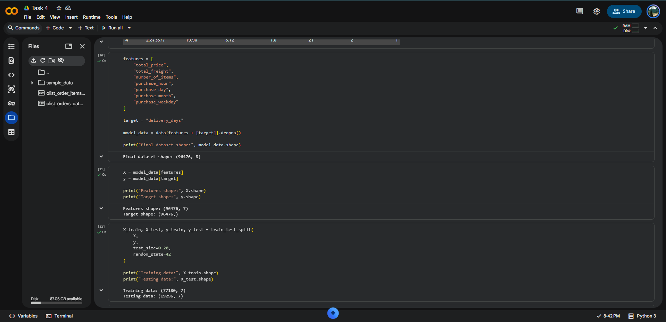
Figure 6. Model training and execution output.
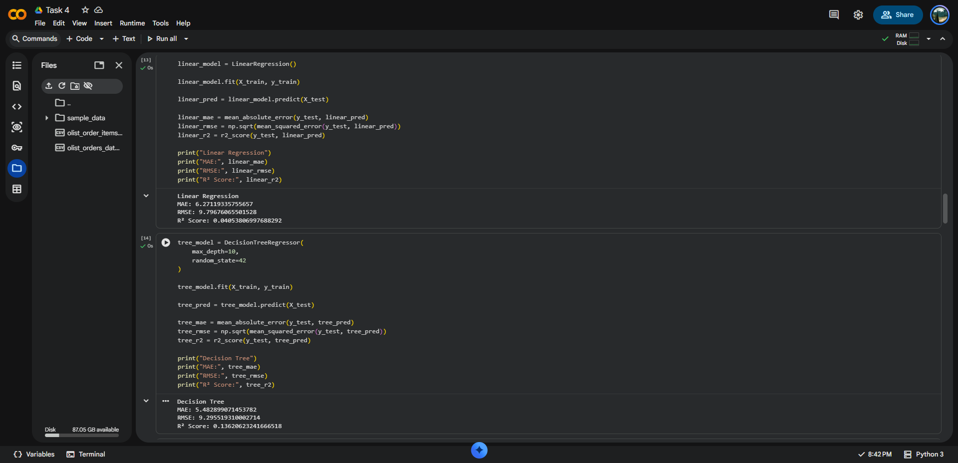
Figure 7. Model training and execution output.
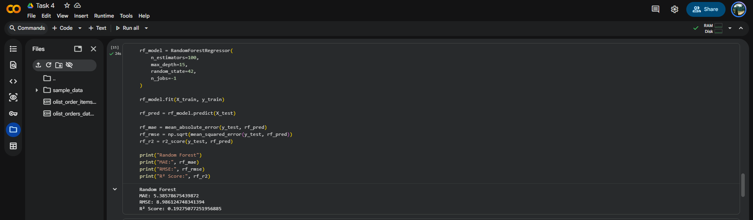
Figure 8. Model training and execution output.

5. Model Evaluation and Validation
The models were evaluated on the unseen 20% test set. Three standard regression metrics were used.
Metric | Full Name | Interpretation
MAE | Mean Absolute Error | Average absolute difference between actual and predicted delivery time. Lower is better.
RMSE | Root Mean Squared Error | Penalizes larger prediction errors more strongly. Lower is better.
R² | Coefficient of Determination | Indicates how much variation in the target is explained by the model. Higher is better.

5.1 Results
Model | MAE | RMSE | R² Score
Linear Regression | 6.271193 | 9.796761 | 0.040538
Decision Tree | 5.482899 | 9.295519 | 0.136263
Random Forest | 5.385787 | 8.986125 | 0.192751
Random Forest achieved the lowest MAE (5.385787 days) and the lowest RMSE (8.986125 days) among the three tested models. It also produced the highest R² score (0.192751). Therefore, Random Forest was selected as the best-performing model for this task.
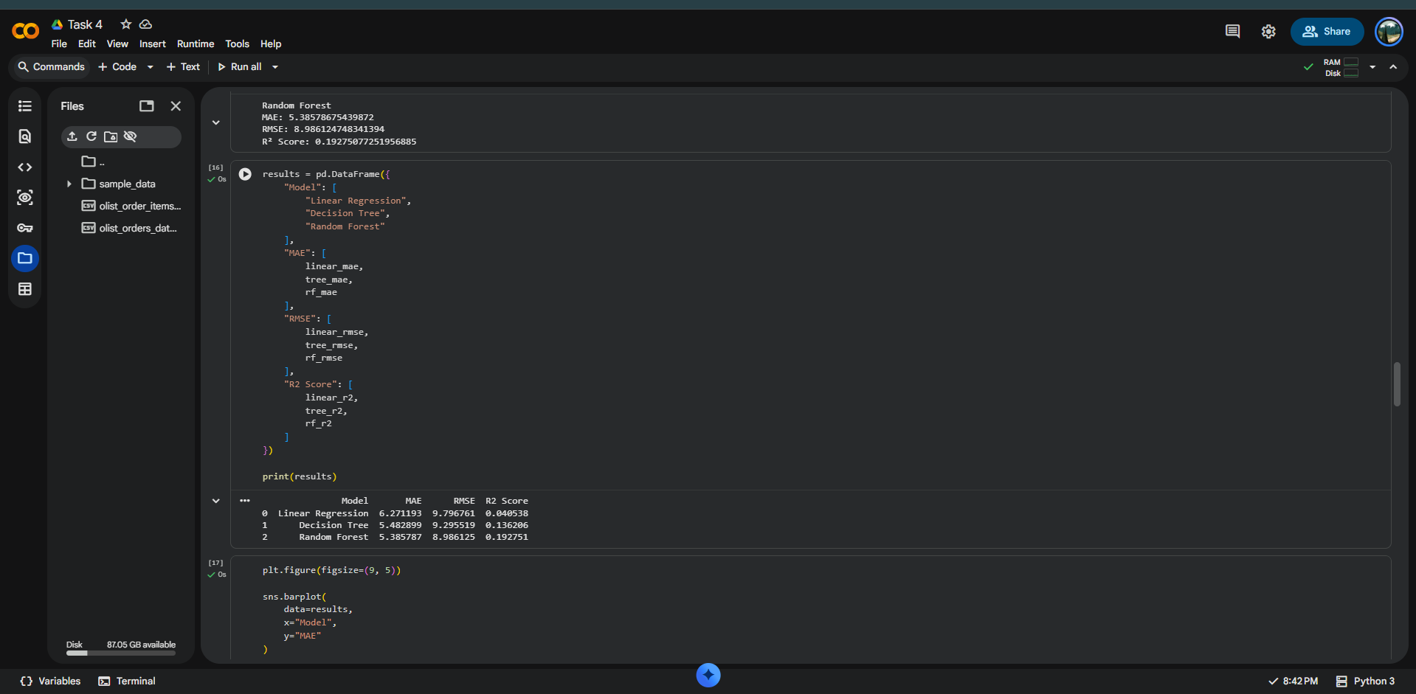
Figure 9. Model evaluation / comparison output.
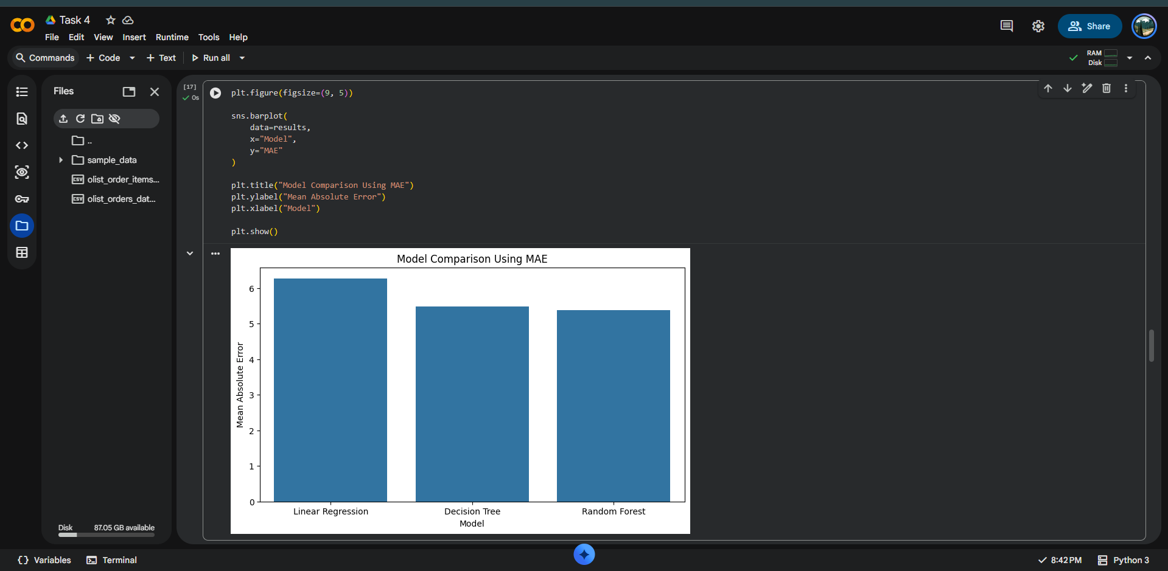
Figure 10. Model evaluation / comparison output.

6. Prediction and Practical Interpretation
A hypothetical order was passed to the trained Random Forest model using the following inputs: total price = 500, total freight = 50, number of items = 2, purchase hour = 14, purchase day = 10, purchase month = 8 and purchase weekday = 2.
Predicted delivery time: 9.92 days
This demonstrates how the trained model can provide an estimated delivery duration for a new order before the actual delivery occurs.
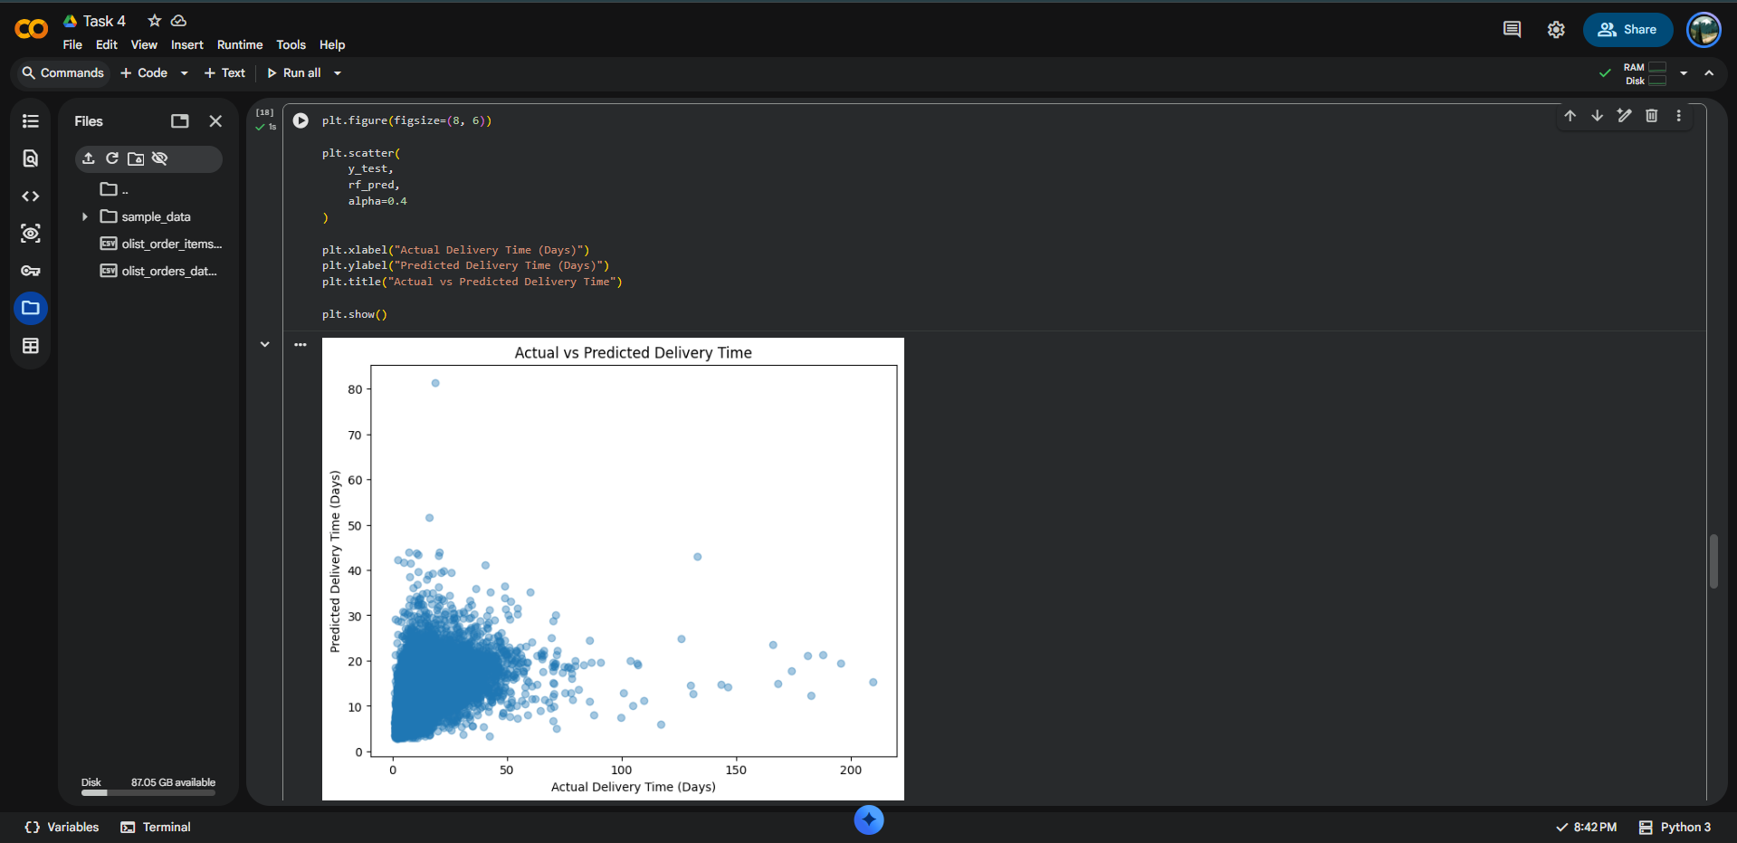
Figure 11. Example prediction for a hypothetical order.

7. Feature Importance Analysis
Random Forest feature importance was used to identify which variables contributed most strongly to the model's predictions. The results were:
Feature | Importance
total_freight | 0.386817
total_price | 0.197260
purchase_month | 0.131384
purchase_day | 0.103759
purchase_hour | 0.099143
purchase_weekday | 0.052840
number_of_items | 0.028797
The most influential feature was total_freight with an importance of 0.386817, followed by total_price with 0.197260. This indicates that freight-related characteristics and order value were the strongest contributors among the selected features. Feature importance should be treated as model-specific importance rather than proof of direct causation.
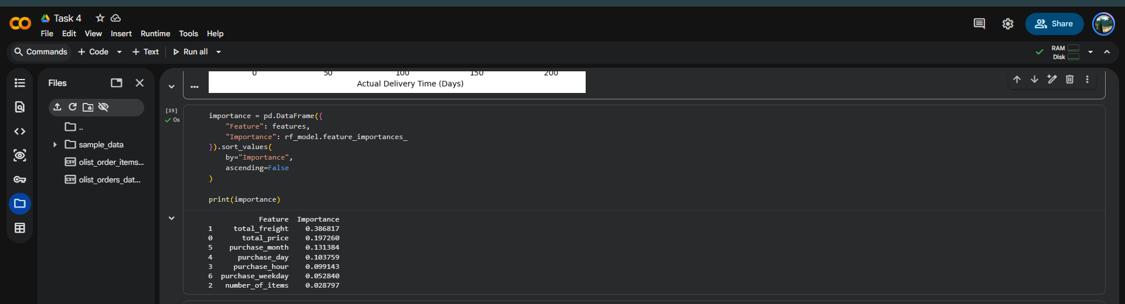
Figure 12. Random Forest feature importance chart.
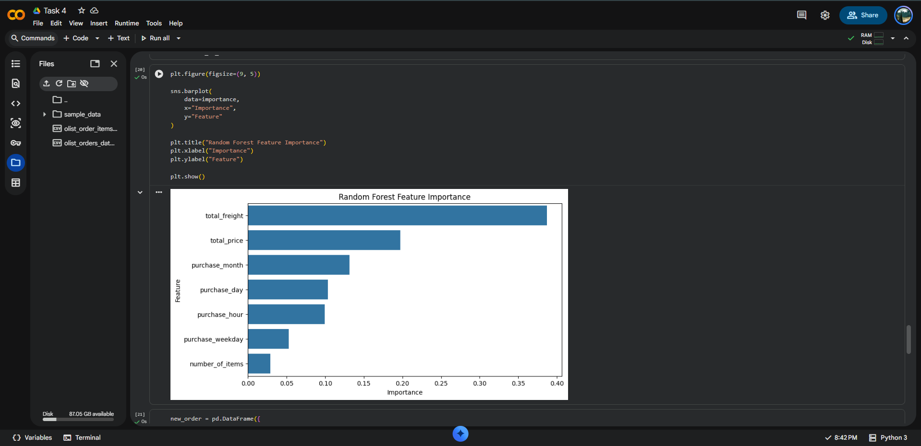
Figure 13. Feature importance values generated in Colab.

8. High-Risk Order Identification
The model was also used to flag orders whose predicted delivery time was greater than 20 days. This threshold was used as an operational screening rule to identify potentially delayed shipments.
High-risk predicted orders identified: 1,466
High-risk orders as a percentage of the test set: 7.60%
Average delivery time across the modeling data: 12.56 days
The high-risk table provides actual delivery time, predicted delivery time and prediction error. This can be used as an early-warning mechanism for operational teams.
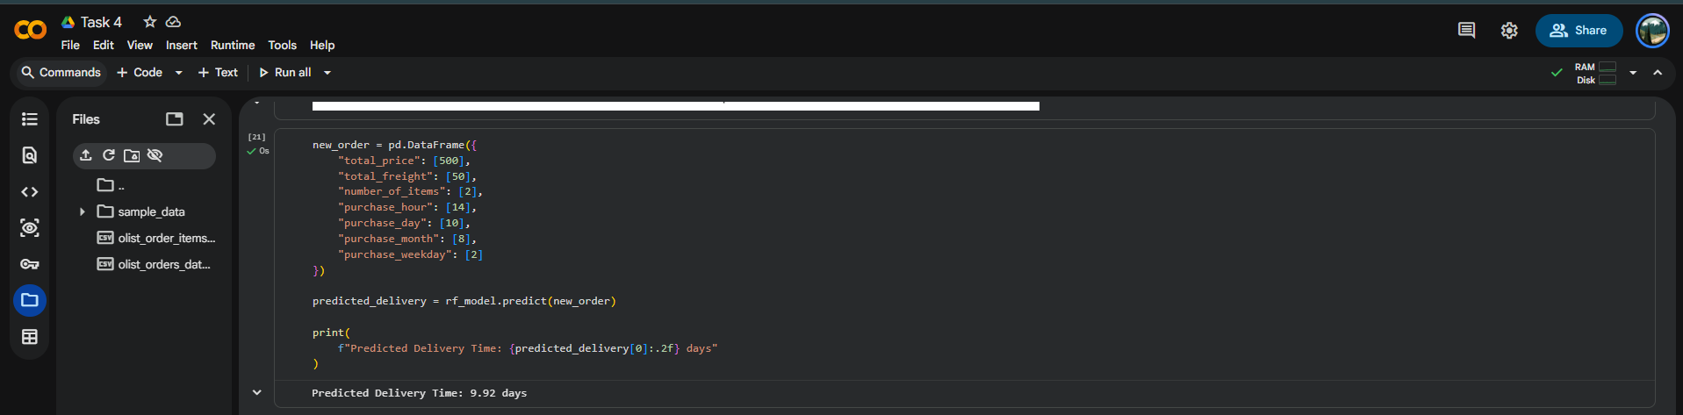
Figure 14. High-risk order identification output.
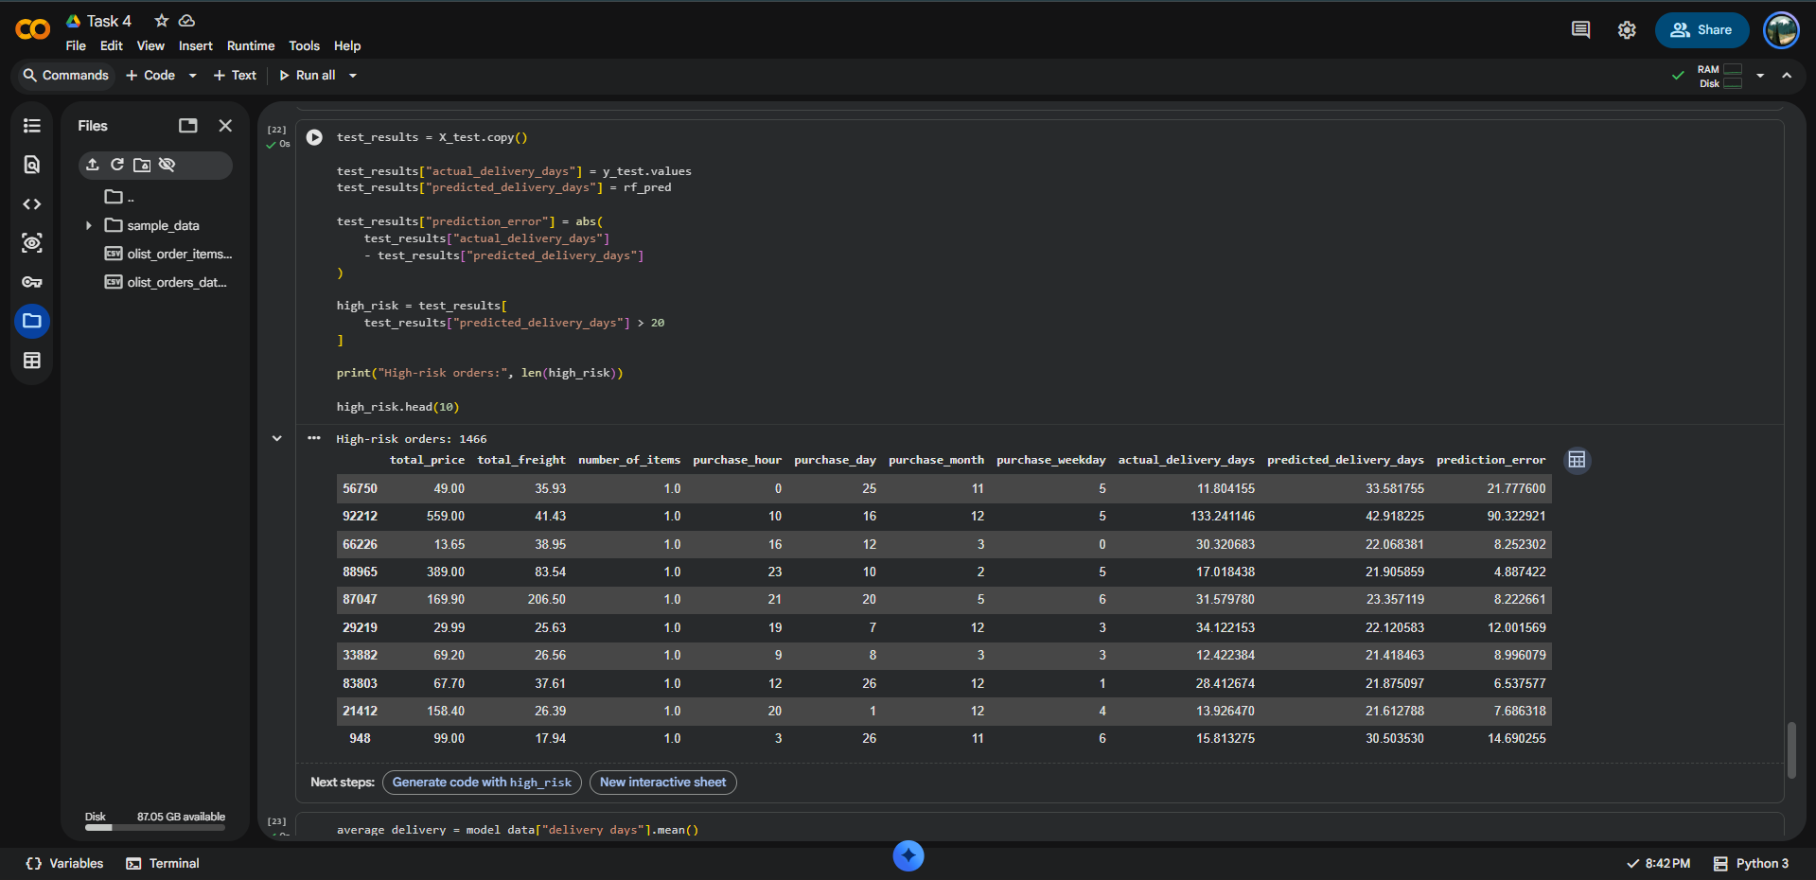
Figure 15. Average delivery time and high-risk order percentage.

9. Logistics Optimization Strategies
1. Early delay detection
Use the Random Forest prediction for each incoming order. Orders with high predicted delivery times can be routed to an exception-management queue before the delay becomes critical.
2. Freight and transportation review
Because total freight had the highest model importance, logistics managers should investigate high-freight shipments, carrier assignments and transportation lanes for avoidable cost or delay.
3. Resource allocation
Allocate additional delivery capacity, vehicles or operational attention to shipments predicted to have long delivery times.
4. Improved delivery estimates
Use model predictions as a data-driven input to estimated delivery dates rather than relying only on static averages.
5. Seasonal planning
Purchase month and day were meaningful model features. Historical seasonal patterns can therefore be incorporated into staffing and transportation planning.
6. Continuous model improvement
Retrain the model periodically with recent orders, and add stronger logistics variables such as seller location, customer location, distance, carrier, product category and warehouse information when available.

10. Actual vs Predicted Analysis
The actual-versus-predicted scatter plot provides a visual assessment of prediction quality. A strong model would place observations close to an ideal diagonal relationship. The plot in this analysis shows a broad spread, indicating that the selected features do not capture all factors that determine delivery time. This is consistent with the moderate R² value of 0.192751.
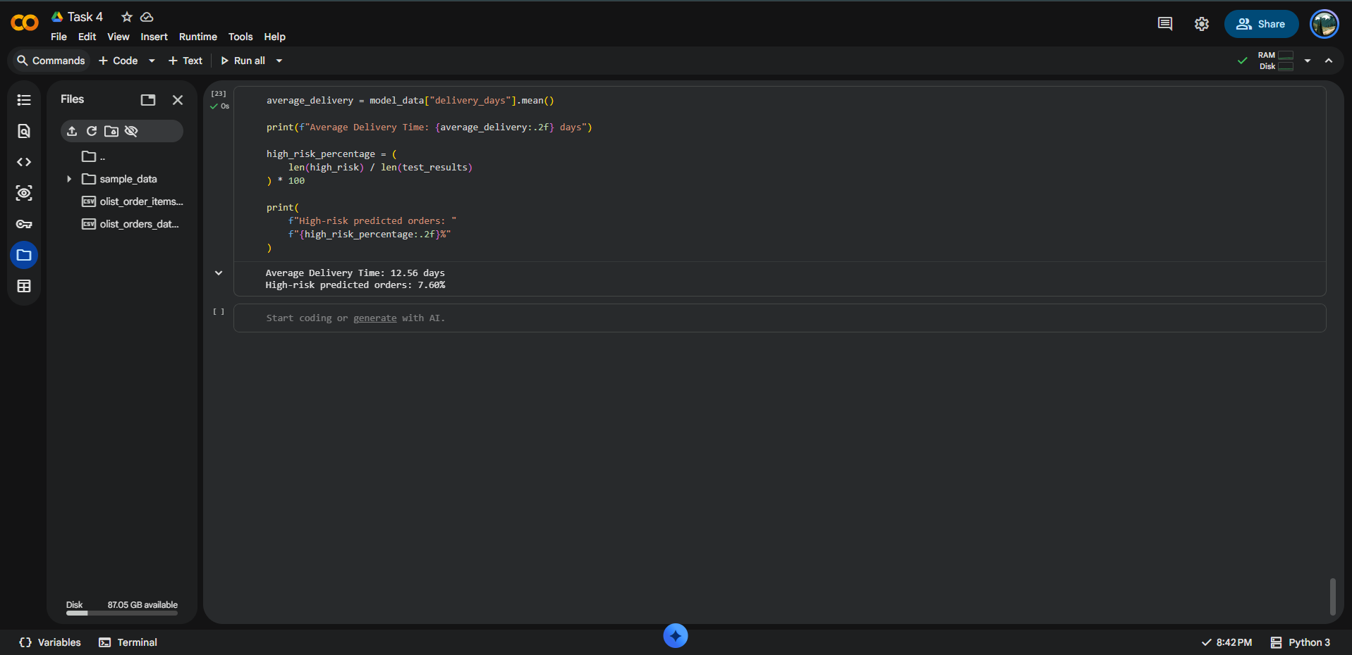
Figure 16. Actual versus predicted delivery time.

11. Code and Methodology Summary
# Create target
orders["delivery_days"] = (
orders["order_delivered_customer_date"]
- orders["order_purchase_timestamp"]
).dt.total_seconds() / 86400
# Aggregate item-level information
item_summary = items.groupby("order_id").agg(
total_price=("price", "sum"),
total_freight=("freight_value", "sum"),
number_of_items=("order_item_id", "count")
).reset_index()
# Merge and prepare modeling data
data = orders.merge(item_summary, on="order_id", how="left")
model_data = data[features + [target]].dropna()
# Evaluate predictions
mae = mean_absolute_error(y_test, rf_pred)
rmse = np.sqrt(mean_squared_error(y_test, rf_pred))
r2 = r2_score(y_test, rf_pred)

12. Discussion
The model comparison demonstrates that Random Forest performed better than both Linear Regression and the selected Decision Tree configuration on the test set. The improvement is visible in both MAE and RMSE, while the R² score is also higher.
However, the R² value of approximately 0.193 indicates that a large proportion of delivery-time variation remains unexplained by the current seven features. This is an important analytical finding, not a failure of the workflow. Delivery time is influenced by operational factors that are not present in the current feature set, such as origin-destination distance, seller and customer locations, carrier performance, warehouse processing time, product characteristics, traffic and regional constraints.

13. Actionable Recommendations
- Deploy the model as an early-warning scoring system for high-risk orders.
- Prioritize investigation of shipments with predicted delivery times above the operational threshold.
- Analyze high-freight orders for carrier, route and transportation-mode optimization.
- Add geographic and carrier-level variables to improve predictive accuracy.
- Use cross-validation and hyperparameter tuning in the next iteration to improve model generalization.
- Monitor MAE and RMSE after deployment and retrain when performance degrades.
- Combine prediction with an optimization layer that allocates limited delivery resources to the highest-risk shipments.

14. Conclusion
This Week 4 task successfully implemented a predictive modeling workflow for logistics delivery-time forecasting. The process included data preparation, feature engineering, train-test splitting, model training, evaluation, prediction, feature-importance analysis and high-risk order identification.
Among the evaluated models, Random Forest provided the best test performance with an MAE of 5.385787 days, RMSE of 8.986125 days and R² of 0.192751. The model predicted 9.92 days for the example order, while the high-risk screening rule identified 1,466 test orders, representing 7.60% of the test set.
The results show how predictive analytics can support proactive logistics management. The strongest next step is to enrich the dataset with operational and geographic variables and then combine the prediction model with optimization methods for routing, resource allocation and cost minimization.

Appendix A: Colab Execution Evidence
The screenshots below are included as evidence that the analysis, model training, evaluation and optimization-related calculations were executed in the Task 4 Google Colab notebook.
Appendix Figure 1. Task 4 notebook evidence.
Appendix Figure 2. Task 4 notebook evidence.
Appendix Figure 3. Task 4 notebook evidence.
Appendix Figure 4. Task 4 notebook evidence.
Appendix Figure 5. Task 4 notebook evidence.
Appendix Figure 6. Task 4 notebook evidence.
Appendix Figure 7. Task 4 notebook evidence.
Appendix Figure 8. Task 4 notebook evidence.
Appendix Figure 9. Task 4 notebook evidence.
Appendix Figure 10. Task 4 notebook evidence.

