In [64]:

**import** pandas **as** pd **import** numpy **as** np **import** seaborn **as** sns

**import** matplotlib.pyplot **as** plt

**%matplotlib** inline

**import** warnings warnings**.**filterwarnings('ignore')

**from** sklearn.model_selection **import** train_test_split

**from** sklearn **import** metrics

df**=**pd**.**read_csv("C:\\Users\\Owner\\Desktop\\Machine Learning BE\\Practical\\Practica df**.**head()

|  |  |  |  |  |  |  |  |  |  |
| --- | --- | --- | --- | --- | --- | --- | --- | --- | --- |
| Out[64]: | **RowNumber** | **CustomerId** | **Surname** | **CreditScore** | **Geography** | **Gender** | **Age** | **Tenure** | **Balance** |
|  | **0** 1 | 15634602 | Hargrave | 619 | France | Female | 42 | 2 | 0.00 |
|  | **1** 2 | 15647311 | Hill | 608 | Spain | Female | 41 | 1 | 83807.86 |
|  | **2** 3 | 15619304 | Onio | 502 | France | Female | 42 | 8 | 159660.80 |
|  | **3** 4 | 15701354 | Boni | 699 | France | Female | 39 | 1 | 0.00 |
|  | **4** 5 | 15737888 | Mitchell | 850 | Spain | Female | 43 | 2 | 125510.82 |
| C |  |  |  |  |  |  |  |  | C |
|  |  |  |  |  |  |  |  |  |  |
| In [65]: | df**.**shape |  |  |  |  |  |  |  |  |
| Out[65]: | (10000, 14) |  |  |  |  |  |  |  |  |
| In [66]: | df**.**columns |  |  |  |  |  |  |  |  |

Out[66]:

In [67]:

Index(['RowNumber', 'CustomerId', 'Surname', 'CreditScore', 'Geography',

'Gender', 'Age', 'Tenure', 'Balance', 'NumOfProducts', 'HasCrCard', 'IsActiveMember', 'EstimatedSalary', 'Exited'],

dtype='object')

*# input data*

x**=**df[['CreditScore','Age', 'Tenure', 'Balance', 'NumOfProducts', 'HasCrCard','IsAct

*# output data*

y**=**df[ 'Exited']

In [68]:

sns**.**countplot(x**=**y);

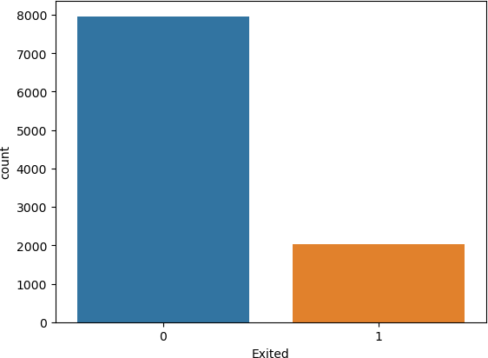

In [69]:

y**.**value_counts()

|  |  |  |  |  |  |  |
| --- | --- | --- | --- | --- | --- | --- |
| Out[69]: | | 0  1 | 7963  2037 | | | |
|  |  | Name: Exited, dtype: int64 | | | | |
| In | [70]: | *# Normalise*  **from** sklearn.preprocessing **import** StandardScaler | | | | |
|  |  |  | | | | |
| In | [71]: | Scaler **=**StandardScaler() | | | | |
|  |  |  | | | | |
| In | [72]: | x_scaled**=**Scaler**.**fit_transform(x) | | | | |
|  |  |  | | | | |
| In | [73]: | x_scaled | | | | |
| Out[73]: | | array([[-0.32622142,  0.97024255, | | 0.29351742, -1.04175968,  0.02188649], | ..., | 0.64609167, |
| [-0.44003595, | | | | 0.19816383, -1.38753759, | ..., | -1.54776799, |
| 0.97024255, | | | | 0.21653375], |  |  |
| [-1.53679418, | | | | 0.29351742, 1.03290776, | ..., | 0.64609167, |
| -1.03067011, | | | | 0.2406869 ], |  |  |
| ..., | | | |  |  |  |
| [ 0.60498839, | | | | -0.27860412, 0.68712986, | ..., | -1.54776799, |
| 0.97024255, | | | | -1.00864308], |  |  |
| [ 1.25683526, | | | | 0.29351742, -0.69598177, | ..., | 0.64609167, |
| -1.03067011, | | | | -0.12523071], |  |  |
| [ 1.46377078, | | | | -1.04143285, -0.35020386, | ..., | 0.64609167, |
| -1.03067011, | | | | -1.07636976]]) |  |  |

In [75]:

**from** sklearn.model_selection **import** train_test_split

In [76]:

x_train,x_test,y_train,y_test **=**train_test_split(x_scaled,y,random_state**=**0,test_siz

In [77]:

x**.**shape

Out[77]:

In [78]:

Out[78]:

In [79]:

Out[79]:

In [80]:

(10000, 8)

x_train**.**shape

(7500, 8)

x_test**.**shape

(2500, 8)

In [81]:

ann**=** MLPClassifier(hidden_layer_sizes**=**(100,100,100),random_state **=** 0, max_iter**=**100

**from** sklearn.neural_network **import** MLPClassifier

In [82]:

ann**.**fit(x_train,y_train)

Out[82]:

MLPClassifier(hidden_layer_sizes=(100, 100, 100), max_iter=100, random_st ate=0)

MLPClassifier

▾

In [83]:

y_pred **=** ann**.**predict(x_test)

In [84]: **from** sklearn.metrics **import** ConfusionMatrixDisplay,classification_report,accuracy_s

In [85]:

Out[85]:

In [86]:

Out[86]:

y_test**.**value_counts()

0 1991

1 509

Name: Exited, dtype: int64

ConfusionMatrixDisplay**.**from_predictions(y_test,y_pred)

<sklearn.metrics._plot.confusion_matrix.ConfusionMatrixDisplay at 0x139fa9f38b0>

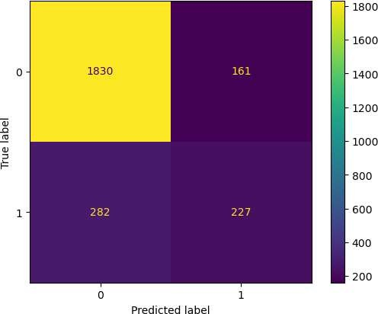

In [87]:

Out[87]:

In [88]:

In [89]:

accuracy_score(y_test,y_pred)

0.8228

print(classification_report(y_test,y_pred))

|  |  |  |  |  |
| --- | --- | --- | --- | --- |
|  | precision | recall | f1-score | support |
| 0 | 0.87 | 0.92 | 0.89 | 1991 |
| 1 | 0.59 | 0.45 | 0.51 | 509 |
| accuracy |  |  | 0.82 | 2500 |
| macro avg | 0.73 | 0.68 | 0.70 | 2500 |
| weighted avg | 0.81 | 0.82 | 0.81 | 2500 |

Requirement already satisfied: imbalanced-learn in c:\users\owner\anaconda3\lib\si te-packages (0.10.1) Requirement already satisfied: joblib>=1.1.1 in c:\users\owner\anaconda3\lib\site-

**!**pip install imbalanced-learn

packages (from imbalanced-learn) (1.1.1)

Requirement already satisfied: scipy>=1.3.2 in c:\users\owner\anaconda3\lib\site-p ackages (from imbalanced- learn) (1.10.0)

Requirement already satisfied: threadpoolctl>=2.0.0 in c:\users\owner\anaconda3\li

b\site-packages (from imbalanced-learn) (2.2.0)

Requirement already satisfied: numpy>=1.17.3 in c:\users\owner\anaconda3\lib\site- packages (from imbalanced-learn) (1.23.5)

Requirement already satisfied: scikit-learn>=1.0.2 in c:\users\owner\anaconda3\lib

\site-packages (from imbalanced-learn) (1.2.1)

In [90]:

**from** imblearn.over_sampling **import** RandomOverSampler

In [91]:

ros **=** RandomOverSampler (random_state **=**0)

In [92]:

x_res,y_res **=** ros**.**fit_resample(x,y)

In [93]:

y_res**.**value_counts()

|  |  |  |  |  |  |  |
| --- | --- | --- | --- | --- | --- | --- |
| Out[93]: | | 1  0 | 7963  7963 | | | |
|  |  | Name: Exited, dtype: int64 | | | | |
| In | [94]: | *# Normalise*  **from** sklearn.preprocessing **import** StandardScaler | | | | |
|  |  |  | | | | |
| In | [95]: | Scaler **=**StandardScaler() | | | | |
|  |  |  | | | | |
| In | [96]: | x_scaled**=**Scaler**.**fit_transform(x_res) | | | | |
|  |  |  | | | | |
| In | [97]: | x_scaled | | | | |
| Out[97]: | | array([[-0.29877723, 0.08418894, -1.01840607,  1.08223556, 0.00817382], | | | ..., | 0.6512495 , |
|  | | [-0.4103938 , -0.01032629, -1.36135608, | | | ..., | -1.53550983, |
| 1.08223556, | | | | 0.20261687], |  |  |
| [-1.48597169, | | | | 0.08418894, 1.03929402, | ..., | 0.6512495 , |
| -0.92401325, | | | | 0.22674468], |  |  |
| ..., | | | |  |  |  |
| [-0.84671313, | | | | 1.02934128, 0.01044398, | ..., | 0.6512495 , |
| -0.92401325, | | | | 1.28878188], |  |  |
| [-0.96847667, | | | | 0.65128034, -0.67545605, | ..., | -1.53550983, |
| 1.08223556, | | | | -1.21851316], |  |  |
| [-1.5874413 , | | | | 0.74579558, 1.03929402, | ..., | 0.6512495 , |

1.08223556, 1.42417217]])

In [98]:

**from** sklearn.model_selection **import** train_test_split

In [99]:

x_train,x_test,y_train,y_test **=**train_test_split(x_scaled,y_res,random_state**=**0,test

In [100…

Out[100]: In [101…

(15926, 8)

x_res**.**shape

**from** sklearn.neural_network **import** MLPClassifier

In [102…

In [103…

ann**.**fit(x_train,y_train)

ann**=** MLPClassifier(hidden_layer_sizes**=**(100,100,100),random_state **=** 0, max_iter**=**100

Out[103]:

MLPClassifier(hidden_layer_sizes=(100, 100, 100), max_iter=100, random_st ate=0)

MLPClassifier

▾

In [104… In [105…

**from** sklearn.metrics **import** ConfusionMatrixDisplay,classification_report,accuracy_s In [106…

y_pred **=** ann**.**predict(x_test)

y_test**.**value_counts()

Out[106]:

In [107…

Out[107]:

In [108…

Out[108]: In [109…

|  |  |  |  |  |  |
| --- | --- | --- | --- | --- | --- |
|  |  | precision | recall | f1-score | support |
| 0 | 0.90 | 0.82 | 0.86 | 1981 |
| 1 | 0.84 | 0.91 | 0.87 | 2001 |
| accuracy |  |  | 0.87 | 3982 |
| macro avg | 0.87 | 0.86 | 0.86 | 3982 |
| weighted avg | 0.87 | 0.87 | 0.86 | 3982 |
| In [ ]: |  |  |  |  |  |

1 2001

0 1981

Name: Exited, dtype: int64

ConfusionMatrixDisplay**.**from_predictions(y_test,y_pred)

<sklearn.metrics._plot.confusion_matrix.ConfusionMatrixDisplay at 0x139fa836860>

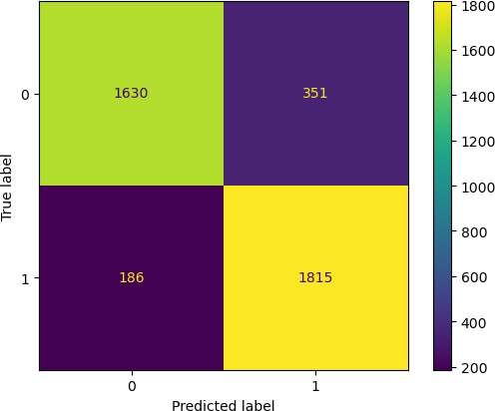

accuracy_score(y_test,y_pred)

0.865143144148669

print(classification_report(y_test,y_pred))