Practical No:3

Implement Gradient Descent Algorithm to find the local minima of a function. For example, find the local minima of the function y=(x+3)² starting from the point x=2

In [1]:

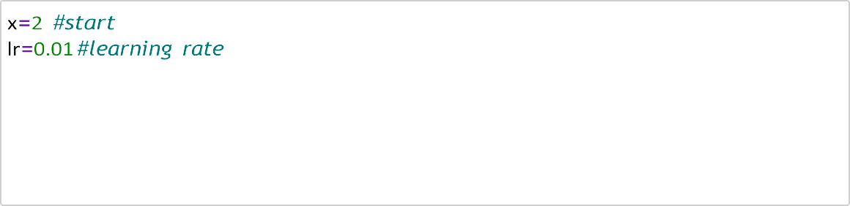

precision **=** 0.000001

previous_step_size **=** 1

max_iter **=** 10000

iters **=**0

gf **= lambda** x: (x **+** 3) **\*\*** 2

In [2]:

In [3]:

gd**=**[]

In [4]:



**while** precision **<** previous_step_size **and** iters **<** max_iter: prev **=** x x **=** x**-** lr **\*** gf(prev)

previous_step_size **=** abs(x **-** prev) iters **+=** 1 print('Iteration',iters,'Value',x) gd.append(x)

Iteration 1 Value 1.75

Iteration 2 Value 1.524375

Iteration 3 Value 1.31967530859375

Iteration 4 Value 1.133079360877005

Iteration 5 Value 0.9622559108439301

Iteration 6 Value 0.8052611918137536

Iteration 7 Value 0.6604610644345152

Iteration 8 Value 0.5264713123921045

Iteration 9 Value 0.4021113132208596

Iteration 10 Value 0.28636769934540596

Iteration 11 Value 0.1783655727923978

Iteration 12 Value 0.07734549564927831

Iteration 13 Value -0.017355057346650715

Iteration 14 Value -0.10631676588600673

Iteration 15 Value -0.19005079247993095

Iteration 16 Value -0.26900893796835756

Iteration 17 Value -0.34359205977732477 •

Iteration 18 Value -0.41415709122610556

Iteration 19 Value -0.4810229267146679

In [5]:

print('Local Minima:',x)

Local Minima: -2.990001240409911

In [6]:

plt.plot(range(len(gd)), gd)

Out[6]: [<matplotlib.lines.Line2D at 0x24ccf0cf2d0>]

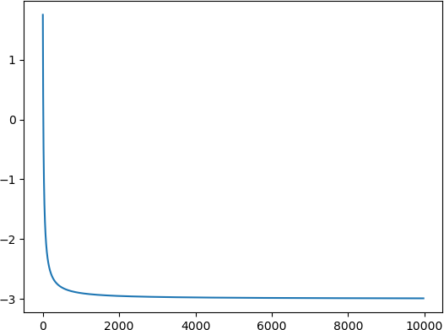

In [ ]: