|  |
| --- |
|  |
| Wilco Construction Company |
|  |
| “State Qualified Contractors” |

**Wilco Construction Company**

2017

Authored by: Gureleen Kaur, Srushti Gangireddy, Wenjie Li

**TABLE OF CONTENTS**

**Introduction**

**Scope and Focus of the database solution**

**Future scope**

**Relations in parenthetical methods**

**Proposed database design**

**Description of changes**

**Forms**

**DDL SQL syntax and sample queries**

**Web application prototypes**

**Conclusion**

-

**INRODUCTION**

Wilco Construction Company, started 20 years ago by Jack Wilson and Bob Wilson, is a State Qualified Highway Construction Contractor in Ohio. Wilco has a very organized structure with very few official titles. The company wins a good number of projects every year and the profits of the company show that the business is growing. But there are few problems because of the increase in the amount of paper work and the change policies. The three main problems are: **Generating compliance reports, Calculating complex payrolls, and Tracking inventories and tools.** There is a need to develop an Information System which can help the company mainly to generate EEOC reports. Company can also need a simple system to calculate payroll and tracking inventories.

Sue and her team designed a new improved Information Systems with the help of the information provided in the forms below:

* WILCO EEOC Compliance form
* WILCO employee information form
* Sample state compensation and hours worked
* Sample of proposed WILCO weekly pay information form

We have developed a database design to implement the proposed Information System which will overcome problems faced by the company. In this project, we are creating an application with front end in HTML that is linked to the database which is designed. This will help the user to maintain, control, and retrieve the information required by the company to perform various operations.

This application will help the Wilco Construction Company to resolve its problems and also help it to generate required reports for tracking and maintenance purposes.

**SCOPE AND FOCUS OF THE DATABASE SOLUTION**

This section will define the scope and discuss our main focus of the database model proposed. The following points will cover both of them:

* The scope and main focus of this database model is the successful generation of EEOC reports. EEOC Compliance System is very important for the company because it has to send a report including the work hours of females and minorities to the EEOC biweekly.
* If the company is not able to send it on time, it can go out of business. According to Susan, if EEOC Compliance System is ready and running then other modules can be added fairly easily.
* To cover Exhibit A which includes Wilco’s EEOC policies, State regulations required that this be posted at every job site where Wilco was completing a project. This Exhibit made clear about the regulatory environment required by the company.
* Other focus of the proposed database solution is that it would make it easier to track inventories that are required on a particular project because the company has an outdated and completely manual system, which makes it hard to maintain the inventories. In addition to this, the database model would make the calculation of payrolls much simpler.
* We are building a database that can easily pick up enough skills to make incremental changes in the future.
* In our previous proposed database model we have solved these issues and would do further changes as required by the company by following all the stack of forms and exhibits that were handed over Susan to Mary.

**FUTURE SCOPE**

This section describes the future scope of the project. It explains what can be added to this proposed Information System which will help to resolve any future operational issues or automate other business operations.

The proposed Information System can solve the most pressing problems of the company. Even though it is simple and require less complexity due to budget constraints, it can be further enhanced to automate majority of the operations done in the company. Some of those operations are as follows:

* Instead of having traditional paper time-cards, employees can fill in their hours of work into the system by logging into their accounts. Also, swipe ID cards can be used to track check-in and check-out time.
* More pages can be added to the website containing options to bid for contracts, view various reports about projects, and store information of suppliers and future project partners.
* The inventory system of our IS can be enhanced further to include option to automatically reorder the inventory from the specific suppliers in case the stock goes down by a set number.

Hence, undoubtedly the system is simple initially, it is also flexible enough to plug in more components and solve the problems related to various business operations of the company apart from just generating EEOC reports, tracking inventories, calculating payrolls; three main issues faced by the company.

**RELATIONS IN PARENTHETICAL METHOD**

This section describes the relations and various assumptions made while developing the database model.

* EMPLOYEE(EmployeeID, FirstName, LastName, SSN, Email, DateOfBirth, Gender, EEOCode, MinorityStatus, StreetAddress, City, State, Zip, MobileNumber)

This table will describe the general information about each employee of the company. Attributes like Gender, MinorityStatus, and EEOCode will help in the generation of the EEOC reports.

* PROJECT(ProjectID, ProjectName, ProjectDescription, ProjectSupervisor, Inspector, DistanceFromUH, ProjectStartDate, ProjectEndDate)

This table defines various attributes of each project like ProjectID, Project name, description, start and end date, etc. The attribute DistanceFromUH defines the location of the project site and the site’s distance from the Union Hall which is used in determining the wages of the employees.

* SKILL(SkilID, SkillCode, SkillName, HourlyRate, FringeBenefits)

The SKILL table contains each skill’s ID, code and name. Hourly rate and the fringe benefits are different for each skill. Specific attributes are defined to find these two. If there are changes in the hourly rates, it will be reflected only on this table.

* SKILL_PROJECT(SkillID, ProjectID, DistanceFromUH, HourlyRate)

This table is the intersection table between SKILL and PROJECT. Hence it contains SkillID and ProjectID as the primary keys. The only function of this table is to determine the Hourly Rate of each employee which is dependent on the skill and also the distance of the project site from the Union Hall. Hence, this table uses the required information from its two parent tables and compute the HourlyRate.

* TIMESHEET(EmployeeID, ProjectID, DateOfWork, CheckInTime, CheckOutTime, *SkillID*)

TIMESHEET table connects employees with skills to determine how many hours each employee has worked on a particular skill. This table will form the basis of generating EEOC reports to show that 10% of the skill is assigned to females and minorities. It will simplify the calculation of the payrolls of each employee. EmployeeID and ProjectID will form the composite primary key and SkillID will be the foreign key in this table.

* EQUIPMENT(EquipmentID, EquipmentName, EquipmentType, DateOfPurchase, AcquisitionCost, QuantityOnHand, MaintenanceDue, RentedEquipment)

This table give the details of the equipment of the company. Total number of equipment used and available to the company can be determined by this table. The DateOfPurchase of the equipment will determine its MaintenanceDue which will be automatically entered into the system once we know the DateOfPurchase. The RentedEquipment attribute will have a Boolean value to determine whether a particular equipment is rented or purchased. This will help the company to keep a better track of its inventory.

* EQUIPMENT_USAGE(EquimentUsageID, *ProjectID, EquipmentID,* Eq_CheckInTimeSTamp, Eq_CheckOutTimeStamp, Count, *EmployeeID)*

This table will connect the PROJECT, EQUIPMENT, and EMPLOYEE tables in order to determine which equipment is checked-in by which employee and for what particular project. The attributes to keep track of the check-in and check-out time will help the system to keep a better track of the equipment.

**PROPOSED DATABASE DESIGN**

The revised database design model as shown below helps in the improvement in the functionality of the entire system:

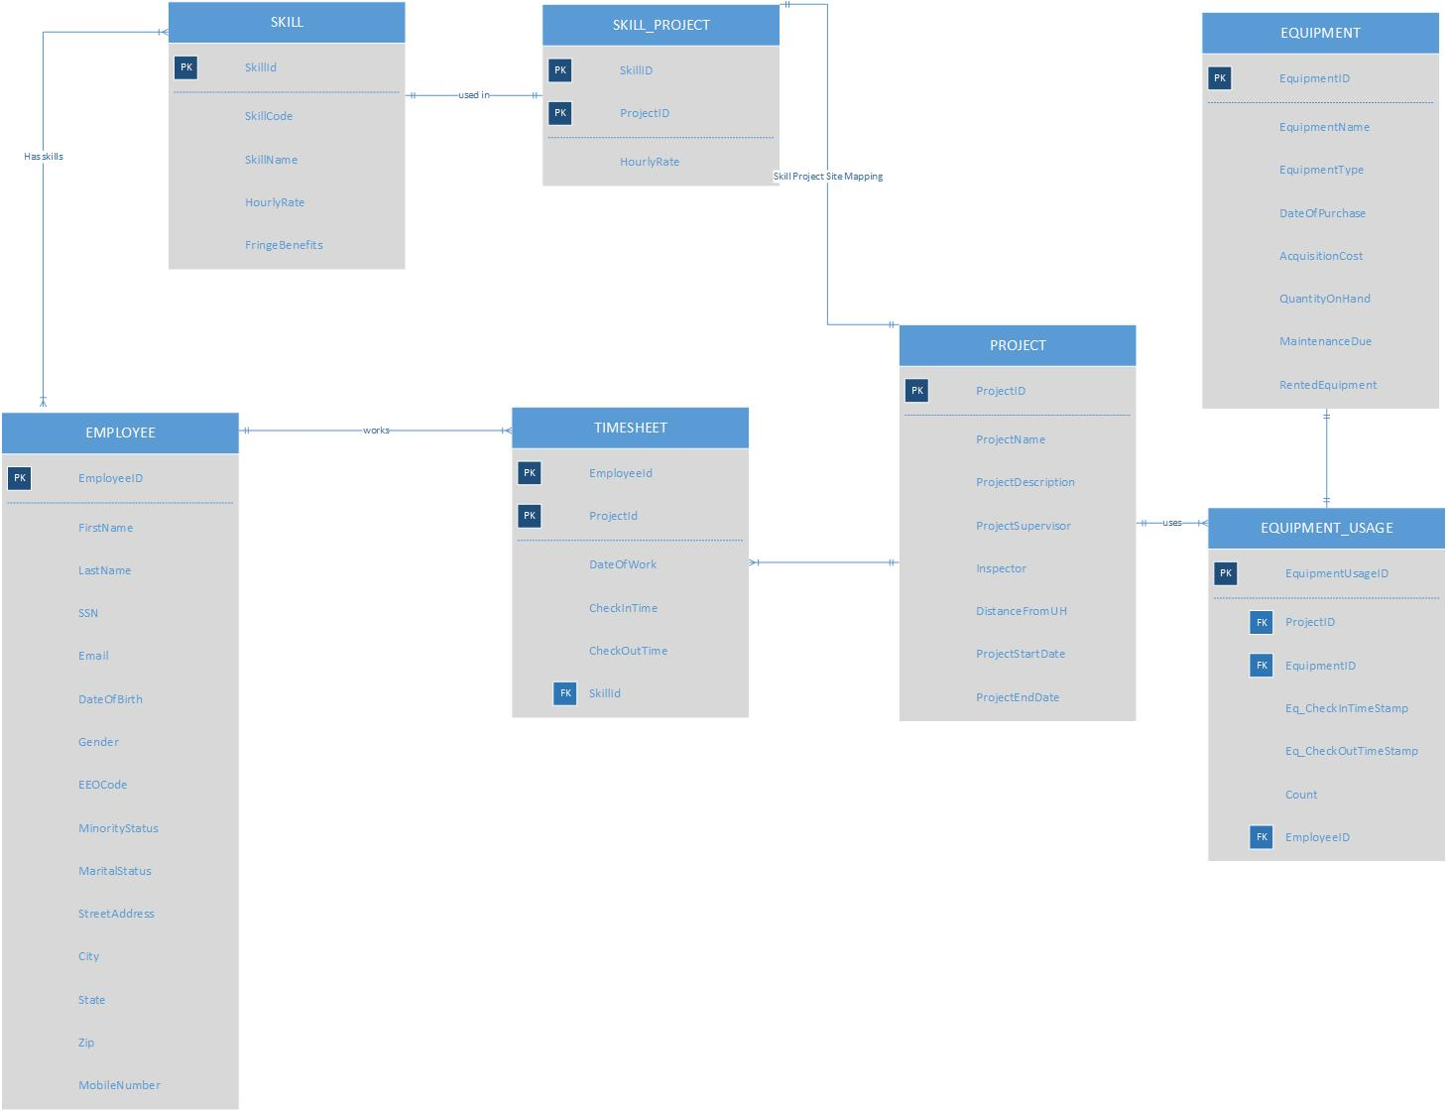 **Figure1: Database design for Wilco Construction Company**

**DESCRIPTION OF CHANGES**

According to the requirements of the Wilco Construction Company, we have made several changes to our preliminary database model and made it more flexible to add further options. Those changes are as follows:

* New attributes such as EEOCode, MinorityStatus, MaritalStatus, SSN, etc. have been added to the EMPLOYEE table which helped us in the generation of EEOC Compliance reports every two weeks for each employee.
* Eliminated the SITE table from our database and added the column: DistanceFromUH in the PROJECT table to calculate the wage of each employee.
* Changed the name of DAILYDUTYINFO table to TIMESHEET since the latter is shorter and more relevant to the context. Also, there were two paths to the SITE table from PROJECT and DAILYDUTYINFO each. We resolved this by eliminating SITE.
* Created an intersection table: SKILL_PROJECT between SKILL and PROJECT which represents the Skill Project Site mapping.
* Eliminated the SUPPLIER table since we are not concerned about knowing the equipment supplier information. Also, removed the STOCK table since it contained almost the same columns as the EQUIPMENT table.
* Added the DateOfPurchase column in the EQUIPMENT table which automatically updated the MaintenanceDue value and removes the need to manually enter this value.
* Inserted a surrogate key EquipmentUsageID in the EQUIPMENT_USAGE table which ensures the uniqueness of the rows.

With these changes, retrieving data from the database has become more accurate with no redundancies. Wilco has a wide scope and many more details can be added to simplify the information processing for the company.

**FORMS**

**DDL SQL SYNTAX AND SAMPLE QUERIES**

A database for Wilco Construction Company is created to have all the queries reside in one database itself. There are seven table in Wilco database:

* EMPLOYEE
* SKILL
* PROJECT
* SKILL_PROJECT
* TIMESHEET
* EQUIPMENT
* EQUIPMENT_USAGE
* INCOME TAX
* EEOC_Code

The query part of the database creation and all the DDL syntax for table creation and insertion of values in the tables is provided in the .txt file attached. Some of the sample queries are as follows:

**EEOC_Code**

create table EEO_CODE(

EEO_Code int not null identity(1,1),

EEO_Description varchar(50) not null,

constraint EEO_CODE_PK primary key(EEO_CODE)

);

insert into EEO_CODE values('Black not of Hispanic Origin');

insert into EEO_CODE values('Hispanic');

insert into EEO_CODE values('Asian/Pacific Islander');

insert into EEO_CODE values('American Indian or Alaskan Native');

insert into EEO_CODE values('Non-Minority (White)');

**Employee**

create table Employee(

EmployeeID int not null,

FirstName varchar(50),

LastName varchar(50),

SSN varchar(15),

Email varchar(50),

DateOfBirth date,

Gender varchar(20),

EEOCode int,

MinorityStatus Varchar(10),

MaritalStatus varchar(10),

StreetAddress varchar(50),

City varchar(50),

StateName varchar(50),

Zip varchar(15),

MobileNumber varchar(20),

constraint Employee_PK primary key(EmployeeID),

constraint Employee_AK unique(SSN),

constraint Employee_FK foreign key(EEOCode) references EEO_Code(EEO_Code)

);

insert into EMPLOYEE (EmployeeID, FirstName, LastName, SSN, Email, DateOfBirth, Gender, EEOCode, MinorityStatus, MaritalStatus, StreetAddress, City, StateName, Zip, MobileNumber) values (1, 'Davidde', 'Parradine', '310-69-3294', 'dparradine0@cam.ac.uk', '8/25/1971', 'Male', 2, 'true', 'true', '8986 Packers Plaza', 'Springfield', 'Illinois', '62718', '1-(217)865-4141');

insert into EMPLOYEE (EmployeeID, FirstName, LastName, SSN, Email, DateOfBirth, Gender, EEOCode, MinorityStatus, MaritalStatus, StreetAddress, City, StateName, Zip, MobileNumber) values (2, 'Malena', 'Prichard', '329-12-7035', 'mprichard1@paginegialle.it', '9/29/1966', 'Female', 5, 'false', 'false', '0 Helena Street', 'Baton Rouge', 'Louisiana', '70826', '1-(225)161-9968');

insert into EMPLOYEE (EmployeeID, FirstName, LastName, SSN, Email, DateOfBirth, Gender, EEOCode, MinorityStatus, MaritalStatus, StreetAddress, City, StateName, Zip, MobileNumber) values (3, 'Pearle', 'Farrimond', '748-60-2687', 'pfarrimond2@dedecms.com', '12/6/1968', 'Female', 2, 'true', 'false', '0324 Hanson Way', 'Hartford', 'Connecticut', '06145', '1-(860)937-3509');

insert into EMPLOYEE (EmployeeID, FirstName, LastName, SSN, Email, DateOfBirth, Gender, EEOCode, MinorityStatus, MaritalStatus, StreetAddress, City, StateName, Zip, MobileNumber) values (4, 'Joanna', 'Rolse', '976-36-6192', 'jrolse3@networkadvertising.org', '2/27/1980', 'Female', 3, 'true', 'true', '6564 Londonderry Drive', 'Columbus', 'Georgia', '31904', '1-(706)302-2030');

insert into EMPLOYEE (EmployeeID, FirstName, LastName, SSN, Email, DateOfBirth, Gender, EEOCode, MinorityStatus, MaritalStatus, StreetAddress, City, StateName, Zip, MobileNumber) values (5, 'Keir', 'Painswick', '522-74-9018', 'kpainswick4@cbsnews.com', '5/16/1993', 'Male', 2, 'true', 'false', '61223 Lien Place', 'Washington', 'District of Columbia', '20535', '1-(202)721-5506');

**Skill**

create table SKILL(

SkillID int not null identity(1,1),

SkillCode varchar(5) not null,

SkillName varchar(50) null,

SkillHourlyRate money,

FringeBenefits money,

constraint Skill_PK primary key(SkillID)

);

insert into skill values('LAB','Labor',11.00,3.00);

insert into skill values('CAR','Carpentry',12.00,3.00);

insert into skill values('MAS','Masonry',13.00,3.00);

insert into skill values('IRN','Iron Work',14.00,3.00);

insert into skill values('EQP','Equipment Operation',15.00,3.00);

**Project**

create table PROJECT(

ProjectID varchar(20) not null,

ProjectName varchar(50),

ProjectSupervisorID int,

Inspector varchar(100),

DistanceFromUH int,

ProjectStartDate date,

ProjectEndDate date,

constraint Project_PK primary key(ProjectID)

);

insert into PROJECT (ProjectID, ProjectSupervisorID, Inspector, DistanceFromUH, ProjectStartDate, ProjectEndDate, ProjectName) values ('OH-PIK-335-005', 20, 'Falkner Pitson', 15, '03/28/2013', '08/04/2013', 'Township project');

insert into PROJECT (ProjectID, ProjectSupervisorID, Inspector, DistanceFromUH, ProjectStartDate, ProjectEndDate, ProjectName) values ('OH-PIK-335-006', 50, 'Xaviera Ayce', 40, '10/29/2011', '05/25/2013', 'County Project');

insert into PROJECT (ProjectID, ProjectSupervisorID, Inspector, DistanceFromUH, ProjectStartDate, ProjectEndDate, ProjectName) values ('OH-PIK-335-007', 15, 'Rutter Hoffner', 5, '01/12/2013', '07/01/2015', 'Private Project');

insert into PROJECT (ProjectID, ProjectSupervisorID, Inspector, DistanceFromUH, ProjectStartDate, ProjectEndDate, ProjectName) values ('OH-PIK-335-008', 10, 'Pam Conboy', 10, '06/28/2010', '10/13/2013', 'Ohio Highway Division Project');

insert into PROJECT (ProjectID, ProjectSupervisorID, Inspector, DistanceFromUH, ProjectStartDate, ProjectEndDate, ProjectName) values ('OH-PIK-335-009', 50, 'Berton Kiggel', 0, '10/09/2010', '01/22/2014', 'Township project');

insert into PROJECT (ProjectID, ProjectSupervisorID, Inspector, DistanceFromUH, ProjectStartDate, ProjectEndDate, ProjectName) values ('OH-PIK-336-005', 50, 'Johnny McKune', 20, '02/23/2013', '09/07/2014', 'County Project');

create table SKILL_PROJECT(

SkillProjectID int not null identity(1,1) primary key,

SkillID int,

DistanceFromUH int,

HourlyRate money,

constraint skill_project_fk1 foreign key(SkillID) references Skill(SkillID)

);

Skill_Project table is the intersection table that records the hourly pay for each skill at different distances.

insert into SKILL_PROJECT values(1,0,(select SkillHourlyRate from SKILL where SkillID = 1));

insert into SKILL_PROJECT values(1,5,(select SkillHourlyRate from SKILL where SkillID = 1)*1.5);

insert into SKILL_PROJECT values(1,10,(select SkillHourlyRate from SKILL where SkillID = 1)*2);

insert into SKILL_PROJECT values(1,15,(select SkillHourlyRate from SKILL where SkillID = 1)*2.5);

insert into SKILL_PROJECT values(1,20,(select SkillHourlyRate from SKILL where SkillID = 1)*3);

insert into SKILL_PROJECT values(2,0,(select SkillHourlyRate from SKILL where SkillID = 2));

insert into SKILL_PROJECT values(2,5,(select SkillHourlyRate from SKILL where SkillID = 2)*1.5);

insert into SKILL_PROJECT values(2,10,(select SkillHourlyRate from SKILL where SkillID = 2)*2);

insert into SKILL_PROJECT values(2,15,(select SkillHourlyRate from SKILL where SkillID = 2)*2.5);

insert into SKILL_PROJECT values(2,20,(select SkillHourlyRate from SKILL where SkillID = 2)*3);

create table TIMESHEET(

TimesheetID int,

EmployeeID int,

ProjectID varchar(20),

SkillID int,

CurrentDayDate date,

CheckInTime datetime,

CheckOutTime datetime,

constraint Timesheet_PK primary key(TimesheetID),

constraint Timesheet_fk1 foreign key(EmployeeID) references EMPLOYEE(EmployeeID) on delete cascade,

constraint Timesheet_fk2 foreign key(ProjectID) references PROJECT(ProjectID) on delete cascade,

constraint Timesheet_fk3 foreign key(SkillID) references SKILL(SkillID) on delete cascade

);

Timesheet table records the employee check in and check out information to work dialy.

**Detailed work breakdown:**

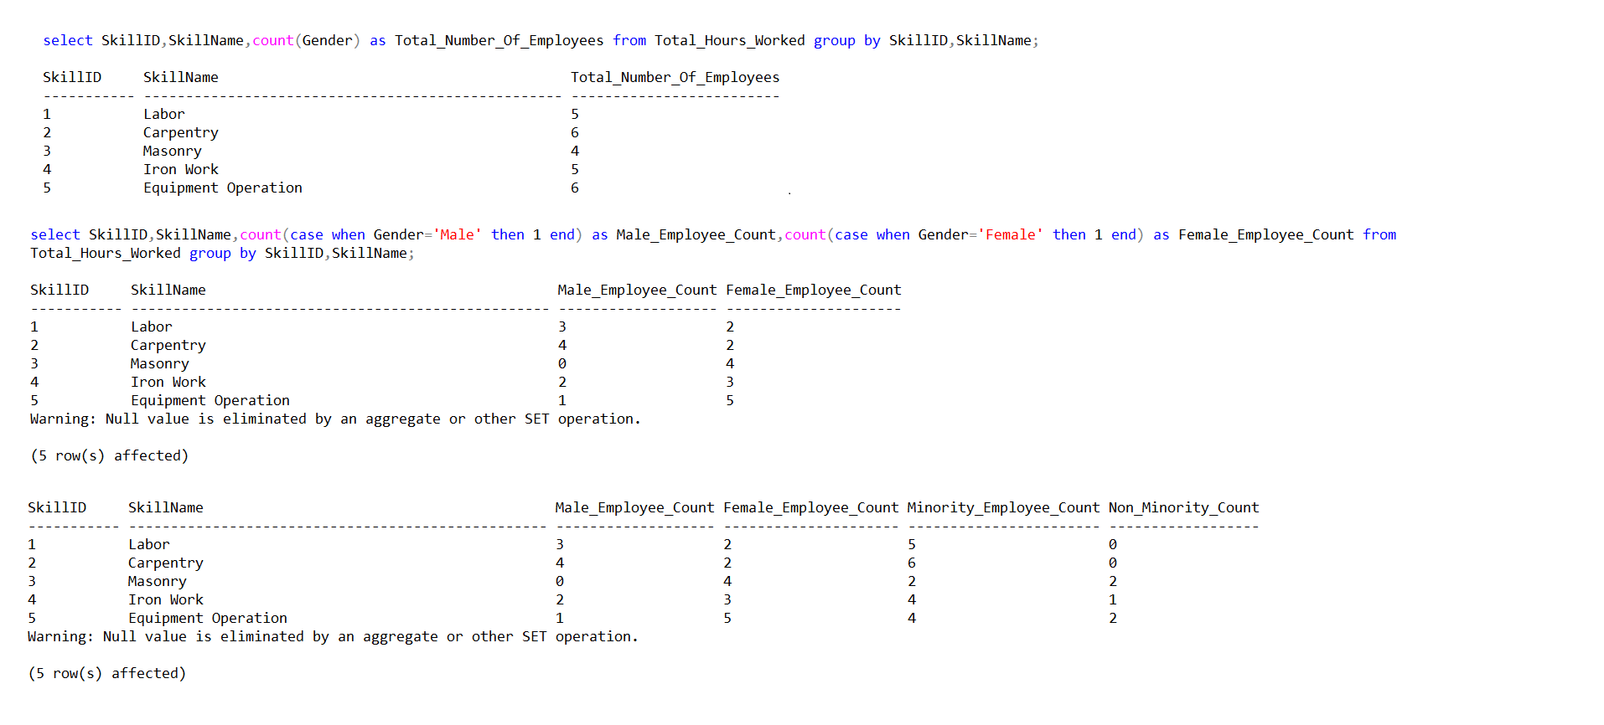

**EEOC Compliance**

For generating EEOC Compliance form, we are first calculating the number of male and female minority and non-minority employees. We are then calculating the percentage of minority and female employees out of the total number of employees working in each project site.

All the logic needed to generate EEOC Compliance form would be the same every two weeks, only the date needs to be changed bi-weekly.

The form generation was easy as we have the EEOC Code, Minority Status and the Gender of each employee in database.

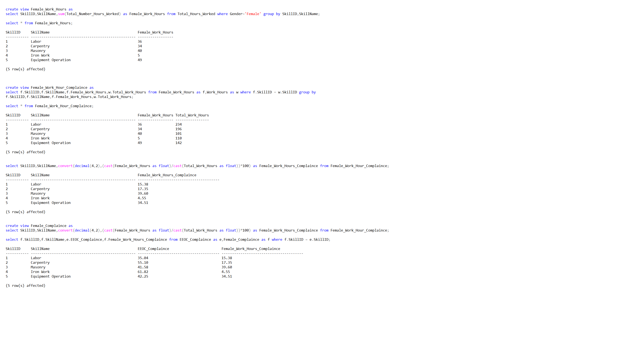

**Payroll Calculation:**

We first defined the hourly rate, fringe benefits for each skill as specified in Exhibit C in the Skill table in database. Then, we created the intersection table which specifies the hourly rate of each skill for specific distance from Union Hall.

Next step was getting the break-down of the number of hours’ employee worked on each skill in different project sites in one week. We have created some views to extract this information which are attached in the queries file. Using the intersection table Skill_Project and the view we have calculated the pay for each employee for each skill using which the gross pay can be extracted.

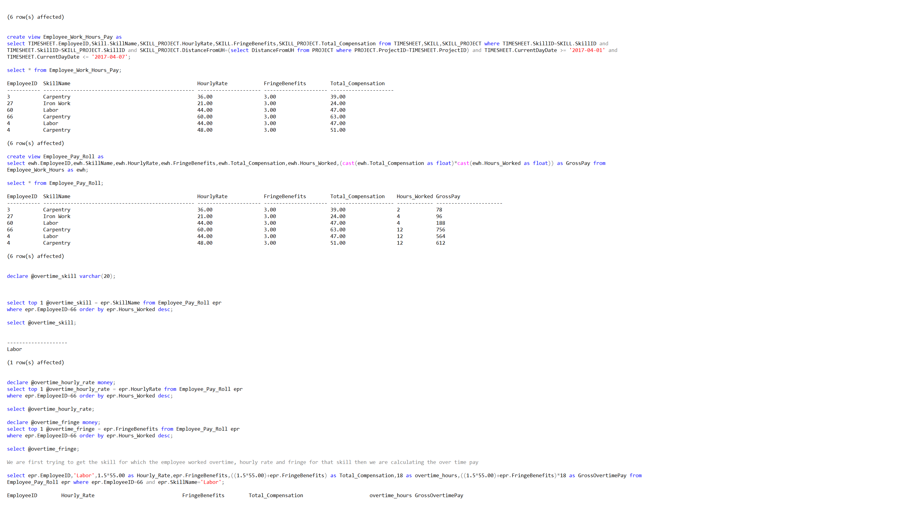

We have calculated overtime pay by first defining the variables called overtimehours and overtimeskill and getting the number of hours the employee worked overtime and the skill on which they have worked overtime and then calculating the pay for that specific number of hours.

**WEB APPLICATION PROTOTYPES**

The Web application prototype for Wilco Construction Company is an illustration on how the database can be connected to the Web application to make it easy to access for Mary Wilson who is a sole officer to manage all employee wage calculation and EEOC Compliance Issue.

**Home page:** It is the main page a visitor navigating to a website from a web search engine

will see. Navigation to all the forms is done through the home page. Different forms can be

viewed and accessed from the navigation tabs located at the upper right side of the website.

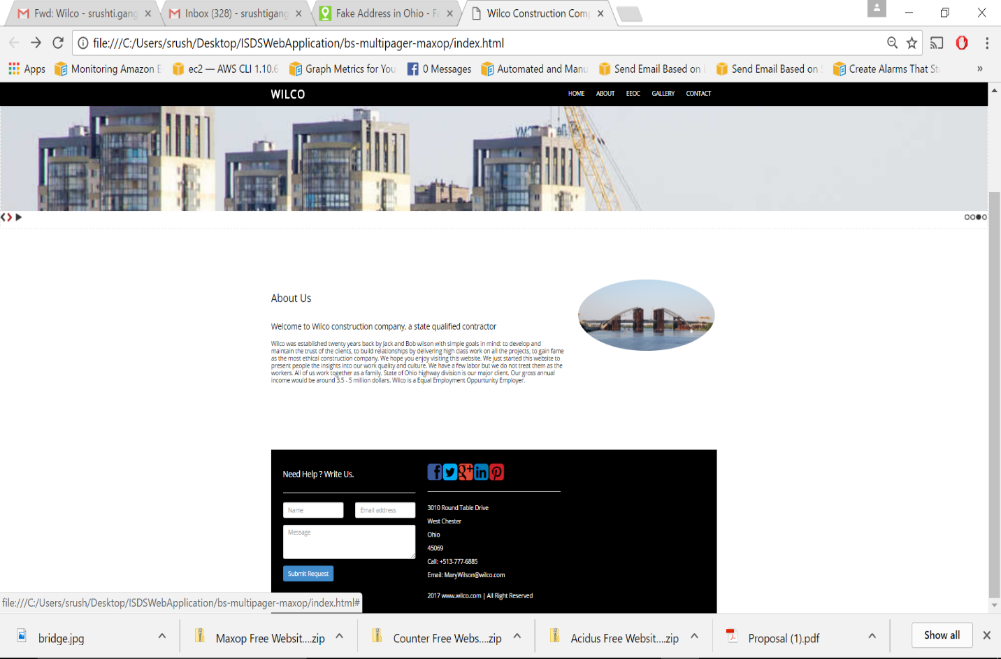

**Figure 2: Home page**

**Employee Information page:** Once the user logs into their account using the EmployeeID, he/she is given an access to employee information form as shown below.

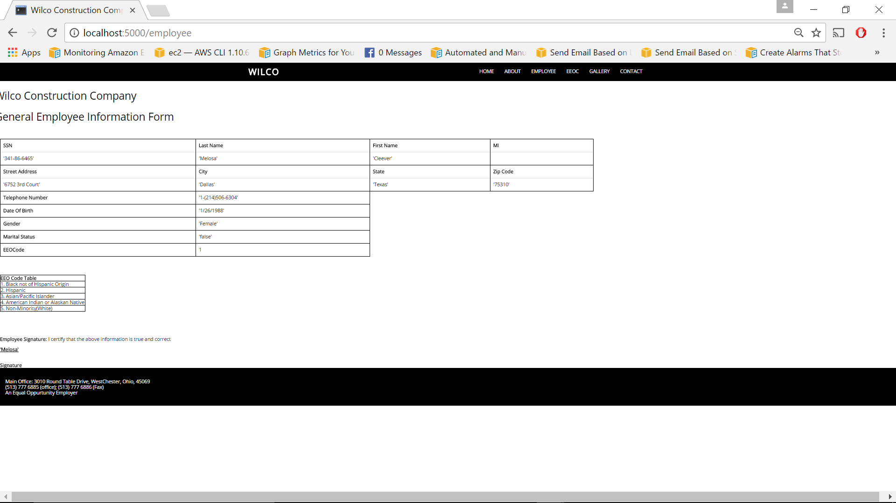

**Figure 2: Employee Information page**

**EEOC Compliance report:** Once a user clicks on the EEOC tab located at the upper right side of the home page, EEOC report is generated after logging in with the required information. This report is divided into four different parts: Date of the report generated, contractor and the project information and finally the detailed work hour breakdown for that employee.

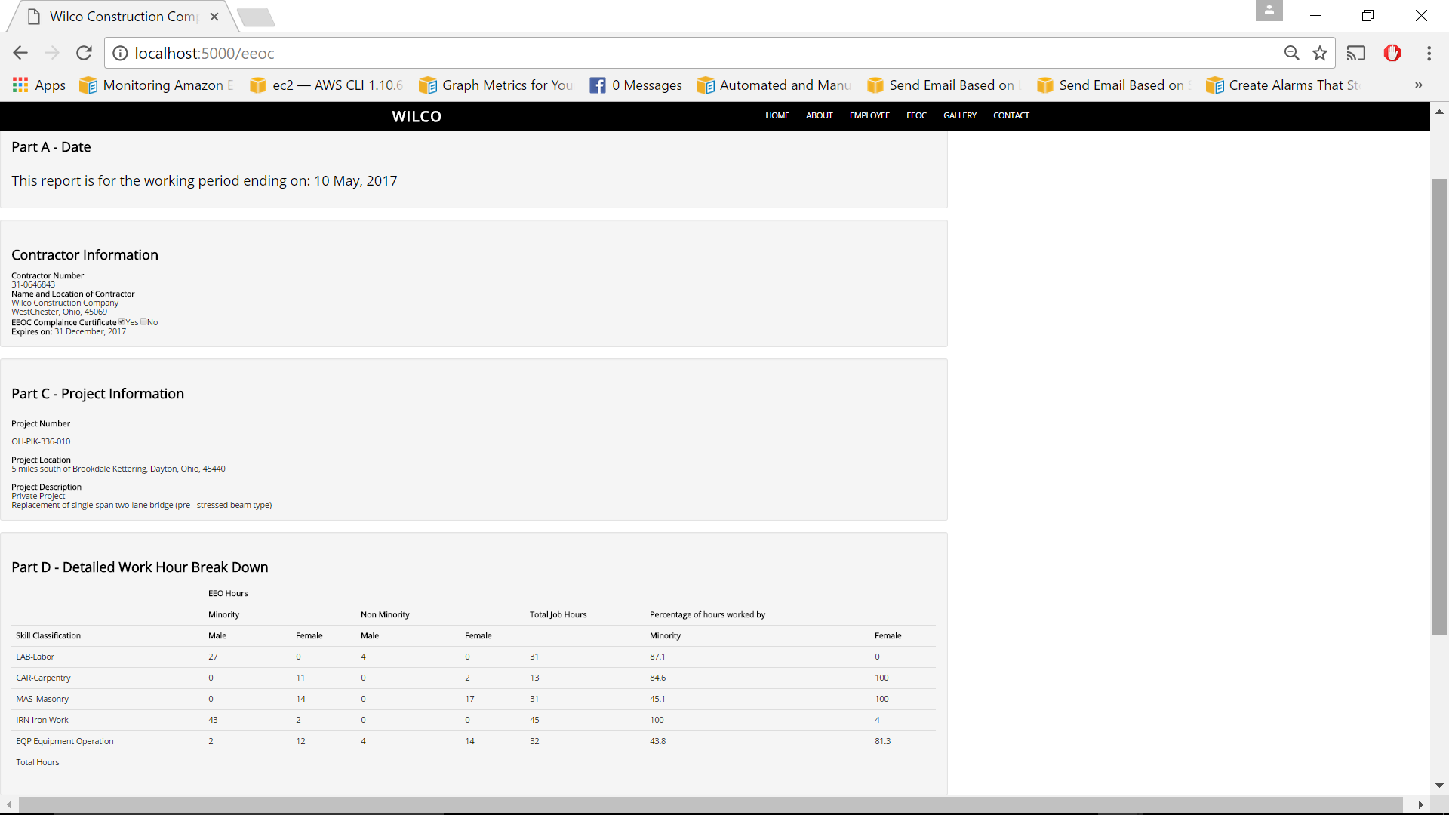

**Figure 4: EEOC Compliance report**

**Payroll report page:** This web page displays the pay scale of the employees per their skill type. It alsothe number of regular hour wage calculation and the overtime hour wage calculation.

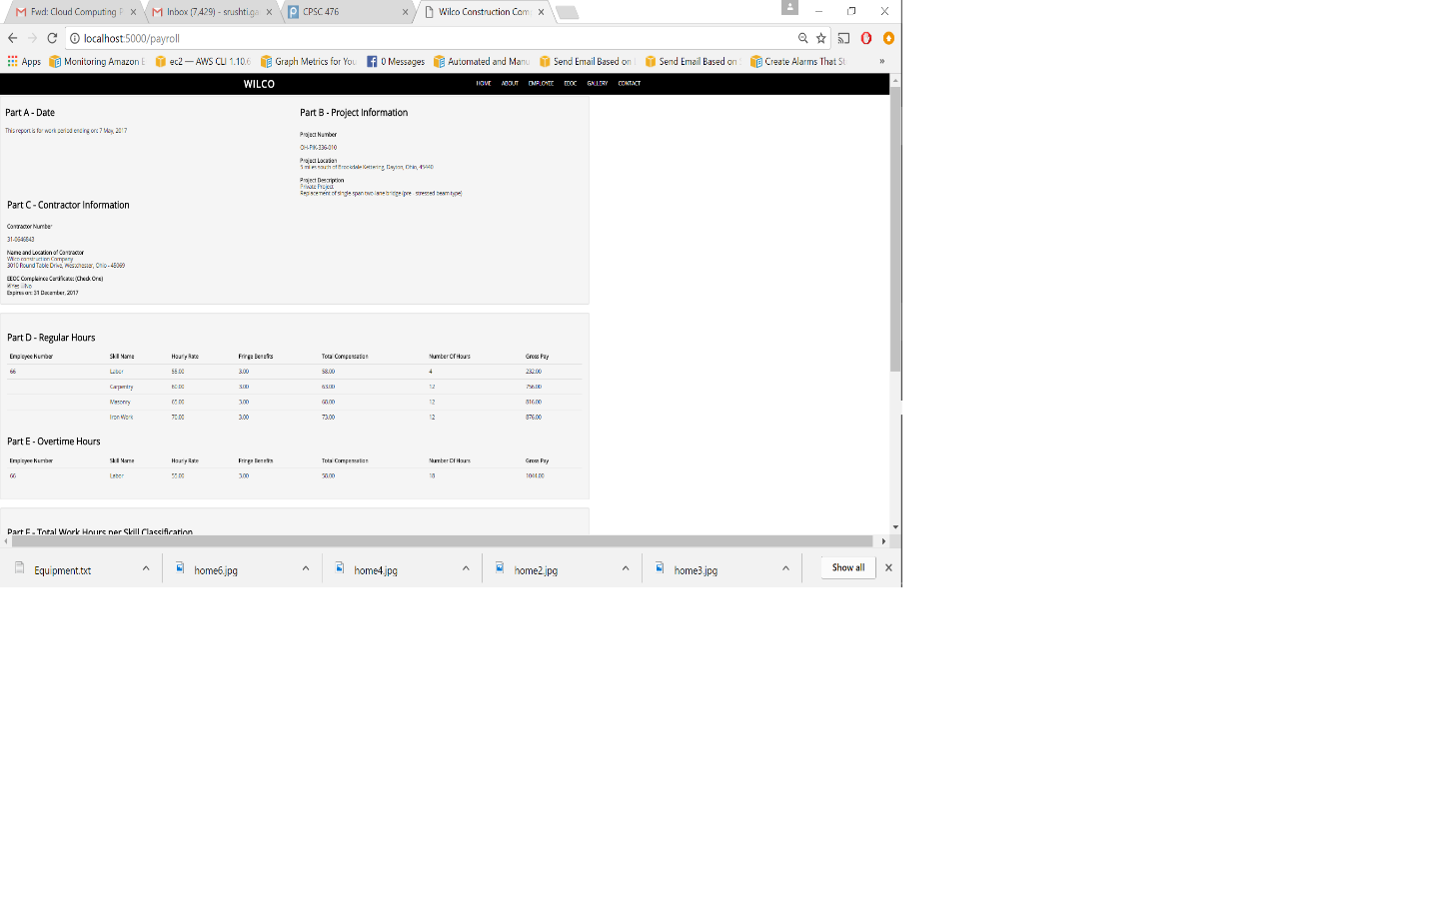

**Figure 5: Payroll report page**

**CONCLUSION**

With the proposed database model and the web application prototypes, Wilco construction company will be able to solve all the issues regarding salary and employment. This model also provides them with a better means to handle their inventory and project needs. The employees will have an access to salary reports generated weekly or monthly which will help them manage their work hours in the future more effectively.

For any organization to run efficiently and effectively, time management is very important. With this database model, Mary will be able to concentrate more on other managerial duties and responsibilities rather than worrying about the generation of payroll, EEOC reports, and handling the inventories.

In the future, Wilco can also undertake other Business Intelligence and Data Warehouse solutions as the company continues to grow.