**DAILY ONLINE ACTIVITIES SUMMARY**

|  |  |  |  |  |  |  |  |  |
| --- | --- | --- | --- | --- | --- | --- | --- | --- |
| **Date:** | **18/05/2020** | | | | | **Name:** | **Anvita Keni** | |
| **Sem & Sec** | **8th sem A sec** | | | | | **USN:** | **4AL16CS016** | |
| **Online Test Summary** | | | | | | | | |
| **Subject** | | **SMS** | | | | | | |
| **Max. Marks** | | **60** | | **Score** | | | **57** | |
| **Certification Course Summary** | | | | | | | | |
| **Course** | **Introduction to Ethical hacking** | | | | | | | |
| **Certificate Provider** | | | **Great Learning Academy** | | **Duration** | | | **6 hour** |
| **Coding Challenges** | | | | | | | | |
| **Problem Statement: Prob 1: Using methods charAt() & length() of String class, write a program to print the frequency of each character in a string.**  **Prob 2: Write a java program to print even and odd numbers series respectively from two threads:t1 and t2 synchronizing on a shared object**  **Let t1 print message “ping -- >” and t2 print message “,--pong”. Take as command line arguments, the following inputs to the program: Sleep interval for thread t1.** | | | | | | | | |
| **Status:Solved** | | | | | | | | |
| **Uploaded the report in Github** | | | | | **Yes** | | | |
| **If yes Repository name** | | | | | **Anvita_Keni** | | | |
| **Uploaded the report in slack** | | | | | **Yes** | | | |

Online Test Details:

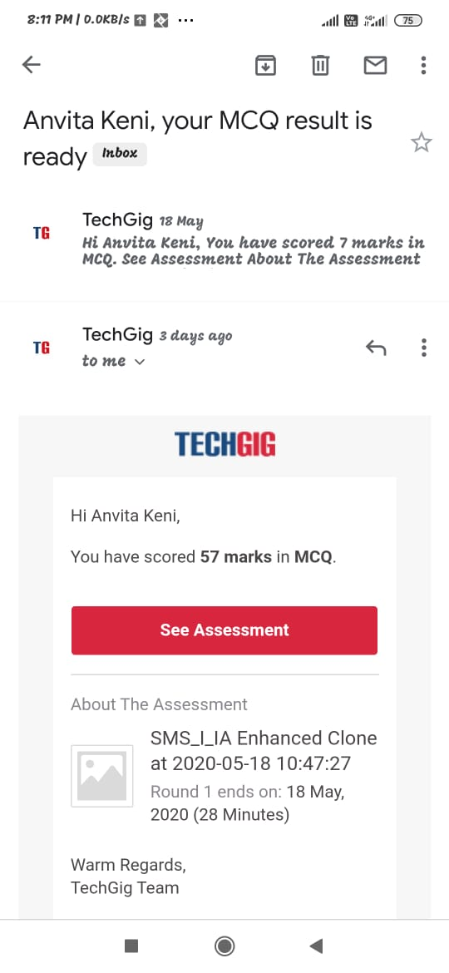

Certification Course Details:

