**DAILY ONLINE ACTIVITIES SUMMARY**

|  |  |  |  |  |  |  |  |  |
| --- | --- | --- | --- | --- | --- | --- | --- | --- |
| **Date:** | **20-05-2020** | | | | | **Name:** | **Anvita Keni** | |
| **Sem & Sec** | **8th , A** | | | | | **USN:** | **4AL16CS016** | |
| **Online Test Summary** | | | | | | | | |
| **Subject** | | **IoT** | | | | | | |
| **Max. Marks** | | **30** | | **Score** | | | **20** | |
| **Certification Course Summary** | | | | | | | | |
| **Course** | **Introduction to Ethical Hacking** | | | | | | | |
| **Certificate Provider** | | | **Great Learning Academy** | | **Duration** | | | **6 hour** |
| **Coding Challenges** | | | | | | | | |
| **Problem Statement:**  If a linked list is: 1 → 2 → 3 → 4 → 5 → 6 → 7 → 8   |  | | --- | |  | |  | The value of size k is 2 | |  | Then the linked list looks like: 2 → 1 → 4 → 3 → 6 → 5 → 8 → 7 | |  |  | |  | If a linked list is: 1 → 2 → 3 → 4 → 5 → 6 → 7 → 8 | |  | The value of size k is 3 | |  | Then the linked list looks like: 3 → 2 → 1 → 6 → 5 → 4 → 8 → 7 | | | | | | | | | |
| **Status: Solved** | | | | | | | | |
| **Uploaded the report in Github** | | | | | **Yes** | | | |
| **If yes Repository name** | | | | | **Anvita_Keni** | | | |
| **Uploaded the report in slack** | | | | | **Yes** | | | |

Online test details

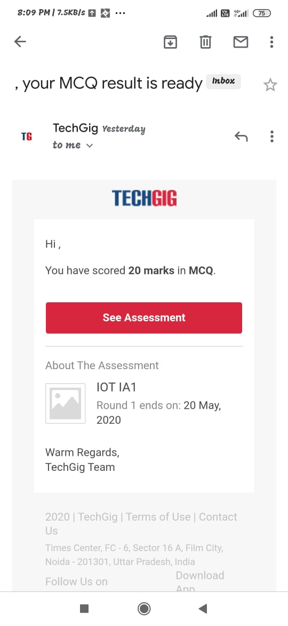

Certification Course Details:

