**DAILY ONLINE ACTIVITIES SUMMARY**

|  |  |  |  |  |  |  |  |  |
| --- | --- | --- | --- | --- | --- | --- | --- | --- |
| **Date:** | **21-05-2020** | | | | | **Name:** | **Anvita Keni** | |
| **Sem & Sec** | **8th , A** | | | | | **USN:** | **4AL16CS016** | |
| **Online Test Summary** | | | | | | | | |
| **Subject** | | **SMS** | | | | | | |
| **Max. Marks** | | **60** | | **Score** | | | **43** | |
| **Certification Course Summary** | | | | | | | | |
| **Course** | Introduction to Ethical Hacking | | | | | | | |
| **Certificate Provider** | | | Great Learning Academy | | **Duration** | | | 6 hour |
| **Coding Challenges** | | | | | | | | |
| **Problem Statement:** Create the SLL, and then Reverse the Link in SLL until Head becomes NULL. Each Time Reversing the Link, Head must be moved to next immediate node. | | | | | | | | |
| **Status:** Solved | | | | | | | | |
| **Uploaded the report in Github** | | | | | Yes | | | |
| **If yes Repository name** | | | | | Anvita_Keni | | | |
| **Uploaded the report in slack** | | | | | Yes | | | |

Online test details:

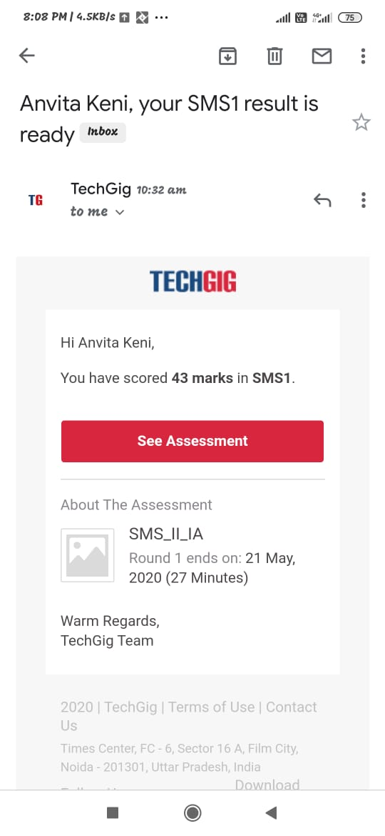

Online certificate details:

