**DAILY ONLINE ACTIVITIES SUMMARY**

|  |  |  |  |  |  |  |  |  |
| --- | --- | --- | --- | --- | --- | --- | --- | --- |
| **Date:** | **01-06-2020** | | | | | **Name:** | **Niharika G V** | |
| **Sem & Sec** | **8 sem , A sec** | | | | | **USN:** | **4al16cs059** | |
| **Online Test Summary** | | | | | | | | |
| **Subject** | | **SMS** | | | | | | |
| **Max. Marks** | | **60** | | **Score** | | | **60** | |
| **Certification Course Summary** | | | | | | | | |
| **Course** | **Learn Ethical Hacking in 2020 : Beginner to Advanced** | | | | | | | |
| **Certificate Provider** | | | **Udemy** | | **Duration** | | | **30 Hr** |
| **Coding Challenges** | | | | | | | | |
| Problem Statement: c program to print right angled triangle numbers star pattern | | | | | | | | |
| **Status: Completed** | | | | | | | | |
| **Uploaded the report in Github** | | | | | **yes** | | | |
| **If yes Repository name** | | | | | **Daily progress Reports** | | | |
| **Uploaded the report in slack** | | | | | **yes** | | | |

Online Test Details: (Attach the snapshot and briefly write the report for the same)

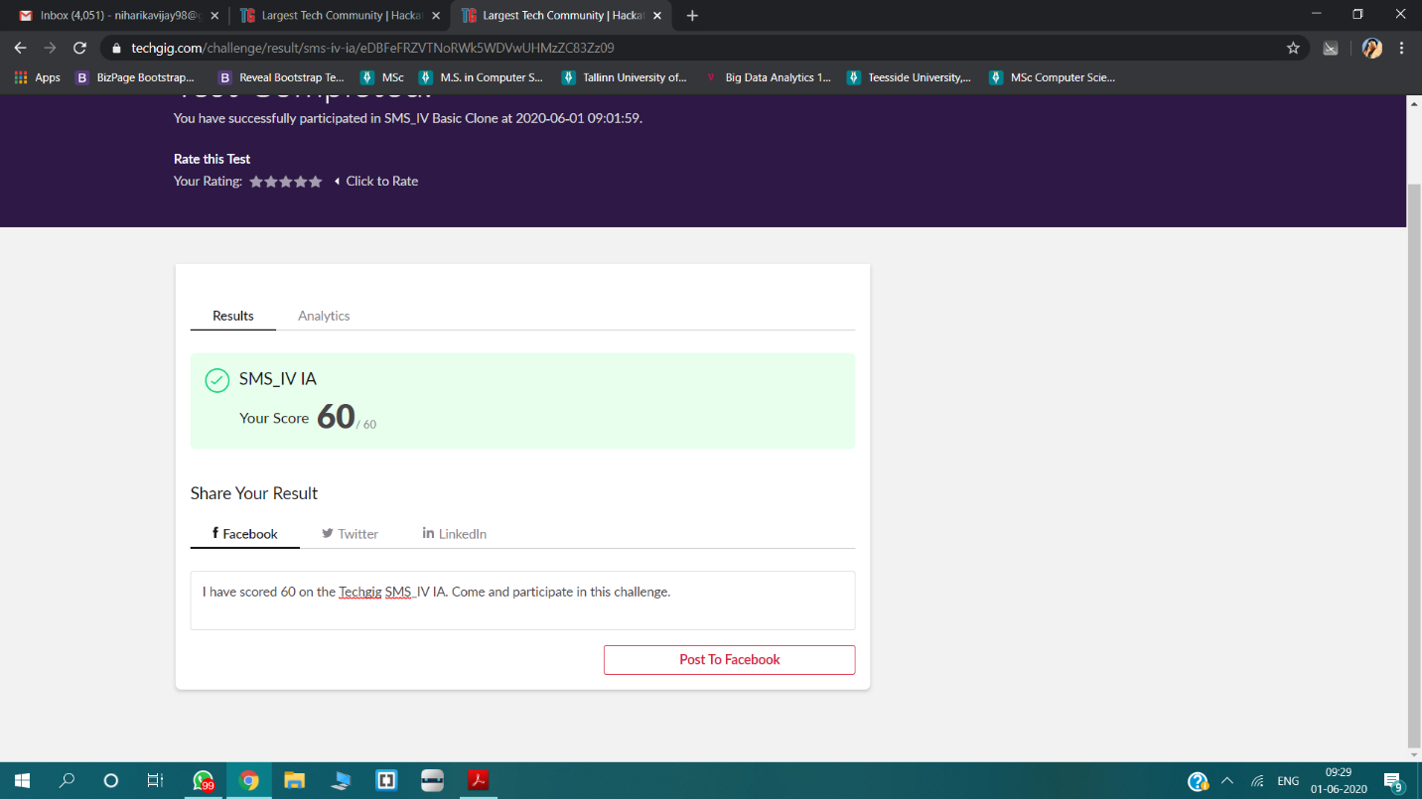

Certification Course Details: (Attach the snapshot and briefly write the report for the same)

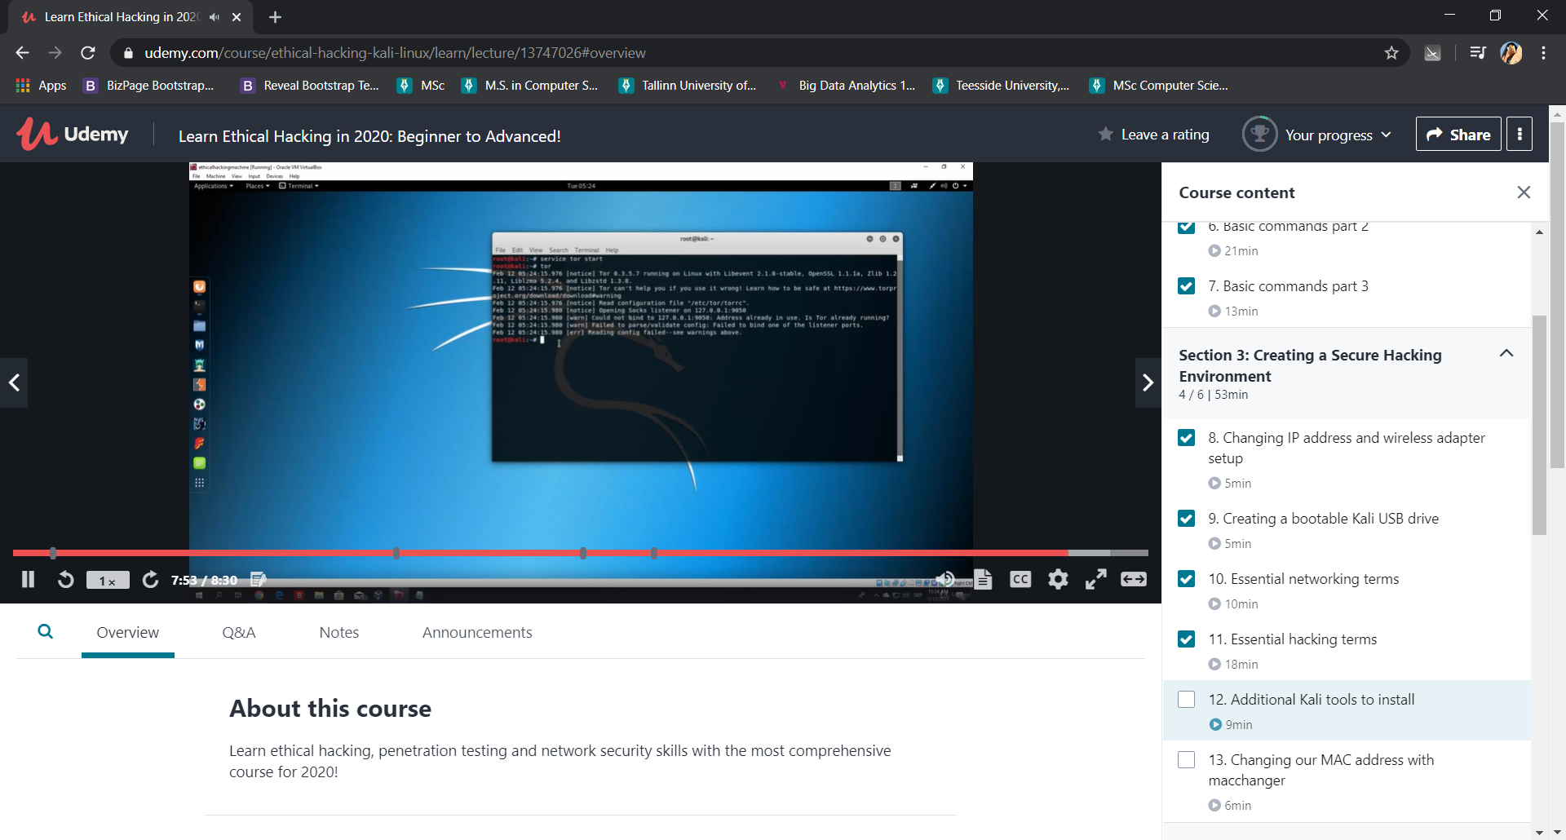

Coding Challenges Details: (Attach the snapshot and briefly write the report for the same)

|  |  |
| --- | --- |
|  | int main() |
|  | { |
|  | int Rows, i, j; |
|  |  |
|  | printf("Please Enter the Number of Rows: "); |
|  | scanf("%d", &Rows); |
|  |  |
|  | printf("\nPrinting Right Angled Triangle \n \n"); |
|  | for ( i = 1 ; i <= Rows; i++ ) |
|  | { |
|  | for ( j = 1 ; j <= i; j++ ) |
|  | { |
|  | printf("* "); |
|  | } |
|  | printf("\n"); |
|  | } |
|  | return 0; |
|  | } |