**DAILY ONLINE ACTIVITIES SUMMARY**

|  |  |  |  |  |  |  |  |  |
| --- | --- | --- | --- | --- | --- | --- | --- | --- |
| **Date:** | **03-06-2020** | | | | | **Name:** | **Niharika G V** | |
| **Sem & Sec** | **8 sem , A sec** | | | | | **USN:** | **4al16cs059** | |
| **Online Test Summary** | | | | | | | | |
| **Subject** | | **NA** | | | | | | |
| **Max. Marks** | |  | | **Score** | | |  | |
| **Certification Course Summary** | | | | | | | | |
| **Course** | **Learn Ethical Hacking in 2020 : Beginner to Advanced** | | | | | | | |
| **Certificate Provider** | | | **Udemy** | | **Duration** | | | **30 Hr** |
| **Coding Challenges** | | | | | | | | |
| **Problem Statement:** **1**. **to read the number and compute the series.**  **2. to count the number in th series.**  **3. to check whether number is palindrome or not.**  **4. to find the number between 0 and 50 which are not divisible by 2 and 3.**  **5.micro and array update**  Top of Form | | | | | | | | |
| **Status:completed** | | | | | | | | |
| **Uploaded the report in Github** | | | | | **yes** | | | |
| **If yes Repository name** | | | | | **Daily progress Reports** | | | |
| **Uploaded the report in slack** | | | | | **yes** | | | |

**Online Test**

No Test

Certification course on RPA

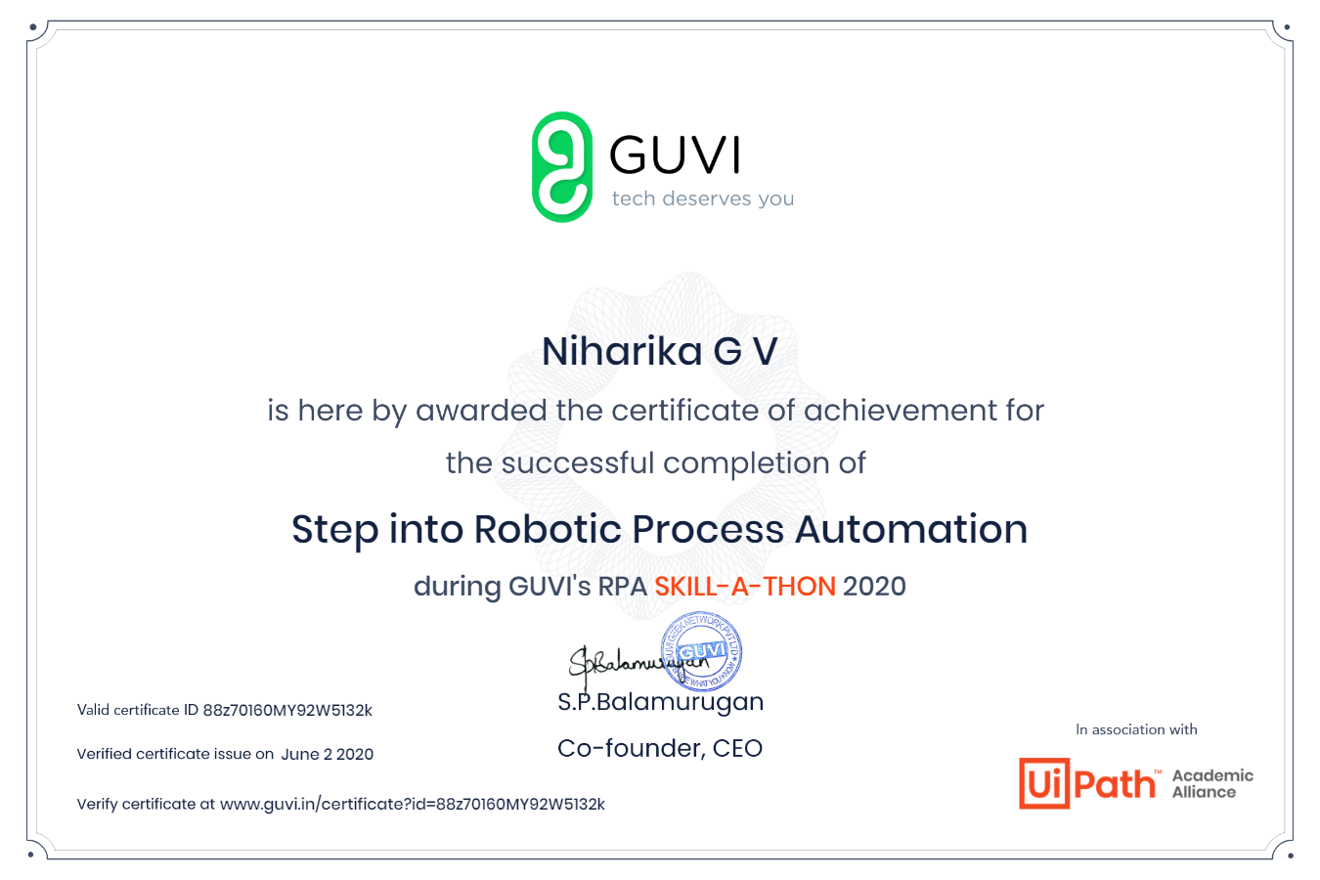

Coding

Bottom of Form

Top of Form

Bottom of Form

1)

ch = input("Enter a character: ")

if(ch=='A' or ch=='a' or ch=='E' or ch =='e' or ch=='I'

or ch=='i' or ch=='O' or ch=='o' or ch=='U' or ch=='u'):

print(ch, "is a Vowel")

else:

print(ch, "is a Consonant")