**DAILY ONLINE ACTIVITIES SUMMARY**

|  |  |  |  |  |  |  |  |
| --- | --- | --- | --- | --- | --- | --- | --- |
| **Date:** | **06/06/2020** | | | | **Name:** | **Niharika G V** | |
| **Sem & Sec** | **8th sem, A sec** | | | | **USN:** | **4AL16CS059** | |
| **Online Test Summary** | | | | | | | |
| **Subject** | | **IOT** | | | | | |
| **Max. Marks** | | **30** | | **Score** | | **30** | |
| **Certification Course Summary** | | | | | | | |
| **Course** | **Learn Ethical Hacking in 2020 : Beginner to Advanced** | | | | | | |
| **Certificate Provider** | | | **Udemy** | **Certificate Provider** | | | **Udemy** |
| **Coding Challenges** | | | | | | | |
| **Problem Statement: 1) C Program to swap two numbers without third variable.** | | | | | | | |
| **Status: Completed** | | | | | | | |
| **Uploaded the report in Github** | | | | **Yes** | | | |
| **If yes Repository name** | | | | **CODES (Namrathasonu)** | | | |
| **Uploaded the report in slack** | | | | **Yes** | | | |

Online Test Details:

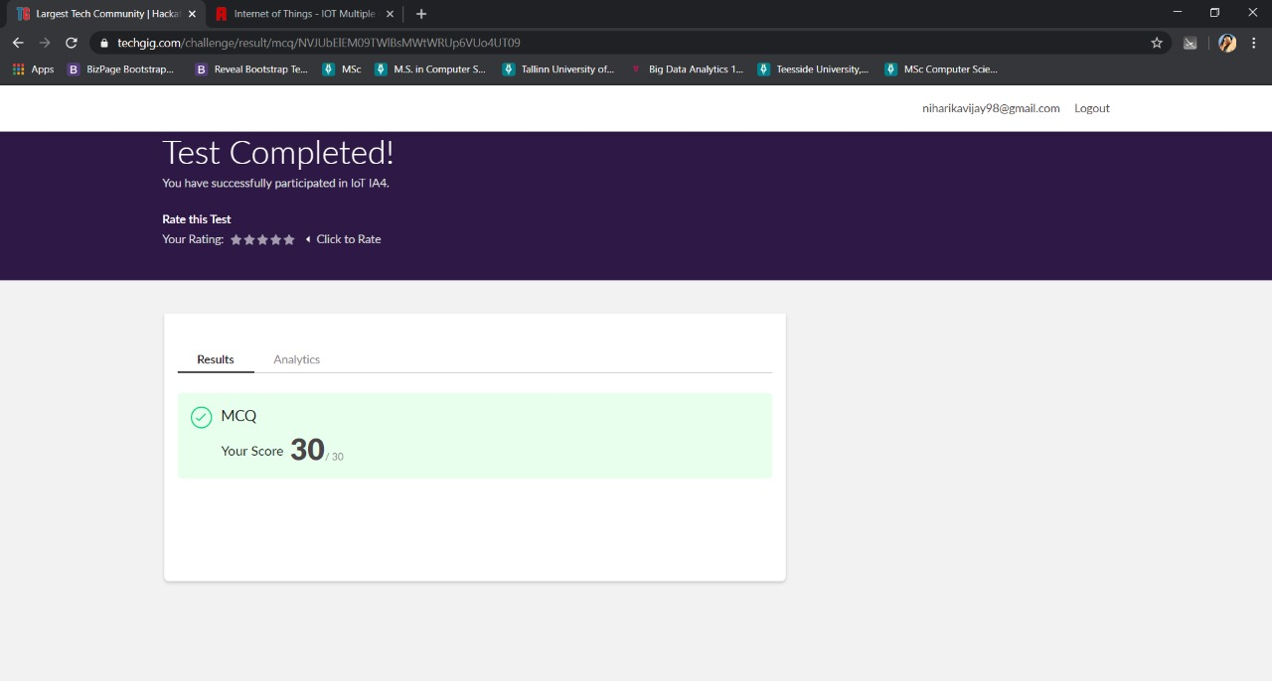

Certification Course Details:

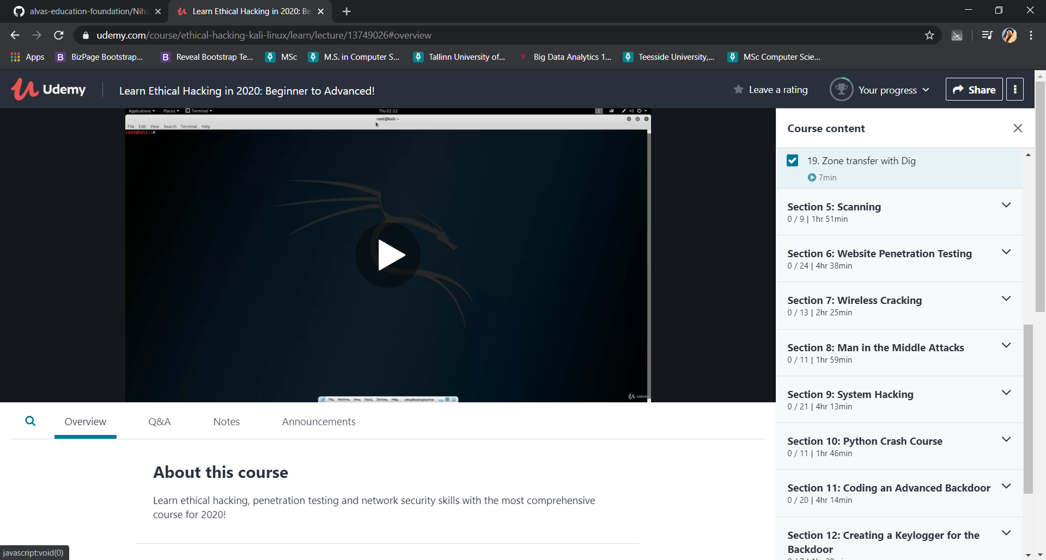

Coding Challenges Details:

1)

#include<stdio.h>

int main()

{

int a=10, b=20;

printf("Before swap a=%d b=%d",a,b);

a=a+b;//a=30 (10+20)

b=a-b;//b=10 (30-20)

a=a-b;//a=20 (30-10)

printf("\nAfter swap a=%d b=%d",a,b);

return 0;

}