**DAILY ONLINE ACTIVITIES SUMMARY**

|  |  |  |  |  |  |  |  |
| --- | --- | --- | --- | --- | --- | --- | --- |
| **Date:** | **07-06-2020** | | | | **Name:** | **Niharika G V** | |
| **Sem & Sec** | **8th sem, A sec** | | | | **USN:** | **4AL16CS059** | |
| **Online Test Summary** | | | | | | | |
| **Subject** | | **No Test Conducted** | | | | | |
| **Max. Marks** | |  | | **Score** | |  | |
| **Certification Course Summary** | | | | | | | |
| **Course** | **Learn Ethical Hacking in 2020 : Beginner to Advanced** | | | | | | |
| **Certificate Provider** | | | **Udemy** | **Duration** | | | **30hr** |
| **Coding Challenges** | | | | | | | |
| **Problem Statement: 1) Python program to display the Fibonacci sequence** | | | | | | | |
| **Status: Completed** | | | | | | | |
| **Uploaded the report in Github** | | | | **Yes** | | | |
| **If yes Repository name** | | | | **Daily progress** | | | |
| **Uploaded the report in slack** | | | | **Yes** | | | |

Online Test Details: **No Test Conducted**

Certification Course Details:

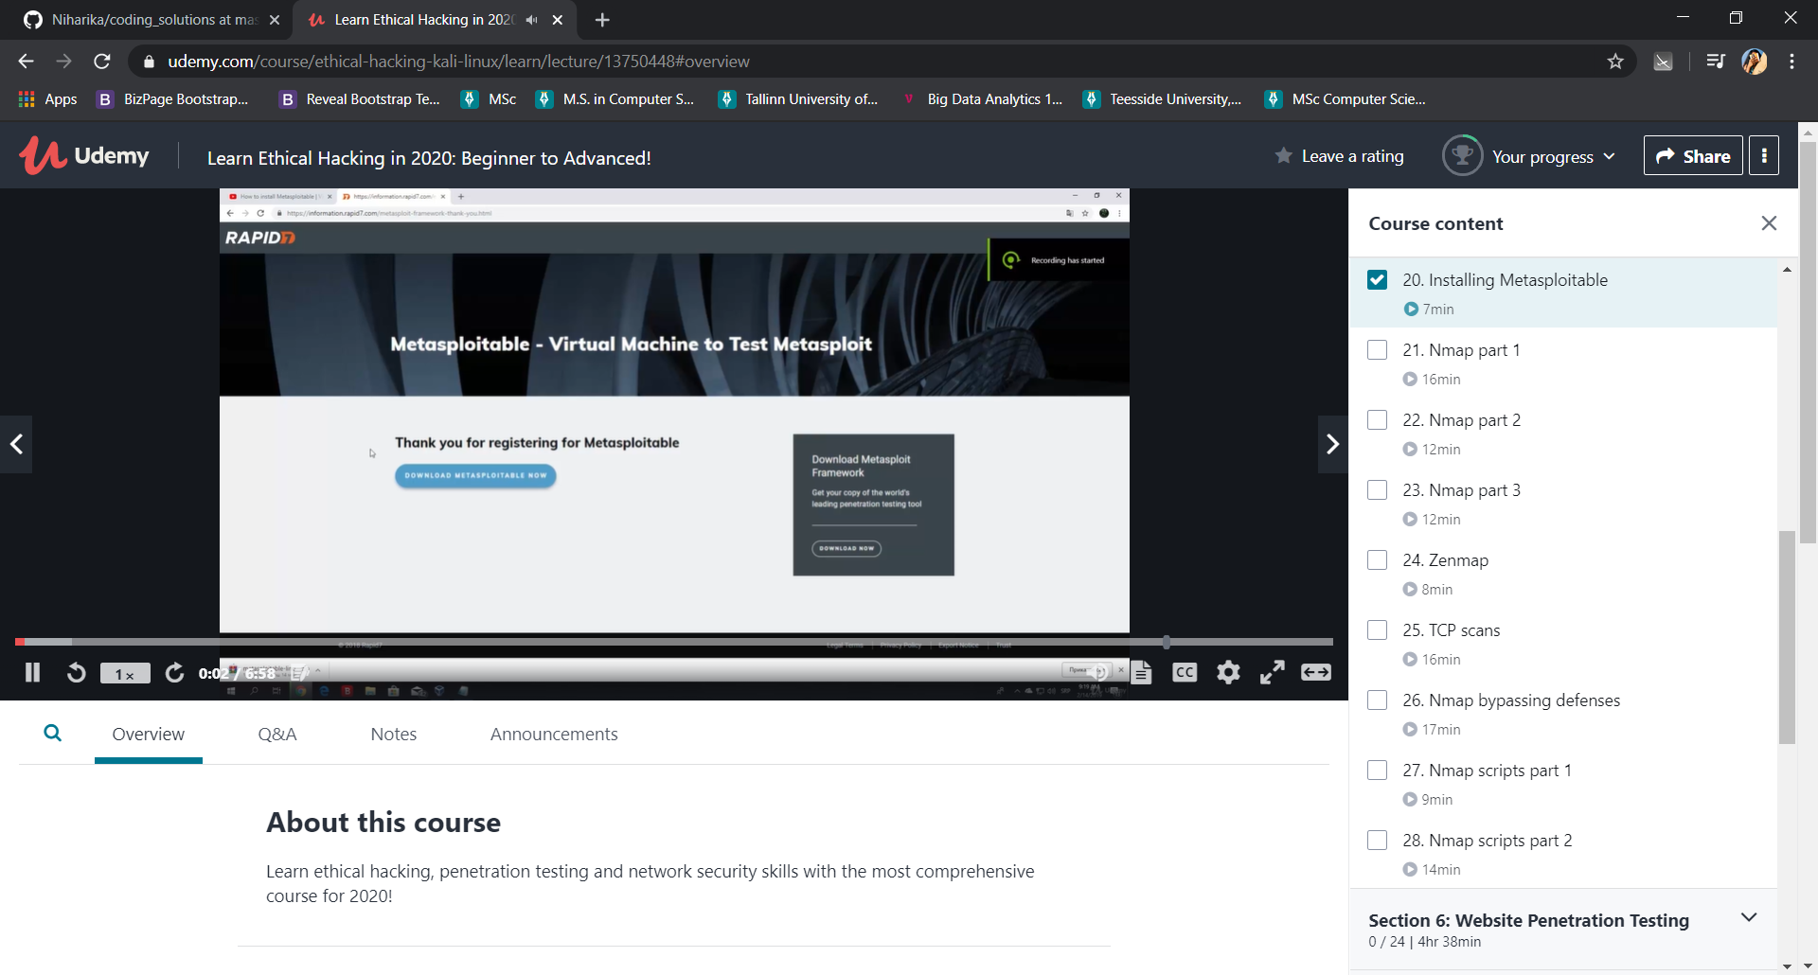

Coding Challenges Details:

1)

def recur_fibo(n):

if n <= 1:

return n

else:

return(recur_fibo(n-1) + recur_fibo(n-2))

nterms = 10

if nterms <= 0:

print("Plese enter a positive integer")

else:

print("Fibonacci sequence:")

for i in range(nterms):

print(recur_fibo(i))