**DAILY ONLINE ACTIVITIES SUMMARY**

|  |  |  |  |  |  |  |  |  |
| --- | --- | --- | --- | --- | --- | --- | --- | --- |
| **Date:** | **19-05-2020** | | | | | **Name:** | **Niharika G V** | |
| **Sem & Sec** | **8 A** | | | | | **USN:** | **4AL16CS059** | |
| **Online Test Summary** | | | | | | | | |
| **Subject** | | **IOT** | | | | | | |
| **Max. Marks** | | **60** | | **Score** | | | **57** | |
| **Certification Course Summary** | | | | | | | | |
| **Course** | **Introduction to Ethical Hacking** | | | | | | | |
| **Certificate Provider** | | | **Bright Learning** | | **Duration** | | | **254 min** |
| **Coding Challenges** | | | | | | | | |
| **Problem Statement:** | | | | | | | | |
| **Status:** | | | | | | | | |
| **Uploaded the report in Github** | | | | |  | | | |
| **If yes Repository name** | | | | |  | | | |
| **Uploaded the report in slack** | | | | |  | | | |

Online Test Details: (Attach the snapshot and briefly write the report for the same)

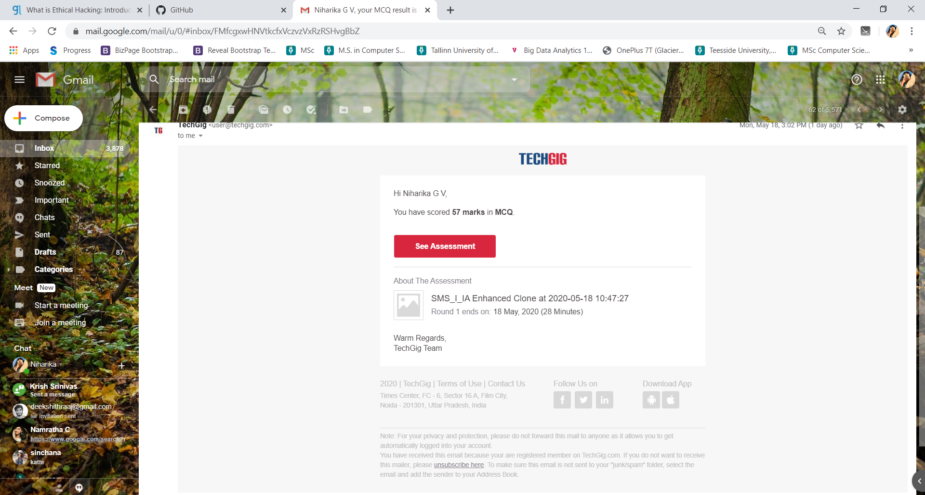

Certification Course Details: (Attach the snapshot and briefly write the report for the same)

Coding Challenges Details: (Attach the snapshot and briefly write the report for the same)

1) Using methods charAt() & length() of String class, write a program to print the

frequency of each character in a string.

“Hello friend”

Output should be

-: 1

d: 1

e: 2

f: 1

(continued for all character in the string)

package pk;

import java.util.Scanner;

public class StringOperators

{

public static void main(String args[])

{

int i;

String str;

int counter[] = new int[256];

Scanner in = new Scanner(System.in);

System.out.print("Enter a String : ");

str=in.nextLine();

for (i = 0; i < str.length(); i++) {

counter[(int) str.charAt(i)]++;

}

// Print Frequency of characters

for (i = 0; i < 256; i++) {

if (counter[i] != 0) {

System.out.println((char) i + ":-" + counter[i] + " times");

}

}

}

}

2) Write down a java program to print even and odd numbers series respectively

from two threads: t1 and t2 synchronizing on a shared object

Let t1 print message “ping — >” and t2 print message “,—-pong”.

Take as command line arguments, the following inputs to the program:

Sleep Interval for thread t1

Write down a java program to print even and odd numbers series respectively from two

threads: t1 and t2 synchronizing on a shared object

Let t1 print message “ping — >” and t2 print message “,—-pong”.

Take as command line arguments, the following inputs to the program:

Sleep Interval for thread t1

Sleep Interval for thread t2

Message per cycle

No of cycles

public class PingPong extends Thread {

static StringBuilder object = new StringBuilder("");

public static void main(String[] args) throws InterruptedException {

Thread t1 = new PingPong();

Thread t2 = new PingPong();

t1.setName("\nping");

t2.setName(" pong");

t1.start();

t2.start();

}

@override

public void run() {

working();

}

void working() {

while (true) {

synchronized (object) {

try {

System.out.print(Thread.currentThread().getName());

object.notify();

object.wait();

} catch (InterruptedException e) {

e.printStackTrace();

}

}

}

}

}