**DAILY ONLINE ACTIVITIES SUMMARY**

|  |  |  |  |  |  |  |  |  |
| --- | --- | --- | --- | --- | --- | --- | --- | --- |
| **Date:** | **19-05-2020** | | | | | **Name:** | **Niharika G V** | |
| **Sem & Sec** | **8 A** | | | | | **USN:** | **4AL16CS059** | |
| **Online Test Summary** | | | | | | | | |
| **Subject** | | **BDA** | | | | | | |
| **Max. Marks** | | **30** | | **Score** | | | **22** | |
| **Certification Course Summary** | | | | | | | | |
| **Course** | **Introduction to Ethical Hacking** | | | | | | | |
| **Certificate Provider** | | | **Bright Learning** | | **Duration** | | | **254 min** |
| **Coding Challenges** | | | | | | | | |
| **Problem Statement: 1. To check if the 2 strings are anagrams**  **2. Java program** | | | | | | | | |
| **Status: solved** | | | | | | | | |
| **Uploaded the report in Github** | | | | | **Yes** | | | |
| **If yes Repository name** | | | | | **Coding daily progress** | | | |
| **Uploaded the report in slack** | | | | | **Yes** | | | |

Online Test Details: (Attach the snapshot and briefly write the report for the same)

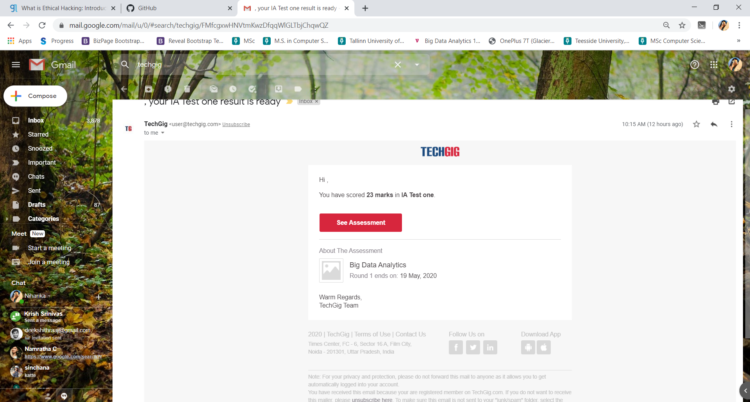

Certification Course Details: (Attach the snapshot and briefly write the report for the same)



Continuation if previous day’s course.   
Discusses about the various tools that are used for ethical hacking along with the explanation of what exactly they do and how they work. Some of the tools, for example are NMAP, Metasploit, Burpsuite,Sqlmap,Ettercap.

Also discussed about the steps in ethical hacking

1. Reconnaissance
2. scanning
3. Gaining Access
4. Maintaining access
5. Clearing track
6. reporting

All discussed in detail with an example of a bank robbery.

Also a demonstration was given following the above steps with explanation.

Coding Challenges Details: (Attach the snapshot and briefly write the report for the same)

program1:  
package shortestpalindromeexample.java;  
import java.util.Scanner;

public class ShortestPalindromeDemo {

public static String shortestPalindrome(String str) {

int x=0;  
int y=str.length()-1;

while(y>=0){  
if(str.charAt(x)==str.charAt(y)){  
x++;  
}  
y--;  
}

if(x==str.length())  
return str;

String suffix = str.substring(x);  
String prefix = new StringBuilder(suffix).reverse().toString();  
String mid = shortestPalindrome(str.substring(0, x));

return prefix+mid+suffix;  
}

public static void main(String[] args) {

Scanner in = new Scanner(System.in);

System.out.println("Enter a String to find out shortest palindrome");

String str=in.nextLine();

System.out.println("Shortest palindrome of "+str+" is "+shortestPalindrome(str));

}

program 2  
import java.util.Stack;

class Node {  
int data;  
Node next;

Node(int i)

{

this.data = i;

this.next = null;

}

};

class Main  
{  
public static boolean isPalindrome(Node head)  
{  
// construct an empty stack  
Stack s = new Stack<>();  
Node node = head;  
while (node != null) {  
s.push(node.data);  
node = node.next;  
}

node = head;

while (node != null)

{

int top = s.pop();

if (top != node.data) {

return false;

}

node = node.next;

}

return true;

}

public static void main(String[] args)

{

Node head = new Node(1);

head.next = new Node(2);

head.next.next = new Node(3);

head.next.next.next = new Node(2);

head.next.next.next.next = new Node(1);

if (isPalindrome(head)) {

System.out.print("Linked List is a palindrome.");

} else {

System.out.print("Linked List is not a palindrome.");

}

}

}