**DAILY ONLINE ACTIVITIES SUMMARY**

|  |  |  |  |  |  |  |  |  |
| --- | --- | --- | --- | --- | --- | --- | --- | --- |
| **Date:** | **26-05-2020** | | | | | **Name:** | **Niharika G V** | |
| **Sem & Sec** | **8 A** | | | | | **USN:** | **4AL16CS059** | |
| **Online Test Summary** | | | | | | | | |
| **Subject** | | **BDA** | | | | | | |
| **Max. Marks** | | **40** | | **Score** | | | **30** | |
| **Certification Course Summary** | | | | | | | | |
| **Course** | **Introduction to Ethical Hacking** | | | | | | | |
| **Certificate Provider** | | | **Great Learning** | | **Duration** | | | **254 min** |
| **Coding Challenges** | | | | | | | | |
| **Problem Statement: 1) Python program to find sum of the array.**  **2) Python program to swap elements at given positions.** | | | | | | | | |
| **Status: solved** | | | | | | | | |
| **Uploaded the report in Github** | | | | | **Yes** | | | |
| **If yes Repository name** | | | | | **Coding daily progress** | | | |
| **Uploaded the report in slack** | | | | | **Yes** | | | |

Online Test Details: (Attach the snapshot and briefly write the report for the same)

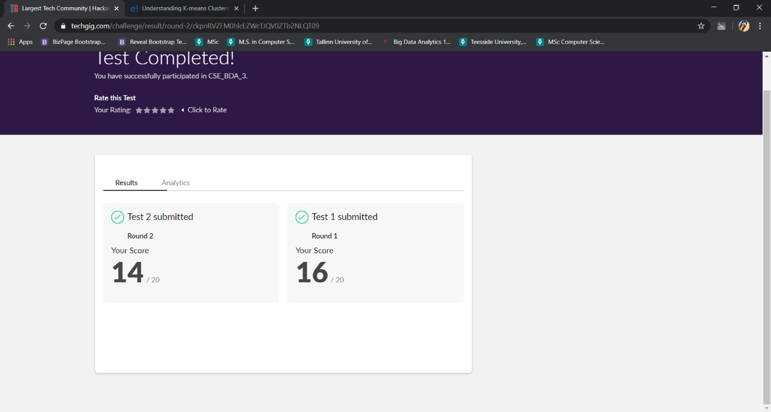

Certification Course Details: (Attach the snapshot and briefly write the report for the same)

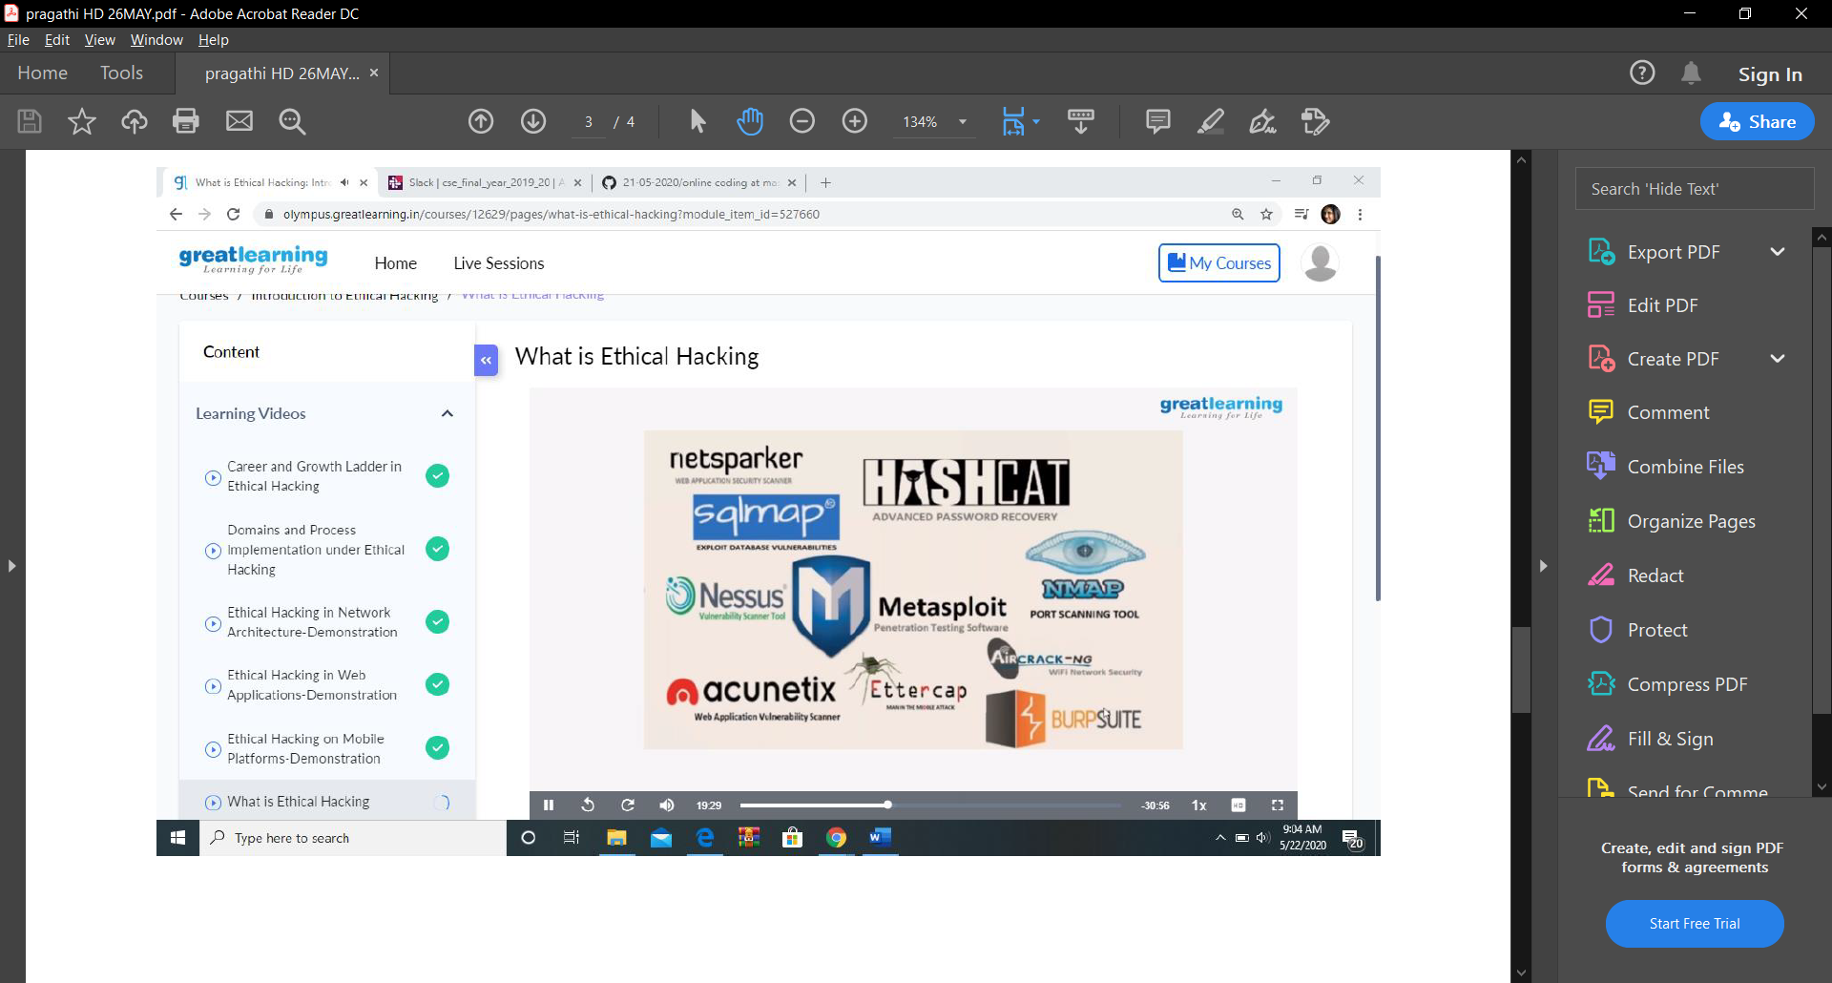

Discusses about the various tools that are used for ethical hacking along with the explanation of what exactly they do and how they work. Some of the tools, for example are NMAP, Metasploit, Burpsuite,Sqlmap,Ettercap.

Also discussed about the steps in ethical hacking

1. Reconnaissance
2. scanning
3. Gaining Access
4. Maintaining access
5. Clearing track
6. reporting

All discussed in detail with an example of a bank robbery.

Also a demonstration was given following the above steps with explanation.

Coding Challenges Details: (Attach the snapshot and briefly write the report for the same)

1) def _sum(arr,n):

return(sum(arr))

arr=[]

arr = [12, 3, 4, 15]

n = len(arr)

ans = _sum(arr,n)

print ('Sum of the array is ', ans)

2) def swapPositions(list, pos1, pos2):

list[pos1], list[pos2] = list[pos2], list[pos1]

return list

List = [23, 65, 19, 90]

pos1, pos2 = 1, 3

print(swapPositions(List, pos1-1, pos2-1))