**DAILY ONLINE ACTIVITIES SUMMARY**

|  |  |  |  |  |  |  |  |
| --- | --- | --- | --- | --- | --- | --- | --- |
| **Date:** | **27/05/20** | | | | **Name:** | **Niharika G V** | |
| **Sem & Sec** | **8th sem, A sec** | | | | **USN:** | **4AL16CS059** | |
| **Online Test Summary** | | | | | | | |
| **Subject** | | **Iot** | | | | | |
| **Max. Marks** | | **30** | | **Score** | | **28** | |
| **Certification Course Summary** | | | | | | | |
| **Course** | **Introduction to Ethical Hacking** | | | | | | |
| **Certificate Provider** | | | **Great Learning** | **Duration** | | | **254 mins** |
| **Coding Challenges** | | | | | | | |
| **Problem Statement: 1) Program to check palindrome.**  **.** | | | | | | | |
| **Status: Completed** | | | | | | | |
| **Uploaded the report in Github** | | | | **Yes** | | | |
| **If yes Repository name** | | | | **Daily Progress reports** | | | |
| **Uploaded the report in slack** | | | | **Yes** | | | |

Online Test Details:

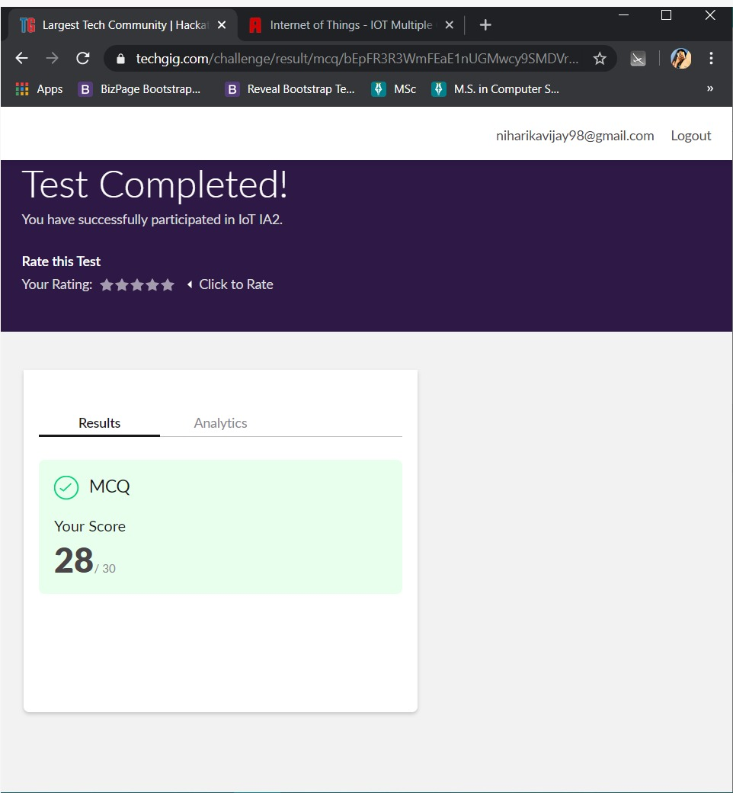

The test was on the subject Internet of Things.

Certification Course Details: **COMPLETED**

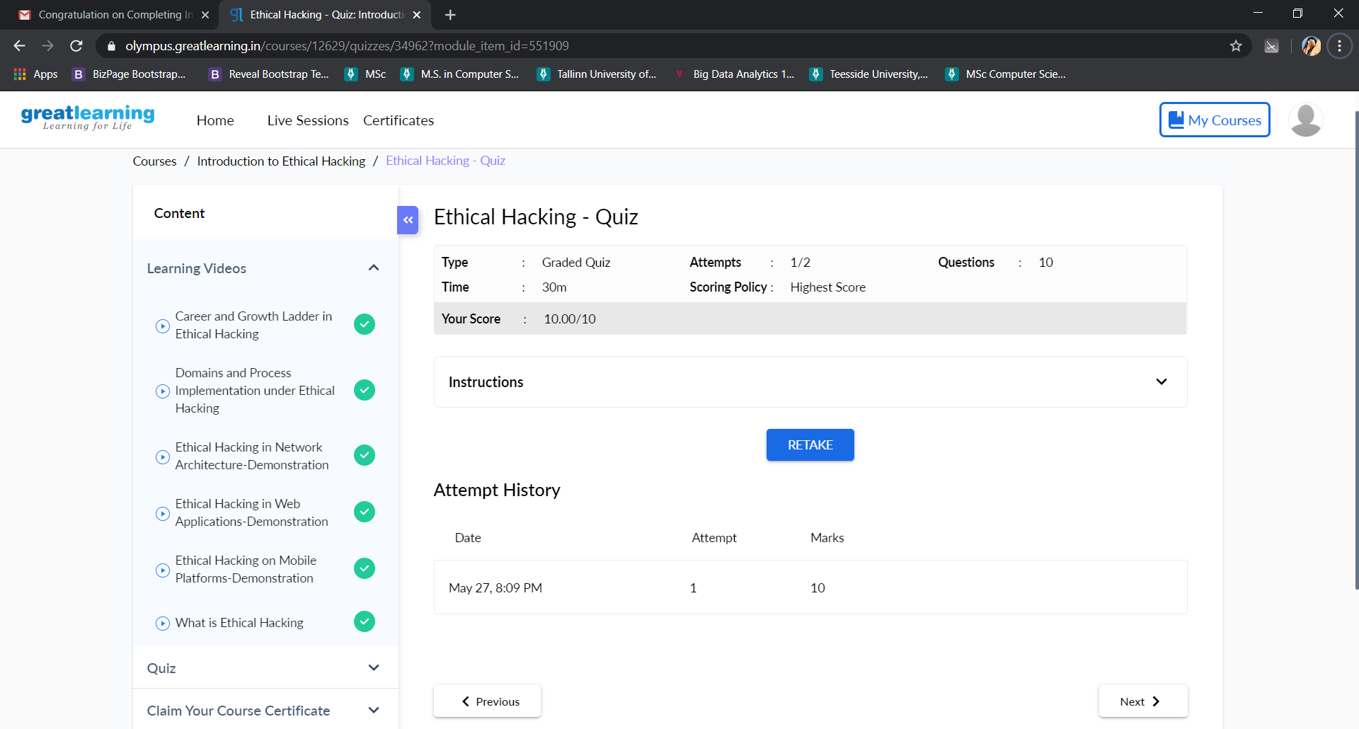

Coding Challenges Details:

1)

#include <stdio.h>

int main() {

int n, reversedN = 0, remainder, originalN;

printf("Enter an integer: ");

scanf("%d", &n);

originalN = n;

while (n != 0) {

remainder = n % 10;

reversedN = reversedN * 10 + remainder;

n /= 10;

}

if (originalN == reversedN)

printf("%d is a palindrome.", originalN);

else

printf("%d is not a palindrome.", originalN);

return 0;

}