**DAILY ONLINE ACTIVITIES SUMMARY**

|  |  |  |  |  |  |  |  |  |
| --- | --- | --- | --- | --- | --- | --- | --- | --- |
| **Date:** | **29-05-2020** | | | | | **Name:** | **Niharika G V** | |
| **Sem & Sec** | **8 sem , A sec** | | | | | **USN:** | **4al16cs059** | |
| **Online Test Summary** | | | | | | | | |
| **Subject** | | **BDA** | | | | | | |
| **Max. Marks** | | **30** | | **Score** | | | **25** | |
| **Certification Course Summary** | | | | | | | | |
| **Course** | **Introduction to Ethical Hacking** | | | | | | | |
| **Certificate Provider** | | | **Great Learning** | | **Duration** | | | **254min** |
| **Coding Challenges** | | | | | | | | |
| **Problem Statement: Python3 program to rotate an array by d elements.** | | | | | | | | |
| **Status: Completed** | | | | | | | | |
| **Uploaded the report in Github** | | | | | **yes** | | | |
| **If yes Repository name** | | | | | **Daily progress Reports** | | | |
| **Uploaded the report in slack** | | | | | **yes** | | | |

Online Test Details: (Attach the snapshot and briefly write the report for the same)

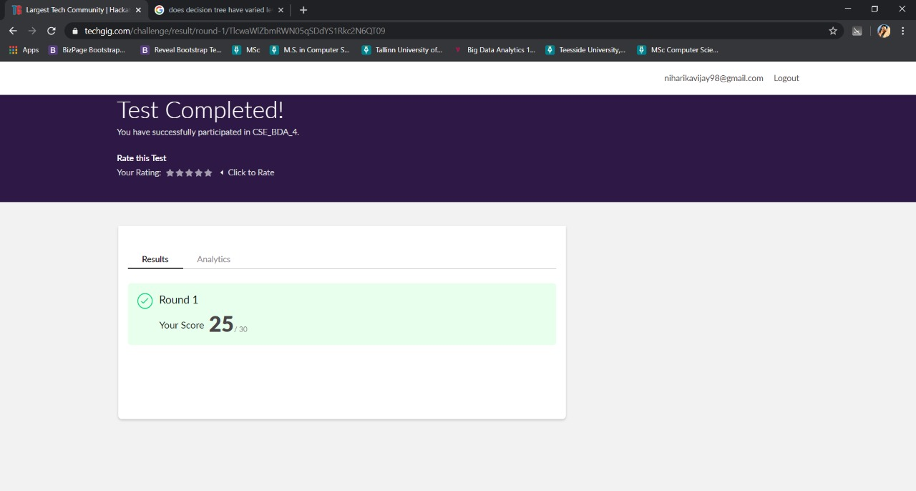

Certification Course Details: (Attach the snapshot and briefly write the report for the same)

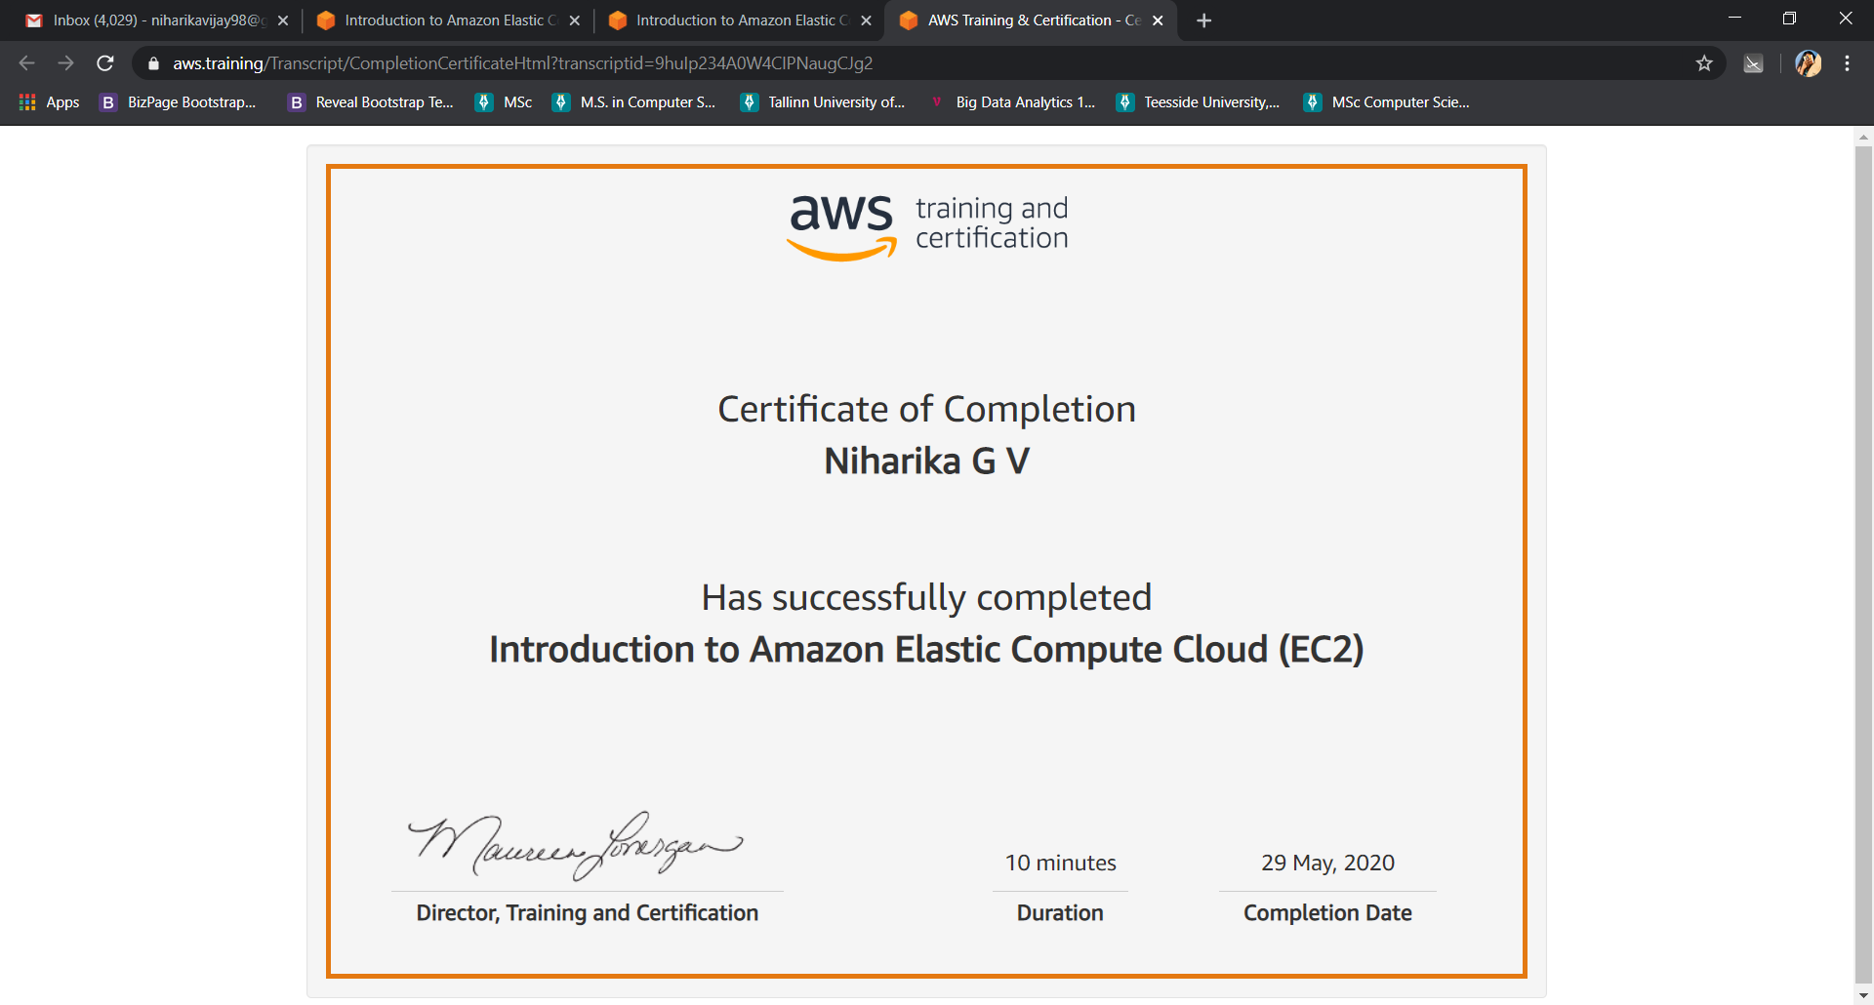

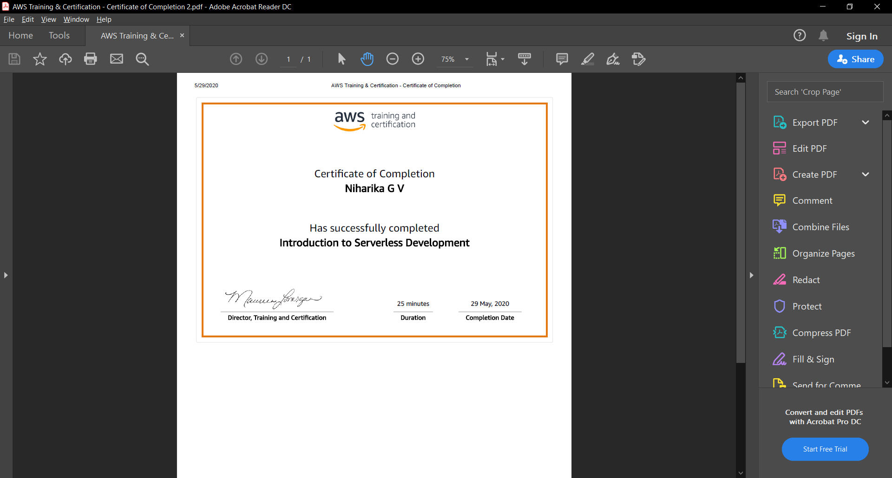

Coding Challenges Details: (Attach the snapshot and briefly write the report for the same)

Program 🡪Write a function rotate(ar[ ], d, n) that rotates arr[ ] of size n by d elements.

def leftRotate(arr, d, n):

    for i in range(d):

        leftRotatebyOne(arr, n)

def leftRotatebyOne(arr, n):

    temp = arr[0]

    for i in range(n-1):

        arr[i] = arr[i + 1]

    arr[n-1] = temp

def printArray(arr, size):

    for i in range(size):

        print ("% d"% arr[i], end =" ")

arr = [1, 2, 3, 4, 5, 6, 7]

leftRotate(arr, 2, 7)

printArray(arr, 7)

output:

[3,4,5,6,7,1,2]