**DAILY ONLINE ACTIVITIES SUMMARY**

|  |  |  |  |  |  |  |  |  |
| --- | --- | --- | --- | --- | --- | --- | --- | --- |
| **Date:** | **31-05-2020** | | | | | **Name:** | **Niharika G V** | |
| **Sem & Sec** | **8 sem , A sec** | | | | | **USN:** | **4al16cs059** | |
| **Online Test Summary** | | | | | | | | |
| **Subject** | | **IOT** | | | | | | |
| **Max. Marks** | | **20** | | **Score** | | | **18** | |
| **Certification Course Summary** | | | | | | | | |
| **Course** | **Learn Ethical Hacking in 2020 : Beginner to Advanced** | | | | | | | |
| **Certificate Provider** | | | **Udemy** | | **Duration** | | | **30 Hr** |
| **Coding Challenges** | | | | | | | | |
| **Problem Statement:** Micro and Array Update Problem. | | | | | | | | |
| **Status: Completed** | | | | | | | | |
| **Uploaded the report in Github** | | | | | **yes** | | | |
| **If yes Repository name** | | | | | **Daily progress Reports** | | | |
| **Uploaded the report in slack** | | | | | **yes** | | | |

Online Test Details: (Attach the snapshot and briefly write the report for the same)

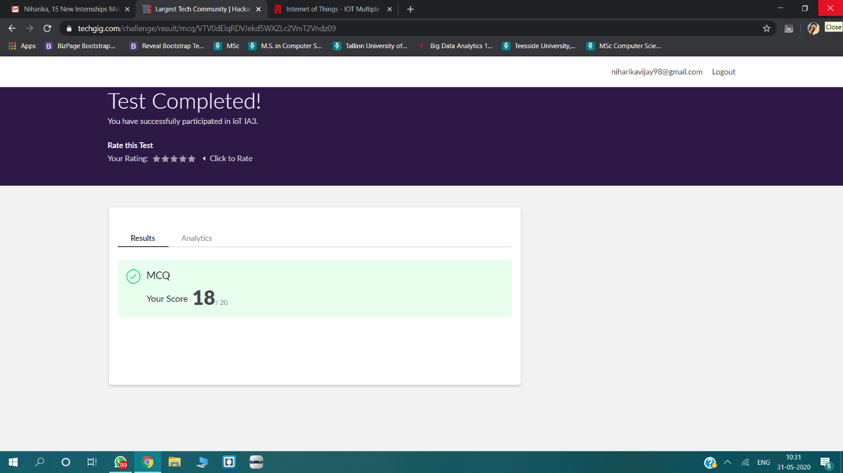

Certification Course Details: (Attach the snapshot and briefly write the report for the same)



Coding Challenges Details: (Attach the snapshot and briefly write the report for the same)

Micro purchased an array *A* having *N* integer values. After playing it for a while, he got bored of it and decided to update value of its element. In one second he can increase value of each array element by *1*. He wants each array element's value to become greater than or equal to *K*. Please help Micro to find out the minimum amount of time it will take, for him to do so.  
**Input:**  
First line consists of a single integer, *T*, denoting the number of test cases.  
First line of each test case consists of two space separated integers denoting *N* and *K*.  
Second line of each test case consists of *N* space separated integers denoting the array *A*.  
**Output:**  
For each test case, print the minimum time in which all array elements will become greater than or equal to *K*. Print a new line after each test case.  
**Constraints:**  
1≤T≤5  
1≤N≤105  
1≤A[i],K≤106

#include<stdio.h>  
int main()  
{  
    int t,n,i,min=10000000000,k;  
    scanf("%d",&t);  
    while(t--)  
    {  
     min=10000000000;  
     scanf("%d%d",&n,&k);  
     int a[n];  
     for(i=0;i<n;i++)  
     {  
      scanf("%d",&a[i]);  
      if(a[i]<min)  
       min=a[i];  
     }  
     //printf("%d ",min);  
     if(min>=k)  
      printf("0\n");  
     else  
      printf("%d\n",k-min);  
    }  
    return 0;  
  
}