**AILY ONLINE ACTIVITIES SUMMARY**

|  |  |  |  |  |  |  |  |  |
| --- | --- | --- | --- | --- | --- | --- | --- | --- |
| **Date:** | **29-05-2020** | | | | | **Name:** | **P Vighnesh Pejathaya** | |
| **Sem & Sec** | **8 sem , A sec** | | | | | **USN:** | **4al16cs060** | |
| **Online Test Summary** | | | | | | | | |
| **Subject** | | **BDA** | | | | | | |
| **Max. Marks** | | **30** | | **Score** | | | **24** | |
| **Certification Course Summary** | | | | | | | | |
| **Course** | **Angular &NodeJS (Part -3)** | | | | | | | |
| **Certificate Provider** | | | **Udemy** | | **Duration** | | | **80 min** |
| **Coding Challenges** | | | | | | | | |
| **Problem Statement: Pink Floyd and Happiness Program in Python.** | | | | | | | | |
| **Status: Completed** | | | | | | | | |
| **Uploaded the report in Github** | | | | | **yes** | | | |
| **If yes Repository name** | | | | | **Alvas-education-foundation/p_vighnesh** | | | |
| **Uploaded the report in slack** | | | | | **yes** | | | |

Online Test Details: (Attach the snapshot and briefly write the report for the same)

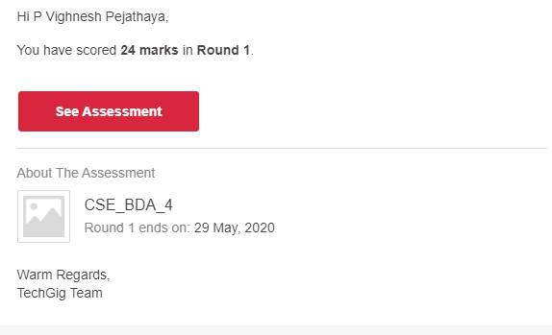

Certification Course Details: (Attach the snapshot and briefly write the report for the same)

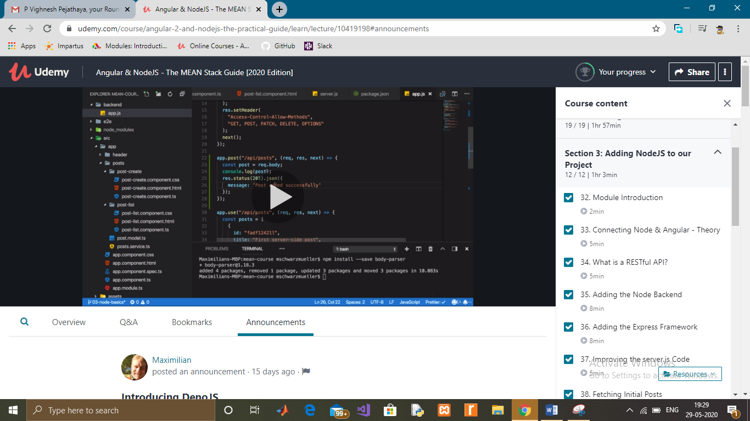

Coding Challenges Details: (Attach the snapshot and briefly write the report for the same)

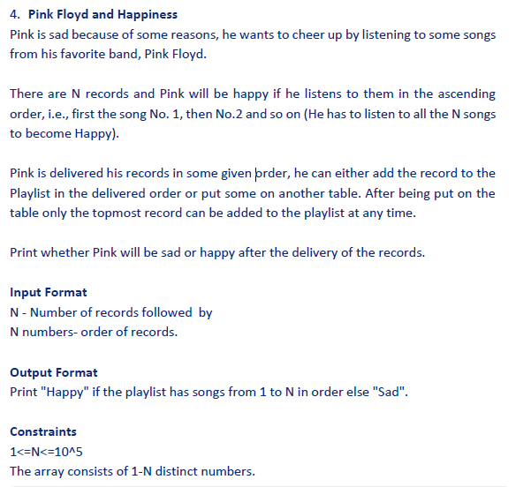

Program:

|  |  |  |  |  |  |  |  |  |  |  |  |  |  |  |  |  |  |  |  |  |  |  |
| --- | --- | --- | --- | --- | --- | --- | --- | --- | --- | --- | --- | --- | --- | --- | --- | --- | --- | --- | --- | --- | --- | --- |
| |  |  | | --- | --- | | l=list() s=list() |  | | n=int(input()) |  | | for i in range(0,n): |  | | m=int(input()) |  | | l.append(m) |  | | s.append(i+1) |  | | l.sort() |  | | if l==s: |  | | print("happy") |  | | else: |  | | print("sad") |  | |