**DAILY ONLINE ACTIVITIES SUMMARY**

|  |  |  |  |  |  |  |  |  |
| --- | --- | --- | --- | --- | --- | --- | --- | --- |
| **Date:** | **02-06-2020** | | | | | **Name:** | **P Vighnesh Pejathaya** | |
| **Sem & Sec** | **8 sem , A sec** | | | | | **USN:** | **4al16cs060** | |
| **Online Test Summary** | | | | | | | | |
| **Subject** | | **N/A** | | | | | | |
| **Max. Marks** | |  | | **Score** | | |  | |
| **Certification Course Summary** | | | | | | | | |
| **Course** | **Amazon DynamoDB** | | | | | | | |
| **Certificate Provider** | | | **AWS** | | **Duration** | | | **150min** |
| **Coding Challenges** | | | | | | | | |
| **Problem Statement: Pink Floyd and Happiness Program in Python.** | | | | | | | | |
| **Status: Completed** | | | | | | | | |
| **Uploaded the report in Github** | | | | | **yes** | | | |
| **If yes Repository name** | | | | | **Alvas-education-foundation/p_vighnesh** | | | |
| **Uploaded the report in slack** | | | | | **yes** | | | |

Online Test Details: (Attach the snapshot and briefly write the report for the same)

NOT Conducted.

Certification Course Details: (Attach the snapshot and briefly write the report for the same)

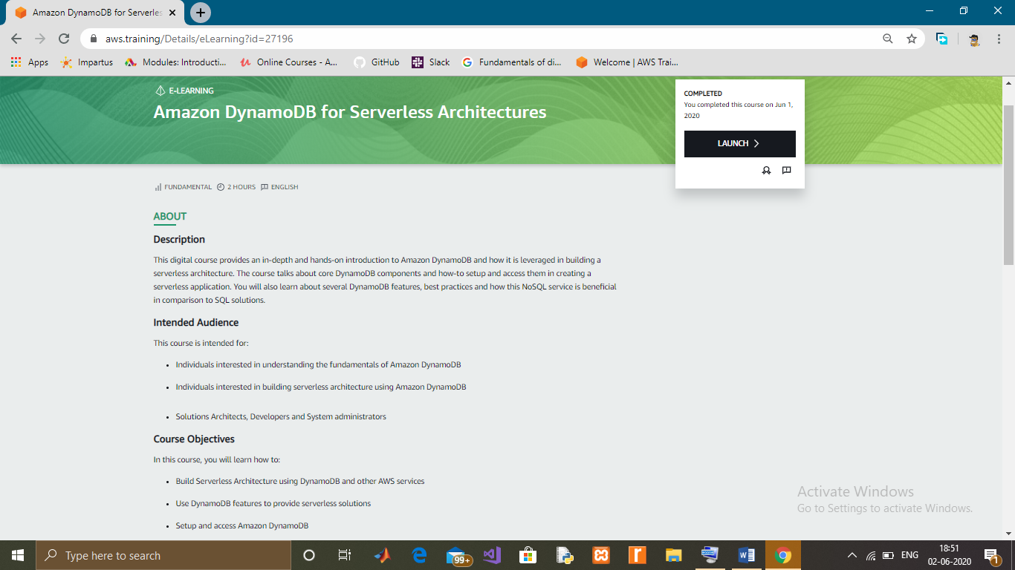

Coding Challenges Details: (Attach the snapshot and briefly write the report for the same)

Inversion Count for an array indicates – how far (or close) the array is from being sorted. If array is already sorted then inversion count is 0. If array is sorted in reverse order that inversion count is the maximum.  
Formally speaking, two elements a[i] and a[j] form an inversion if a[i] > a[j] and i < j.

**Example:**  
The sequence 2, 4, 1, 3, 5 has three inversions (2, 1), (4, 1), (4, 3).

Constraints:

1 ≤ T ≤ 100,

1 ≤ N ≤ 107,

1 ≤ C ≤ 1018

Example:

Input:

1

5

2 4 1 3 5

Output:

3