**DAILY ONLINE ACTIVITIES SUMMARY**

|  |  |  |  |  |  |  |  |  |
| --- | --- | --- | --- | --- | --- | --- | --- | --- |
| **Date:** | **03-06-2020** | | | | | **Name:** | **P Vighnesh Pejathaya** | |
| **Sem & Sec** | **8 sem , A sec** | | | | | **USN:** | **4al16cs060** | |
| **Online Test Summary** | | | | | | | | |
| **Subject** | | **N/A** | | | | | | |
| **Max. Marks** | |  | | **Score** | | |  | |
| **Certification Course Summary** | | | | | | | | |
| **Course** | **Angular &NodeJS (Part -5)** | | | | | | | |
| **Certificate Provider** | | | **Udemy** | | **Duration** | | | **80 min** |
| **Coding Challenges** | | | | | | | | |
| **Problem Statement:** Program to find the leaders in the array**.** | | | | | | | | |
| **Status: Completed** | | | | | | | | |
| **Uploaded the report in Github** | | | | | **yes** | | | |
| **If yes Repository name** | | | | | **Alvas-education-foundation/p_vighnesh** | | | |
| **Uploaded the report in slack** | | | | | **yes** | | | |

Online Test Details: (Attach the snapshot and briefly write the report for the same)

Not Conducted.

Certification Course Details: (Attach the snapshot and briefly write the report for the same)

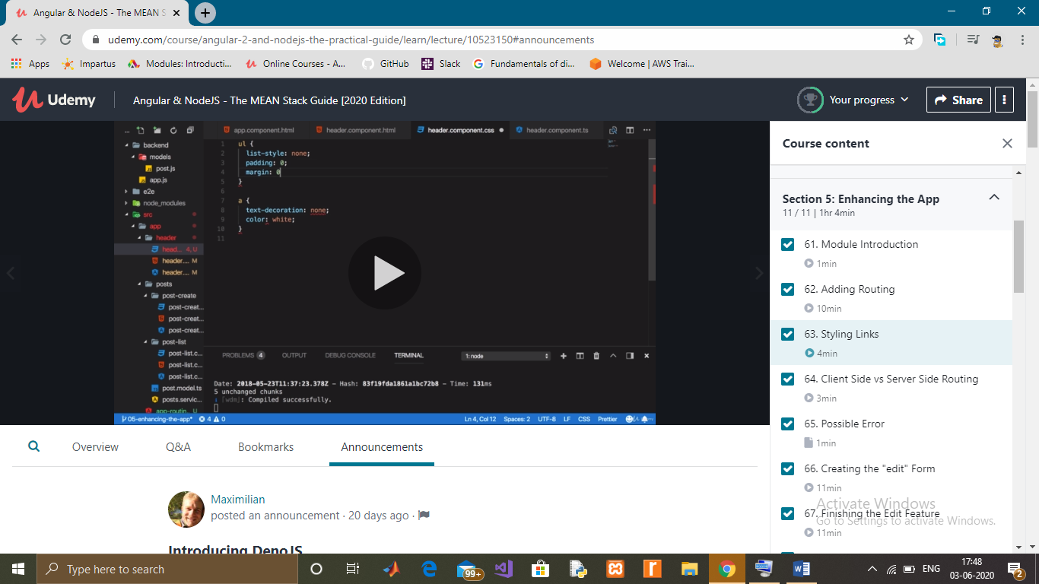

Coding Challenges Details: (Attach the snapshot and briefly write the report for the same)

Write a java program to print all the LEADERS in the array. An element is leader if it is greater than all the elements to its right side. And the rightmost element is always a leader.

For example int the array {16, 17, 4, 3, 5, 2}, leaders are 17, 5 and 2.

Output:

17 5 2

Time Complexity: O(n*n)