**DAILY ONLINE ACTIVITIES SUMMARY**

|  |  |  |  |  |  |  |  |  |
| --- | --- | --- | --- | --- | --- | --- | --- | --- |
| **Date:** | **04-06-2020** | | | | | **Name:** | **P Vighnesh Pejathaya** | |
| **Sem & Sec** | **8 sem , A sec** | | | | | **USN:** | **4AL16CS060** | |
| **Online Test Summary** | | | | | | | | |
| **Subject** | | **SNS** | | | | | | |
| **Max. Marks** | | **60** | | **Score** | | | **45** | |
| **Certification Course Summary** | | | | | | | | |
| **Course** | **Angular &NodeJS (Part -6)** | | | | | | | |
| **Certificate Provider** | | | **Udemy** | | **Duration** | | | **80 min** |
| **Coding Challenges** | | | | | | | | |
| Problem Statement: Java Program for Selection Sorting. | | | | | | | | |
| **Status: Completed** | | | | | | | | |
| **Uploaded the report in Github** | | | | | **yes** | | | |
| **If yes Repository name** | | | | | **Alvas-education-foundation/p_vighnesh** | | | |
| **Uploaded the report in slack** | | | | | **yes** | | | |

Online Test Details: (Attach the snapshot and briefly write the report for the same)

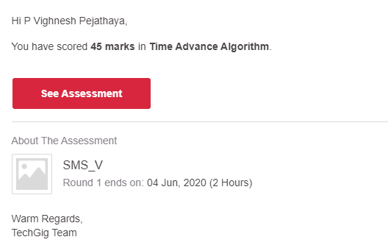

Certification Course Details: (Attach the snapshot and briefly write the report for the same)

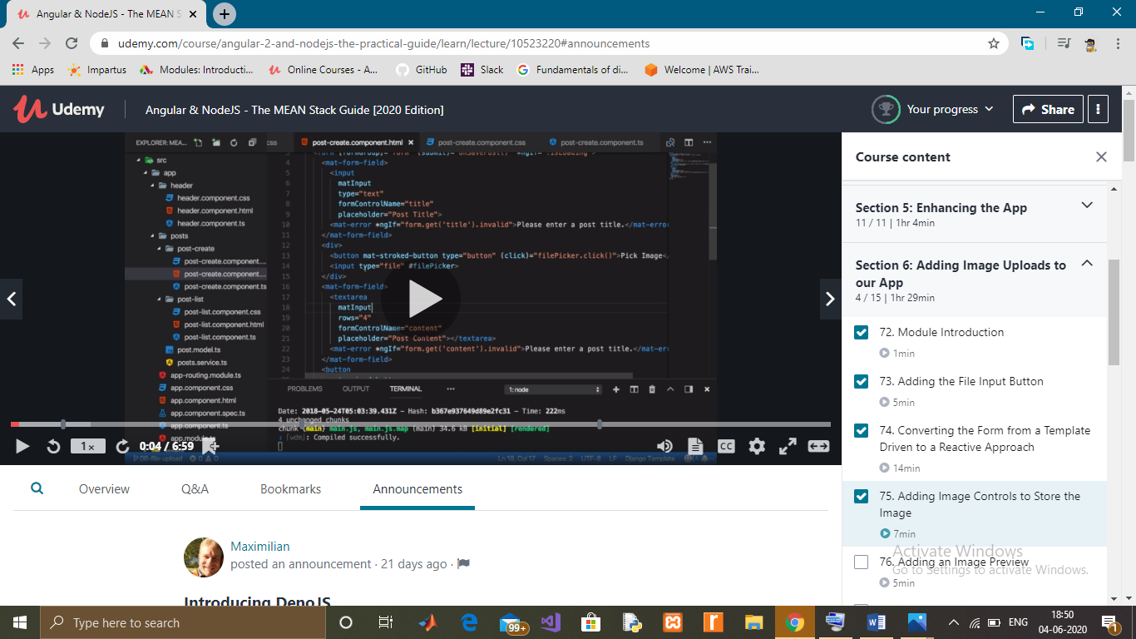

Coding Challenges Details: (Attach the snapshot and briefly write the report for the same)

**Selection sort algorithm** works by dividing the original array in two subarrays: Sorted subarray and unsorted subarray, initially the sorted subarray is empty. This algorithm works by repeatedly finding the minimum element from the unsorted subarray and replacing it with the first element of the array, thus making that part of the array as sorted subarray. This happens repeatedly until the whole array is sorted.

The algorithm maintains two subarrays in a given array.

1) The subarray which is already sorted.  
2) Remaining subarray which is unsorted.

In every iteration of selection sort, the minimum element (considering ascending order) from the unsorted subarray is picked and moved to the sorted subarray.