**DAILY ONLINE ACTIVITIES SUMMARY**

|  |  |  |  |  |  |  |  |  |
| --- | --- | --- | --- | --- | --- | --- | --- | --- |
| **Date:** | **05-06-2020** | | | | | **Name:** | **P Vighnesh Pejathaya** | |
| **Sem & Sec** | **8 sem , A sec** | | | | | **USN:** | **4al16cs060** | |
| **Online Test Summary** | | | | | | | | |
| **Subject** | | **BDA** | | | | | | |
| **Max. Marks** | | **30** | | **Score** | | | **11** | |
| **Certification Course Summary** | | | | | | | | |
| **Course** | **Web development with flask** | | | | | | | |
| **Certificate Provider** | | | **TCS-Linkedin** | | **Duration** | | | **120 min** |
| **Coding Challenges** | | | | | | | | |
| Problem Statement: Program to get current working directory in Java. | | | | | | | | |
| **Status: Completed** | | | | | | | | |
| **Uploaded the report in Github** | | | | | **yes** | | | |
| **If yes Repository name** | | | | | **Alvas-education-foundation/p_vighnesh** | | | |
| **Uploaded the report in slack** | | | | | **yes** | | | |

Online Test Details: (Attach the snapshot and briefly write the report for the same)

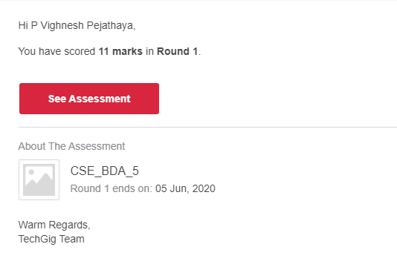

Certification Course Details: (Attach the snapshot and briefly write the report for the same)

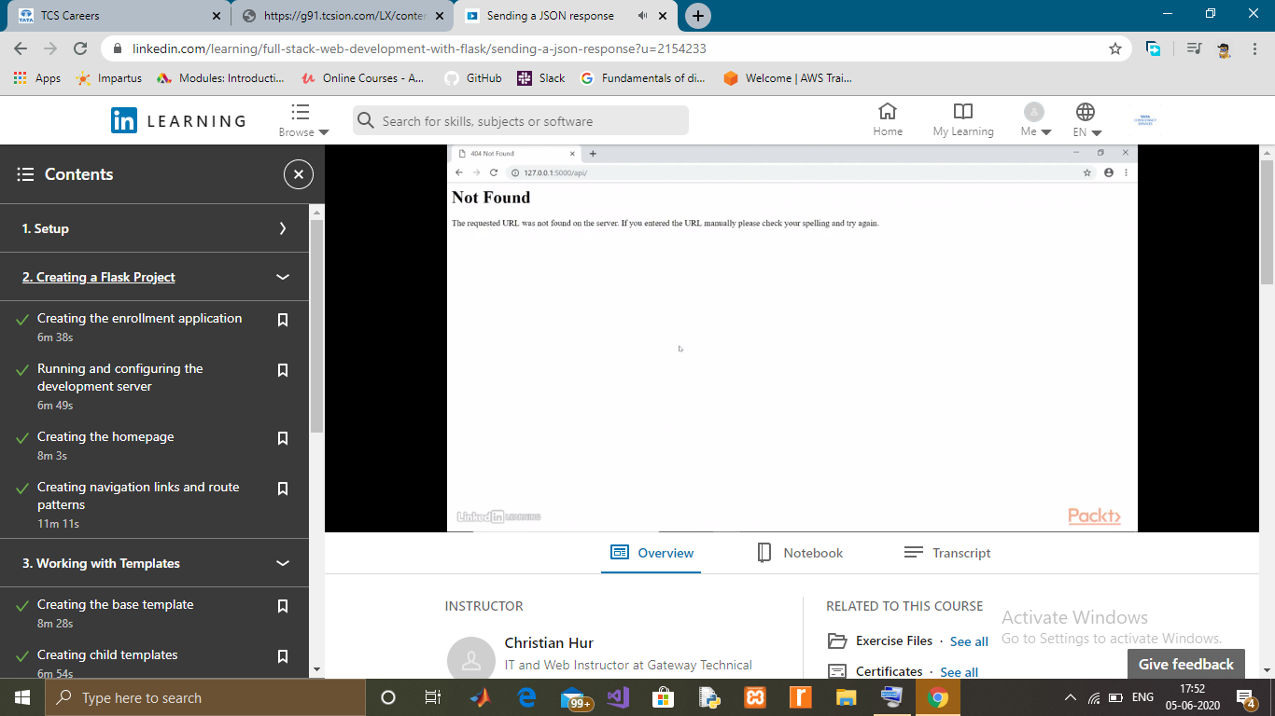

Coding Challenges Details: (Attach the snapshot and briefly write the report for the same)

Java Program to Get Current Working DirectoryIn this program, you'll learn to get the current working directory in Java. When you run the program, the output will be: example

Working Directory = C:\Users\Admin\Desktop\currDir

In the above program, we used System's getProperty() method to get the user.dir property of the program. This returns the directory which contains our Java project.