**DAILY ONLINE ACTIVITIES SUMMARY**

|  |  |  |  |  |  |  |  |  |
| --- | --- | --- | --- | --- | --- | --- | --- | --- |
| **Date:** | **9-06-2020** | | | | | **Name:** | **P Vighnesh Pejathaya** | |
| **Sem & Sec** | **8 sem , A sec** | | | | | **USN:** | **4al16cs060** | |
| **Online Test Summary** | | | | | | | | |
| **Subject** | | **BDA** | | | | | | |
| **Max. Marks** | | **30** | | **Score** | | | **26** | |
| **Certification Course Summary** | | | | | | | | |
| **Course** | **Cyber Security** | | | | | | | |
| **Certificate Provider** | | | **TCS** | | **Duration** | | | **80 min** |
| **Coding Challenges** | | | | | | | | |
| **Problem Statement: Python Program to find the resolution(size) of the image.** | | | | | | | | |
| **Status: Completed** | | | | | | | | |
| **Uploaded the report in Github** | | | | | **yes** | | | |
| **If yes Repository name** | | | | | **Alvas-education-foundation/p_vighnesh** | | | |
| **Uploaded the report in slack** | | | | | **yes** | | | |

Online Test Details: (Attach the snapshot and briefly write the report for the same)

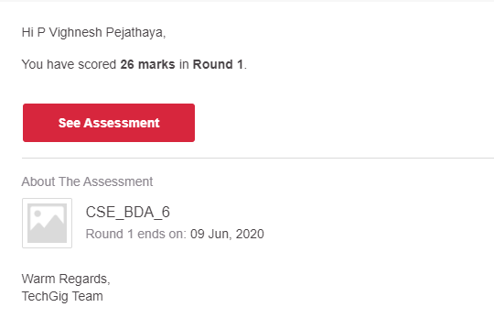

Certification Course Details: (Attach the snapshot and briefly write the report for the same)

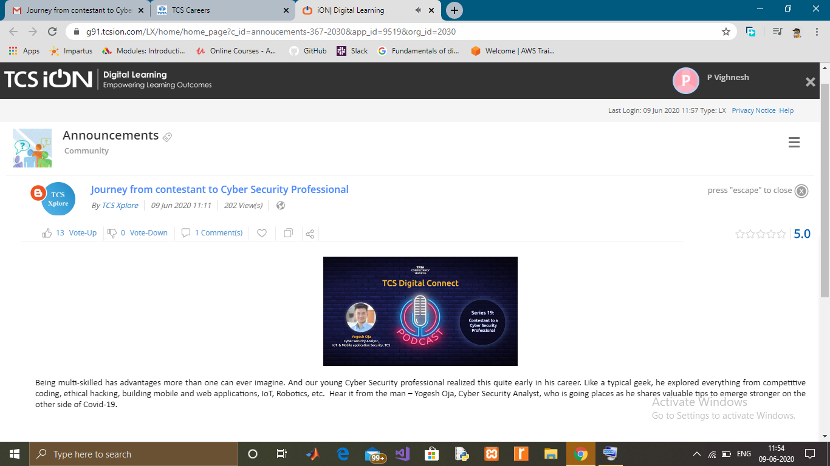

Coding Challenges Details: (Attach the snapshot and briefly write the report for the same)

JPEG (pronounced "jay-peg") stands for Joint Photographic Experts Group. It is one of the most widely used compression techniques for image compression.

Most of the file formats have headers (initial few bytes) which contain useful information about the file.

For example, jpeg headers contain information like height, width, number of color (grayscale or RGB) etc. In this program, we find the resolution of a jpeg image reading these headers, without using any external library.

Output:

The resolution of the image is 280 x 280