**DAILY ONLINE ACTIVITIES SUMMARY**

|  |  |  |  |  |  |  |  |  |
| --- | --- | --- | --- | --- | --- | --- | --- | --- |
| **Date:** | **10-06-2020** | | | | | **Name:** | **P Vighnesh Pejathaya** | |
| **Sem & Sec** | **8 sem , A sec** | | | | | **USN:** | **4al16cs060** | |
| **Online Test Summary** | | | | | | | | |
| **Subject** | | **NA** | | | | | | |
| **Max. Marks** | |  | | **Score** | | |  | |
| **Certification Course Summary** | | | | | | | | |
| **Course** | **Advanced DataBase and SQL(Part 6-14)** | | | | | | | |
| **Certificate Provider** | | | **Udemy** | | **Duration** | | | **120 min** |
| **Coding Challenges** | | | | | | | | |
| **Problem Statement: Python program to print the inverted star pattern.** | | | | | | | | |
| **Status: Completed** | | | | | | | | |
| **Uploaded the report in Github** | | | | | **yes** | | | |
| **If yes Repository name** | | | | | **Alvas-education-foundation/p_vighnesh** | | | |
| **Uploaded the report in slack** | | | | | **yes** | | | |

Online Test Details: (Attach the snapshot and briefly write the report for the same)

Not Conducted.

Certification Course Details: (Attach the snapshot and briefly write the report for the same)

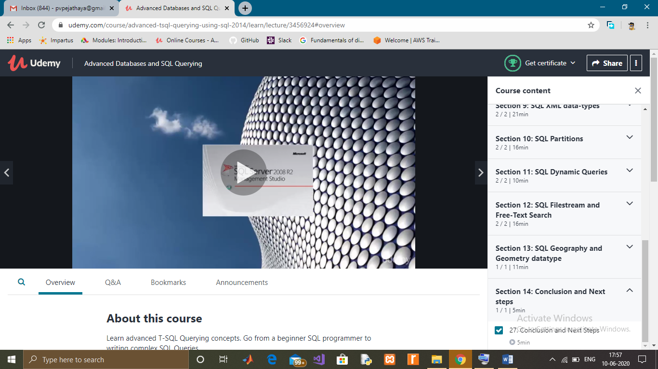

Coding Challenges Details: (Attach the snapshot and briefly write the report for the same)

This is a Python Program to read a number n and print an inverted star pattern of the desired size.

**Problem Description**

The program takes a number n and prints an inverted star pattern of the desired size.

**Problem Solution**

1. Take a value from the user and store it in a variable n.  
2. Use a for loop where the value of i ranges between the values of n-1 and 0 with a decrement of one with each iteration.  
3. Multiply empty spaces with n-i and ‘*’ with i and print both of them.  
4. Exit.