**DAILY ONLINE ACTIVITIES SUMMARY**

|  |  |  |  |  |  |  |  |  |
| --- | --- | --- | --- | --- | --- | --- | --- | --- |
| **Date:** | **11-06-2020** | | | | | **Name:** | **P Vighnesh Pejathaya** | |
| **Sem & Sec** | **8 sem , A sec** | | | | | **USN:** | **4AL16CS060** | |
| **Online Test Summary** | | | | | | | | |
| **Subject** | | **SMS** | | | | | | |
| **Max. Marks** | | **60** | | **Score** | | | **54** | |
| **Certification Course Summary** | | | | | | | | |
| **Course** | **Computer Science Principles: The Internet** | | | | | | | |
| **Certificate Provider** | | | **LinkedIn** | | **Duration** | | | **60 min** |
| **Coding Challenges** | | | | | | | | |
| **Problem Statement: Shell-sorting program.** | | | | | | | | |
| **Status: Completed** | | | | | | | | |
| **Uploaded the report in Github** | | | | | **yes** | | | |
| **If yes Repository name** | | | | | **Alvas-education-foundation/p_vighnesh** | | | |
| **Uploaded the report in slack** | | | | | **yes** | | | |

Online Test Details: (Attach the snapshot and briefly write the report for the same)

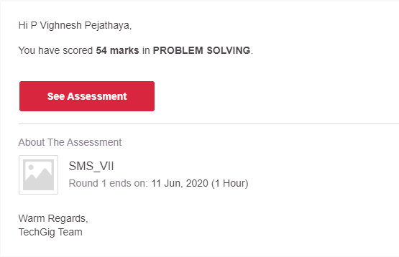

Certification Course Details: (Attach the snapshot and briefly write the report for the same)

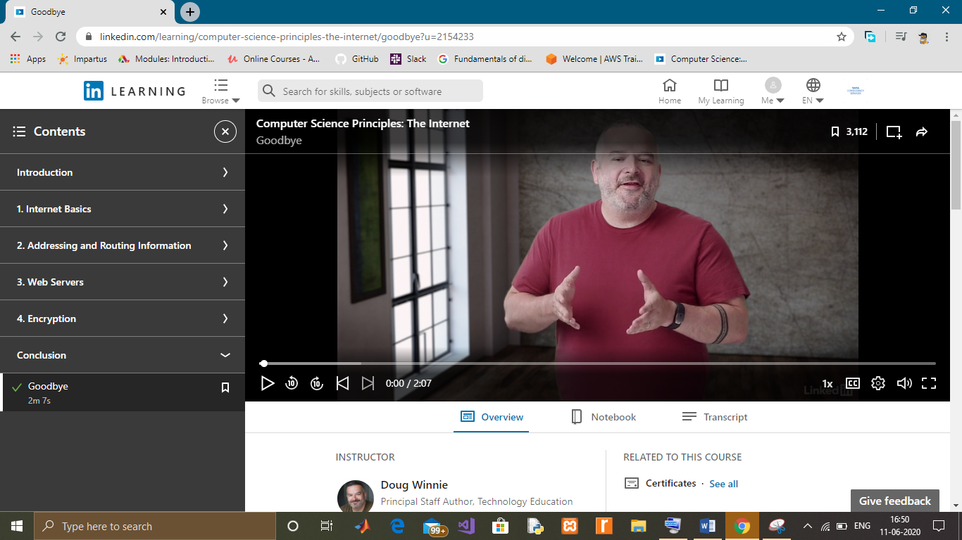

Coding Challenges Details: (Attach the snapshot and briefly write the report for the same)

Python Program for ShellSort

In shellSort, we make the array h-sorted for a large value of h. We keep reducing the value of h until it becomes 1. An array is said to be h-sorted if all sublists of every h\’th element is sorted.

**Output:**

Array before sorting:

12 34 54 2 3

Array after sorting:

2 3 12 34 54