**DAILY ONLINE ACTIVITIES SUMMARY**

|  |  |  |  |  |  |  |  |  |
| --- | --- | --- | --- | --- | --- | --- | --- | --- |
| **Date:** | 19/05/2020 | | | | | **Name:** | P Vighnesh Pejathaya | |
| **Sem & Sec** | VIII,A sec | | | | | **USN:** | 4al16cs060 | |
| **Online Test Summary** | | | | | | | | |
| **Subject** | | BDA | | | | | | |
| **Max. Marks** | | 30 | | **Score** | | | 22 | |
| **Certification Course Summary** | | | | | | | | |
| **Course** | Introduction to Conceptual Development. | | | | | | | |
| **Certificate Provider** | | | TCS | | **Duration** | | | 45 min. |
| **Coding Challenges** | | | | | | | | |
| **Problem Statement:** Program to find shortest Palindrome. | | | | | | | | |
| **Status:**Completed. | | | | | | | | |
| **Uploaded the report in Github** | | | | | Yes | | | |
| **If yes Repository name** | | | | | pvighnesh/Online-Certification-Course  pvighnesh/Daily-codding | | | |
| **Uploaded the report in slack** | | | | | Yes. | | | |

Online Test Details: (Attach the snapshot and briefly write the report for the same)

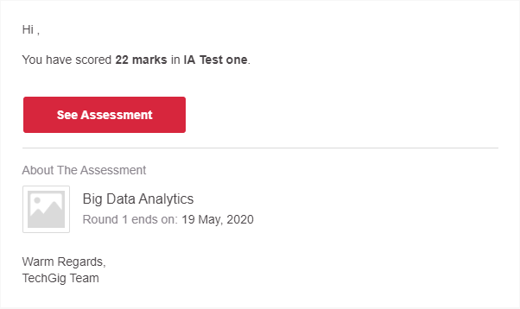

Certification Course Details: (Attach the snapshot and briefly write the report for the same)

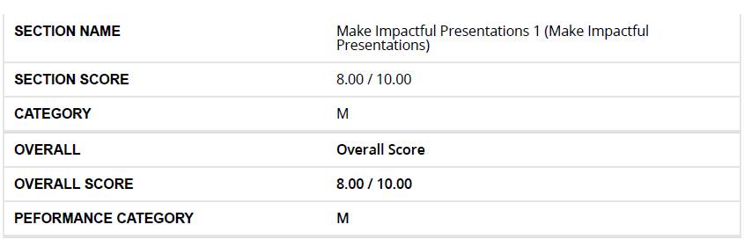

Coding Challenges Details: (Attach the snapshot and briefly write the report for the same)

Java Program to find the shortest Palindrome.

