**DAILY ONLINE ACTIVITIES SUMMARY**

|  |  |  |  |  |  |  |  |  |
| --- | --- | --- | --- | --- | --- | --- | --- | --- |
| **Date:** | 22/05/2020 | | | | | **Name:** | P Vighnesh Pejathaya | |
| **Sem & Sec** | VIII,A sec | | | | | **USN:** | 4al16cs060 | |
| **Online Test Summary** | | | | | | | | |
| **Subject** | | BDA | | | | | | |
| **Max. Marks** | | 40 | | **Score** | | | 27 | |
| **Certification Course Summary** | | | | | | | | |
| **Course** | TCS Career Edge Course. | | | | | | | |
| **Certificate Provider** | | | TCS | | **Duration** | | | 45 min |
| **Coding Challenges** | | | | | | | | |
| **Problem Statement:** Program to find the number that is missing in array. | | | | | | | | |
| **Status:**Completed. | | | | | | | | |
| **Uploaded the report in Github** | | | | | yes | | | |
| **If yes Repository name** | | | | | pvighnesh/Online-Certification-Course  pvighnesh/Daily-codding | | | |
| **Uploaded the report in slack** | | | | | Yes. | | | |

Online Test Details: (Attach the snapshot and briefly write the report for the same)

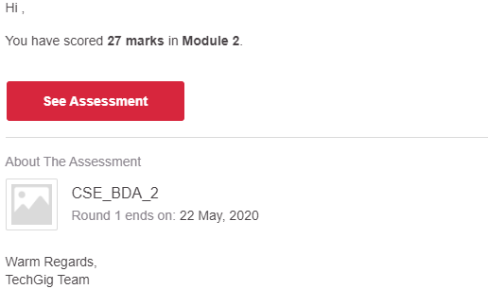

Certification Course Details: (Attach the snapshot and briefly write the report for the same)

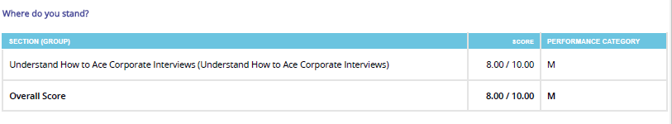

Coding Challenges Details: (Attach the snapshot and briefly write the report for the same)

C# Program to find the missing number in an array.

class Find {

static int getMissNo(int[] arr, int n)

{

int total = (n + 1) * (n + 2) / 2;

for (int i = 0; i < n; i++)

total -= arr[i];

return total;

}

public static void Main()

{

int[] a = { 1, 2, 4, 5, 6 };

int nor = getMissNo(arr, 5);

Console.Write(nor);

}

}