**DAILY ONLINE ACTIVITIES SUMMARY**

|  |  |  |  |  |  |  |  |  |
| --- | --- | --- | --- | --- | --- | --- | --- | --- |
| **Date:** | **26-05-2020** | | | | | **Name:** | **P vighnesh Pejathaya** | |
| **Sem & Sec** | **8 sem , A sec** | | | | | **USN:** | **4al16cs060** | |
| **Online Test Summary** | | | | | | | | |
| **Subject** | | **BDA** | | | | | | |
| **Max. Marks** | | **40** | | **Score** | | | **36** | |
| **Certification Course Summary** | | | | | | | | |
| **Course** | **AI** | | | | | | | |
| **Certificate Provider** | | | **TCS** | | **Duration** | | | **2 Days** |
| **Coding Challenges** | | | | | | | | |
| **Problem Statement: Program to obtaine number series.**  **Program to find numbers not devisible by 2& 3.** | | | | | | | | |
| **Status: Completed** | | | | | | | | |
| **Uploaded the report in Github** | | | | | **yes** | | | |
| **If yes Repository name** | | | | | **Alvas-education-foundation/p_vighnesh** | | | |
| **Uploaded the report in slack** | | | | | **yes** | | | |

Online Test Details: (Attach the snapshot and briefly write the report for the same)

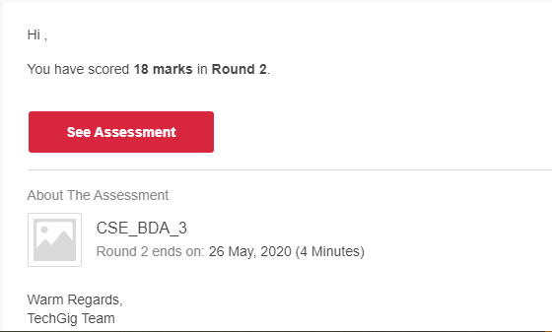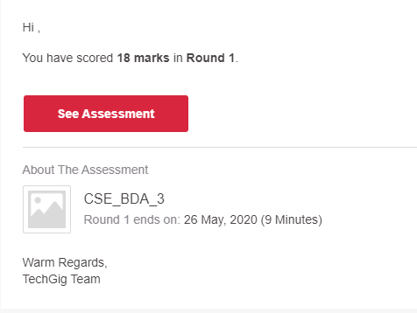

Certification Course Details: (Attach the snapshot and briefly write the report for the same)

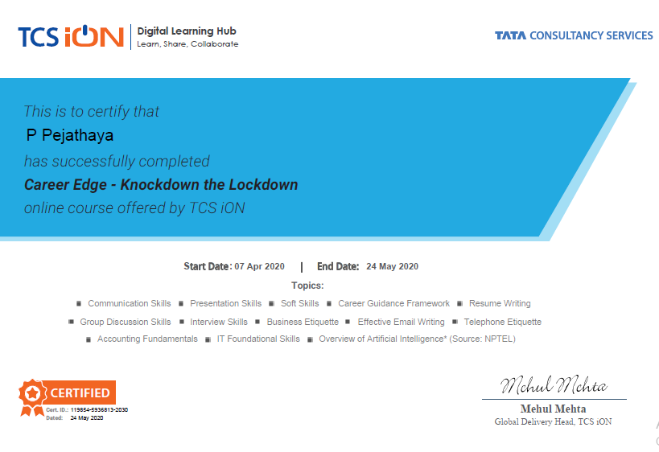

Coding Challenges Details: (Attach the snapshot and briefly write the report for the same)

1)A Python Program to Print all Integers that Aren’t Divisible by Either 2 or 3 and Lie between 1 and 50

2)A Python Program to read a number n and print and compute the series “1+2+…+n=”.  
Problem Description  
The program takes a number n and prints and computes the series “1+2+…+n=”.

🡪for i in range(0,51):

if(i%2!=0&i%3!=0):

print(i)

------

🡪n = int(input("Enter a Number : "))

series_sum = []

for i in range(1,n+1):

series_sum.append(i)

if i==n:

print(i, end='')

else:

print(i,end=' + ')

print(' = ', sum(series_sum), sep='')