**DAILY ONLINE ACTIVITIES SUMMARY**

|  |  |  |  |  |  |  |  |  |
| --- | --- | --- | --- | --- | --- | --- | --- | --- |
| **Date:** | **27-05-2020** | | | | | **Name:** | **P vighnesh Pejathaya** | |
| **Sem & Sec** | **8 sem , A sec** | | | | | **USN:** | **4al16cs060** | |
| **Online Test Summary** | | | | | | | | |
| **Subject** | | **IOT** | | | | | | |
| **Max. Marks** | | **30** | | **Score** | | | **27** | |
| **Certification Course Summary** | | | | | | | | |
| **Course** | **Angular &NodeJS** | | | | | | | |
| **Certificate Provider** | | | **Udemy** | | **Duration** | | | **90 min** |
| **Coding Challenges** | | | | | | | | |
| **Problem Statement: Program to find Subarray.** | | | | | | | | |
| **Status: Completed** | | | | | | | | |
| **Uploaded the report in GitHub** | | | | | **yes** | | | |
| **If yes Repository name** | | | | | **Alva’s-education-foundation/p_vighnesh** | | | |
| **Uploaded the report in slack** | | | | | **yes** | | | |

Online Test Details: (Attach the snapshot and briefly write the report for the same)

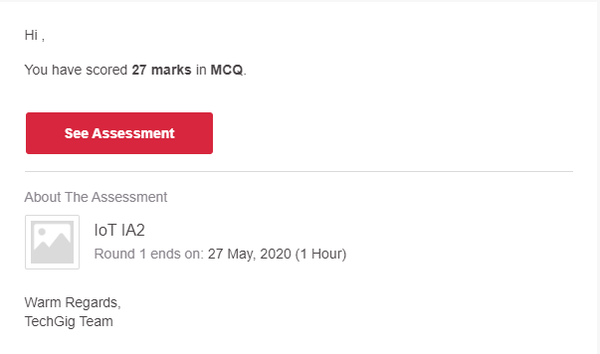

Certification Course Details: (Attach the snapshot and briefly write the report for the same)

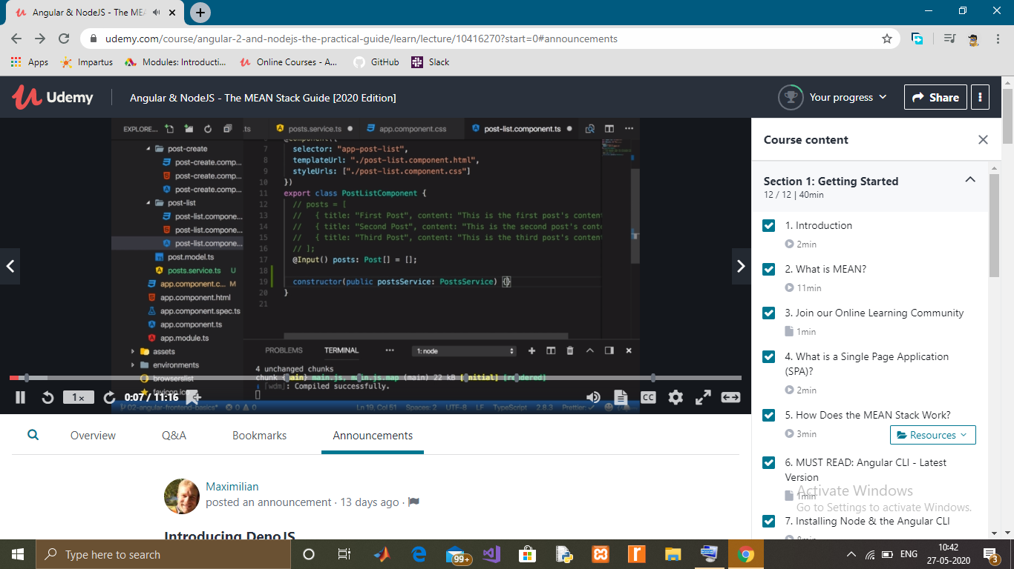

Coding Challenges Details: (Attach the snapshot and briefly write the report for the same)

Program 🡪Given an array A of size N where the array elements contain values from 1 to N with duplicates, the task is to find total number of subarrays, which start and end with the same element.

