**DAILY ONLINE ACTIVITIES SUMMARY**

|  |  |  |  |  |  |  |  |  |
| --- | --- | --- | --- | --- | --- | --- | --- | --- |
| **Date:** | **31-05-2020** | | | | | **Name:** | **P Vighnesh Pejathaya** | |
| **Sem & Sec** | **8 sem , A sec** | | | | | **USN:** | **4al16cs060** | |
| **Online Test Summary** | | | | | | | | |
| **Subject** | | **IOT** | | | | | | |
| **Max. Marks** | | **20** | | **Score** | | | **13** | |
| **Certification Course Summary** | | | | | | | | |
| **Course** | **Angular &NodeJS (Part -4)** | | | | | | | |
| **Certificate Provider** | | | **Udemy** | | **Duration** | | | **80 min** |
| **Coding Challenges** | | | | | | | | |
| **Problem Statement:** Frustrated coders Program.  **.** | | | | | | | | |
| **Status: Completed** | | | | | | | | |
| **Uploaded the report in Github** | | | | | **yes** | | | |
| **If yes Repository name** | | | | | **Alvas-education-foundation/p_vighnesh** | | | |
| **Uploaded the report in slack** | | | | | **yes** | | | |

Online Test Details: (Attach the snapshot and briefly write the report for the same)

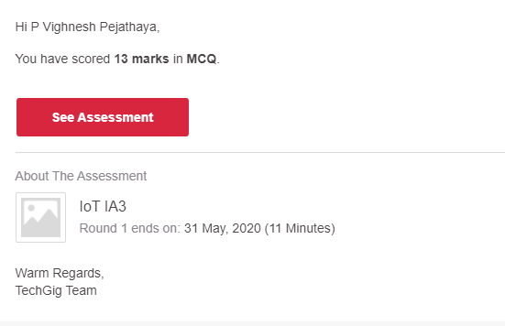

Certification Course Details: (Attach the snapshot and briefly write the report for the same)

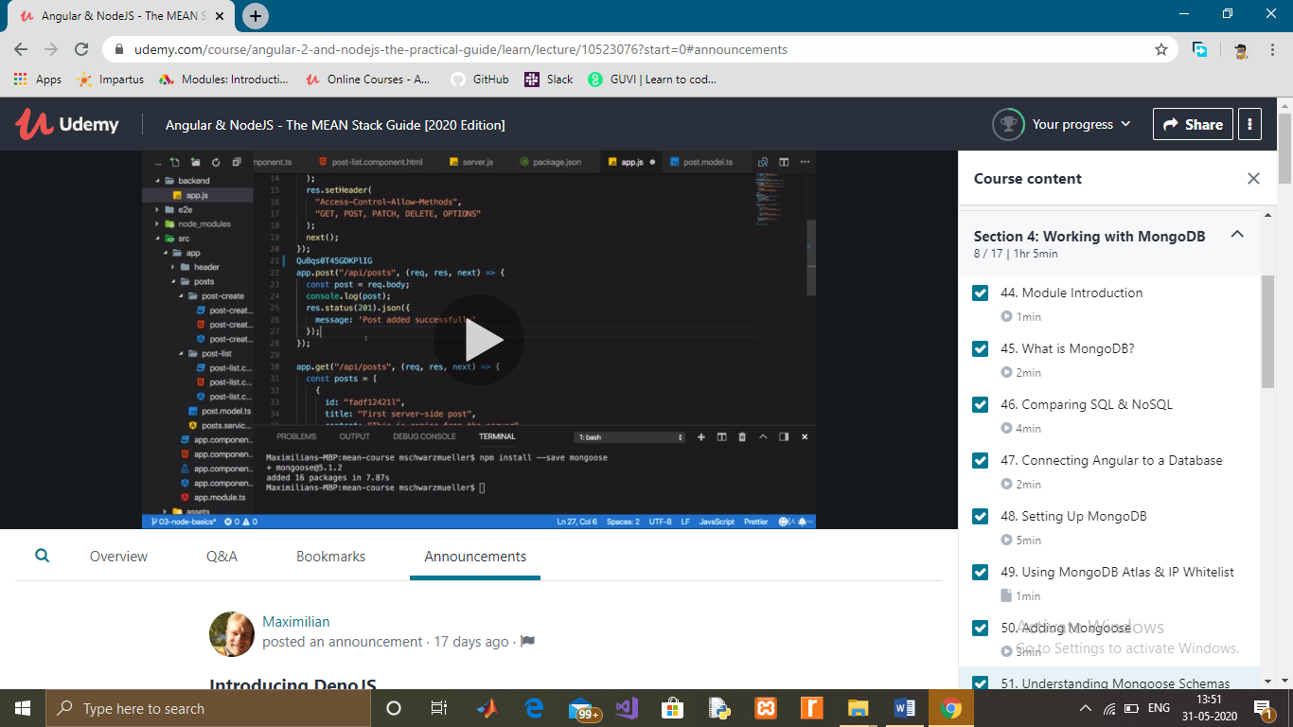

Coding Challenges Details: (Attach the snapshot and briefly write the report for the same)

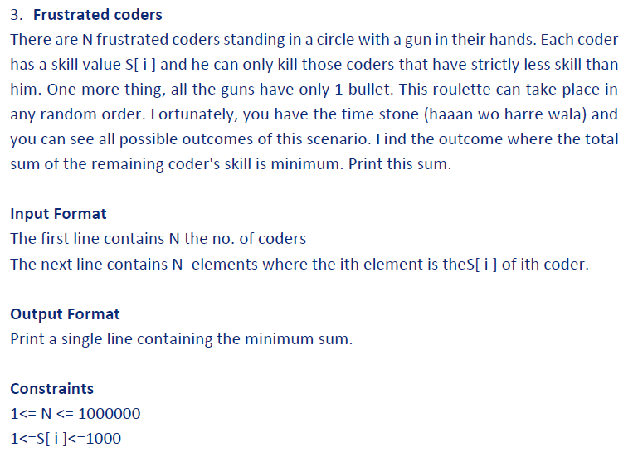

C++ Program:

#include<bits/stdc++.h>

using namespace std;

main()

{

ios_base::sync_with_stdio(false);

cin.tie(NULL);

int n;

cin>>n;

int a[n];

int sum=0;

for(int i=0; i<n; i++)

{

cin>>a[i];

}

sort(a,a+n);

for(int i=1; i<n; i++)

{

for(int j=i-1; j>=0; j--)

{

if(a[i]>a[j]&&a[j]!=0)

{

a[j]=0;

break;

}}}

sum=0;

for(int i=0; i<n; i++)

{

sum+=a[i];

}

cout<<sum;

}