**DAILY ONLINE ACTIVITIES SUMMARY**

|  |  |  |  |  |  |  |  |  |
| --- | --- | --- | --- | --- | --- | --- | --- | --- |
| **Date:** | **08-06-2020** | | | | | **Name:** | **P Vighnesh Pejathaya** | |
| **Sem & Sec** | **8 sem , A sec** | | | | | **USN:** | **4al16cs060** | |
| **Online Test Summary** | | | | | | | | |
| **Subject** | | **SMS** | | | | | | |
| **Max. Marks** | | **60** | | **Score** | | | **60** | |
| **Certification Course Summary** | | | | | | | | |
| **Course** | **E- Commerce 101** | | | | | | | |
| **Certificate Provider** | | | **IIDE** | | **Duration** | | | **180 min** |
| **Coding Challenges** | | | | | | | | |
| **Problem Statement:** C Program to Generate All the Set Partitions of n Numbers Beginning from 1 and so on. | | | | | | | | |
| **Status: Completed** | | | | | | | | |
| **Uploaded the report in Github** | | | | | **yes** | | | |
| **If yes Repository name** | | | | | **Alvas-education-foundation/p_vighnesh** | | | |
| **Uploaded the report in slack** | | | | | **yes** | | | |

Online Test Details: (Attach the snapshot and briefly write the report for the same)

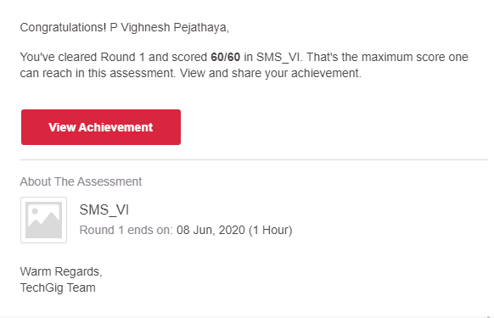

Certification Course Details: (Attach the snapshot and briefly write the report for the same)

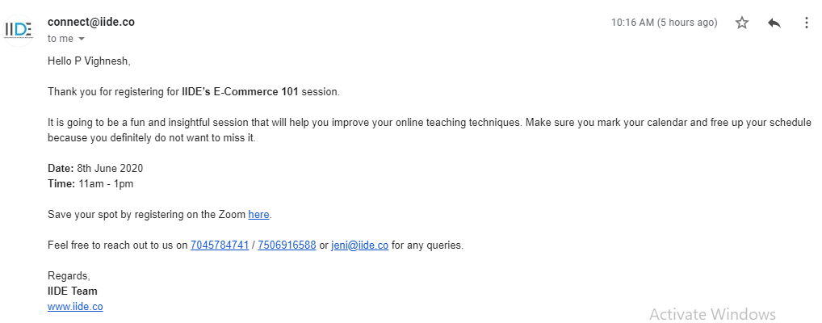

Coding Challenges Details: (Attach the snapshot and briefly write the report for the same)

This C program generates all the set of partitions of n Numbers beginning from 1 to n.

This algorithm partitions an integer into numbers which sum up to form the original number. It generates partitions of a set of numbers for a given range.

This algorithm partitions an integer into numbers which sum up to form the original number. It generates partitions of a set of numbers for a given range.

**Sample Input**

Enter a number N to generate all set partition from 1 to N: 5  
Integer partition for 1 is:  
1

Integer partition for 2 is:  
2  
11

Integer partition for 3 is:  
3  
12  
111

Integer partition for 4 is:  
4  
13  
112  
1111  
22

Integer partition for 5 is:  
5  
14  
113  
1112  
11111  
122  
23