

**Project Report on**

**Name of the Project**

**Submitted to**

**VISHWAKARMA UNIVERSITY, PUNE**

**Under the Initiative of**

**Contemporary Curriculum, Pedagogy, and Practice**

**(C2P2)**

**ADVANCE WEB TECHNOLOGY LAB**

**By**

|  |  |
| --- | --- |
| **Name of the Student** | **:Srushti Ladkat** |
| **SRN. No.** | **:202202136** |
| **Class/div.** | **: SY / F** |
| **Roll no.** | **: 34** |

**Faculty In-charge: Prof. Jayendra Jadhav**

**Department of Computer Engineering**

**Faculty of Science & Technology**

**Academic Year**

**2023-2024 Term-II**

1. **Project Title**

Quiz Application

1. **Problem Statement**

An application for creating and taking multiple-choice quizzes

1. **Introduction**

QuizMaster: Empowering Learning Through Interactive Quizzes

Welcome to QuizMaster, your comprehensive platform for creating and taking multiple-choice quizzes. Whether you're a teacher, student, or quiz enthusiast, QuizMaster offers a user-friendly interface and robust features to enhance your learning and engagement.

Key Features:

1. Easy Quiz Creation: Craft quizzes effortlessly with our intuitive quiz builder. Choose from various question formats, including text-based, image-based, and audio-based questions. Add options and designate correct answers with a simple click.

2. Customization Options: Tailor quizzes to your needs with customizable features such as themes, time limits, and difficulty levels. Personalize the quiz experience for your audience and objectives.

3. Multimedia Integration: Enrich questions with multimedia elements such as images, videos, and audio clips. Create visually engaging quizzes that captivate participants and reinforce learning objectives.

4. Real-time Collaboration: Collaborate with colleagues, classmates, or friends in real-time on quiz creation and editing. Streamline teamwork and ensure accuracy and quality in quiz content.

5. Seamless Sharing: Share quizzes effortlessly via email, social media, or direct link. Invite participants to take quizzes individually or in groups, fostering collaboration and friendly competition.

6. Analytics and Insights: Track quiz performance with comprehensive analytics and insights. Gain valuable data on completion rates, question difficulty, and participant responses. Use insights to refine quizzes and optimize learning outcomes.

7. Responsive Design: Access QuizMaster anytime, anywhere, across devices. Our responsive web application ensures a seamless experience on desktop computers, tablets, and smartphones.

8. Community Engagement: Join a vibrant community of educators, students, and quiz enthusiasts. Share quiz templates, participate in themed challenges, and engage in discussions on best practices and strategies.

1. **Software/Hardware Requirement**

**4.1 Software Requirements:**

* Web Browser: QuizMaster is a web-based application, so users will need a modern web browser to access it. Compatible browsers include Google Chrome, Mozilla Firefox, Safari, Microsoft Edge, and others.
* Operating System: QuizMaster is platform-independent and can run on various operating systems, including Windows, macOS, Linux, and others.
* AngularJS: Since you've used AngularJS for development, ensure that the user's browser supports AngularJS. Most modern browsers are compatible with AngularJS, but it's essential to consider compatibility for older browser versions.
* HTML/CSS: Users' web browsers must support HTML and CSS for rendering the QuizMaster interface correctly. This shouldn't be an issue with modern browsers.
* XAMPP (or similar local server environment): If you're using XAMPP for PHP development, ensure that users have access to a similar local server environment with PHP support. This is necessary for hosting the PHP backend of the QuizMaster application locally.
* PHP: Ensure that users' local server environments support PHP. The version of PHP required may depend on the specific features and functionality implemented in QuizMaster. Ensure compatibility with the PHP version used during development.

**4.2 Hardware Requirements:**

* Computer: Users will need access to a computer or laptop to run QuizMaster. The application should be compatible with standard desktop and laptop configurations.
* Processor and Memory: Since QuizMaster is a web-based application, it doesn't have strict processor and memory requirements on the user's end. However, users should have a computer with a processor and memory sufficient to run their web browser smoothly.
* Storage: Users don't need significant storage space on their computers for QuizMaster since it's a web application. Standard storage capacities found on most computers should be more than adequate.
* Internet Connection: A stable internet connection is required to access QuizMaster since it's a web-based application. Ensure that users have access to a reliable internet connection for optimal performance.

1. **Output**

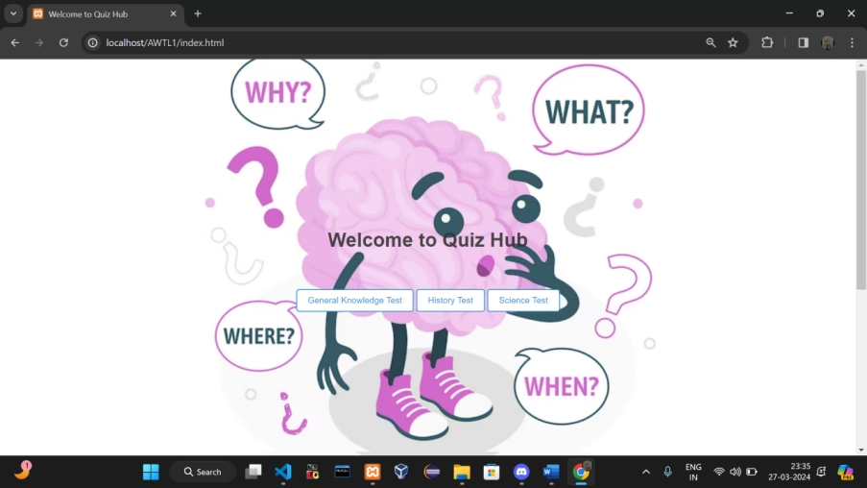

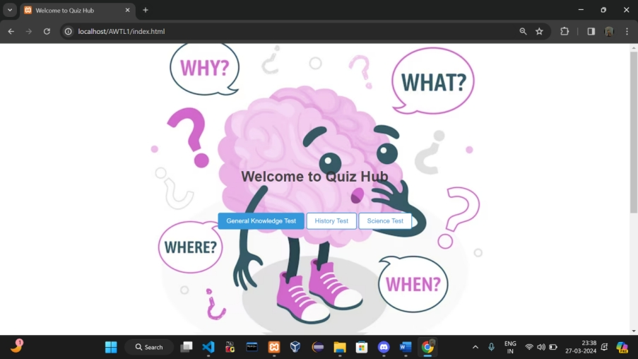

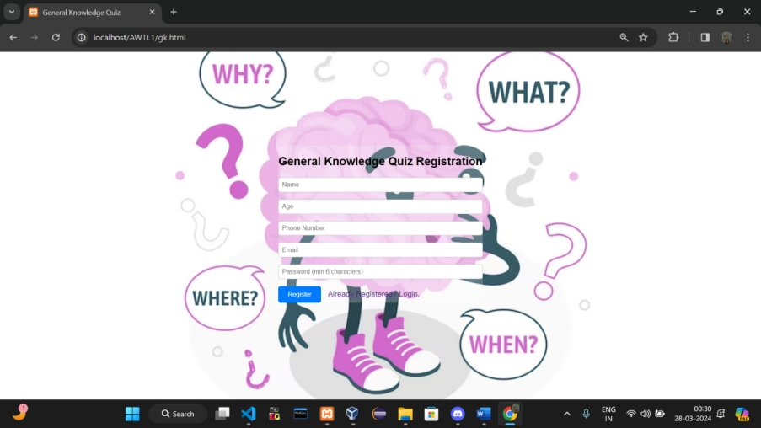

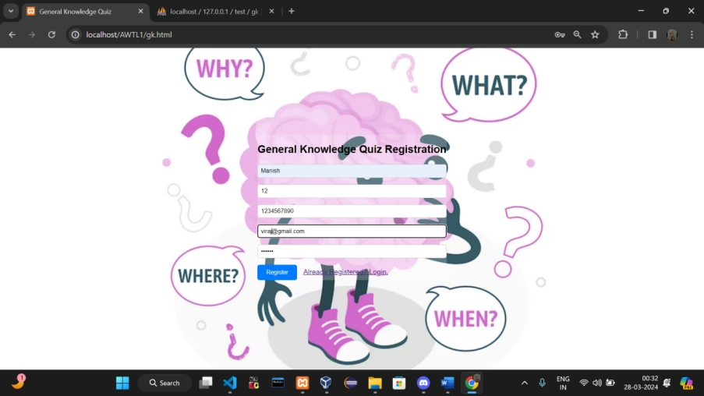

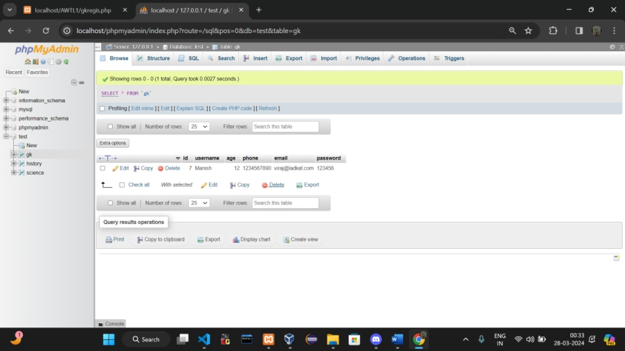

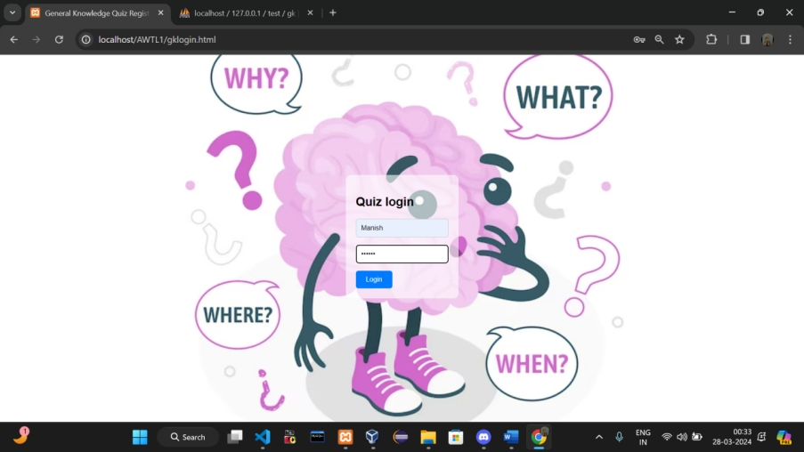

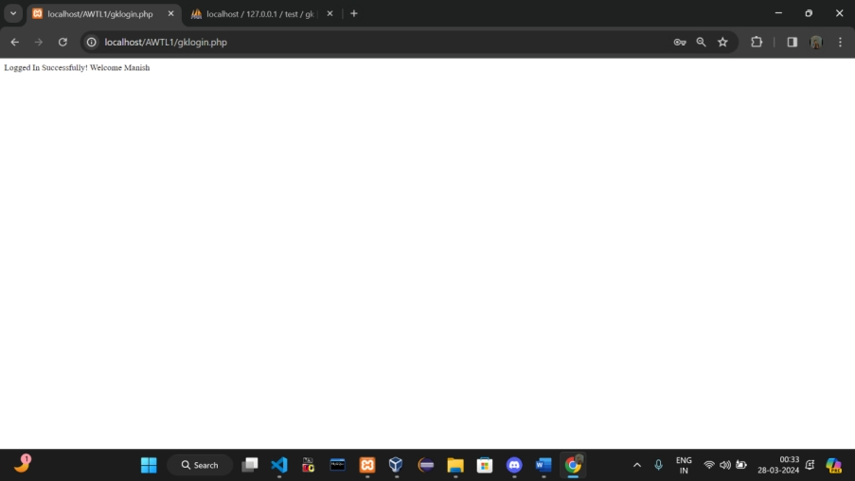

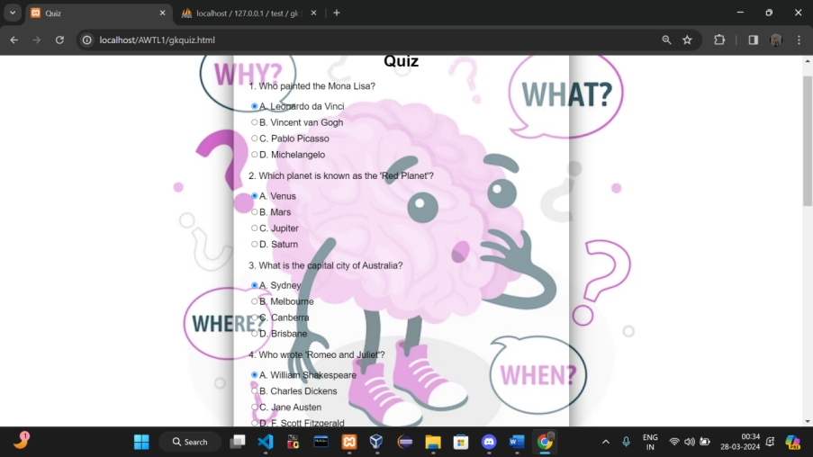

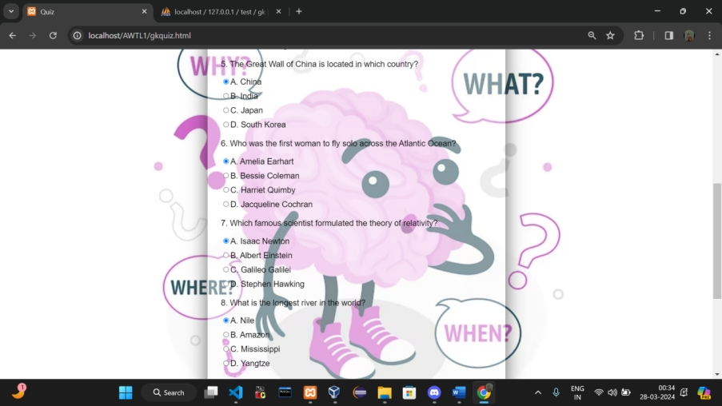



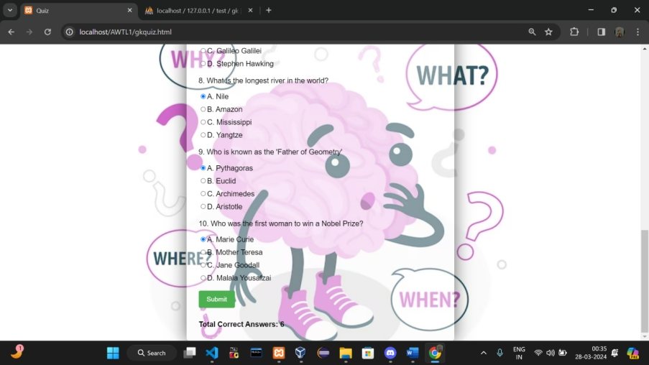

1. **Conclusion**

QuizMaster revolutionizes learning with its user-friendly interface, robust features, and commitment to engagement. Educators craft immersive quizzes tailored to teaching objectives, while students benefit from interactive learning experiences. With analytics driving continuous improvement and a vibrant community fostering collaboration, QuizMaster empowers learners to excel.