# **Vehicle detection in foggy weather(Prototype Artifact)**

# **Note**We have implemented software part of the system as system includes hardware part we were unable to implement complete prototype.**

# Steps

Previous Next

**Step 1: (‎9/‎16/‎2021 10:47:13 AM)** User right click on "main_code.py (list item)" in "Prototype"

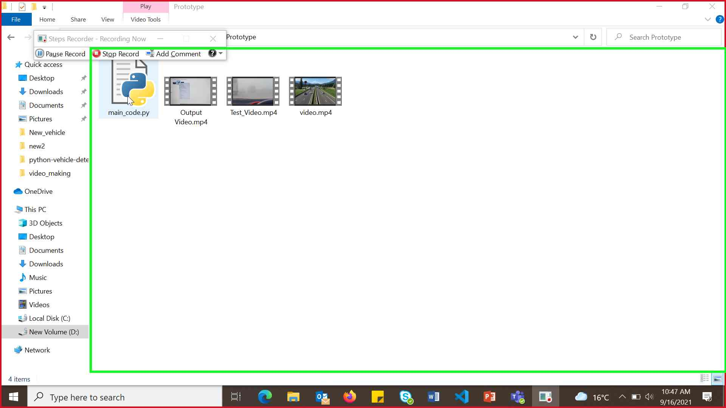Step 1 screenshot.

Previous Next

**Step 2: (‎9/‎16/‎2021 10:47:16 AM)** User left click on "Edit with IDLE (menu)"

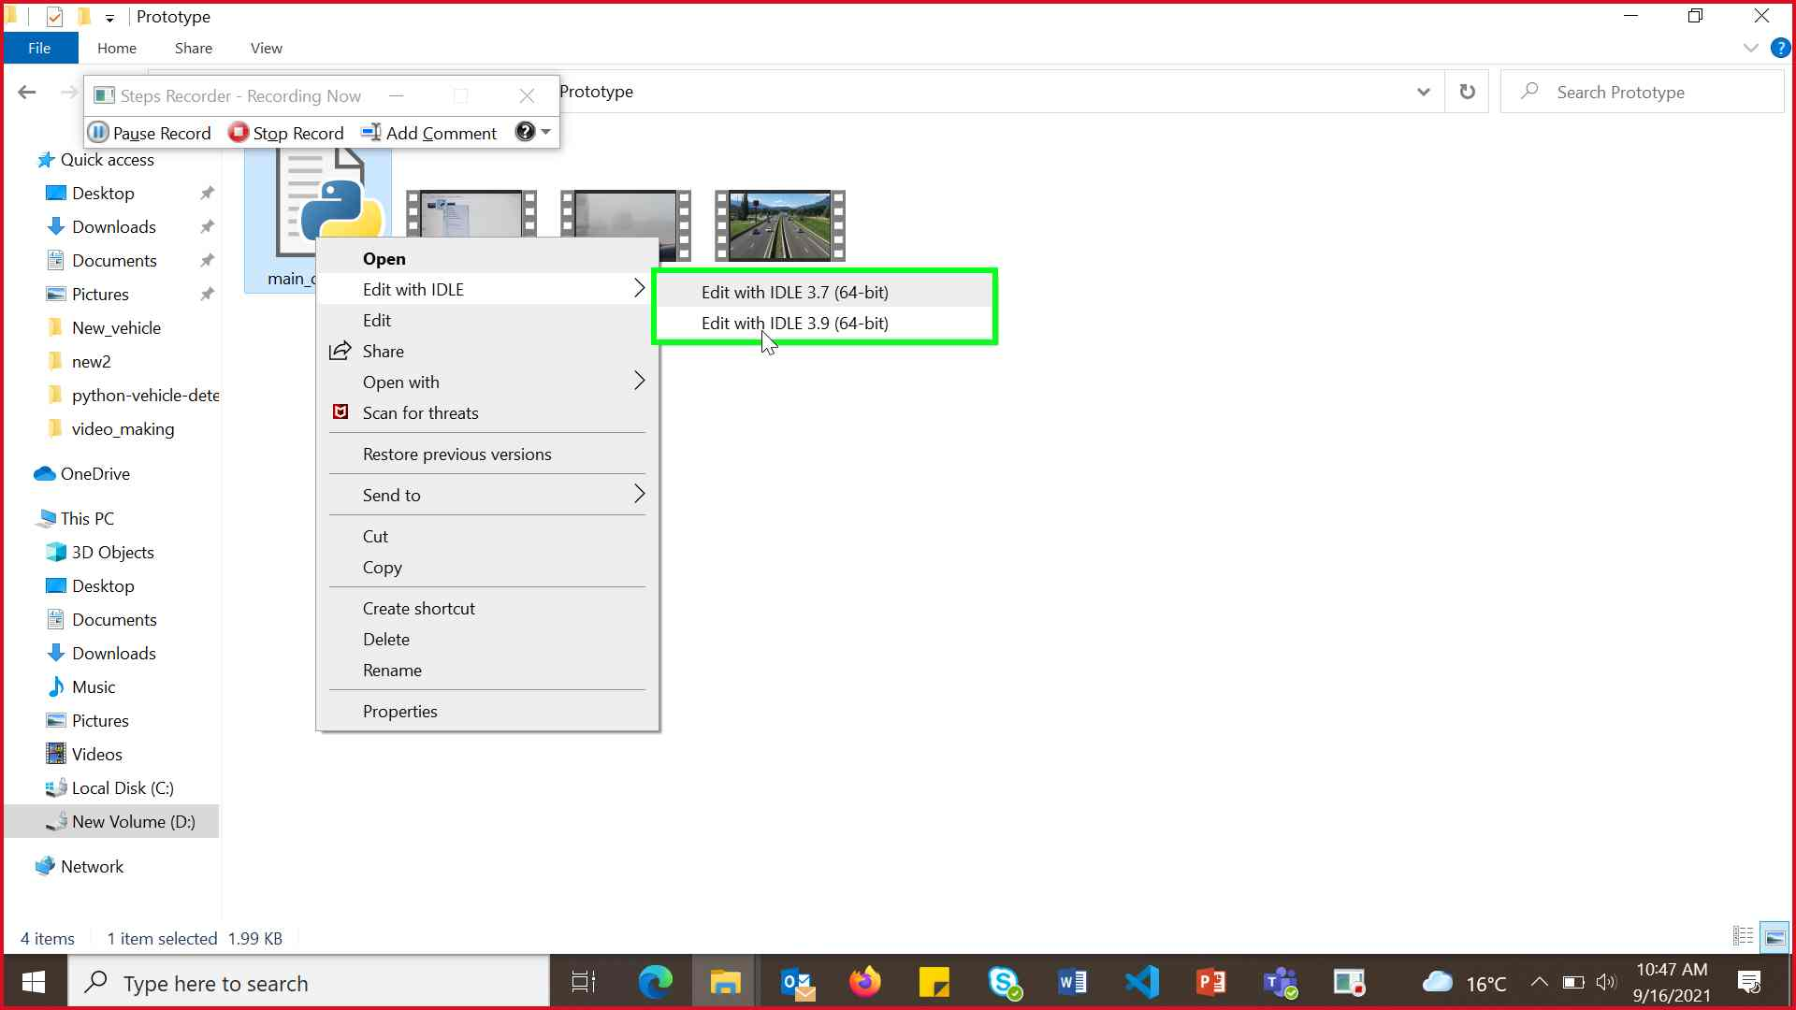Step 2 screenshot.

Previous Next

**Step 3: (‎9/‎16/‎2021 10:47:25 AM)** User left click on "Run (menu item)" in "main"

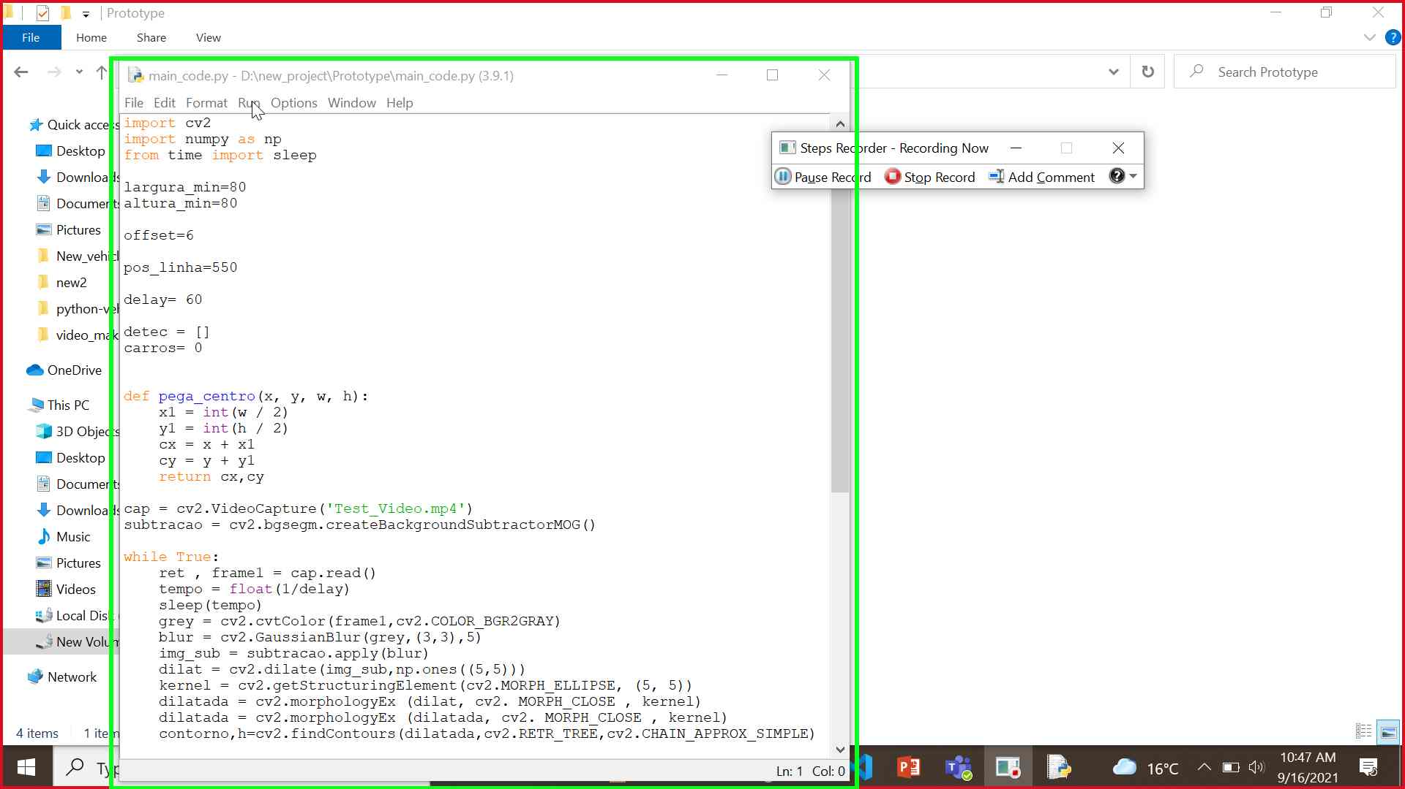Step 3 screenshot.

Previous Next

**Step 4: (‎9/‎16/‎2021 10:47:26 AM)** User left click on "Run (menu)"

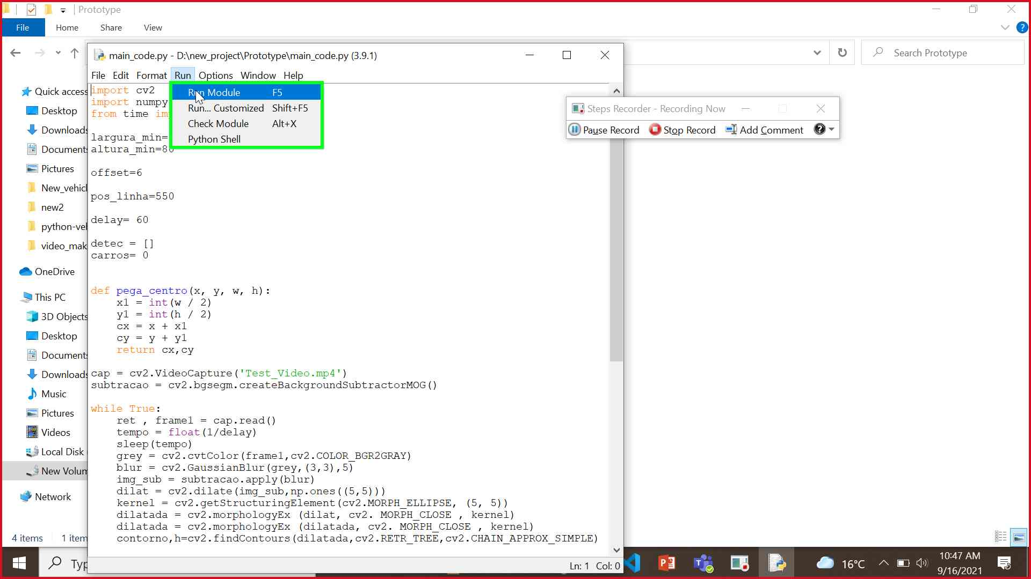Step 4 screenshot.

Previous Next

**Step 5: (‎9/‎16/‎2021 10:47:34 AM)** User left click on "Detector (window)" in "Detector"

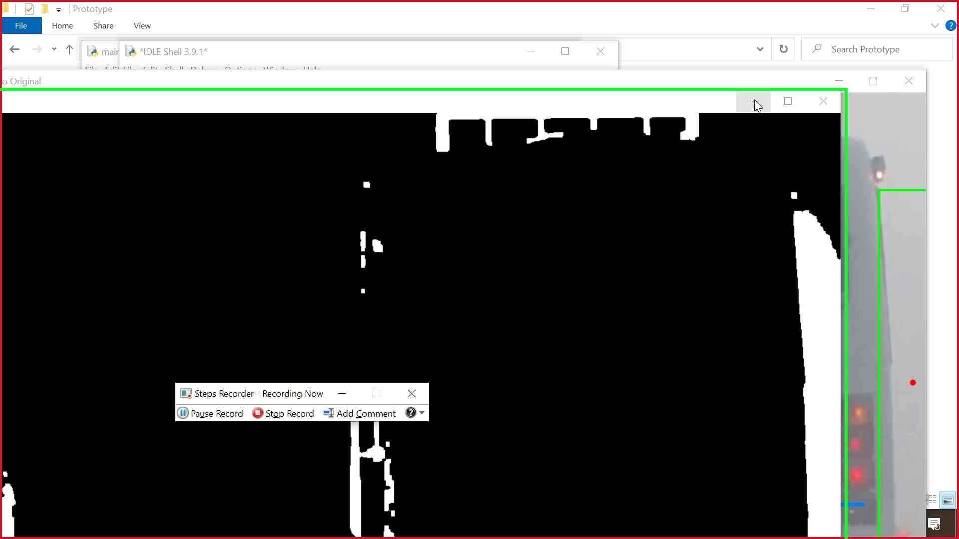Step 5 screenshot.

Previous Next

**Step 6: (‎9/‎16/‎2021 10:47:40 AM)** User left click on "Video Original (window)" in "Video"

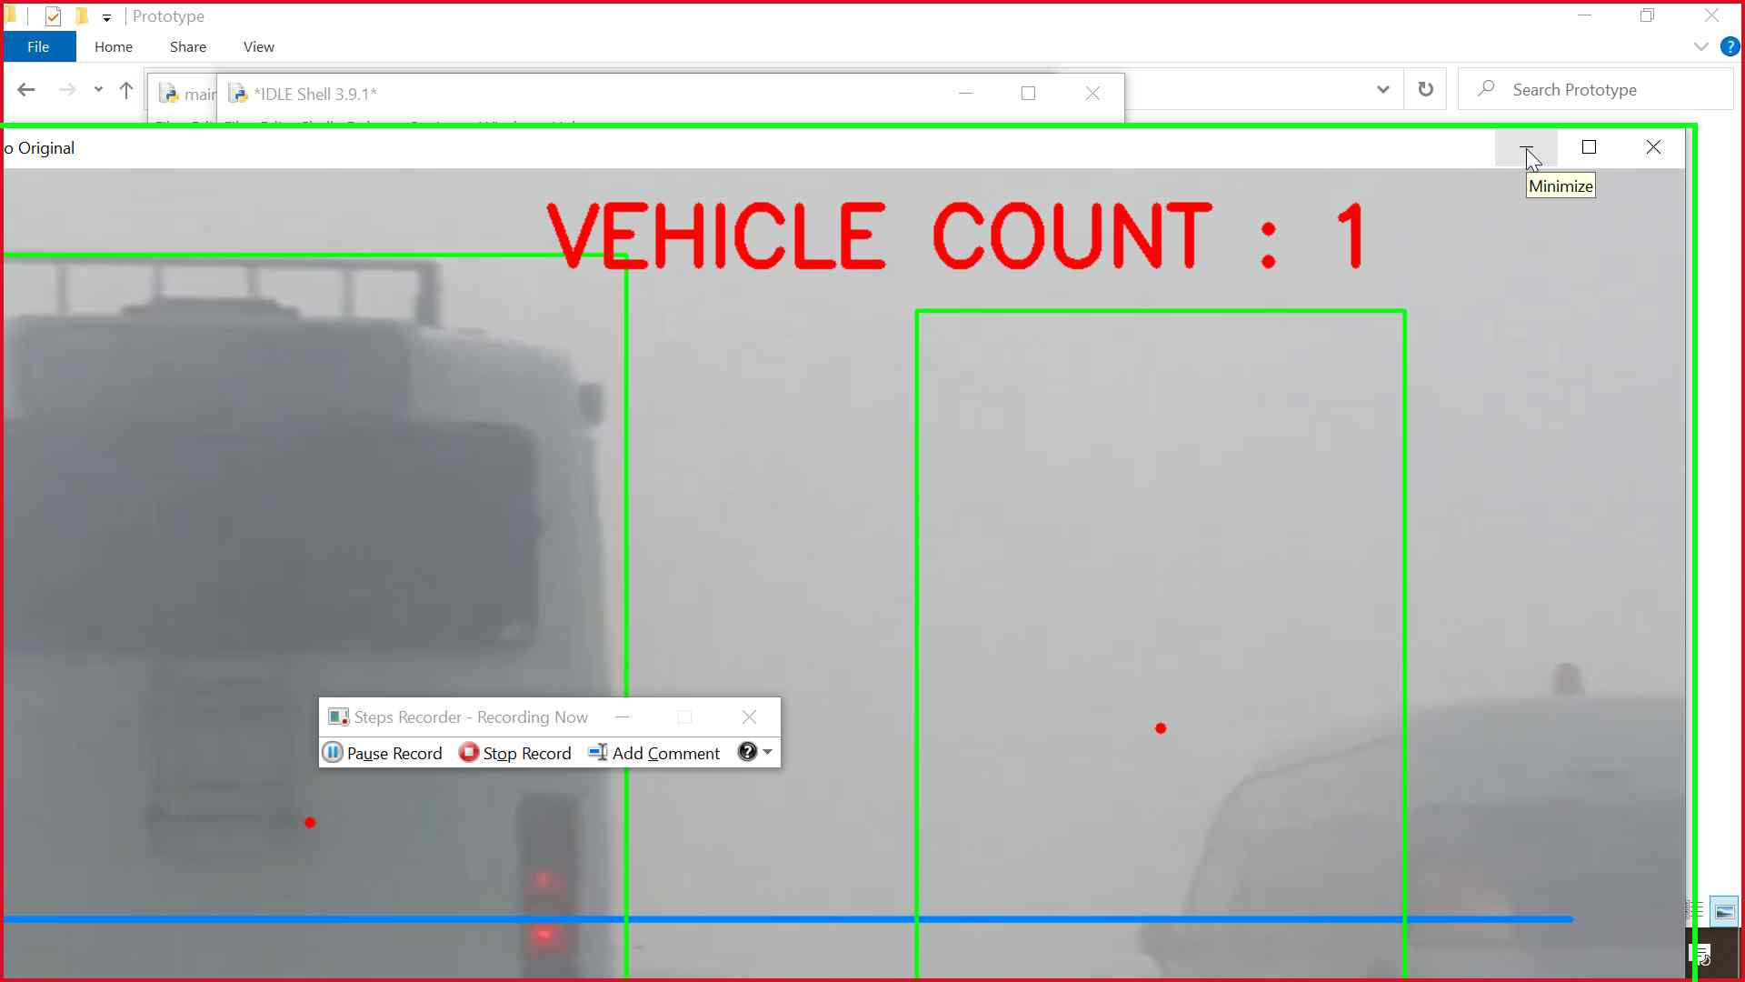Step 6 screenshot.

Previous Next

**Step 7: (‎9/‎16/‎2021 10:47:43 AM)** User mouse drag start on "*IDLE Shell 3.9.1* (window)" in "*ID"

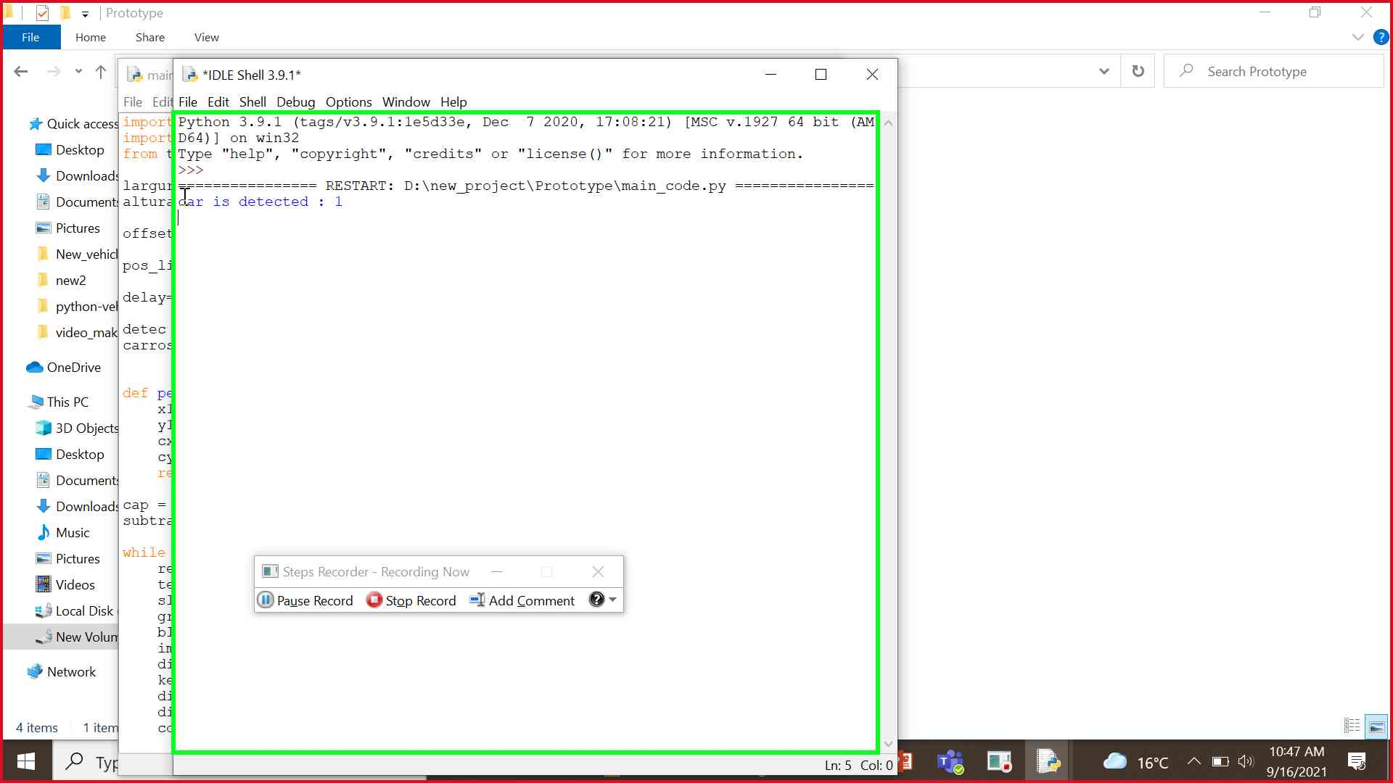Step 7 screenshot.

Previous Next

**Step 8: (‎9/‎16/‎2021 10:47:44 AM)** User mouse drag end on "*IDLE Shell 3.9.1* (window)" in "*ID"

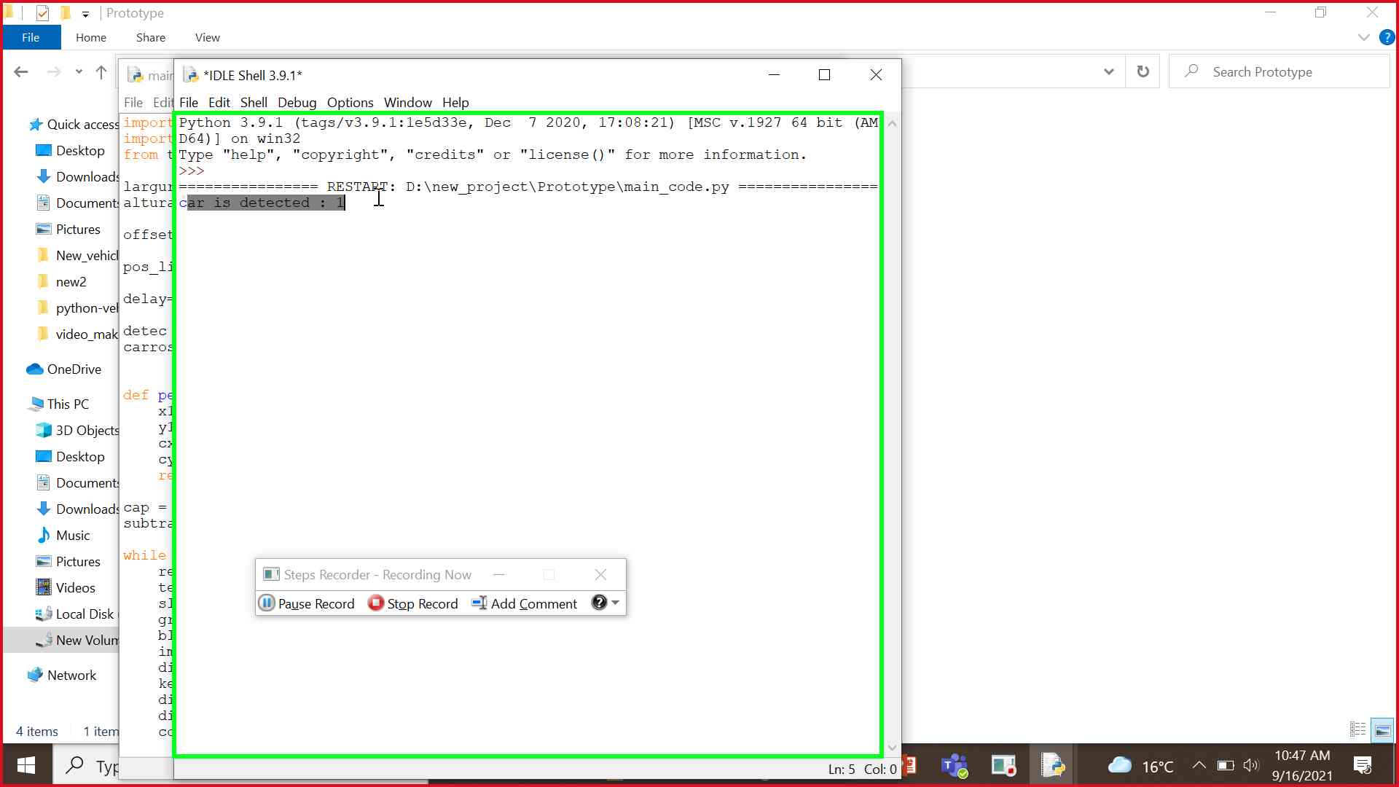Step 8 screenshot.

Return to top of page...