DATA CLEANING & VISUALIZATION PROJECT
Student Performance Data Analysis Using Python
Tools: Python • Pandas • NumPy • Matplotlib
1. Project Overview
This project demonstrates the complete process of cleaning, processing, analyzing, and visualizing a raw student-performance dataset. The dataset contains academic and lifestyle-related variables such as study hours, attendance, assignment score, sleep hours, and subject scores. The raw data intentionally contains common data-quality problems so that realistic preprocessing techniques can be demonstrated.
2. Objectives
- Identify and handle missing values.
- Detect and remove duplicate records.
- Identify and manage unusual or outlier values.
- Create meaningful calculated fields for analysis.
- Use Python libraries to analyze and visualize the data.
- Extract clear insights and communicate them through data storytelling.
3. Dataset Description
The raw dataset contains 123 records before cleaning and includes information for students across four departments: CSE, IT, ECE, and Mechanical. The main variables are Student ID, Student Name, Department, Study Hours per Day, Attendance Percentage, Assignment Score, Sleep Hours, Math Score, Programming Score, and Communication Score.
4. Data Quality Problems Identified
- Missing values: 11 cells were intentionally included in the raw dataset.
- Duplicate records: 3 duplicate rows were identified and removed.
- Outliers: unrealistic values were introduced in variables such as study hours, attendance, sleep hours, and scores.
- Data consistency: numeric fields were converted to numeric data types before analysis.
5. Data Cleaning Process
Pandas was used as the primary data-cleaning library. First, the dataset was loaded and inspected using head(), info(), isnull(), and duplicated(). Duplicate records were removed. Missing numerical values were replaced using the median of the corresponding column, which reduces the influence of extreme observations. Outliers were detected using the Interquartile Range (IQR) method and treated by clipping values to the acceptable IQR-based boundaries. A new Average Score column was then calculated from the three subject scores.
6. Performance Classification
Students were grouped into four performance levels using their average subject score: Needs Improvement (below 50), Average (50–70), Good (70–85), and Excellent (above 85). This classification makes the results easier to interpret and supports simple performance-based storytelling.
7. Visualizations and Findings
The analysis produced six visual reports. The average score across subjects shows that Math_Score has the highest average score at approximately 80.0.
The department comparison indicates that CSE has the highest average performance, at approximately 76.2.
The relationship between study time and average score has a correlation of approximately 0.64. This suggests a positive association in this sample: students who spend more time studying generally tend to have higher average scores, although correlation does not prove that study time alone causes higher performance.
The most common performance category is 'Good', containing 89 students.
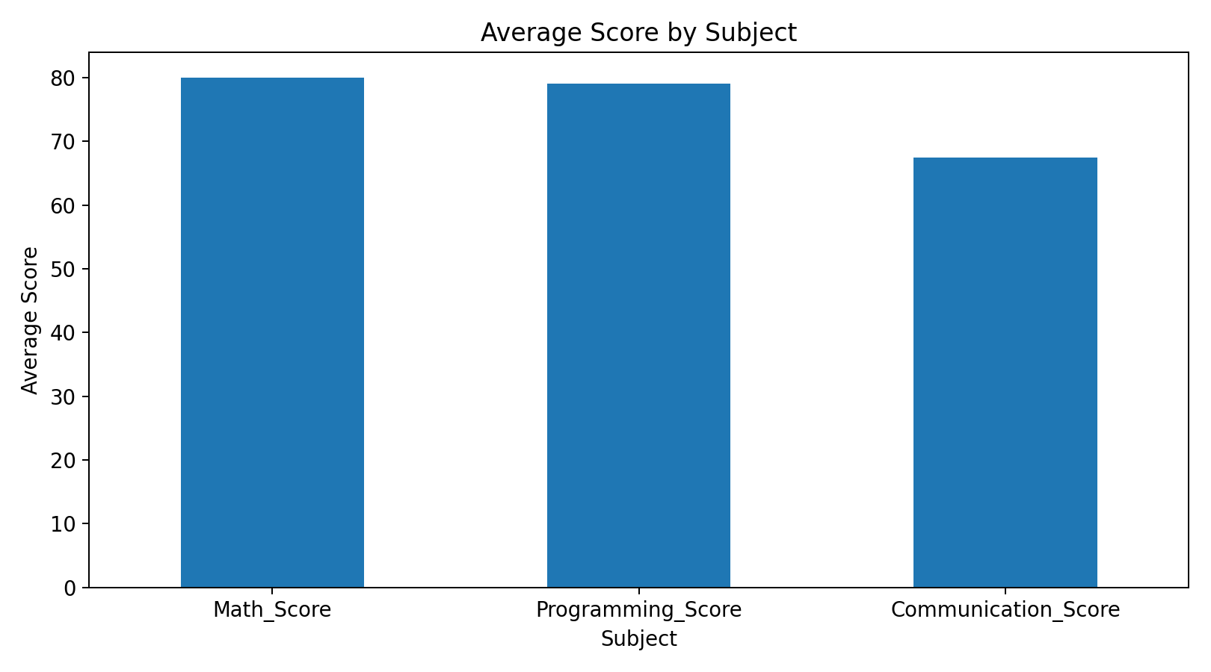
Figure 1. Average Score by Subject
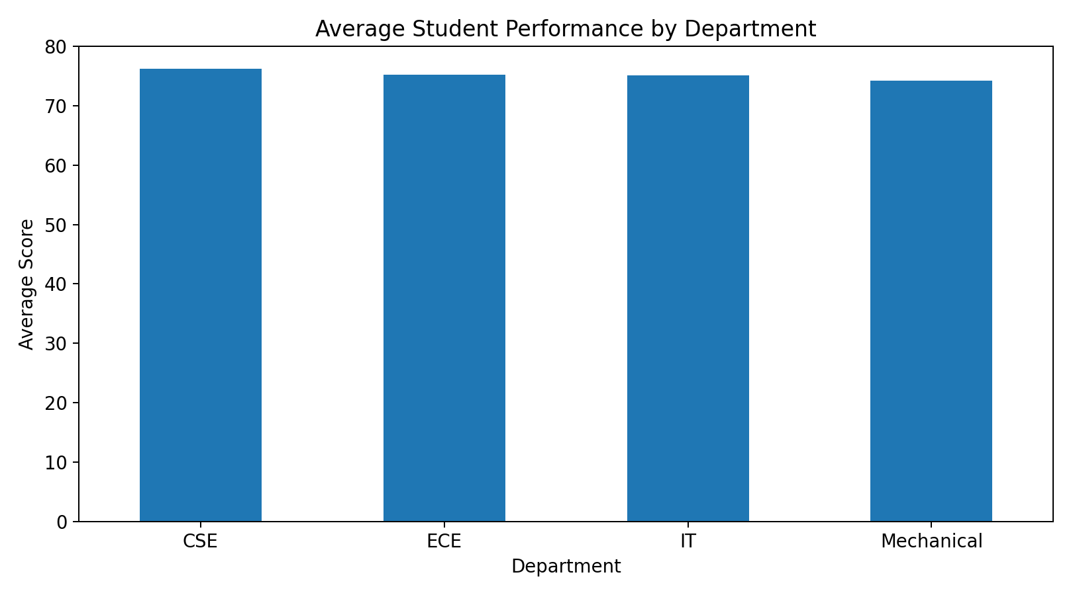
Figure 2. Average Performance by Department
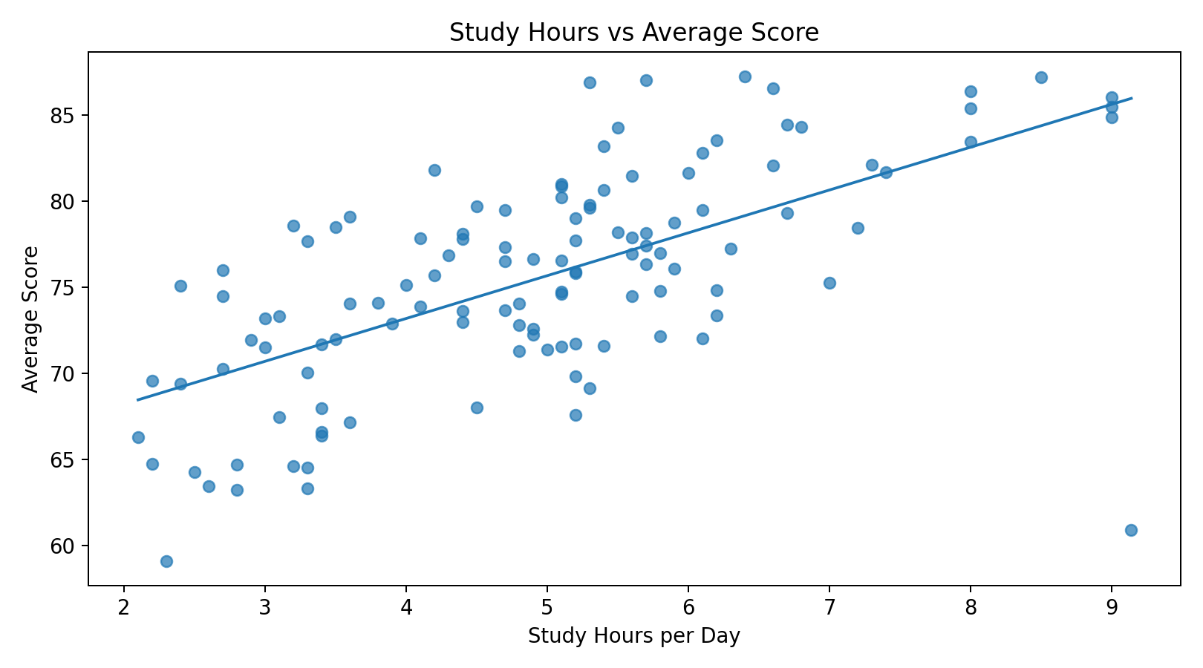
Figure 3. Study Hours vs Average Score
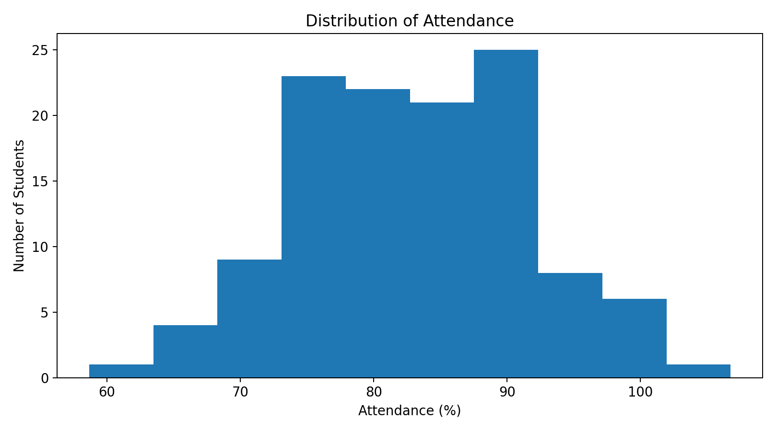
Figure 4. Attendance Distribution
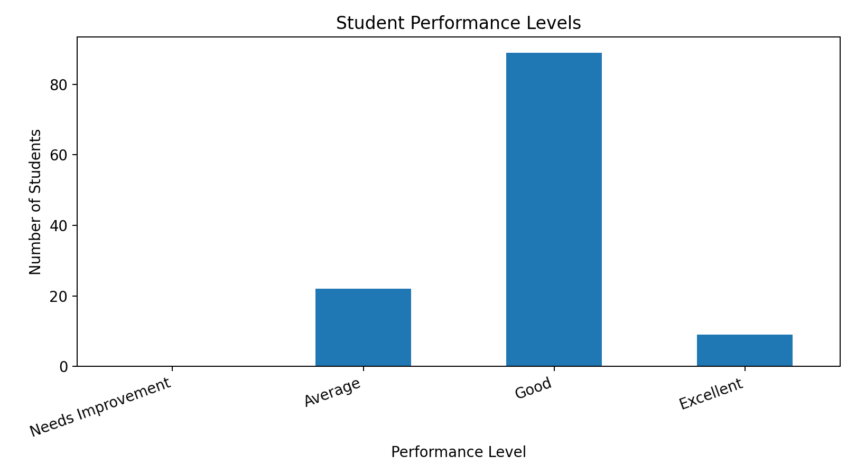
Figure 5. Student Performance Levels
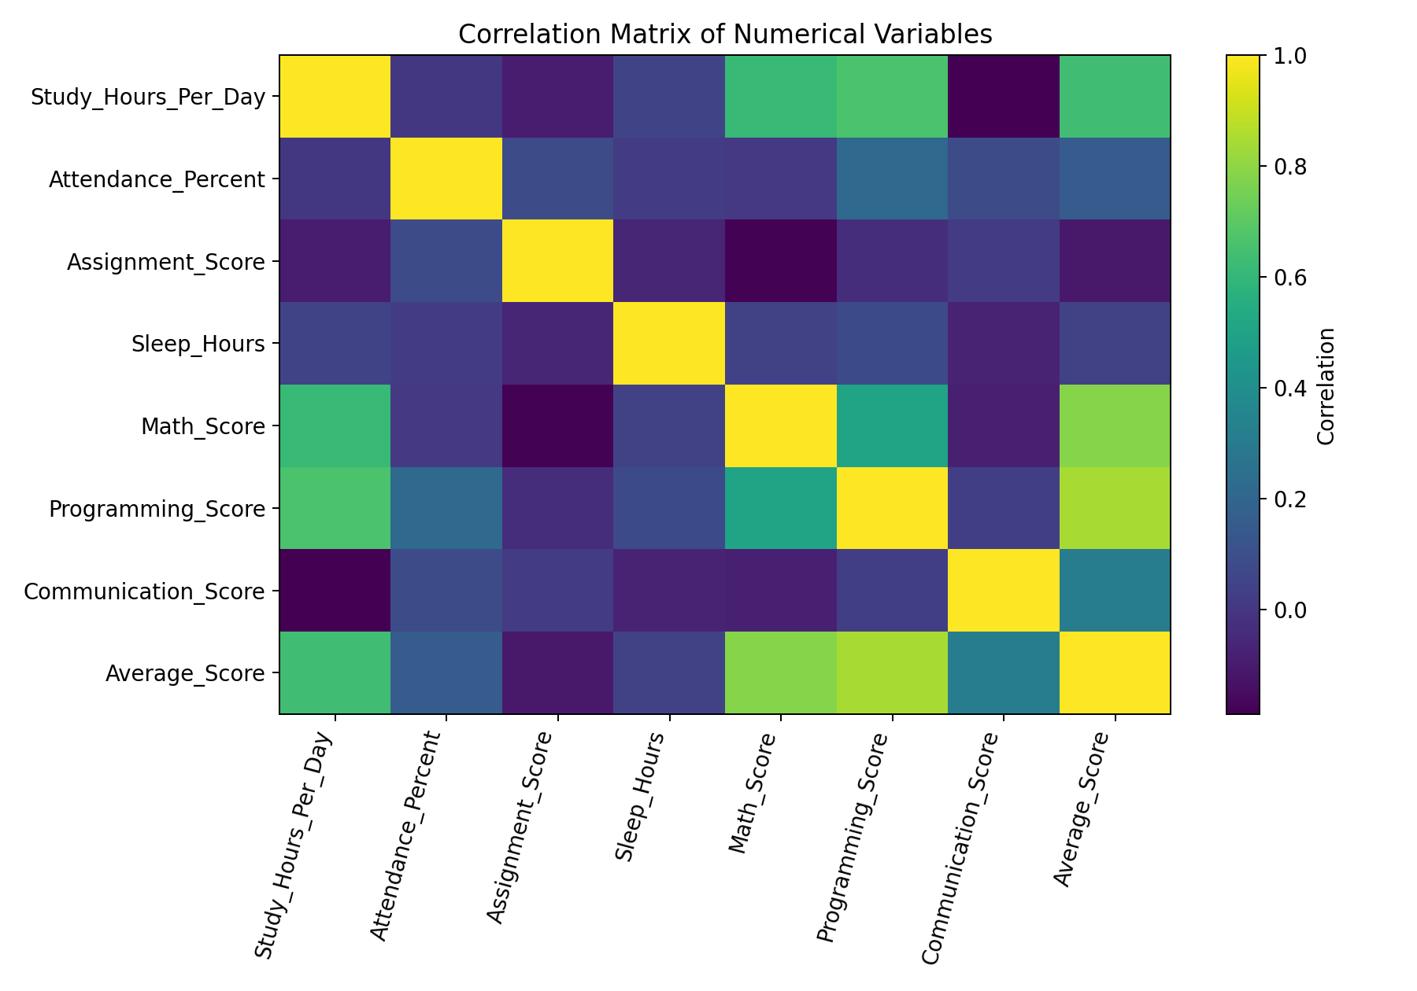
Figure 6. Correlation Matrix
8. Key Insights
- Math_Score is the strongest-performing subject based on the average score.
- CSE records the highest average performance among the four departments in this dataset.
- Study hours show a positive relationship with average academic performance in the cleaned data.
- Attendance is concentrated around a relatively high range, indicating generally regular attendance.
- The most common overall performance category is Good.
- Cleaning the data before visualization improves the reliability and interpretability of the results.
9. Conclusion
This project demonstrates a practical data-analysis workflow from raw data to meaningful insights. The cleaning stage addressed missing values, duplicates, outliers, and data types before analysis was performed. Visualizations then converted numerical results into an understandable form. The project shows how Python can be used to prepare data, discover patterns, and communicate findings effectively. The same workflow can be applied to business, education, healthcare, finance, and other real-world datasets.
10. Files Included
- raw_student_performance.csv – original dataset containing data-quality issues.
- cleaned_student_performance.csv – processed dataset ready for analysis.
- data_cleaning_visualization.py – complete Python source code.
- charts/ – six generated visualization images.
- Project report – this document.

