**ECE3011 –Microwave Engineering**

**A Project Report**

**CIRCULAR RING PATCH ANTENNA DESIGN**

***Submitted by***

**ELAVARTHI SRUTHI 20BEC1028**

**KOLA SAI KISHORE 20BEC1224**

**KOPPARAPU GREESHMA LAKSHMI 20BEC1228**

**DEVARA HIMABINDU 20BEC1353**

**DEPARTMENT OF ELECTRONICS AND COMMUNICATION**

**ENGINEERING**



**Vandalur – Kelambakkam Road**

**Chennai – 600127**

**April 2023**

**BONAFIDE CERTIFICATE**

Certified that this project report e­­­­ntitled “**CIRCULAR RING PATCH ANTENNA DESIGN”** is a bonafide work of **Elavarthi Sruthi (20BEC1028), Kola Sai Kishore (20BEC1224), Kopparapu Greeshma Lakshmi (20BEC1228) and Devara Himabindu (20BEC1353)** who carried out the project work under my supervision and guidance for **ECE3011 - Microwave Engineering**

**DR RAVI PRAKASH DWIVEDI**

Professor

School of Electronics Engineering (SENSE),

Vellore Institute of Technology (VIT Chennai)

Chennai – 600127

**ABSTRACT**

A circular ring patch design is a popular type of microstrip antenna used in wireless communication systems. It consists of a circular patch with a concentric ring structure etched on its surface. The dimensions of the ring and patch determine the operating frequency of the antenna and can be adjusted to provide desirable characteristics such as impedance matching, directivity, and bandwidth. It is low profile, easy to fabricate, and can be used in a wide range of applications, including satellite communication, cellular networks, and radar systems. This provides a brief overview of the circular ring patch design and highlights its key features and advantages.

**ACKNOWLEDGEMENT**

We would like to express our deep gratitude to Dr. Ravi Prakash Dwivedi, Professor for his patient guidance, enthusiastic encouragement, and useful critiques of the analysis.

We would also like to thank Dr. Susan Elias, Dean of School of Electronics Engineering, VIT Chennai, for extending the facilities of the School towards our project and our respective Head of the Departments Dr. Mohanaprasad K, for his support throughout the course of our journey at VIT.

We express thanks to our parents, family, and friends for being the guiding light and providing motivation to keep us going despite the delicate situation worldwide.

 

Elavarthi Sruthi Kola Sai Kishore

(20BEC1028) (20BEC1224)

 

Kopparapu Greeshma Lakshmi Devara Himabindu

(20BEC1228) (20BEC1353)

**TABLE OF CONTENTS**

|  |  |  |  |
| --- | --- | --- | --- |
| **SR. NO.** |  | **TITLE**  **LIST OF FIGURES** | **PAGE NO.** |
|  |  | **ABSTRACT** | 3 |
|  |  | **ACKNOWLEDGEMENT** | 4 |
|  |  |  |  |
| **1**  **2** |  | **INTRODUCTION**   * 1. OBJECTIVE   2. TYPES OF ANTENNAS   3. SOFTWARE REQUIRED   4. BASIC PARAMETERS   **DESIGN PARAMETERS**  2.1 SPECIFICATIONS  2.2 APPLICATIONS  2.3 FEED DESIGN  2.4 RADIATION BOUNDARY  2.5 LIMITATIONS |  |
|  |  |  |  |

**3 LITERATURE REVIEW**

**4**

**CHAPTER 1**

**INTRODUCTION**

A circular ring patch antenna is a type of microstrip antenna that consists of a metallic ring-shaped patch printed on a dielectric substrate. One of the key advantages of the circular ring patch antenna is its ability to support circular polarization. By properly adjusting the dimensions and shape of the ring patch, it is possible to create a circularly polarized radiation pattern that can be used in applications such as satellite communication systems and GPS receivers.

Another advantage of the circular ring patch antenna is its wider bandwidth compared to the rectangular patch antenna. This is due to the fact that the circular ring patch has a more symmetrical geometry that can support multiple resonant modes, leading to a broader frequency response.

However, the circular ring patch antenna also has some limitations, such as a lower gain and a larger physical size compared to other microstrip antennas. It also requires more complex feeding techniques to achieve optimum performance.

* 1. **Objective**
     1. **Short Term Objective (Project):**

Design optimization: The primary objective is to optimize the design of the antenna to ensure that it meets the desired specifications. This may involve selecting the appropriate substrate material, determining the dimensions of the antenna, and optimizing the feed structure. The design should be able to operate at the desired frequency range and have a high radiation efficiency, while maintaining a stable impedance over a wide frequency range and maximizing polarization purity.

Simulation and testing: Once the design is optimized, the short-term objective may be to test the antenna's performance using simulation software and physical testing. The results should be verified to ensure that the antenna meets the desired specifications and that any design issues are identified and addressed.

Fabrication and assembly: After the design is optimized and the performance is tested, the short-term objective may be to fabricate and assemble the antenna. This may involve selecting the appropriate manufacturing process, such as photolithography or laser cutting, and assembling the antenna components in a controlled environment to ensure that the antenna performs as expected.

The short-term objectives for building a circular ring patch antenna are to optimize the design, test the performance, and fabricate and assemble the antenna to ensure that it meets the desired specifications.

* + 1. **Long Term Objective (Product):**

Based on the potential applications of the circular ring antenna and the broader context of wireless communication systems, some potential long-term objectives of the project may include:

Integration into diverse wireless communication systems: The circular ring antenna can be integrated into various wireless communication systems that operate in different frequency bands, such as the UHF, VHF, and microwave bands. This can enable the development of more versatile and adaptable wireless communication systems that can operate in multiple frequency bands and support a wide range of applications.

Improvement of communication system performance: The circular ring antenna can help improve the performance of wireless communication systems by providing better coverage, higher gain, and reduced interference. This can lead to enhanced user experience, increased efficiency, and reduced costs for communication system operators.

Development of new applications and services: The circular ring antenna can enable the development of new applications and services that require high-speed wireless communication capabilities in different frequency bands. For example, the antenna can be used in the development of satellite communication systems, wireless sensors networks, and radar systems.

Advancements in antenna technology: The circular ring antenna can serve as a platform for the advancement of antenna technology, particularly in the areas of miniaturization, bandwidth enhancement, and polarization diversity. This can lead to the development of more compact, efficient, and adaptable antennas that can be used in various wireless communication applications.

Overall, the long-term objectives of the project may involve integrating the circular ring antenna into diverse wireless communication systems, improving communication system performance, enabling the development of new applications and services, and advancing antenna technology.

* 1. **TYPES OF ANTENNAS**

Antennas are metallic structures used to transmit or capture radio electromagnetic signals. Antennas play a key role in transmitting and receiving electromagnetic radiation, as they receive electrical signals from a transmission line and change them into radio waves. Antenna parameters include bandwidth, gain, radiation pattern, polarization, impedance & beamwidth. Antennas provide an easy method to transmit signals wherever other techniques are not possible. For example, the pilot of an airplane needs to converse with the ATC personnel frequently, so the communication between them can be done through wireless communication through antennas. Antennas are used in military applications, such as electronic warfare, surveillance, and communication systems. Antennas are used in medical applications such as magnetic resonance imaging (MRI) to generate and detect radiofrequency signals. There are many types of antennas, each with its own design, characteristics, and applications. Here are some of the most common types of antennas:

**Log periodic Antenna**

A log-periodic antenna is a multi-element, directional narrow beam antenna that works on a wide range of frequencies. The log periodic antenna is characterized by a design that repeats a logarithmic pattern of progressively smaller elements. The log periodic antenna typically consists of a series of parallel wires, with each wire acting as a dipole element for a specific frequency range. It is used in applications with variable bandwidth, gain, and directivity. Bow Tie and Log-Periodic Dipole Array antennas are type of Log periodic antennas.

**Rectangular Microstrip Antennas**

Rectangular Microstrip Antenna consists of a thin, flat rectangular metal patch that is printed on a dielectric substrate, which is usually much thinner than the wavelength of the operating frequency. Low profile antennas are preferred for spacecraft or aircraft applications due to their size, weight, cost, performance, and ease of installation. However, they are inefficient and narrow in bandwidth, with a fraction of a percent or a few percent.

**Planar Inverted – F Antennas**

Planar Inverted-F Antennas are a type of linear Inverted F antenna (IFA) with a plate replacing the wire radiating element to increase the bandwidth. They can be hidden into the mobile housing and reduce backward radiation by absorbing power. The PIFA's radiation pattern is omnidirectional in the horizontal plane, making it useful for applications that require coverage over a wide area. The PIFA is commonly used in applications such as wireless communication systems, including Wi-Fi, Bluetooth, and cellular networks.

**Dipole Antenna**

Dipole antennas are simple to construct and use, consisting of two thin metal rods with a sinusoidal voltage difference between them. The length of the rods is chosen to have a quarter length of the wavelength at operational frequencies. The dipole antenna's radiation pattern is characterized by a figure-eight shape, with the strongest radiation occurring in the direction perpendicular to the axis of the antenna and the weakest radiation occurring along the axis. The radiation pattern is symmetrical, meaning that it is the same in all directions. Half-wave Dipole antenna, Folded dipole antenna, short dipole antenna, log-periodic dipole antenna are some popular types of dipole antenna.

**Short Dipole Antenna**

The short dipole antenna is an open-circuited wire that gives priority to the size of the wire relative to the wavelength of the frequency of operation. The structure of a Short Dipole Antenna consists of two equal-length conductive elements that are positioned end-to-end and separated by an insulating material. The elements are usually made of metal, such as copper or aluminium, and are typically straight rods or wires. One of the main advantages of the short dipole antenna is its small size and low weight, which makes it well-suited for use in portable devices.

**Monopole Antenna**

A monopole antenna is half of a dipole antenna located over a grounded plane, with half the total power radiated and double the directivity. Monopole antennas are commonly used in radio and television broadcasting, cellular and wireless communications, and other applications where a compact and omnidirectional antenna is required. They are also used in RFID systems, where a small and low-cost antenna is required for reading and transmitting data.

**Loop Antenna**

Loop antennas are like dipole and monopole antennas in that they are simple and easy to construct. They are used in communication links with a frequency of around 3 GHz and can also be used as electromagnetic field probes in microwave bands. The antenna's efficiency is dependent on the loop's circumference, which could either be electrically small or electrically large. Small loops are used as receiving antennas, while resonance loops are used at higher frequencies. They have similar characteristics such as high-radiation efficiency.

**Horn Antenna**

Horn antennas are used for feed and calibration antennas, with low SWR, moderate directivity, wide bandwidth, and easy construction & adjustment.

**Parabolic Reflector Antenna**

The parabolic reflector antenna is used in domestic satellite TV reception, general satellite communications, terrestrial microwave data links, and other applications due to its high gain, narrow beamwidths, and high directivity.

**Double Reflector Antenna**

Reduce losses by arranging feeder closer to transmit/receive equipment.

* 1. **SOFTWARE REQUIRED**

**ANYSY Electronic Desktop Software**

ANSYS is a software suite used for engineering simulation and design. It provides a comprehensive set of tools for simulating various physical phenomena such as structural mechanics, heat transfer, fluid dynamics, electromagnetics, and more. It is widely used in various industries such as aerospace, automotive, defence, energy, healthcare, and more. ANSYS provides a wide range of features and capabilities for engineering simulation and design, including Multiphysics simulation, high-performance computing, CAD integration, optimization, material modelling, Multiphysics co-simulation, design exploration, additive manufacturing simulation, virtual testing, and more.

**HFSS in ANSYS**

HFSS (High-Frequency Structure Simulator) is a software tool within the ANSYS suite that is used for simulating high-frequency electromagnetic fields. It is commonly used in the design and analysis of antennas, microwave components, and RF/microwave circuits.

The simulation process in HFSS involves several steps, from geometry creation to results analysis. Geometry creation involves creating a 3D model, material assignment, mesh generation, boundary conditions, excitation setup, simulation setup, solver settings, and results analysis. Results analysis involves visualizing electromagnetic fields, calculating S-parameters, and analyzing radiation patterns. HFSS provides several solver settings to optimize the simulation performance and accuracy.

* 1. **BASIC PARAMETERS**

**Return Loss**

Return loss is a measure of the amount of power reflected by an antenna back towards the transmitter. It is calculated as the ratio of the power of the incident signal to the power of the reflected signal, expressed in decibels (dB). The higher the return loss value, the better the impedance match between the antenna and the transmission line.

**VSWR**

VSWR (Voltage Standing Wave Ratio) is a measure of the amount of reflection that occurs when an electromagnetic wave is transmitted from a source to an antenna. It is defined as the ratio of the maximum voltage to the minimum voltage on the transmission line or at the antenna terminals. It is related to return loss, which is a measure of the amount of power reflected by an antenna. Both parameters are important in antenna design and performance evaluation.

**Fractional Bandwidth**

Fractional bandwidth is a measure of the frequency range over which an antenna can operate efficiently, expressed as a percentage of its center frequency. It is important for broadband applications, as it allows the antenna to operate over a wider range of frequencies. It is difficult to achieve a high fractional bandwidth while maintaining good performance in other areas.

**Resonance Frequency**

Resonance frequency is the frequency at which an antenna exhibits the maximum response or sensitivity. It is determined by the physical dimensions and geometry of the antenna, as well as the dielectric properties of the surrounding medium. It can be affected by a variety of factors, such as nearby objects, other antennas, and the characteristics of the signal being transmitted or received.

**Gain**

Gain is a measure of the directional effectiveness of an antenna in transmitting or receiving electromagnetic waves. It is the ratio of the radiation intensity of an antenna in a given direction to that of a hypothetical isotropic antenna, and is commonly expressed in decibels (dB). Gain is an important parameter in antenna design and is used to describe the performance of real-world antennas compared to ideal isotropic antennas.

**Efficiency**

Antenna efficiency is the ratio of radiated power to total input power, which determines the overall performance of an antenna. It can be calculated using the formula: (Radiated power) / (Total input power). It can be affected by factors such as the quality of the materials used, the design, and the environment in which the antenna is used.

**Directivity**

Directivity is a measure of the concentration of radiation in a particular direction from an antenna. It is a fundamental parameter of antenna performance that describes how well an antenna can transmit or receive electromagnetic waves in a particular direction. It is the ratio of the radiation intensity of an antenna in each direction to that of a hypothetical isotropic antenna and is commonly expressed in decibels (dB). It can also be expressed in terms of a beamwidth, which is the angular separation between the half-power points of the radiation pattern.

**Radiation Pattern**

A radiation pattern is a graphical representation of the relative strength of the electromagnetic field radiated by an antenna in various directions. It provides information about the directionality and polarization of the radiated energy and is an important tool for antenna design and analysis. Different types of antennas have different radiation patterns and are optimized for different applications.

**CHAPTER 2**

**DESIGN PARAMETERS**

* 1. **SPECIFICATIONS**

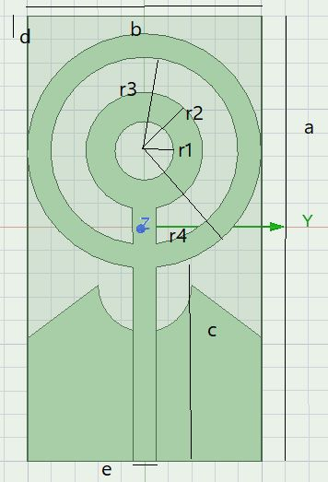

a=38mm, b=20mm, c= 17mm, d=2mm, e=2mm

r1=3mm, r2=5mm, r3=8mm, r4=10mm,

Thickness of substrate=1.6mm

Material of substrate=FR4 epoxy

Permittivity =4.4

Gain= 2.614dB from 4.77 to 6.39 GHz

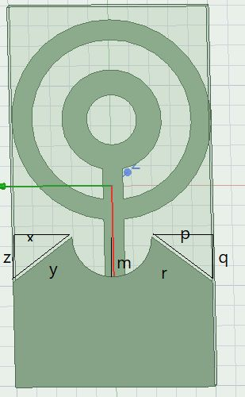

p=6mm, r=7.5mm, q=4.5mm

z=4.5mm, y=7.5mm, x= 6mm, m=4mm

**2.1.8 FEED DESIGN**

The feed design of a circular ring patch antenna is typically a coaxial cable connected to the center of the circular ring, which acts as a resonant element. There are several types of feed designs, such as microstrip line feed, proximity feed, and aperture-coupled feed.

**Microstrip line feed**

Microstrip lines are used to connect a circular ring patch to a coaxial cable, which is designed to match the impedance of the coaxial cable.

**Coplanar Waveguide**

A CPW feed is a transmission line used to feed electromagnetic energy into an antenna. It is connected to the antenna through a transition structure that matches the impedance of the feed to the impedance of the antenna. It provides a balanced transmission line, wide bandwidth, and low loss transmission.

**Aperture coupled feed**

The coaxial cable is connected to a probe that extends through the aperture and couples energy into the patch antenna.

**Direct coaxial feed**

The coaxial cable is connected to the circular ring patch at a point opposite the ground plane, but this can lead to unwanted modes of radiation

**Proximity feed**

The loop antenna induces a current in the circular ring patch, which excites the coaxial cable.

**2.1.9 RADIATION BOUNDARY**

The radiation boundary of a circular ring patch antenna is the region in space where the electromagnetic waves radiated by the antenna have a significant amplitude. It is determined by the geometry of the antenna, the frequency of operation, and the radiation pattern of the antenna. The size of the radiation boundary depends on the wavelength of the radiation and the resonant frequency of the antenna. To calculate the radiation boundary, numerical electromagnetic simulation software can be used. It is important to ensure that the radiation boundary does not interfere with other nearby electronics or communication systems by carefully designing the antenna and using appropriate shielding and filtering techniques. In some cases, it may also be necessary to adjust the orientation of the antenna to avoid interference.

**2.2 APPLICATIONS**

* Circular ring patch antennas have a wide range of applications across various fields, such as wireless communication, radar systems, remote sensing, medical applications, RFID, and navigation systems.
* They offer a low profile, flexible design, and wide bandwidth, making them suitable for use in a range of applications.
* Circular ring patch antennas are commonly used in wireless communication systems, radar systems, remote sensing, medical applications, RFID, and navigation systems. They offer high directivity and sensitivity, making them ideal for long-range detection and tracking.

**CHAPTER 3**

**LITERATURE REVIEW**

[1] Title of the paper is Design of a Dual Band SNG Metamaterial Based Antenna for LTE 46/WLAN and KA-Band Application, the technique used is SNG meta surface. Surface impedance can be varied and manipulated by patterning the meta surface unit cells, which has broad applications in surface wave absorbers and surface waveguides. They also enable beam shaping in both transmission and reflection. Another important application is to radiate in a leaky wave mode as an antenna. The return loss of the antenna is -11dB to -32.4dB, gain of the antenna is 4.52dB to 9.13dB for desired Ka band and 1.17 to 5.04dB for LTE 46/WLAN band, band width of the antenna is-10 dB (from 5.35-5.69GHz for LTE 46/WLNA and 17.81-20.67GHz for Ka-Band) and size of the antenna is 20.2*28.4 mm^2.

The advantages are the monopole antenna has many conventional advantages such as small size, lightweight as well as easy to fabricate. All these features make the monopole antenna, a suitable candidate for the wireless communication systems and disadvantages are like one of major limitations of this antenna is low gain which is not desirable specifically in case of higher frequencies. These requirements have led to much research into antenna development using monopole configuration.

[2] Title of the paper is Metamaterial Inspired planar Broadband Antenna, the technique used is rectangular strip to improve the impedance match of the antenna without much alteration in the resonant frequency. The Permittivity used for this antenna is 4.4, VSWR Bandwidth 60.5% from 750MHz to 1.4GHz, GSM 800(880-960MHz) and ISM 900(902-928MHz), size of the antenna is 50*30mm, VSWR ratio of the antenna is 2:1. Return loss of the antenna is 9.54 dB.

The advantages are the meandering element metamaterial which is proved by extracted negative permittivity, and the disadvantages are When the thickness of the substrate is increased, keeping all the other parameters constant, there is a slight increase in the lower resonating frequency. At the same time this results in a considerable increase in the higher resonance matching, with a slight decrease in its resonating frequency.

[3] Title of the paper is Design of Metamaterial Based Multilayer Antenna for Navigation/Wi-Fi/Satellite Applications, the technique used is microstrip line feed, insert feed and quarter-wave feed. Permittivity used for this antenna is 4.4, return loss of the antenna is 1.40dB, 1.56dB, gain of the antenna is 3.73dBi, 6.18dBi, 1.35dBi, band width used fi=or the antenna is 2.10%, 2.18%, 2.09%, size of the antenna is 35*45 mm, frequency of the antenna 1.13GHz, 2.47GHz, 2.74GHz. The advantages are metamaterial antenna design has size five times smaller with wider bandwidth. It does not require active phase shifters or amplifiers unlike traditional phased array antenna. It offers wide angle scanning and excellent beam performance. It offers electronically controlled pointing and polarization. Antennas are flat, light in weight and small. The disadvantages are it is difficult to manufacture metamaterial-based antennas in large quantities. It works for limited range of wavelengths. The shape of the antenna cannot be changed during operation.

[4] Title of the paper is Dual-band Microstrip Patch Antenna Using Integrated Uniplanar Metamaterial-Based EBG, the technique used is MTM-EBG (Metamaterial based electromagnetic bandgap). A recently proposed MTM-based structure, known as the metamaterial-based electromagnetic bandgap structure (MTM-EBG), can realize many of the same dual-band and filtering properties, while being realized in a fully planar, fully printable, and highly compact manner. Permittivity of this antenna is 3, return loss of the antenna is 10dB, bandwidth of the antenna is 1.9dB, 3.6dB, gain of the antenna is 2.6dBi, 6.6dBi, size of the antenna is 28.2*21.0 mm, frequency of the antenna is 2.4GHz, 5.2GHz.

The advantages are the resulting antenna is compact, uniplanar, completely printable, and via-free. Dispersion engineering of the MTM-EBG unit cell through a rigorous multiconductor transmission-line analysis allows simple, systematic design for two or more arbitrary frequencies. The disadvantages are It offers a lower gain. Narrow bandwidth associated with a tolerance problem.

[5] Title of the paper is Optimized Metamaterial Loaded Square Fractal Antenna for Gain and Bandwidth Enhancement, the technique used is OMSFA The OMSFA produces enhanced gain of 9.8 dB at 2.5 GHz. The radiation is more focused because of metamaterial loading. The proposed antenna is recommended for wireless application in the lower region (S band) of the microwave spectrum. The return loss of antenna is resonates well with a deep return loss of -38.9 dB , gain of the antenna is OMSFA produces enhanced gain of 9.8 dB at 2.5 GHz., band width of the antenna is broad bandwidth of 3.2 GHz (128 %) between 2 GHz and 5.2 GHz, size of the antenna is antenna layer spreads over an area of 23 square millimetre on a FR4 substrate whose dielectric permittivity is 4.4. The substrate size measures an area of 46 mm X 28 mm, with 1.6 mm thickness.

The advantages are from the study of performance of OMSFA, it is clearly noticed that the proposed antenna provides enhanced gain of 9.8 dB with a broad BW of 3.2 GHz and a deep RL value of -38.9 dB at 2.5 GHz compared to the SFA without SRR loading. This proposed antenna is recommended for wireless and energy harvesting applications in S band (2-4 GHz). Disadvantages is it's very expensive.

[6] Title of the paper is Performance analysis of CPW-fed hexagonal shaped metamaterial antenna For WiMAX/WLAN applications, the technique used is DNG material. Materials that exhibit both negative permittivity and negative permeability simultaneously are called double-negative (DNG) metamaterials, materials. Return loss of the antenna is return losses at given resonance frequencies are better than -10 dB, gain of antenna is 3.88 dB. Efficiency of the antenna is 97.5, band width of the antenna is metamaterial hexagonal shaped antenna constitute bandwidth of (3.20-3.9) GHz, 700MHz at 3.61 GHz and (4.90 - 5.72 )GHz, 820 MHz at 5.15 GHz., size of the antenna is Dimensions of the proposed geometry of antenna is 29.6×21.7 in mm and thickness of dielectric substrate is 1.6 mm.

To improve impedance matching and for good efficiency trapezoidal form rectangular type of ground plane is exploited. The design of antenna is demonstrating good omnidirectional type radiation pattern in H-plane and eight type bi-directional pattern in E-plane. The disadvantages are Sensitive to Electric and Magnetic fields.

**CHAPTER 4**

**DESIGN AND IMPLEMENTATION**

* 1. **Full ground and Outer ring**

Substrate- Length=40mm, Width=20mm, Thickness=1.6mm

Outer ring dimensions

Outer circle radius=10mm

Inner circle radius=8mm

Patch length=18.5mm, width=2mm

Full ground

Design:

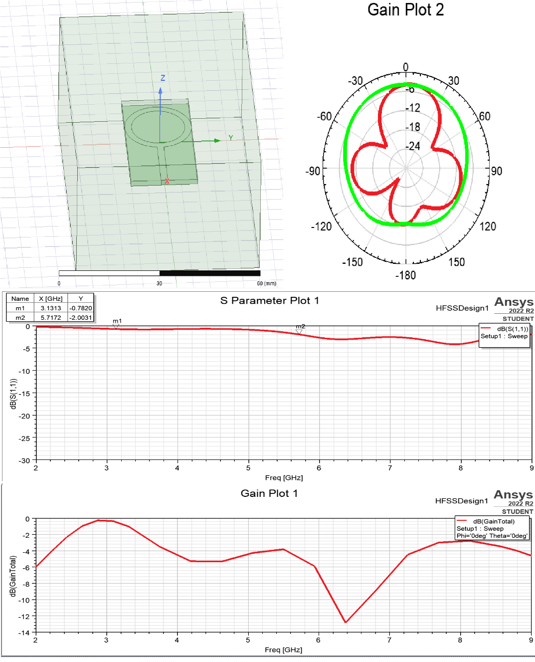

* 1. **Full ground and Inner ring**

Substrate- Length=40mm, Width=20mm, Thickness=1.6mm

Inner ring dimensions

Outer circle radius=5mm

Inner circle radius=3mm

Patch length=24mm, width=2mm

Full ground

Design:

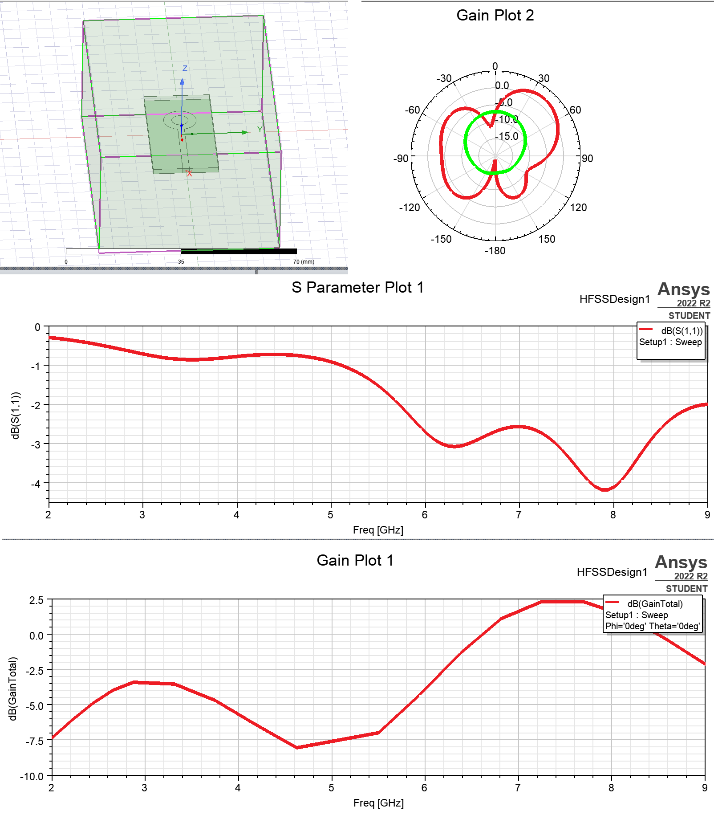

**4.3 Half ground, both Inner and Outer rings**

Substrate- Length=40mm, Width=20mm, Thickness=1.6mm

Outer ring dimensions

Outer circle radius=10mm

Inner circle radius=8mm

Inner ring dimensions

Outer circle radius=5mm

Inner circle radius=3mm

Patch length=17mm, width=2mm

Ground = 20mm

Design:

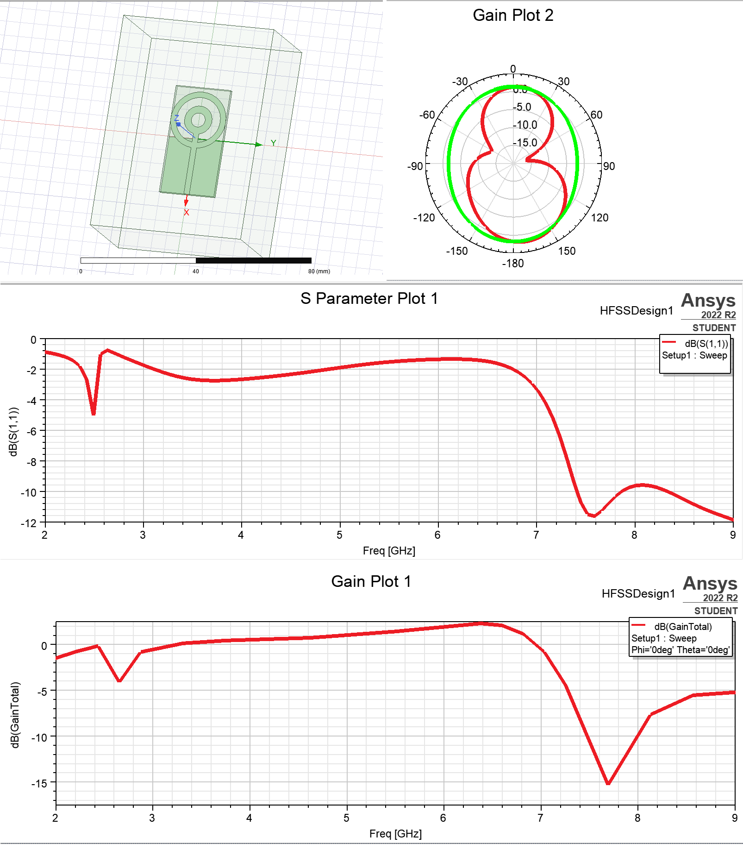

Part-2:

Substrate- Length=38mm, Width=20mm, Thickness=1.6mm

Outer ring dimensions

Outer circle radius=10mm

Inner circle radius=8mm

Inner ring dimensions

Outer circle radius=5mm

Inner circle radius=3mm

Patch length=24mm, width=2mm

Ground=17mm

Design:

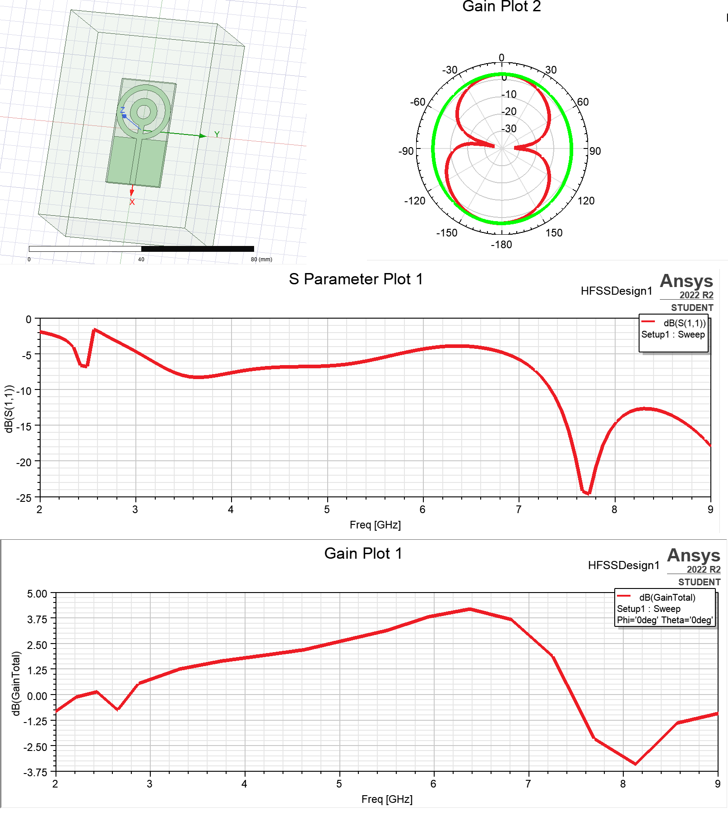

Part-3:

Substrate- Length=38mm, Width=20mm, Thickness=1.6mm

Outer ring dimensions

Outer circle radius=10mm

Inner circle radius=8mm

Inner ring dimensions

Outer circle radius=5mm

Inner circle radius=3mm

Patch length=24mm, width=2mm

Ground=10mm

Design:

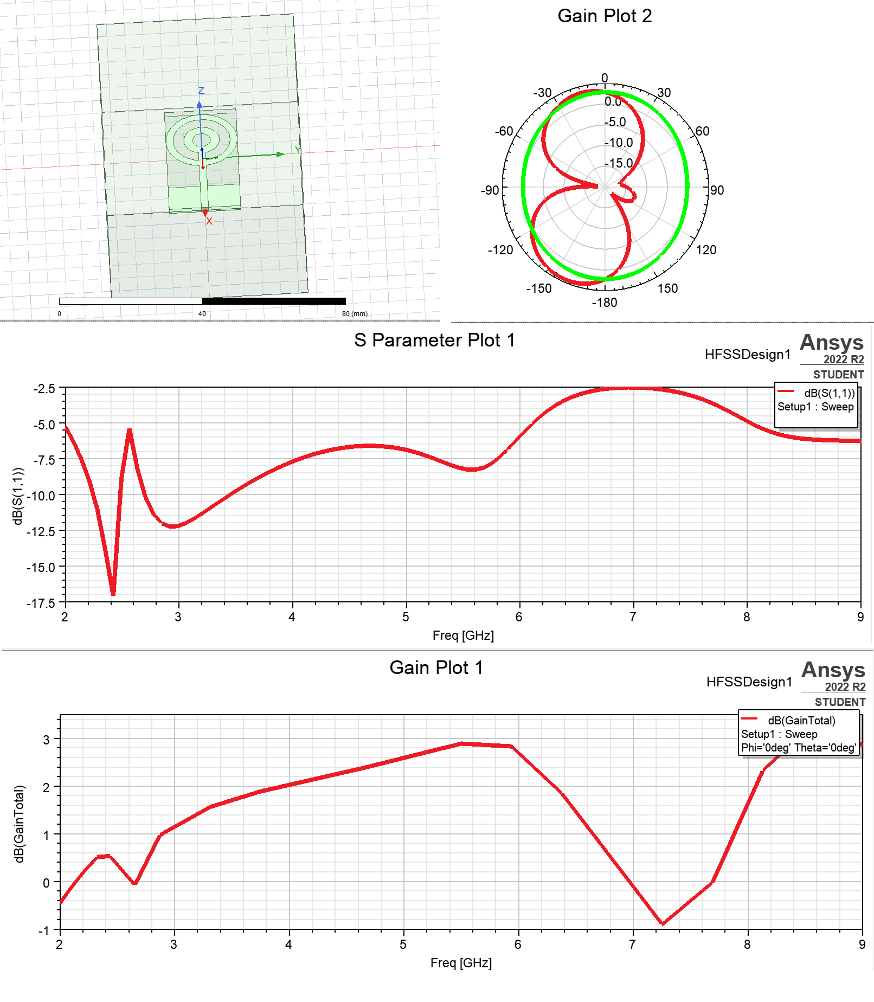

1. **Ground- triangles, both Inner and Outer rings**

Substrate- Length=38mm, Width=20mm, Thickness=1.6mm

Outer ring dimensions

Outer circle radius=10mm

Inner circle radius=8mm

Inner ring dimensions

Outer circle radius=5mm

Inner circle radius=3mm

Patch length=24mm, width=2mm

Ground=17mm

Design:

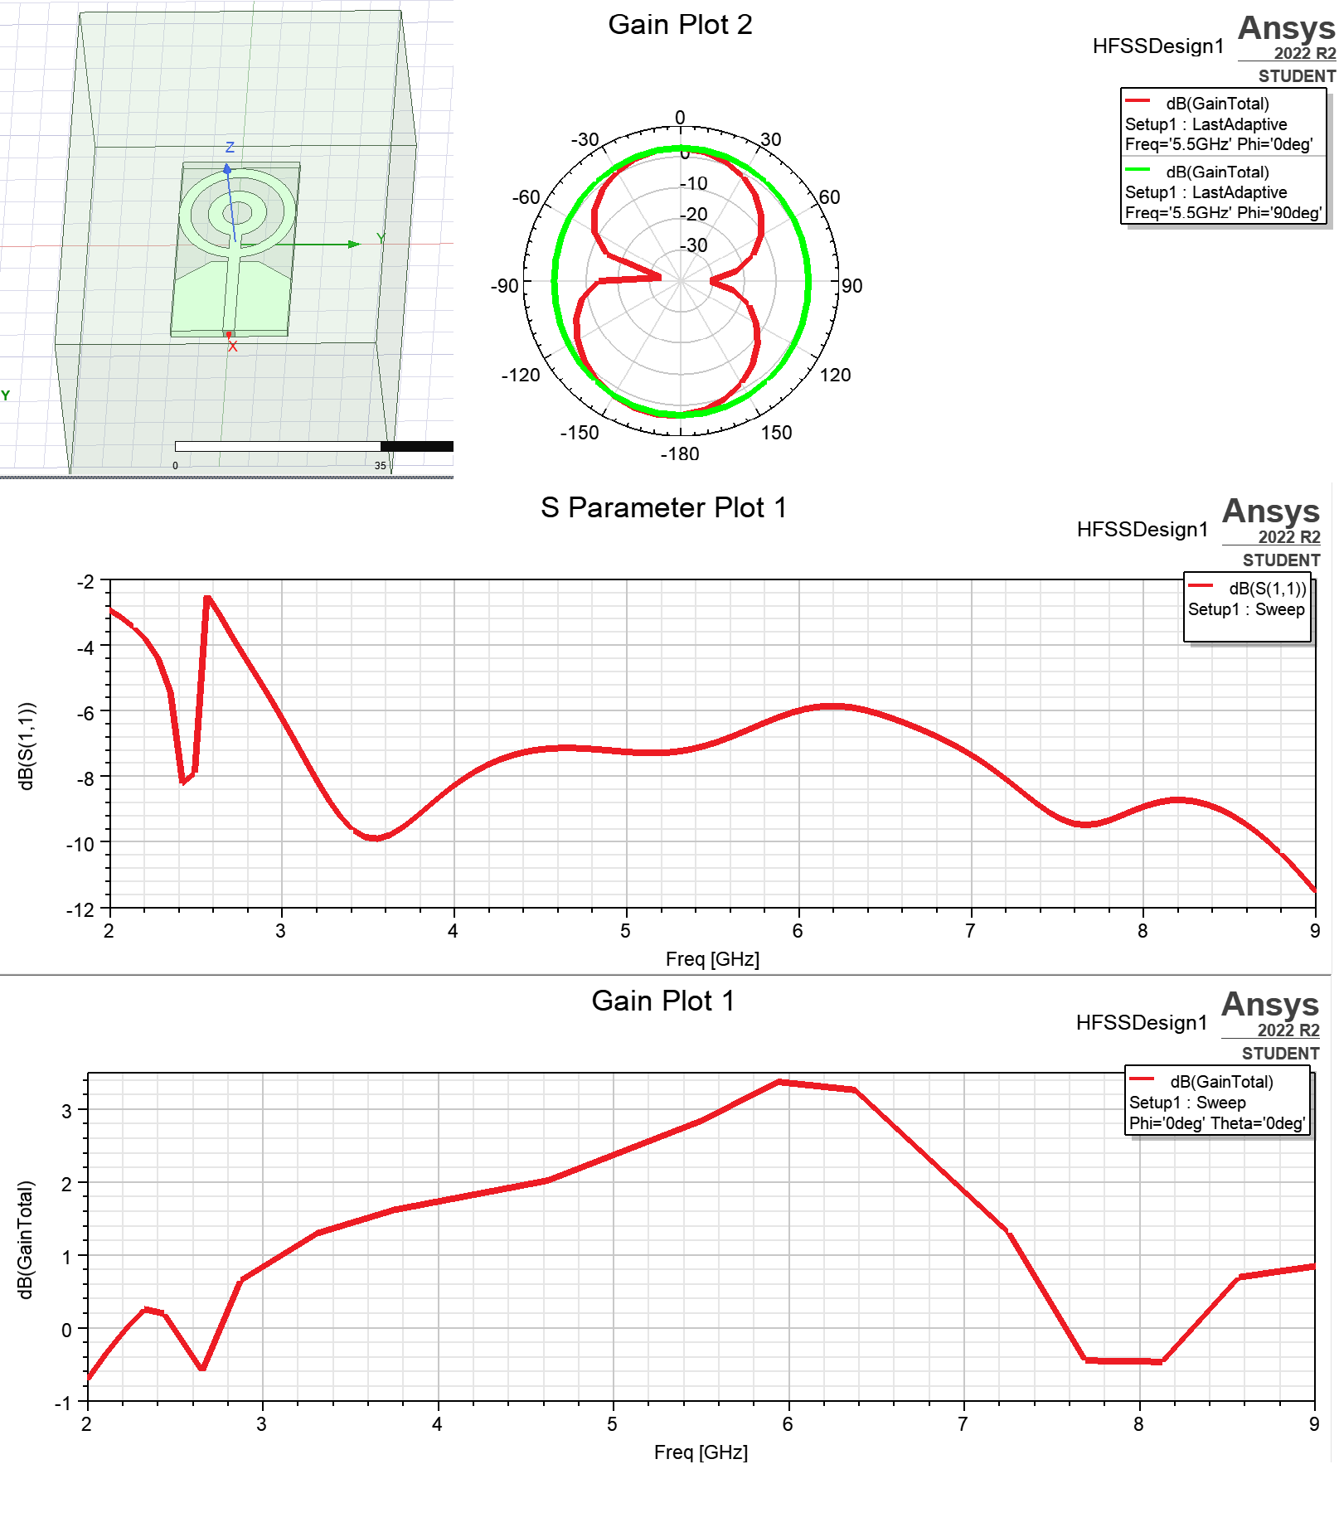

1. **Ground-triangles-circle, both Inner and Outer rings**

Substrate- Length=38mm, Width=20mm, Thickness=1.6mm

Outer ring dimensions

Outer circle radius=10mm

Inner circle radius=8mm

Inner ring dimensions

Outer circle radius=5mm

Inner circle radius=3mm

Patch length=24mm, width=2mm

Ground=15mm

Circle cut from ground radius=4mm

Design:

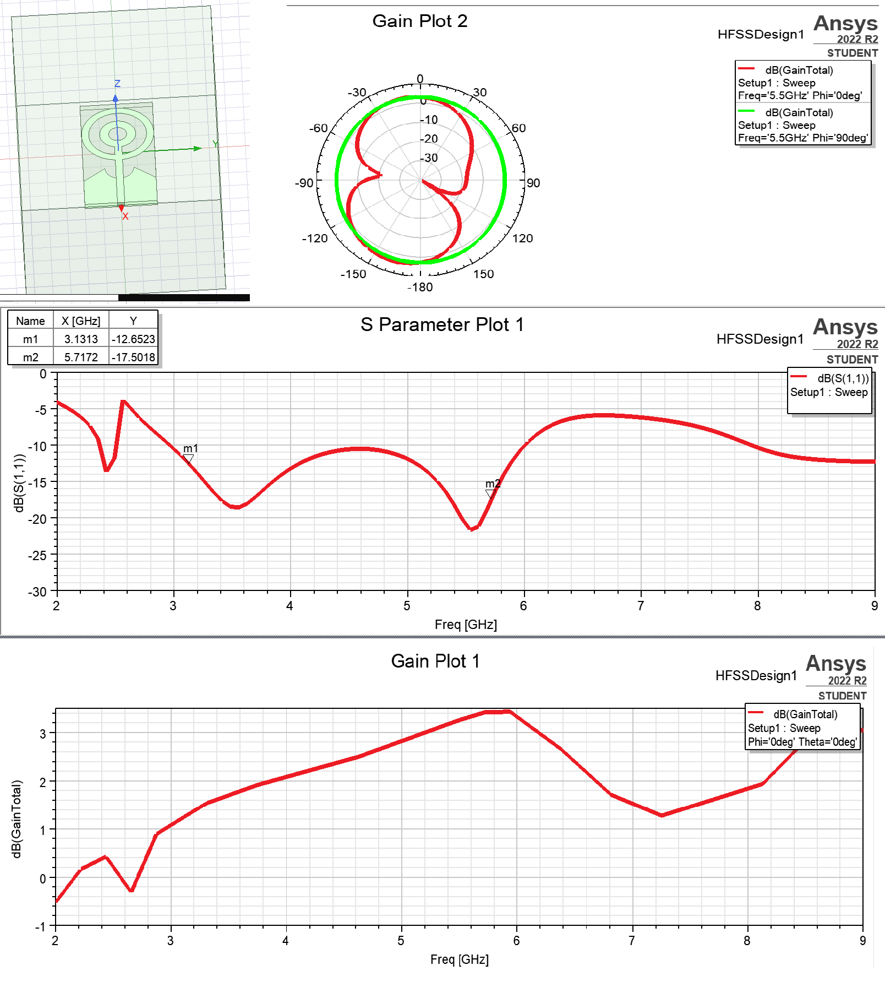

**CHAPTER 4**

**RESULTS AND INFERENCE**

**4.1 RESULTS**

**S – PARAMETER PLOT**

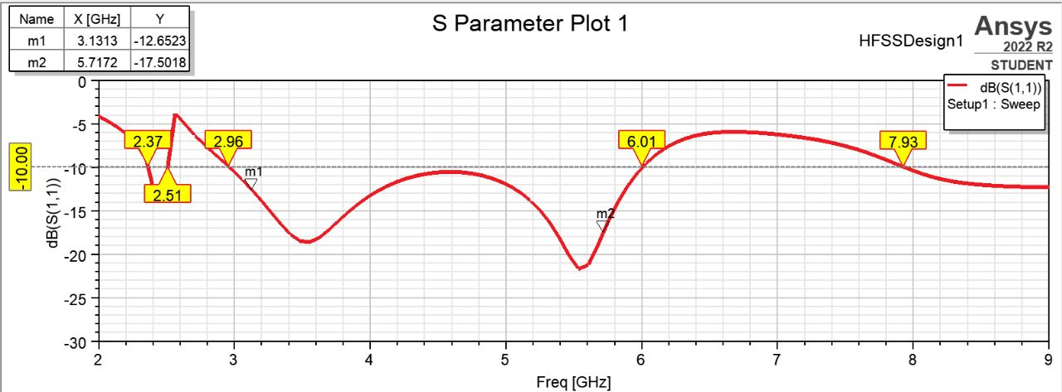

Figure 1 : S Parameters Plot 1

**GAIN PLOT**

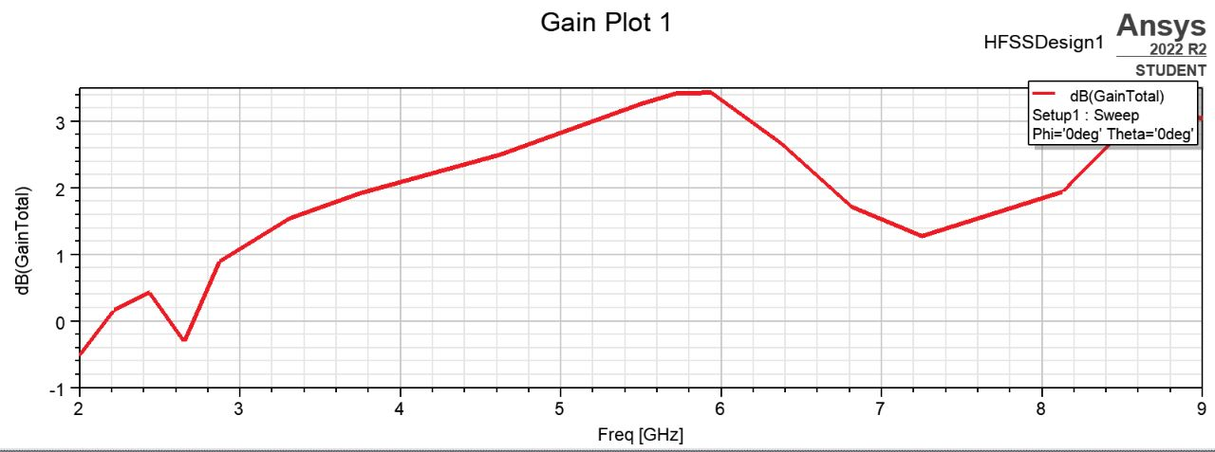

Figure 2 : Gain Plot 1

**RADIATION PATTERN**

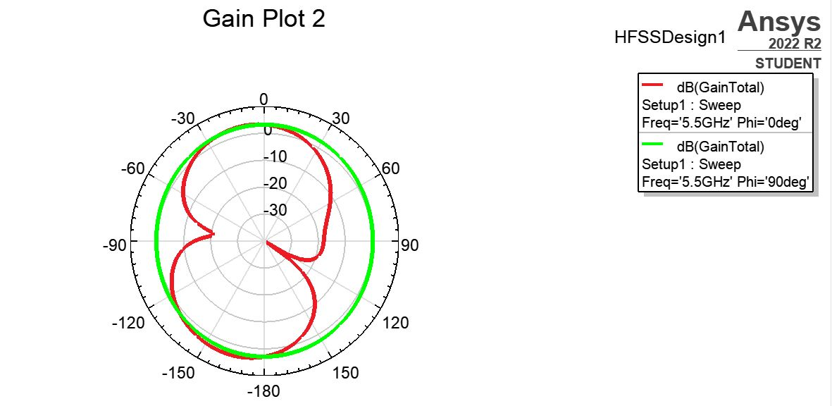

Figure 3 ; Radiation Pattern

**4.2 INFERENCE**

**4.3 LIMITATIONS**

Circular ring patch antennas have several limitations that can affect their performance in certain applications. These include a narrow operating bandwidth, low gain, sensitivity to polarization, susceptibility to environmental factors, and limited power handling capability.

Despite these limitations, circular ring patch antennas are still widely used in various applications due to their compact size, low profile, and ease of fabrication. Despite these limitations, circular ring patch antennas are still widely used due to their compact size, low profile, and ease of fabrication.

**CHAPTER 5**

**CONCLUSION & FUTURE SCOPE**

**5.1 Conclusion**

A circular-ring patch antenna has been explained. The circular-ring patch is gained by introducing two circular slot rings and half length ground with two triangles and half circle excluded in it with proper feeding technique. It can also be concluded that implementation of the metallic structure with the patch enhances the gain, directivity and the radiation efficiency. The antenna gives a maximum peak gain with Omni-Directional radiation pattern and high efficiency. A reconfigurable antenna has been successfully designed for wireless applications with sufficient qualification. Here we have done for 6 cases such as Full Ground and Outer Ring, Full Ground and Inner Ring, Half Ground & both Inner and Outer Rings, Ground-triangle & both Inner and Outer Rings, Ground-triangle-circle & both Inner and Outer Rings. The best outputs of scattering parameter plot, gain plot and radiation pattern got from Ground-triangle-circle & both Inner and Outer Rings.

**5.2 Future Scope**

* The circular ring patch antenna can be optimized for wideband operation, multi-polarization operation, metamaterial integration, dual-band operation, 5G and beyond operation, and high-frequency operation.
* Wideband design allows the antenna to operate over a wider range of frequencies than its current design, while multi-polarization operation allows the antenna to support multiple polarization modes.
* Metamaterial integration can reduce the antenna size, improve radiation efficiency, and increase the bandwidth.
* Dual-band operation allows the antenna to operate at two different frequency bands simultaneously, while 5G and beyond operation allows the antenna to operate in millimetre-wave frequencies and integrated with other millimetre-wave components.

**REFERENCES**

[1] Kang Ding, Yong-Xin Guo and Cheng Gao, “CPW-Fed wideband circularly polarized printed monopole antenna with open-loop and asymmetric ground plane”, IEEE Antennas and Wireless Propagation Lett., vol. 16, pp.833-836, 2017.

[2] Rohit Kumar Saini, Santanu Dwarf, and Mrinal Kanti Mandal, “CPWFed dual-band dual-sense circularly polarized monopole antenna”, IEEE Antennas and Wireless Propagation Lett., vol. 16, pp. 2497-2500, 2017.

[3] Garg. R., Bhartia. P. Bahl &Ittipiboon A. “Microstrip Antenna Design Handbook”, Artech House Norwood, 2001.

[4] Yonghao Xin, Quanyuan Feng, and Dengyao Tian, “A microstrip-linefeed tri-band monopole antenna for WLAN/WiMAX applications”, Progress In Electromagnetic Research Symposium (PIERS), pp. 2747- 2751, August 2016.

[5] You-Jhu Chen, Te-Wei Liu, and Wen-Hua Tu, “CPW-Fed penta-band slot dipole antenna based on comb-like metal sheets”, IEEE Antennas and Wireless Propagation Lett., vol. 16, pp. 202-205, 2017.

[6] Hsiao-Yun Li, Che-Ting Yeh, Jun-Jie Huang, Che-Wei Chang, ChenTsung Yu, and Jia-Shiang Fu, “CPW-Fed frequency-reconfigurable slot loop antenna with a tunable matching network based on ferroelectric varactors”, IEEE Antennas and Wireless Propagation Lett., vol. 14, pp. 614-617, 2015.

[7] Ritesh Kumar badhai1 and Nisha Gupta, “Compact asymmetric coplanar strip fed sinc shaped monopole antenna for multiband applications”, International Journal of Microwave and Wireless Technologies, pp.205– 211, 2017.

[8] Jing Pei, An-Guo Wang, Shun Gao, and Wen Leng, “Miniaturized triple-band antenna with a defected ground plane for WLAN/WiMAX applications”, IEEE Antennas and Wireless Propagation Lett., vol. 10, pp. 298-301, 2011.

[9] M. Ramírez, J. Parrón, J. M. González-Arbesú, and J. Gemio, “Concentric annular-ring microstrip antenna with circular polarization”, IEEE Antennas and Wireless Propagation Lett., vol. 10, pp. 517- 519, 2011.

[10] Emilio Arnieri, Luigi Boccia, Giandomenico Amendola and Giuseppe Di Massa, “A Compact High Gain Antenna for Small satellite Applications”, IEEE Transactions on Antennas and Propagation, vol. 55, no. 2, pp. 277-282, 2007.

[11] Avinash R. Vaidya, Rajiv K. Gupta, Sanjeev K. Mishra, and Jayanta Mukherjee, “Right-Hand/Left-Hand Circularly Polarized High-Gain Antennas Using Partially Reflective Surfaces”, IEEE Antennas and Wireless Propagation Letters, vol. 13, pp. 431-434, 2014.

[12] Young sub-Kim and Young Joong Yoon, “Slot-Coupled Circularly Polarized Array Antenna With Substrate-Integrated Waveguide Cavity for Parallel-Plate-Mode Suppression”, IEEE Transactions on Antennas and Propagation, vol. 65, no. 8, pp. 3999-4006, 2017.

[13] M. Fallah-Rad and L. Shafai, “Gain enhancement in linear and circularly polarized microstrip patch antennas using shorted metallic patches”, IEE Proc.-Microw. Antennas Propag., vol. 152, no. 3, pp. 138-148, 2005.

[14] Xin Hu, Yuanxin Li, Wenkuan Chen, Hong-Zhou Tan, and Yunliang Long, “Novel Dual-Frequency Microstrip Antenna With Narrow HalfRing and Half-Circular Patch”, IEEE Antennas Wireless Propagation Lett., vol. 12, pp. 3-6, 2013.

[15] T. Kumar and A. R. Harish, “Broadband circularly polarized printed slot-monopole antenna”, IEEE Antennas Wireless Propagation Lett., vol. 12, pp. 1531–1534, 2013.