Open folder in vs code.In terminal, to initialize empty git repository,

C:\Users\HP\Desktop\garbage airlines\git session>git init

For first time using git, create user on system

C:\Users\HP\Desktop\garbage airlines\git session>git config --global user.name "Sruthi-Maria"

C:\Users\HP\Desktop\garbage airlines\git session>git config --global user.email "sruthi.maria.jasmine@gmail.com”

C:\Users\HP\Desktop\garbage airlines\git session>git status

To stage/track changes in the file main.py

C:\Users\HP\Desktop\garbage airlines\git session>git add main.py

C:\Users\HP\Desktop\garbage airlines\git session>git status

To stage all files in repository

C:\Users\HP\Desktop\garbage airlines\git session>git add .

To commit

C:\Users\HP\Desktop\garbage airlines\git session>git commit -m "feat: wrote hello world"

To see commits

C:\Users\HP\Desktop\garbage airlines\git session>git log

Connecting repository to github

On github, create new repository

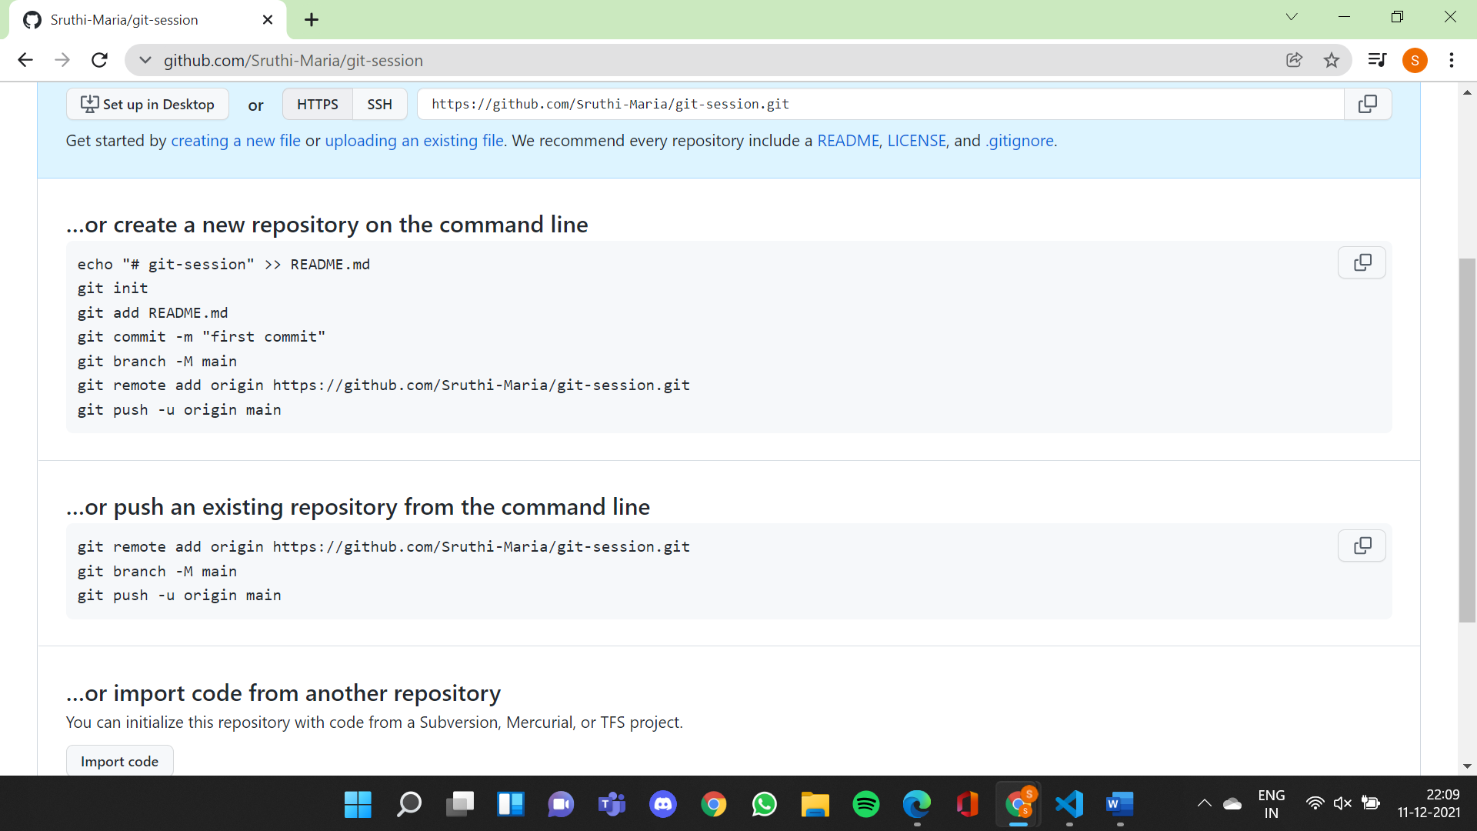

Add remote origin to local repository

C:\Users\HP\Desktop\garbage airlines\git session>git remote add origin https://github.com/Sruthi-Maria/git-session.git

C:\Users\HP\Desktop\garbage airlines\git session>git branch -M master

(for default setting, branch name is master (also shown on bottom tab of vscode))

to push changes/commits made to local repository to remote repository

but to connect local repository to remote repository first-> telling github by default push to https://github.com/Sruthi-Maria/git-session.git repository of master branch

C:\Users\HP\Desktop\garbage airlines\git session>git push --set-upstream origin master

Create a branch on github

C:\Users\HP\Desktop\garbage airlines\git session>git branch dev

To switch from main branch to dev branch

C:\Users\HP\Desktop\garbage airlines\git session>git checkout dev

(current branch can be seen on tab below)

Or shortcut to create and switch

C:\Users\HP\Desktop\garbage airlines\git session>git checkout -b dev2

To list all branches in repository and specify current branch

C:\Users\HP\Desktop\garbage airlines\git session>git branch

To delete a branch, switch to another branch first

C:\Users\HP\Desktop\garbage airlines\git session>git checkout dev

C:\Users\HP\Desktop\garbage airlines\git session>git branch

C:\Users\HP\Desktop\garbage airlines\git session>git branch -d dev2

Making a commit on dev branch