TRAFFICTELLIGENCE:ADVANCED TRAFFIC VOLUME ESTIMATION WITH MACHINE LEARNING

* Pre Requisites
* Prior Knowledge
* Project Objectives
* Project Flow
* Project Structure
* Data Collection
* Data Pre-Processing
* Model Building
* Application Building

**TrafficTelligence: Advanced Traffic Volume Estimation with Machine Learning**

TrafficTelligence is an advanced system that uses machine learning algorithms to estimate and predict traffic volume with precision. By analyzing historical traffic data, weather patterns, events, and other relevant factors, TrafficTelligence provides accurate forecasts and insights to enhance traffic management, urban planning, and commuter experiences.

**Scenario 1: Dynamic Traffic Management** TrafficTelligence enables dynamic traffic management by providing real-time traffic volume estimations. Transportation authorities can use this information to implement adaptive traffic control systems, adjust signal timings, and optimize lane configurations to reduce congestion and improve traffic flow.

**Scenario 2: Urban Development Planning** City planners and urban developers can leverage TrafficTelligence predictions to plan new infrastructure projects effectively. By understanding future traffic volumes, they can design road networks, public transit systems, and commercial zones that are optimized for traffic efficiency and accessibility.

**Scenario 3: Commuter Guidance and Navigation** Individual commuters and navigation apps can benefit from TrafficTelligence's accurate traffic volume estimations. Commuters can plan their routes intelligently, avoiding congested areas and selecting optimal travel times based on predicted traffic conditions. Navigation apps can provide real-time updates and alternative routes to improve overall travel experiences.

**Technical Architecture**

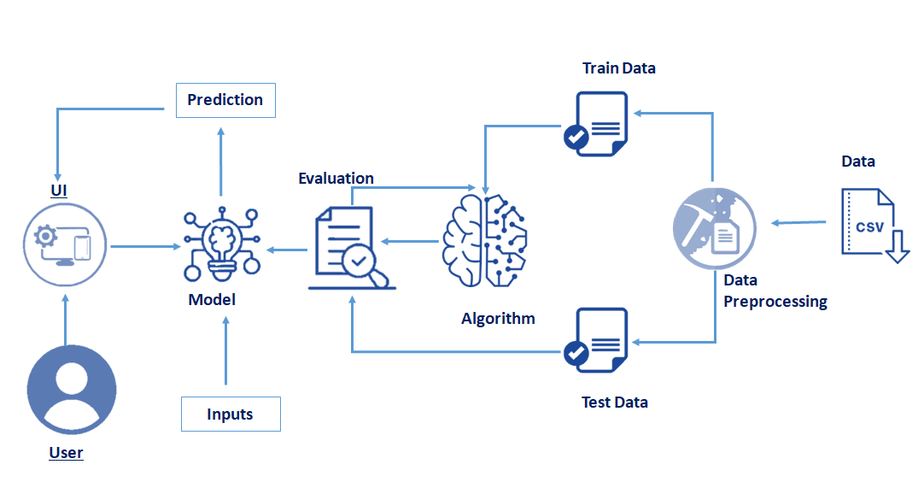

1.Pre Requisites

In **Machine Learning (ML)**, there are several **prerequisites** that help you build a strong foundation before diving into algorithms and model building. Here’s a categorized list of key prerequisites:

**🔢 1. Mathematics**

Understanding the math behind ML helps in grasping why algorithms work the way they do.

* **Linear Algebra**: Vectors, matrices, matrix multiplication, eigenvalues, eigenvectors
* **Calculus**: Derivatives, gradients, partial derivatives (especially for optimization and gradient descent)
* **Probability & Statistics**:
  + Probability theory (Bayes' theorem, conditional probability)
  + Descriptive statistics (mean, median, variance)
  + Distributions (normal, binomial, etc.)
  + Hypothesis testing and p-values

**💻 2. Programming (especially Python)**

Python is the most widely used language in ML due to its rich ecosystem.

* Basic syntax and data structures
* Writing functions and classes
* Using libraries like:
  + NumPy and Pandas for data manipulation
  + Matplotlib and Seaborn for visualization
  + Scikit-learn, TensorFlow, or PyTorch for ML

**📊 3. Data Handling & Preprocessing**

Understanding data and preparing it properly is often the most time-consuming parData cleaning (handling missing values, duplicates)

* Feature engineering (creating and selecting useful features)
* Normalization and scaling
* Data splitting (train/test/validation)

**🧠 4. ML Concepts & Algorithms**

Once the foundations are strong, start learning ML-specific concepts:

* Types of ML: Supervised, Unsupervised, Reinforcement Learning
* Common algorithms:
  + Linear/Logistic Regression
  + Decision Trees, Random Forests
  + k-Nearest Neighbors (k-NN)
  + Support Vector Machines (SVM)
  + Clustering (K-Means, DBSCAN)
  + Neural Networks and Deep Learning

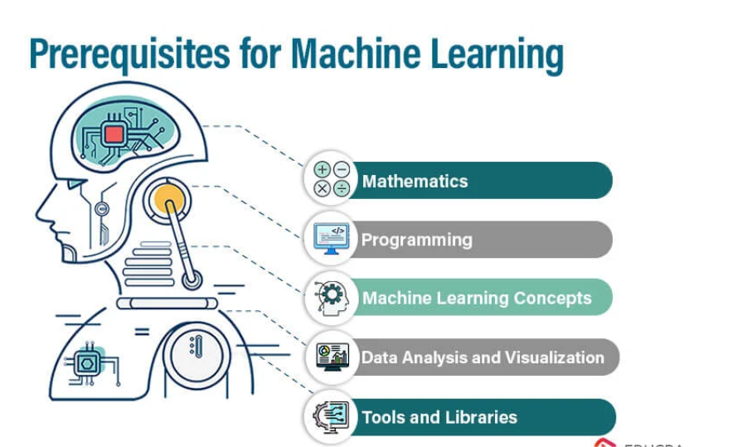

2.Prior Knowledge:

It helps guide model design, reduce the amount of training data required, and improve generalization.

**Types of Prior Knowledge in ML**

1. **Domain Knowledge**
   * Insights from experts about the problem area.
   * Example: In healthcare, knowing that certain symptoms correlate with specific diseases.
2. **Feature Engineering**
   * Using prior knowledge to create or select meaningful input features.
   * Example: Creating a "BMI" feature from height and weight.
3. **Constraints or Rules**
   * Hard or soft constraints based on physical laws or business logic.
   * Example: A model predicting prices shouldn't output negative values.

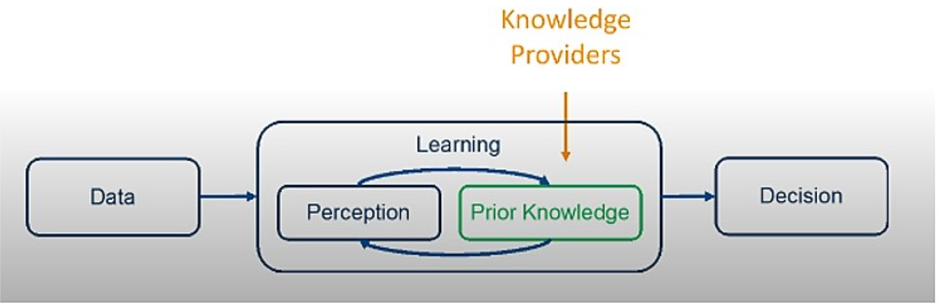

3.Project Objectives:

**1. Accurate Traffic Volume Prediction**

* Develop machine learning models to estimate vehicular traffic volume with high accuracy.
* Focus on various time intervals (e.g., hourly, daily, weekly) and different locations (e.g., urban roads, highways).

**2. Utilize Multisource Data**

* Integrate multiple data sources such as:
  + Historical traffic data
  + Weather data
  + Road infrastructure (lanes, intersections)
  + Temporal features (holidays, weekdays, time of day)
  + Event data (e.g., concerts, sports events)

**3. Model Comparison and Evaluation**

* Compare performance of various ML models:
  + Traditional: Linear Regression, Random Forest, XGBoost
  + Deep Learning: LSTM, GRU, CNN, Transformer-based models
* Use evaluation metrics such as MAE, RMSE, MAPE, and R².

**4. Real-time and Scalable Deployment**

* Explore real-time prediction feasibility using streaming data (e.g., from sensors or GPS)

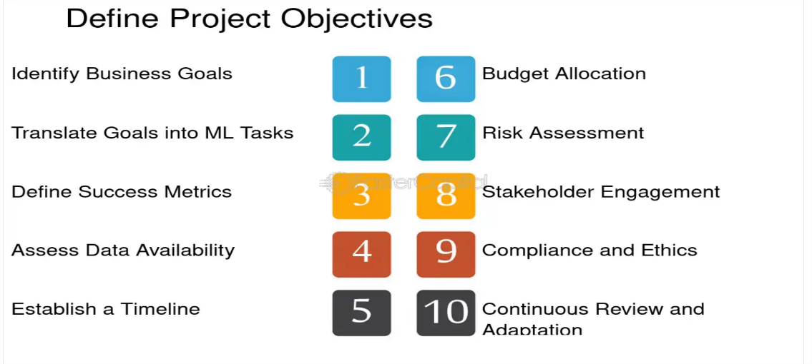

4.project flow:

**1.Problem Definition**

* **Understand the business objective** (e.g., predict churn, classify images).
* **Define the ML task**: classification, regression, clustering, etc.
* **Set success metrics** (accuracy, RMSE, precision, recall, etc.).

**2. Data Collection**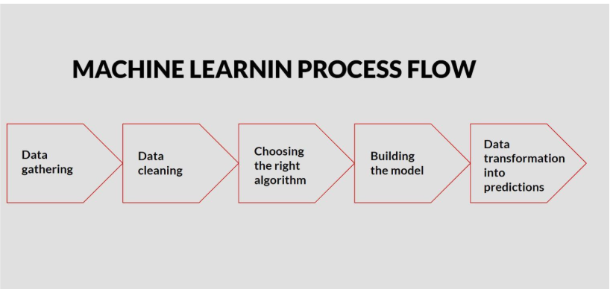

* Gather data from:
  + Databases
  + APIs
  + Web scraping
  + CSV/Excel files, etc.

**3. Data Preprocessing**

* **Data cleaning**: Handle missing values, outliers, duplicates.
* **Data splitting**:
  + Train set
  + Validation set (optional)
  + Test set

**4. Exploratory Data Analysis (EDA)**

* Use visualizations and statistics to understand data:
  + Distribution plots, correlation heatmaps
  + Relationships between features
* Detect patterns, trends, and anomalies.

**5. Model Selection**

* Choose appropriate algorithms:
  + Regression: Linear Regression, Random Forest, etc.
  + Classification: Logistic Regression, SVM, XGBoost, etc.
  + Clustering: K-Means, DBSCAN, etc.
* Consider baseline models first.

**6. Model Training**

* Train models using training data.
* Use cross-validation to prevent overfitting.
* Tune hyperparameters using techniques like Grid Search or Random Search.

**7. Model Evaluation**

* Evaluate using validation/test data.
* Common metrics:
  + Classification: Accuracy, F1-score, ROC-AUC
  + Regression: MAE, RMSE, R².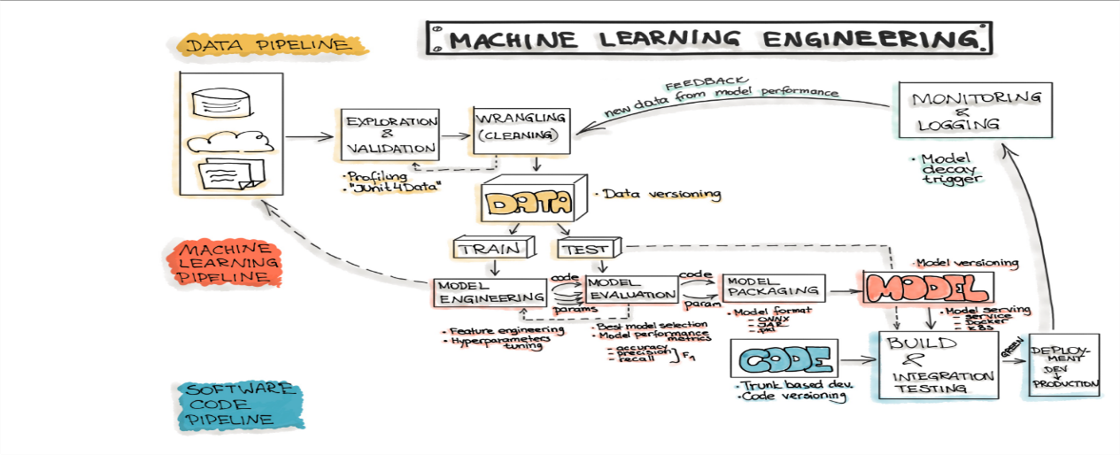

5.project structure:

my_ml_project/

│

├── data/ # Raw and processed data

│ ├── raw/ # Original immutable data dumps

│ └── processed/ # Cleaned and transformed data

│

├── notebooks/ # Jupyter notebooks for EDA, prototyping

│ └── exploratory.ipynb

│

├── src/ # Source code for the project

│ ├── __init__.py

│ ├── data/ # Data loading and preprocessing

│ │ └── load_data.py

│ ├── features/ # Feature engineering scripts

│ │ └── build_features.py

│ ├── models/ # Training and evaluation code

│ │ ├── train_model.py

│ │ └── evaluate_model.py

│ ├── visualization/ # Scripts for visualizations

│ │ └── visualize.py

│ └── utils/ # Utility functions

│ └── helpers.py

│

├── models/ # Trained models and serialized pipelines

│ └── model.pkl

│

├── config/ # Configuration files for parameters, paths

│ └── config.yaml

│

├── tests/ # Unit tests

│ └── test_model.py

│

├── requirements.txt # Python dependencies

├── setup.py # If making it a pip-installable package

├── README.md # Project overview

└── .gitignore # Ignore unnecessary files in version control

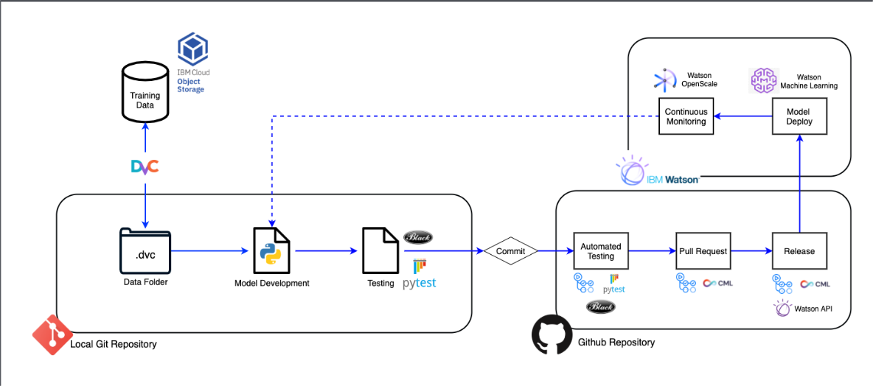

6.Data Collection:

**Data collection** is the process of gathering and measuring information from various sources to build datasets for training, validating, and testing ML models.

* Ensures **data consistency and integrity**
* Allows for **efficient storage and retrieval**
* Serves as the foundation for **analytics, reporting, and machine learning**
* Supports **business decision-making** and operational systems

**1. Manual Entry**

* Via forms, spreadsheets, or user interfaces
* Typically used in small-scale or early-stage applications

**2. Automated Systems**

* Applications automatically insert/update data (e.g., online orders, CRM)

**3. ETL Pipelines (Extract, Transform, Load)**

* Pull data from various sources → Clean → Load into DBMS
* Tools: Talend, Apache NiFi, Informatica, Airflow

**4. API Integration**

* Data from external services (e.g., weather APIs, payment gateways) is pushed to the DB

**5. Sensors / IoT**

* Devices stream data to the DBMS (often through edge computing or time-series DBs)

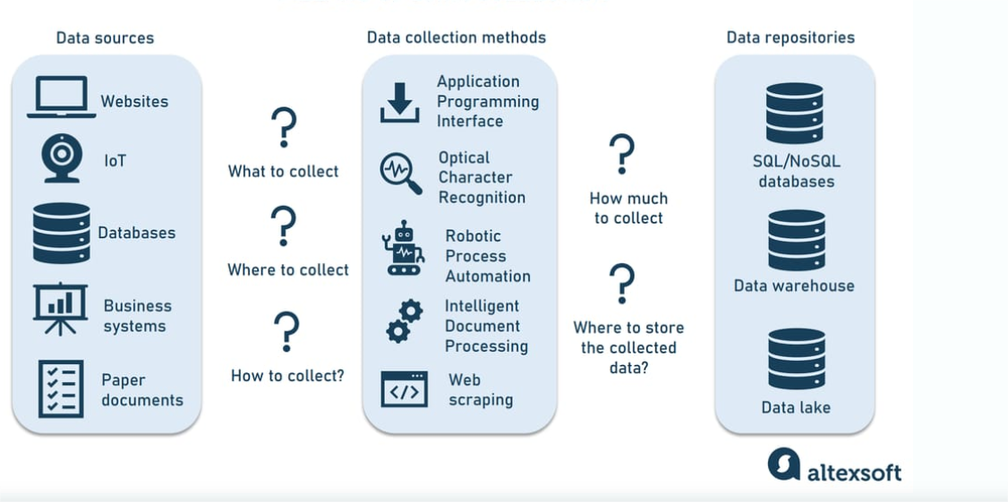

7.Data Pre-processing:

Data preprocessing is a crucial step in any **Machine Learning (ML)** pipeline. It involves transforming raw data into a clean, structured, and meaningful format so that your model can learn effectively from it. Without proper preprocessing, even the best machine learning algorithms might not perform well.

**1. Data Cleaning**

* **Handle Missing Data**: Some data may be missing or null.
  + Techniques:
    - **Imputation**: Replace missing values with mean, median, mode, or use algorithms like KNN or regression for prediction.
    - **Dropping**: Remove rows/columns with too many missing values.

**2. Data Transformation**

* **Normalization/Scaling**: Models like SVM, KNN, and neural networks perform better when features are on similar scales.
  + **Min-Max Scaling**: Rescales the data to a range, typically [0, 1].
  + **Standardization**: Centers the data (mean = 0) and scales it by standard deviation.

**3. Handling Outliers**

Outliers can negatively impact models, especially sensitive ones like linear regression or SVM. Common techniques:

* **IQR (Interquartile Range)**: Identify outliers as values outside 1.5 times the IQR.
* **Z-Score**: Identify outliers based on how far data points are from the mean.

**4.Splitting Data**

After preprocessing, it's important to **split your data** into training, validation, and test sets:

* **Training Set**: For training the model.
* **Validation Set**: For hyperparameter tuning and model evaluation.
* **Test Set**: For final model evaluation.

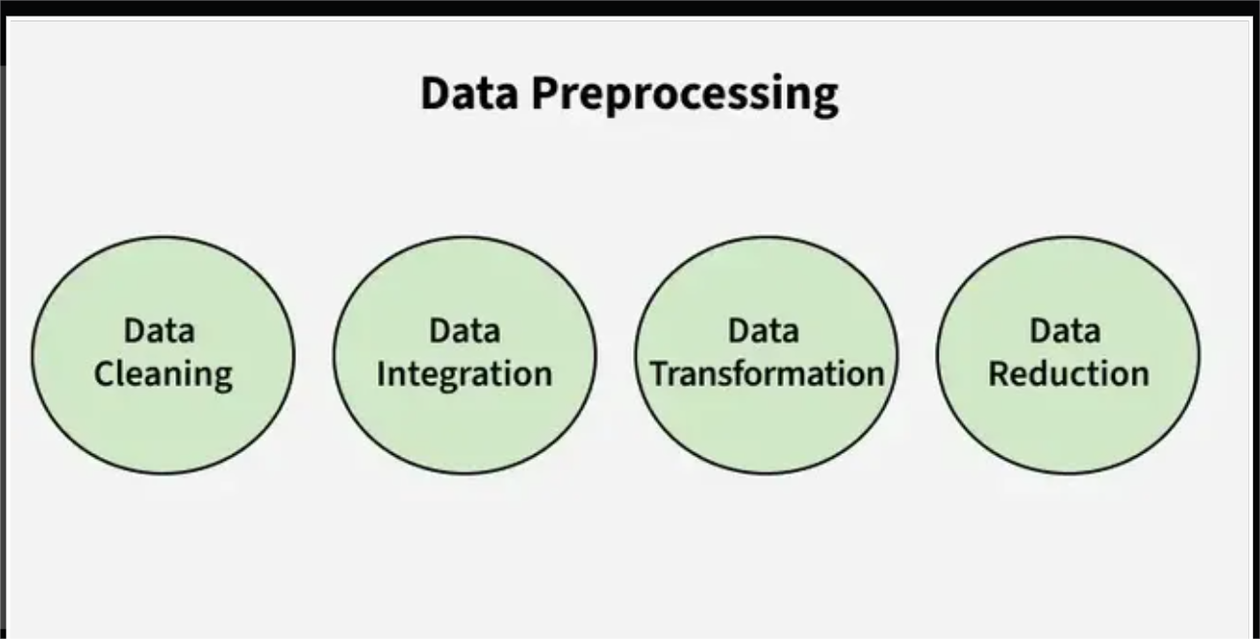

8.Model Building:

Model building is the process of selecting, training, and evaluating a machine learning model on the preprocessed data to make predictions, classify data, or generate insights. It’s one of the most crucial steps in the ML pipeline, and it’s where the **magic happens** in terms of solving the problem at hand.

**1. Define the Problem**

* What type of problem are you solving? Classification, regression, clustering, etc.
* **Examples**: Predicting house prices (regression), detecting spam emails (classification), customer segmentation (clustering).

**2. Select the Algorithm**

* Choose the right algorithm based on the type of problem and the nature of your data. Some common choices:
  + **Classification**: Logistic Regression, Decision Trees, Random Forest, SVM, KNN, XGBoost, Neural Networks
  + **Regression**: Linear Regression, Decision Trees, Random Forest, Ridge/Lasso Regression, XGBoost, Neural Networks
  + **Clustering**: K-means, DBSCAN, Hierarchical Clustering
  + **Dimensionality Reduction**: PCA, LDA
  + **Deep Learning**: CNNs (for images), RNNs (for sequential data like time series or text)

**3. Prepare the Data**

* **Features & Labels**: Separate the data into features (X) and the target variable (y).
* **Train-Test Split**: Split your data into training and testing sets to evaluate the model's performance.
* **Cross-validation**: Use techniques like k-fold cross-validation to validate the model's performance.

Example:python

CopyEdit

from sklearn.model_selection import train_test_split

X = df.drop('target', axis=1)

y = df['target']

X_train, X_test, y_train, y_test = train_test_split(X, y, test_size=0.2, random_state=42)

**4. Train the Model**

* Train the chosen algorithm using the training data.
* Adjust hyperparameters (e.g., learning rate, number of trees, etc.) to improve performance.

Example (Logistic Regression):

python

CopyEdit

from sklearn.linear_model import LogisticRegression

model = LogisticRegression()

model.fit(X_train, y_train)

**5. Evaluate the Model**

* After training the model, assess its performance on the test data.
* Common evaluation metrics:
  + **Classification**: Accuracy, Precision, Recall, F1-score, ROC-AUC
  + **Regression**: Mean Squared Error (MSE), Mean Absolute Error (MAE), R-squared
  + **Clustering**: Silhouette Score, Inertia (for K-Means)

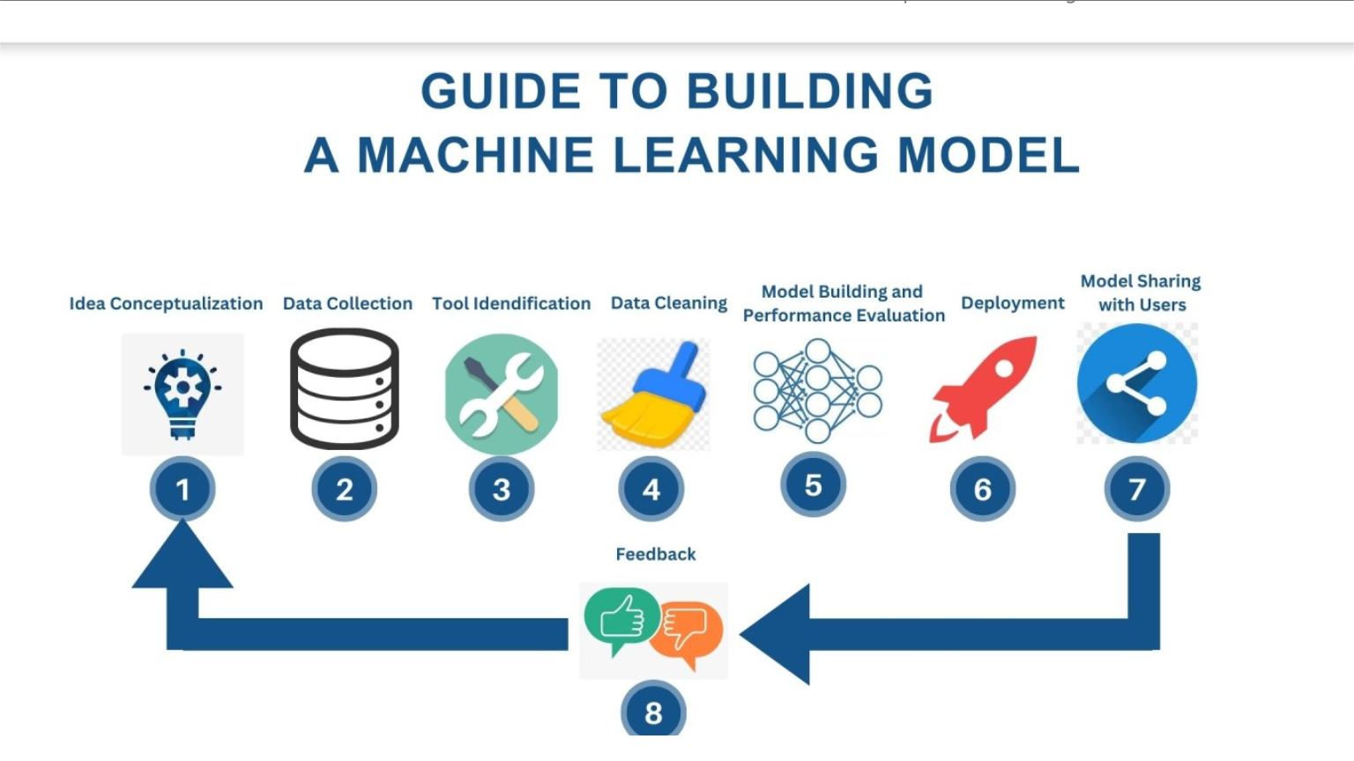

9.Application Building:

Building an application that integrates **Machine Learning (ML)** involves more than just training a model—it’s about **embedding ML capabilities** into an end-user application, whether it’s a **web app**, **mobile app**, **desktop software**, or even an **embedded system**.

**1. Define the Problem & Application Scope**

* Clearly identify the problem you're solving and how ML will add value.
* Example use cases:
  + **Image Classification App**: Predicting the type of object in an image.
  + **Recommendation System**: Recommending movies, products, or content.
  + **Predictive Analytics**: Predicting customer churn, sales forecasting, etc.

**2. Data Collection & Preprocessing**

* This is the stage where your ML model is trained (covered in the earlier sections).
* Data preprocessing (like feature engineering, scaling, and encoding) is essential to prepare the data for both training and integration into the app.

**3. Train the Model**

* **Choose the algorithm** based on the problem (classification, regression, etc.).
* After training, save the model for later use in the application.
* Use libraries like **scikit-learn**, **TensorFlow**, **Keras**, or **PyTorch** for training.
* **Save the Model**: Use serialization techniques like pickle, joblib, or TensorFlow's .h5 format to save the trained model.

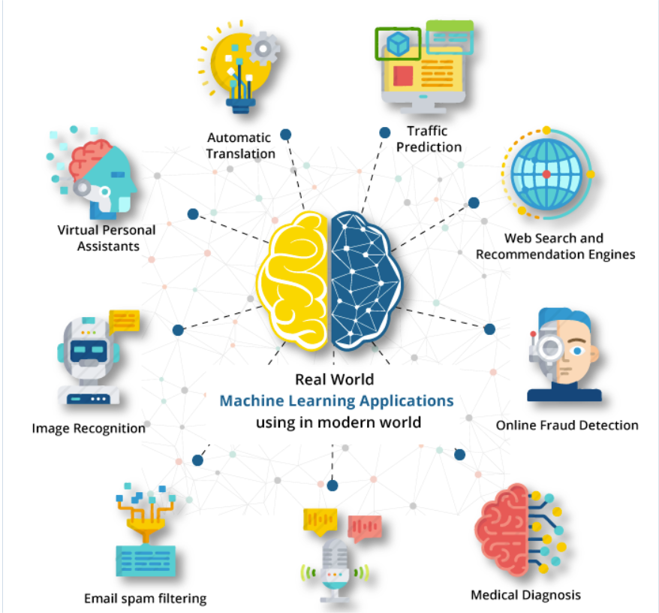

PRESENTED BY

1.P.SNEHITHA(22Q71A05E1)

2.S.SRUTHI(22Q71A05F3)

3.S.AJITHA(22Q71A05G7)

4.G.LAVA KUMAR(22Q71A05D5)

5.S.DINESH(22Q71A05F8)