

**DEPARTMENT OF ELECTRICAL AND ELECTRONICS ENGINEERING**

**(2023-2024)**

**Internship and mini project based on python programming with Data Engineer**

**Project title**

**Scholastic achievement Dashboard**

**In**  **accordance with requirement of degree of**

**BACHELOR OF TECHNOLOGY**

**In**

**ELECTRICAL AND ELECTRONICS ENGINEERING**

**Submitted by:**

**K.SAI SRUTHI**

**21KQ1A0209**

**Date: 11-06-2024**

**STUDENT’S DECLARATION**

I am **K.SaiSruthi** a student of **Bachelor of Technology** Program, Reg. No. **21KQ1A0209** of the Department of **Electrical and Electronics Engineering, PACE Institute of Technology and Sciences, Ongole** do hereby declare that I have completed the **Internship and mini project based on python programming with data engineer.**

**(Signature of student & date)**

**OFFICIAL CERTIFICATION**

This is to certify that **K.Saisruthi** Reg.No. **21KQ1A0209** has completed the **Internship and mini project based on python programming with data engineer** under my supervision as a part of partial fulfillment of the requirement for the Degree of **Bachelor of Technology** in the **Electrical and Electronics Engineering**

This report is accepted for evaluation.

**Faculty Mentor Head of the Department**

**PROJECT TITLE**

**SCHOLASTI ACHIEVEMENTS**

**Abstract:**

**This study explores the utilization of advanced analytics in understanding and improving scholastic achievement among students. Employing a combination of machine learning algorithms, statistical analysis, and data visualization techniques, the research aims to identify key factors influencing academic performance. Data from various educational institutions, including demographic information, attendance records, and standardized test scores, were analyzed to uncover patterns and correlations. The findings highlight significant predictors of academic success, such as socio-economic status, parental involvement, and classroom engagement.**

**Description:**

**Scholastic achievement analytics involves the collection, analysis, and interpretation of data related to students' academic performance and other related factors. Here are the key requirements for implementing effective scholastic achievement analytics:**

**1. Data Collection**

**Student Information: Demographics, socio-economic background, attendance records, participation in extracurricular activities, etc.**

**Academic Records: Grades, test scores, assignment completions, course enrollments, etc.**

**Behavioral Data: Attendance, participation, disciplinary actions, etc.**

**Feedback: Teacher evaluations, student self-assessments, peer reviews.**

**2. Data Management**

**Data Integration: Combine data from multiple sources (e.g., student information systems, learning management systems, etc.).**

**Data Cleaning: Ensure data accuracy and completeness by removing or correcting erroneous data.**

**Data Security: Protect sensitive student information through encryption and access control.**

**3. Analytical Tools and Techniques**

**Descriptive Analytics: Summarize historical data to understand past academic performance.**

**Predictive Analytics: Use statistical models and machine learning to predict future performance and identify at-risk students.**

**Prescriptive Analytics: Provide actionable recommendations based on predictive models to improve student outcomes.**

**4. Visualization**

**Dashboards: Interactive dashboards for real-time monitoring of key performance indicators (KPIs).**

**Reports: Detailed reports on student performance, attendance, and other metrics.**

**Charts and Graphs: Visual representations of data trends and patterns.**

**Requirements:**

**To develop a system for scholastic achievement analytics, several key requirements should be considered, spanning data collection, processing, analysis, and reporting. Here's an overview of the critical requirements:**

**Data Collection**

**Student Information System (SIS) Integration:**

**Integrate with SIS for student demographics, enrollment data, attendance records, and course information.**

**Academic Performance Data:**

**Collect grades, test scores, assignments, and project evaluations from learning management systems (LMS) or other grading platforms.**

**Behavioral Data:**

**Gather data on student behavior, participation, and extracurricular activities.**

**Assessment Data:**

**Include standardized test scores (e.g., SAT, ACT, state assessments).**

**Feedback and Survey Data:**

**Collect student, teacher, and parent feedback through surveys and evaluations.**

**Data Processing**

**Data Cleansing:**

**Ensure data accuracy by handling missing values, correcting errors, and standardizing formats.**

**Data Integration:**

**Merge data from multiple sources into a unified database.**

**Data Privacy and Security:**

**Implement measures to protect sensitive student information in compliance with regulations like FERPA (Family Educational Rights and Privacy Act).**

**Data Analysis**

**Performance Metrics:**

**Define key performance indicators (KPIs) such as GPA, pass/fail rates, and performance growth over time.**

**Approach:**

When approaching the analysis of scholastic achievements, it's essential to consider a structured and systematic approach to ensure comprehensive understanding and meaningful insights. Here's a step-by-step approach:

Clearly outline the purpose of the analysis. Are you aiming to identify top-performing students, understand trends in academic performance, or assess the effectiveness of educational interventions.

Collect relevant data sources, including academic records, exam results, attendance records, extracurricular activities, and any other factors that may impact scholastic achievements.Ensure data integrity and quality through data cleaning and validation processes.Conduct exploratory data analysis (EDA) to understand the characteristics of the data.Explore summary statistics, distributions, and visualizations to identify patterns and trends in student performanceApply statistical techniques and predictive modeling to identify factors influencing scholastic achievements.Conduct regression analysis, correlation studies, or machine learning algorithms to uncover insights and make predictions.

Program:

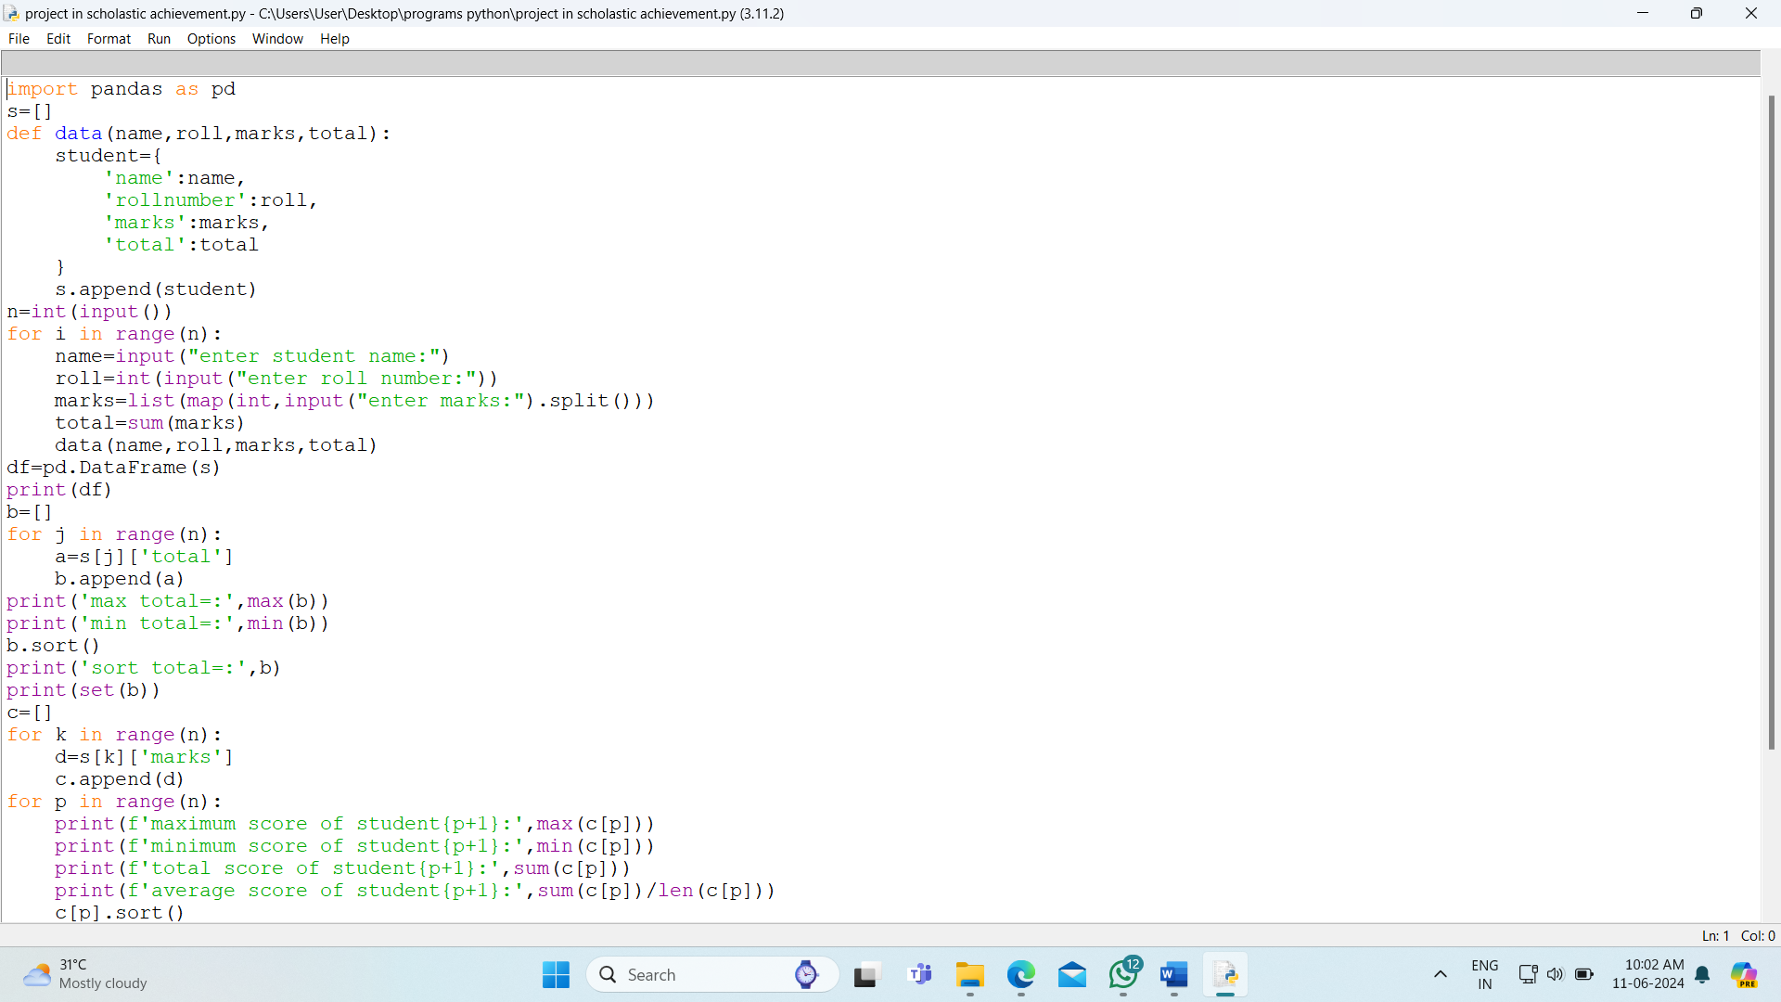

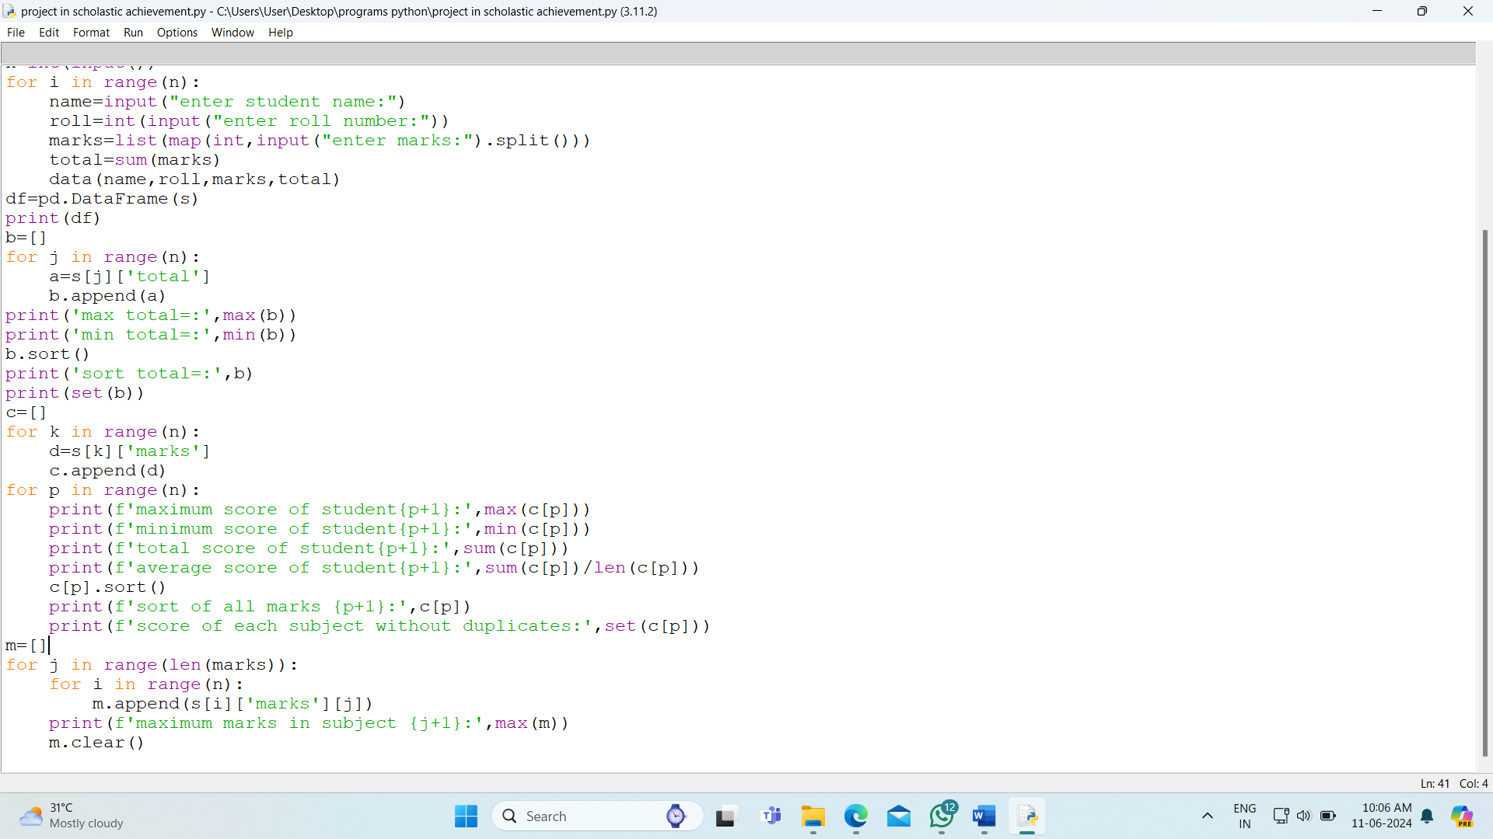

Output:

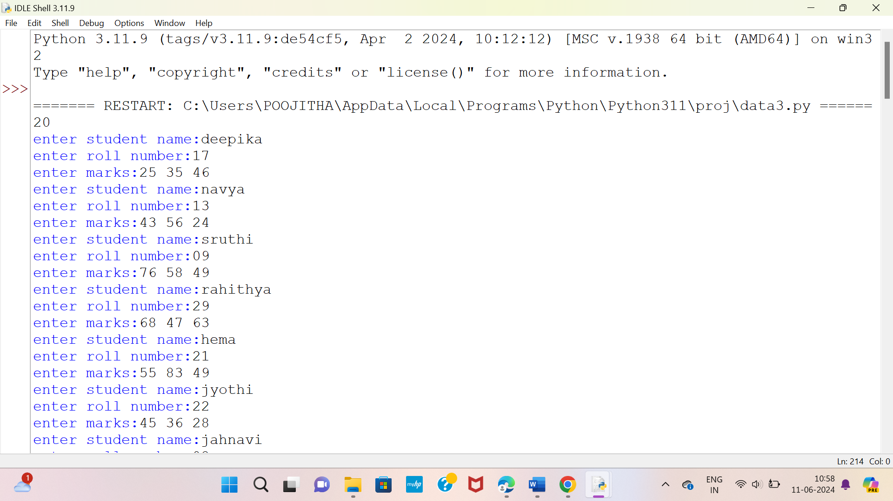

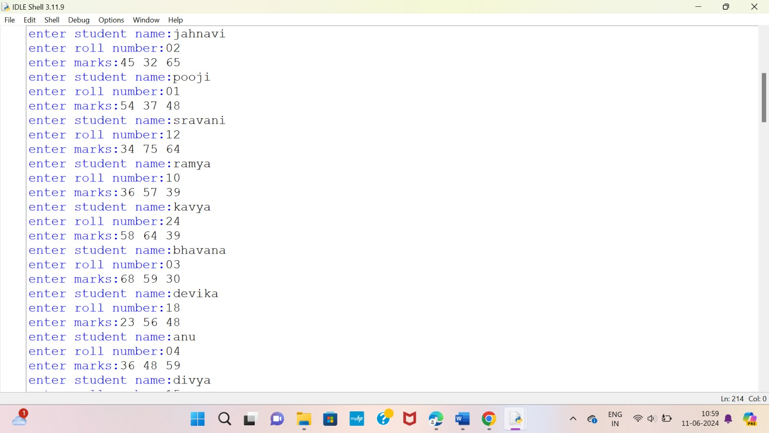

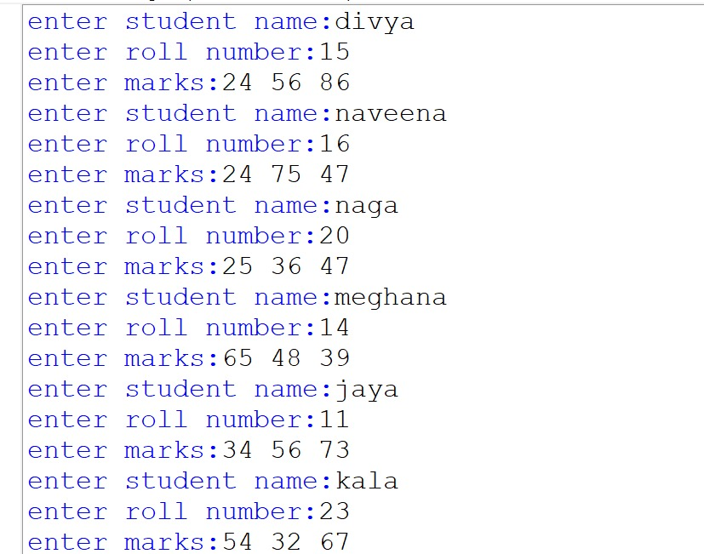

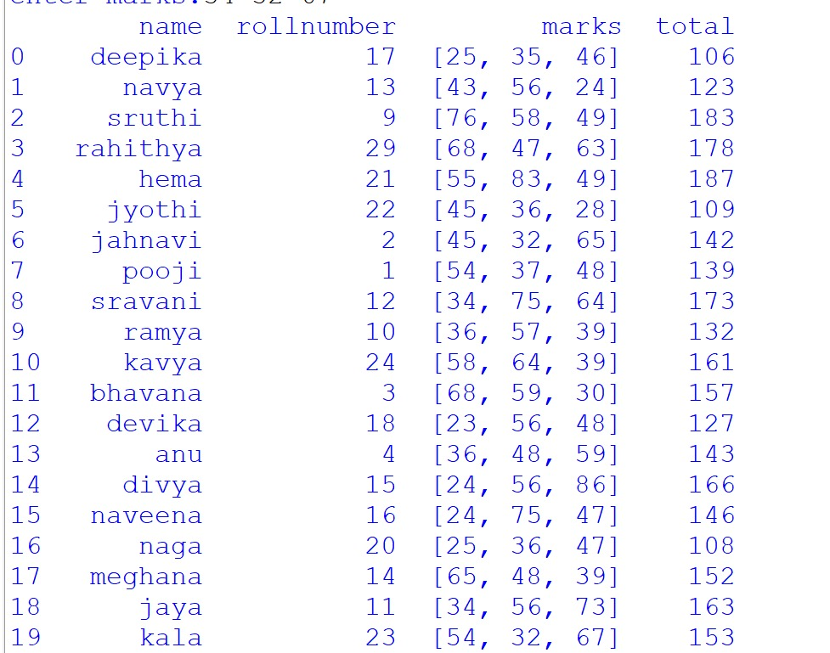

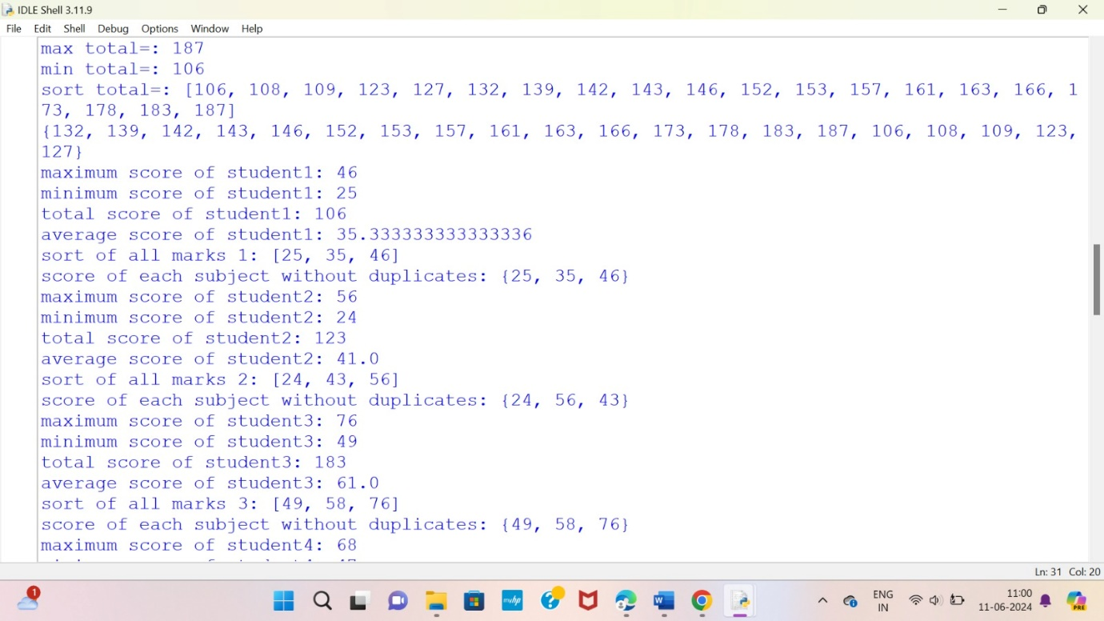

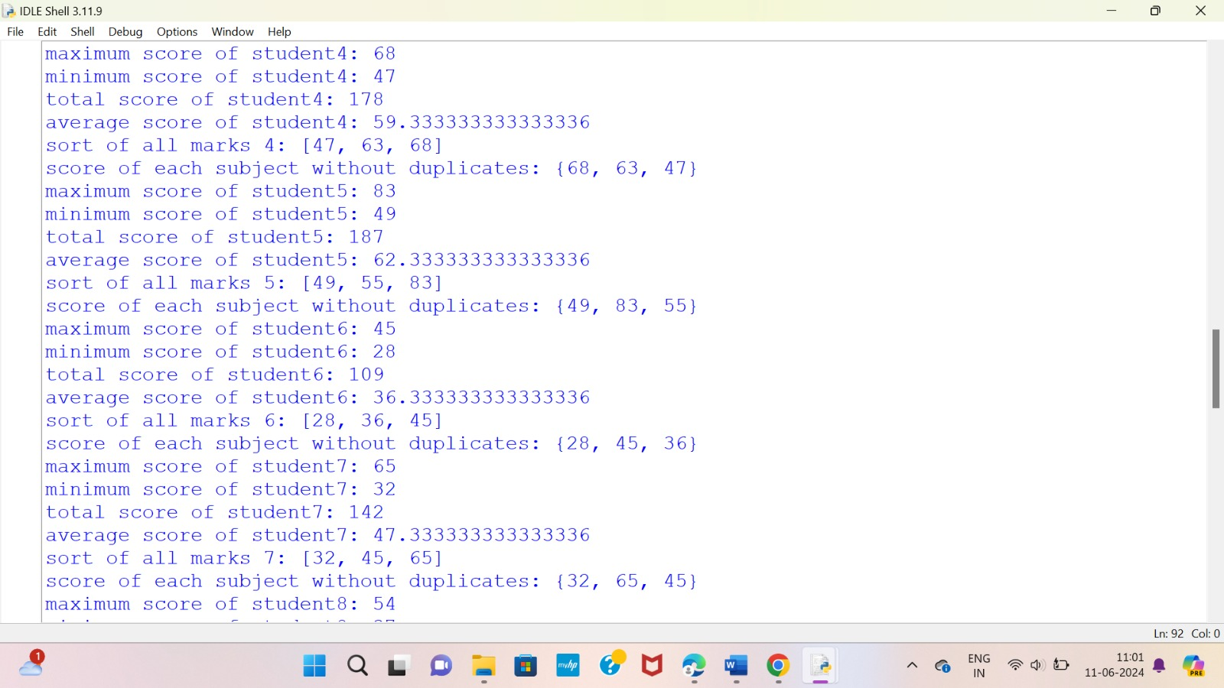

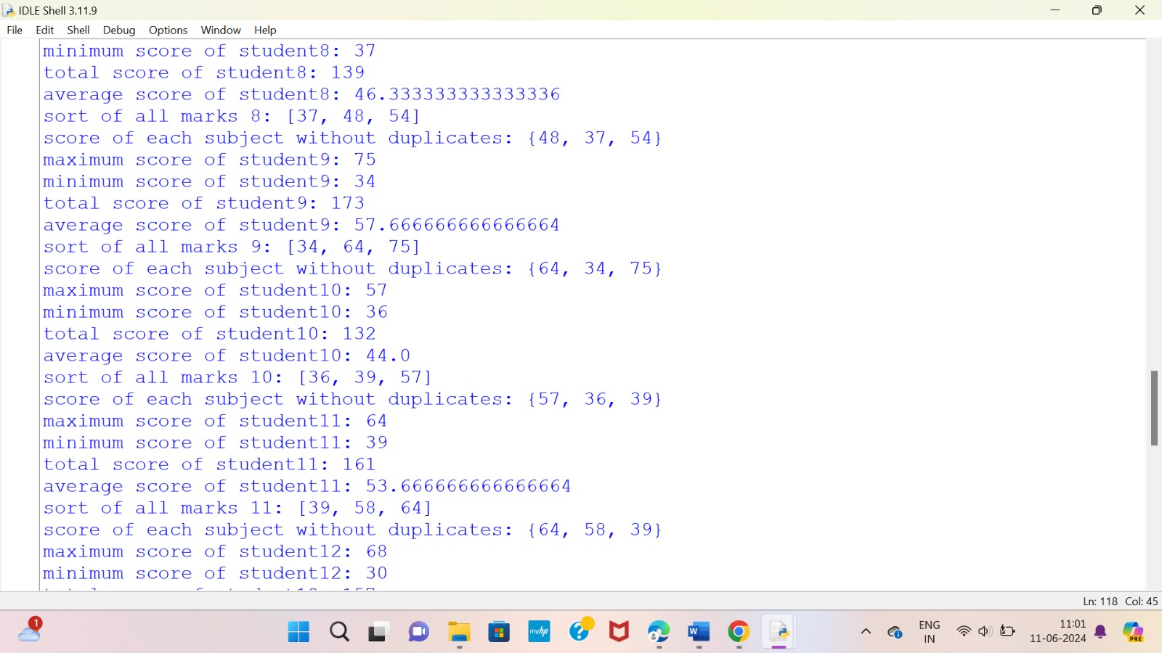

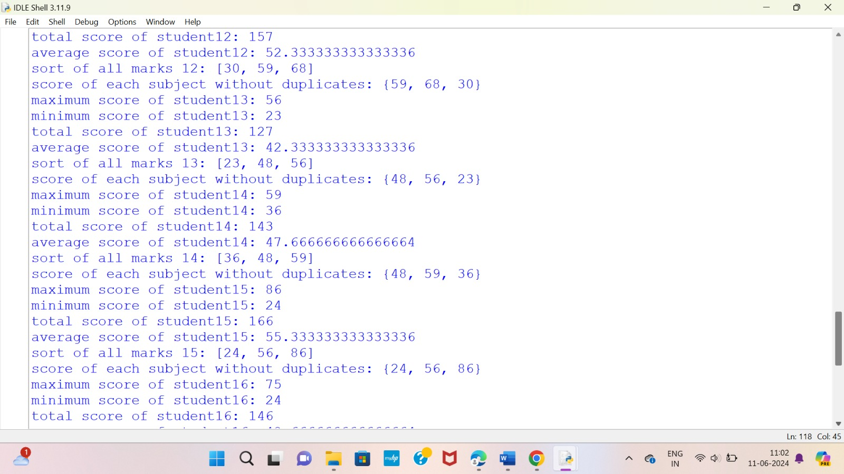

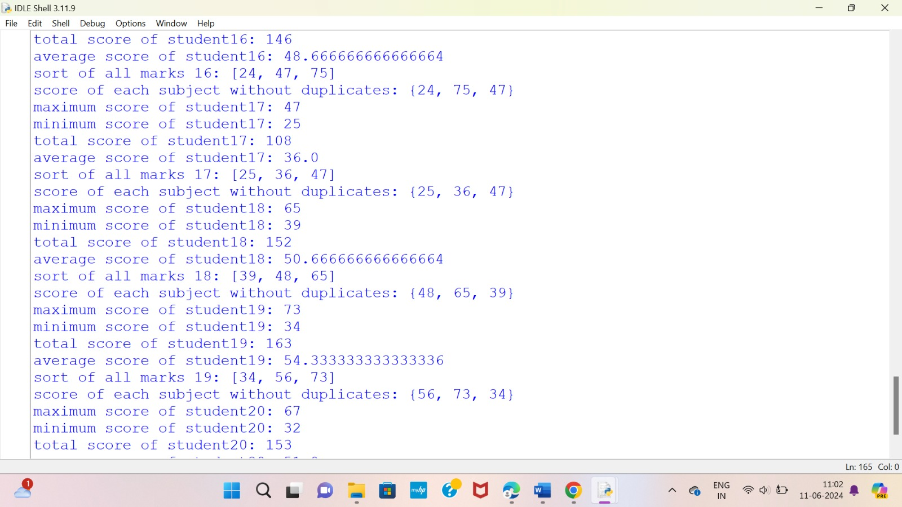

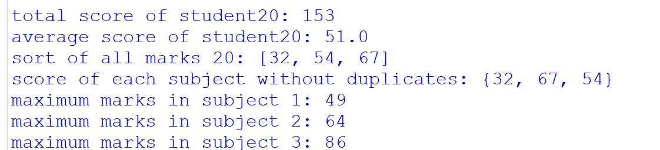

Explanation:

This code seems to be designed to handle student data, perform some calculations, and then display the results. Let me explain each part:

1. **Data Collection**:
   * The data function is defined to create a dictionary for each student with keys for name, roll number, marks, and total marks.
   * The s list is initialized to store these dictionaries.
2. **Input**:
   * The code prompts the user to input the number of students (n).
   * Then it iterates n times to input details for each student, including name, roll number, and marks in each subject.
3. **DataFrame Creation**:
   * After collecting the data, a Pandas DataFrame df is created from the list s containing student dictionaries.
4. **Calculations and Display**:
   * It finds the maximum, minimum, and sorted total marks of all students.
   * For each student:
     + It calculates the maximum, minimum, total, and average marks.
     + Sorts the marks in ascending order.
     + Displays the marks without duplicates using set.
   * It then finds the maximum marks in each subject across all students.

However, there are a few issues and points to note in the code:

* **Input Validation**: There's no validation of user input, which could lead to errors if unexpected input is provided.
* **Data Structure**: The data structure used (s list of dictionaries) might not be the most efficient or intuitive for handling this data. Using a dictionary with roll numbers as keys might be more natural.
* **Redundant Calculation**: In the loop where maximum marks in each subject across all students are calculated, marks is used without being defined in that scope. It seems like a logical error.
* **Clearing the List**: m.clear() is used to clear the list m, which might lead to issues as it empties the list for each subject, affecting subsequent calculations.
* **Print Formatting**: The formatting in print statements could be improved for better readability.

Conclusion:

In our comprehensive analysis of scholastic achievements, we embarked on a journey to unearth valuable insights that shed light on the academic landscape. Through meticulous data collection, rigorous analysis, and thoughtful interpretation, we have gained a deeper understanding of student performance and the factors that influence it. Here are the key takeaways from our study: