Department | Analytical Research & Development

ISMS Class: Internal

- Objective

The objective of this report is to draw conclusions based on the verification conducted on the Test procedure (ANAI-PD-0192.04) for related substances of Enzalutamide API using HPLC. Based on the verification parameters, the method is found to be Precise, Specific and shall be adopted for routine testing.
Limited parameters have been studied as the analytical method was validated and verified at customer site.

- Responsibility
Scientist/Team Member AR&D is responsible for execution method verification and preparation of method verification report.
Team Leader/Group Leader AR&D or designee shall review and ensure the compliance.
DQA/QA is responsible to approve the method verification report.

- References
Analytical Method validation SOP: SOP-GLB-AR&D-0004, Version*
Work instruction on Validation of Analytical Test Procedure for Related substance by Liquid Chromatography: WI-GLB-AR&D-0021*
Documenting the Research data in E-Lab Notebook (ELN) SOP: SOP-CDM-RD-0061*
Test Method Reference No: ANAI-PD-0192.04
Specification No : QC-FPEI-001/05
Protocol No.: PR-CDM-000650
* Current Versions

- Method Verification Parameters Executed
- System Suitability
- Specificity
- Batch Analysis
- Method Precision
- LOQ Precision

- Selection of Batch
The analytical method verification was conducted on the drug substance batch number Elm0030819. The CoA for the same was obtained from the supplier/vendor for the study.

- Instrument & Solvent Details
Following instruments were used for method verification activities
Name of the Instrument | ID | Make | Calibration Due date
Micro balance | CDM-AR&D-MB-0182 | Sartorius | 22-10-2023
Ultrasonic water batch | CDM-AR&D-SON-0321 | Powersonic | 05-02-2024
HPLC | CDM-AR&D-HPLC- 0167 | Agilent | 20-08-2023
HPLC | CDM-AR&D-HPLC- 0174 | Waters | 16-09-2023

Following solvents/chemicals were used for method verification.
Name of the Solvent | Make | Grade | Batch No. | Valid Up to
Perchloric acid | Merck | Emparta | DL1D711501 | 02-07-2025
Acetonitrile | Honeywell | LC-MS | M272M | 03-08-2025

Following standard, and impurities were used for method verification.

S. No. | Standard /Impurity/ Sample Name | Batch number | Valid up to | Potency
1 | Enzalutamide Standard | CFIR-0096-00 | 30-11-2023 | 99.5%
2 | Trifluoromethyl Impurity | CFIM-0560-00 | 31-12-2023 | 85.4%
3 | Desfluoro Impurity | CFIM-0561-00 | 31-12-2023 | 91.9%
4 | Dioxoimidazolidine Impurity | CFIM-0562-00 | 31-12-2023 | 95.8%
5 | Amine amide Impurity | CFIM-0563-00 | 31-12-2023 | 99.3%

- Test Procedure

Related Substances by HPLC:
Chromatographic conditions:
Equipment : A liquid chromatograph is equipped with variable wavelength UV- Detector. (Agilent 1200/1260 series or equivalent)
Column : Symmetry Shield RP18, 250 x 4.6 mm, 5 µm Make & Part No: Waters &186000112]
Flow Rate : 1.0 mL/minute
Wavelength : 210 nm
Column Temperature : 25°C
Injection Volume : 5 µL
Run time : 48 minutes
Diluent : Acetonitrile
Elution : Gradient
Needle wash ; Diluent
Buffer : First filter 1000 mL of Milli-Q water through 0.45 um nylon membrane filter and transfer accurately 1.0 mL of Perchloric acid (70%). Mix well and sonicate to degas.
Mobile phase A : Buffer (100%)
Mobile phase B : Acetonitrile: water(95:05 v/v).
The mobile phase solution is stable upto 48 hours at room tempearature
Gradient program
Time | Mobile Phase A (%) | Mobile Phase B (%)
0.01 | 50 | 50
30 | 0 | 100
39 | 0 | 100
39.5 | 50 | 50
48 | 50 | 50

Impurities stock solution preparation: (500 ppm)
Weigh accurately about 10 mg of each Amine amide impurity, Trifluoromethyl impurity, Dioxoimidazolidine impurity and Desfluoro impurity, transfer into a 20 mL volumetric flask, add about 15 mL of diluent and sonicate to dissolve. Make up to the mark with the same diluent and mix well.
System Suitability test (SST) solution:
Weigh accurately about 10 mg of Enzalutamide standard and transfer into a 10 mL volumetric flask, add.about 8 mL of diluent and sonicate to dissolve, add 30 µL of impurities stock solution and mix well. Make up to the mark with the same diluent and mix well.
Acceptance criteria for SST solution:
- The Resolution between any two known impurities (or) known impurity and Enzalutamide peak should not be less than 2.0, as obtained from SST solution.
ii) Theoretical plates for Enzalutamide peak should not be less than 3000, as obtained from SST solution.
- Tailing factor for the Enzalutamide peak should not be more than 2.0, as obtained from SST solution.
Reference solution preparation:
Weigh accurately about 10 mg of Enzalutamide standard and transfer into a 10 mL volumetric fiask, add about 8 mL of diluent and sonicate to dissolve. Make up to the mark with diluent and mix well. (1000 ppm)
Dilute 100 µL (0.1 mL) of above solution to 100 mL with diluent and mix well. (1 ppm)
Acceptance criteria for reference soluhon:
i) % RSD of 6 replicates of reference solution should not be more than 5.0%.
ii) Detector sensitivity: The S/N ratio for Enzalutamide peak should not be less than 20, as obtained from first injection of reference solution
Test solution preparation-1: (1000 ppm)
Weigh accurately about 10 mg of test sample, and transfer it into a 10 mL volumetric fiask, add about 8 mL of diluent and sonicate to dissolve and dilute to volume with diluent and mix well.
Test solution preparation-2: (1000 ppm)
Weigh accurately about 10 mg of test sample, and transfer it into a 10 mL volumetric lask, add about 8 mL of diluent and sonicate to dissolve and dilute to volume with diluent and mix well.
Note: The sample solution is stable up to 48 hours at room temperature.
Procedure: After equilibrating the column, follow the order of Injections and record the chromatograms. Disregard peaks due to blank.
S. No | Solution Name | No. of Injections
1.0 | Diluent as blank | Confirm neat blank
2.0 | System suitability test solution | 1
3.0 | Diluent as blank | Confirm neat blank
4.0 | Reference solution | 6
5.0 | Test solution preparation-1 | 1
6.0 | Test solution preparation-2 | 1
7.0 | Reference solution (bracketing) | 1
8.0 | Diluent as blank | Confirm neat blank
9.0 | System suitability test solution (bracketing) | 1
RRF for Impurities:
Name | Response factor
Amine amide Impurity | 0.78
Trifluoromethyl Impurity | 1.15
Dioxoimidazolidine Impurity | 0.96
Desfluoro Impurity | 0.99

Impurities calculation: Identify known impurities based on retention time of peaks present in the chromatogram of the test solution and corresponding peaks present in the system suitability solution. Calculate the amount of impurities by area percentage by using the following formula.
SAM A SAM V Std. Potency
Impurity % = ------------ x ------------ x -------------- x C x RF x 100
STD A SAM W 100
Note: For Highest unspecified impurity and other impurities calculation, consider
RF as 1.0
Where,
SAM A Peak area of individual related compound in sample preparation.
STD A Average peak area for Enzalutamide from six consecutive injections of reference solution preparations.
SAM V Volume in mL of Test solution preparation
SAM W Sample weight in mg in Test solution preparation.
C Concentration of Enzalutamide in reference solution preparation in mg/mL
100 Conversion factor for percent.
RF Response factor
Total impurities = Known impurity + Highest individual unspecified impurity + other Impurities

- Method Verification Data

  - System Suitability:
The System suitability solution & reference standard solution were prepared by using Enzalutamide standard & impurities and injected into the HPLC system. The system suitability parameters were evaluated and found to be within the limits.
For Blank, System suitability and reference standard chromatograms refer Annexure, Result ID No.:7879, 7880 and 7889, respectively.
Table 1A: Results of System Suitability
System suitability parameters | Observed value
Blank interference from blank preparation at the retention of peaks of interest. | ND
Resolution between any two known impurities or Known impurity and Enzalutamide peak should not be less than 2.0 | Amine Amide Impurity : NA  Trifluoromethyl Impurity : 22.20  Dioxoimidazolidine Impurity :4.69  Desfluoro Impurity :2.93  Enzalutamide:5.16
Theortical plates of Enzalutamide peak from SST solution | 37058
Tailing factor for Enzalutamide peak from SST solution | 0.97
%RSD of the average peak area response of Enzalutamide peak from standard replicate injections | 0.91
S/N ratio for Enzalutamide peak from first injection of reference solution | 41.72

Reference: ARNo 216569 under ENZ-AMD-NB1 note book.
Acceptance Criteria:
- No peak shall be detected in the blank at the retention time of peaks of interest.
- The Resolution between any two known impurities or Known impurity and Enzalutamide peak should not be less than 2.0, as obtained from SST solution.
- Theoretical plates for Enzalutamide peak should not be less than 3000 as obtained from SST solution.
- The Tailing factor for Enzalutamide peak should not be more than 2.0, as obtained from SST solution.
- The percent relative standard deviation of the average peak area responses of Enzalutamide shall be NMT 5.0%.
- The S/N ratio for Enzalutamide peak should not be less than 20, as obtained from first injection of reference solution.
Inference:

The system suitability results met the acceptance criteria set forth for the method and hence column, system, and method were considered suitable for analysis.

  - Specificity:
Impurity Interference:

The specificity study was conducted by preparing and injecting blank solution, Standard solution, all individual impurities at specification level, as such sample solution and spiked sample solution into the chromatograph equipped with PDA detector.

Table 2A: Impurity Interference & Peak Purity

Name of the Solution | Peak Name | Retention Time (RT) | Purity Angle | Purity Threshold | Purity Flag
Standard Solution | Enzalutamide | 9.834 | 1.438 | 3.260 | No
Individual Impurity | Amine amide impurity | 2.780 | 0.263 | 0.670 | No
Individual Impurity | Trifluoromethyl impurity | 7.418 | 0.382 | 0.739 | No
Individual Impurity | Dioxoimidazolidine impurity | 8.273 | 0.899 | 1.205 | No
Individual Impurity | Desfluoro impurity | 8.811 | 0.498 | 0.791 | No
SST Solution | Enzalutamide | 9.851 | 0.951 | 3.041 | No
SST Solution | Amine amide impurity | 2.821 | 0.363 | 0.692 | No
SST Solution | Trifluoromethyl impurity | 7.443 | 0.685 | 0.886 | No
SST Solution | Dioxoimidazolidine impurity | 8.301 | 1.135 | 1.774 | No
SST Solution | Desfluoro impurity | 8.839 | 0.622 | 1.227 | No
As such sample | Enzalutamide | 9.848 | 0.976 | 2.694 | No
As such sample | Amine amide impurity | ND | ND | ND | NA
As such sample | Trifluoromethyl impurity | ND | ND | ND | NA
As such sample | Dioxoimidazolidine impurity | ND | ND | ND | NA
As such sample | Desfluoro impurity | ND | ND | ND | NA
Spiked Sample | Enzalutamide | 9.860 | 0.961 | 2.666 | No
Spiked Sample | Amine amide impurity | 2.803 | 0.287 | 0.751 | No
Spiked Sample | Trifluoromethyl impurity | 7.463 | 0.559 | 0.795 | No
Spiked Sample | Dioxoimidazolidine impurity | 8.315 | 1.422 | 1.809 | No
Spiked Sample | Desfluoro impurity | 8.849 | 0.992 | 1.182 | No

Reference: ARNo 216594 under ENZ-AMD-NB1 note book.
Acceptance Criteria:
- Impurity(s) peak should not elute at the retention time of main analyte peaks.
- Impurity peaks should not have any Flag in purity results table (For Waters Empower software).in SST, sample & spiked sample.
Inference:

No interference from the impurities was observed at the retention time of Enzalutamide peak. The purity angle observed is less than Purity threshold and no purity flag was observed in the analysed standard & as such sample conditions for Enzalutamide peak. This indicates that there is no interference from any impurities in quantitating Enzalutamide.
  - Batch Analysis:

The batch chosen for the study was prepared in duplicates as per the test procedure and evaluated for the Related substances of Enzalutamide by analysing using HPLC.

Table 3A: Results from Batch Analysis
Batch Analysis
Impurity Name | Preparation-1  (% Impurity) | Preparation-2  (% Impurity) | Acceptance criteria
Amine amide impurity | 0.009 | 0.01 | Not more than 0.15%
Trifluoromethyl impurity | 0.05 | 0.06 | Not more than 0.15%
Dioxoimidazolidine impurity | 0.02 | 0.01 | Not more than 0.15%
Desfluoro impurity | 0.008 | 0.008 | Not more than 0.15%
Single Maximum Unknown | 0.06 | 0.06 | Not more than 0.10%
Total Impurities | 0.27 | 0.25 | Not more than 0.5%

Reference: ARNo 216569 under ENZ-AMD-NB1 note book.
Inference:
The results obtained are within the acceptance limits.

  - Method Precision:
Repeatability

Precision of the method was demonstrated by spiking the known impurities at specfication level (0.15% of each impurity) on the Enzalutamide API for the related substances test method. Prepared six replicate samples and injected in to HPLC system.Calculated % individual known impurity, % Relative standard deviation and 95% confidence interval for the spiked impurities.

Table 4A: Results of Method Precisions

Sample No. | Amine amide  % impurity | Trifluoromethyl % impurity | Dioxoimidazolidine % impurity | Desfluoro  % impurity
1 | 0.1294569 | 0.1920170 | 0.1161884 | 0.1191834
2 | 0.1258451 | 0.1893145 | 0.1082577 | 0.1193937
3 | 0.1283996 | 0.1914349 | 0.1120626 | 0.1211257
4 | 0.1643060 | 0.1956666 | 0.1108515 | 0.1220539
5 | 0.1266140 | 0.1920017 | 0.1088198 | 0.1205865
6 | 0.1387794 | 0.1921227 | 0.1089698 | 0.1187889
Average | 0.1355668 | 0.1920929 | 0.1108583 | 0.1201887
% RSD | 10.94 | 1.07 | 2.69 | 1.06
95% Confidence Interval | 0.1237 & 0.1474 | 0.1905 & 0.1937 | 0.1085 & 0.1132 | 0.1192 & 0.1212

Reference: ARNo 216581 under ENZ-AMD-NB1 note book.
Acceptance Criteria:
- The relative standard deviation for individual Enzalutamide related impurities from the
six spiked sample preparations should be not more than 15.0%
- Report the 95% confidence interval.

Inference:

The results obtained are within the acceptance limits. Hence the method is precise.

  - LOQ Precision:
Precision at about Limit of Quantification (LOQ) was evaluated by spiking known impurity(s) & enzalutamide in six replicates. The solutions were prepared and analysed using HPLC. Calculated the area of individual impurity(s), enzalutamide and % RSD.

Table 5A: Results of LOQ Precision

Sample No. | Amine amide impurity | Trifluoromethyl impurity | Dioxoimidazolidine impurity | Desfluoro impurity | Enzalutamide
1 | 1281 | 1803 | 1668 | 1676 | 1064
2 | 1180 | 1853 | 1593 | 2045 | 1004
3 | 1212 | 2013 | 1529 | 1794 | 1098
4 | 1298 | 1830 | 1310 | 1854 | 1029
5 | 1071 | 1705 | 1592 | 1849 | 1052
6 | 1119 | 1875 | 1501 | 1592 | 1003
Average | 1194 | 1846 | 1532 | 1802 | 1042
% RSD | 7.45 | 5.46 | 8.05 | 8.74 | 3.58

Reference: ARNo 216581 under ENZ-AMD-NB1 note book.
Acceptance Criteria:
The RSD of Enzalutamide and its related impurities from six preparations should be not
more than 15.0%.
The results obtained are within the acceptance limits.
Conclusion
All the attributes evaluated under the analytical method verification for the related substance of Enzalutamide API were found satisfactory. All the results have met the respective acceptance criteria set forth in the protocol and hence the method shall be used for routine analysis.
- Annexure (Chromatograms)

Annexure – 1 Chromatogram of Blank
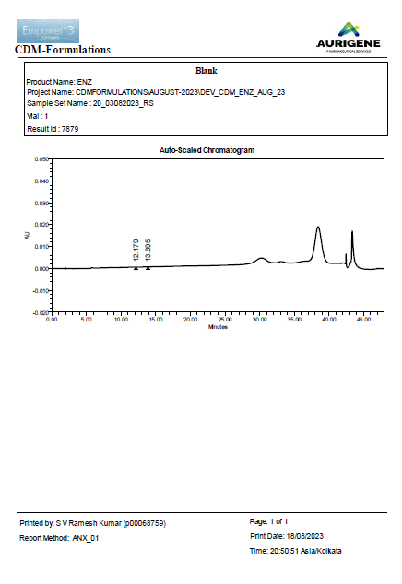

Annexure – 2 Chromatogram of Standard
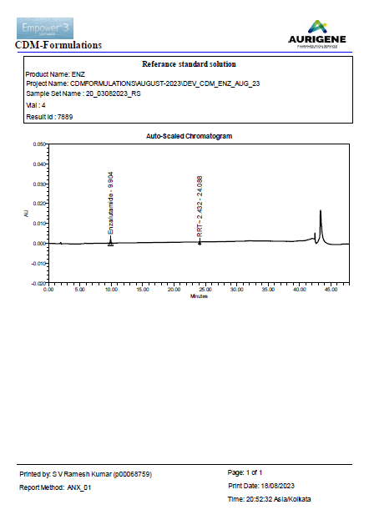

Annexure-3 Chromatogram of System suitability

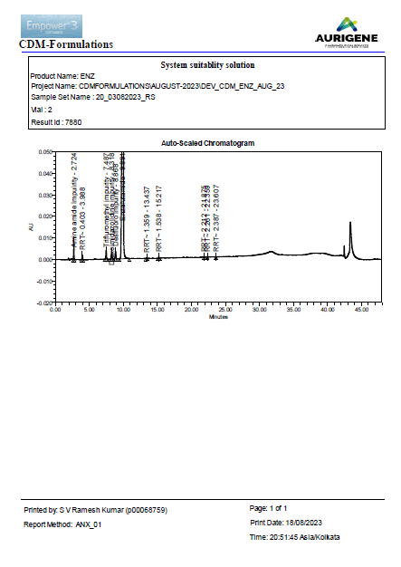

Annexure – 4 Chromatogram of Sample
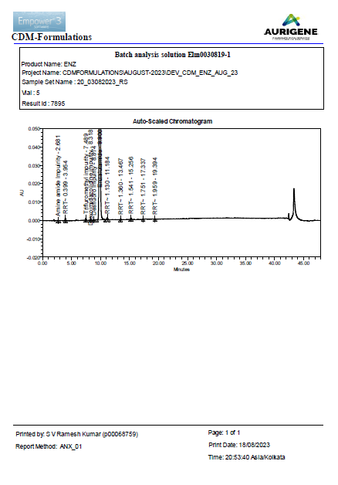

Annexure – 5 Chromatogram of Spiked Sample
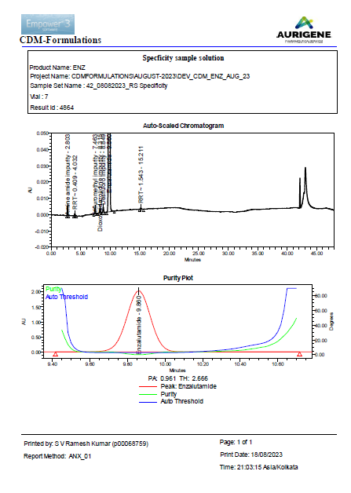
Annexure – 6 Chromatogram of Standard Peak purity

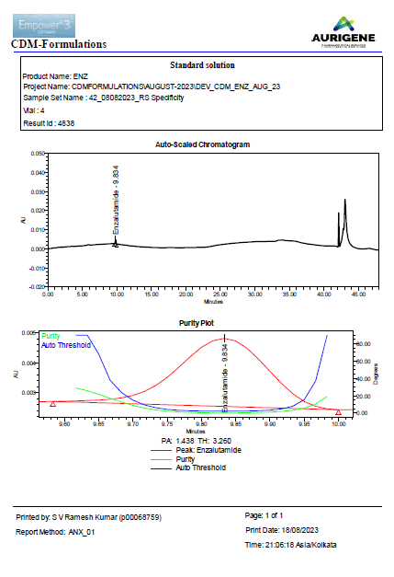

Annexure-7 Chromatogram of Amine amide impurity Purity

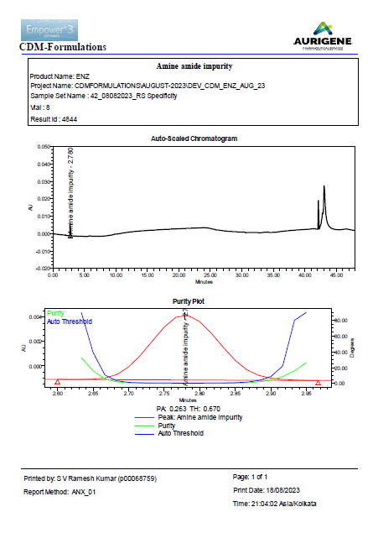
Annexure-8 Chromatogram of Trifluoromethyl impurity Purity
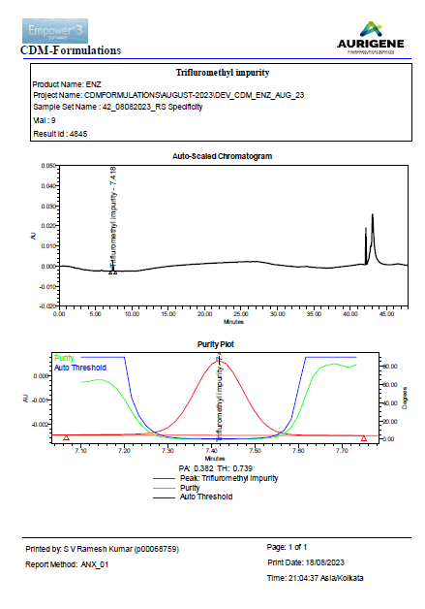

Annexure-9 Chromatogram of Dioxoimidazolidine impurity Purity
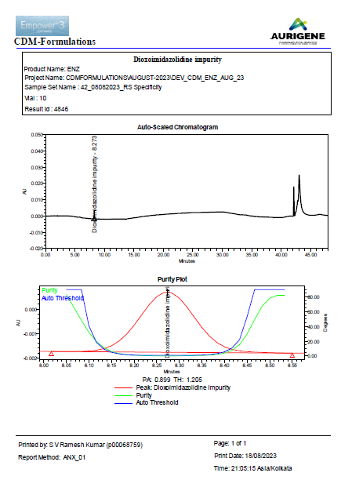

Annexure-10 Chromatogram of Desfluoro impurity Purity
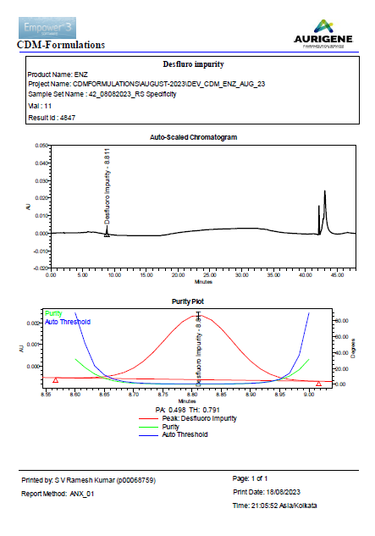

Method validated at customer site.

