ISMS Class : Internal

Objective
To develop & verify the analytical method by HPLC for determining the phthalic acid content in EM-221 Capsules 1 mg, 2 mg, 2.5 mg, 4 mg, 5 mg & 7 mg.

Summary of Method Development
The analytical test method for phthalic acid content of EM-221 1 mg, 2 mg, 4 mg & 7 mg capsules was developed based on the reference SDD method [Document number: SP-CDM-002392].
The chromatographic conditions including the mobile phase composition, chromatographic conditions, and wavelength, standard & sample preparation technique was optimized with change in concentration of solutions to obtain suitable analytical method for determining the phthalic acid content of the EM-221 1 mg, 2 mg, 2.5 mg, 4 mg, 5 mg & 7 mg capsules.

Note: The analytical method development for the Phthalic acid of EM-221 capsules (1mg, 2mg, 4mg, and 7mg) has been successfully completed, with results falling within the specified limits, as outlined in the Analytical Method Development Report (RP-CDM-002448, 2.0). The customer has proposed two additional strengths (2.5mg and 5mg) based on the same formulation as the previously developed and validated strengths (1mg, 2mg, 4mg, and 7mg). Since there are no changes to the composition or addition of new excipients, the existing method remains unchanged. The sample concentration has been optimized for the new strengths, and precision testing has been conducted to ensure consistency with the validated formula.

Details of the study are as shown below:
Product: EM-221-SDD.
Work Done By: M Yuvaraju, V.Raj kumar goud
Work Verified By: Vara Prasad Reddy. D
Analytical Team Leader: Vara Prasad Reddy.D
Location: Aurigene Pharmaceutical Services, CDM-Formulations, Bollaram Road, Miyapur - 500049, Telangana, India.

Materials
Table 1. Materials used for the study.
Material | Batch No. | Potency/Purity/  Assay | Expiry  Date
Phthalic acid (WS) | CFWS-0269-00 | 99.8% | 31-01-2026
Phthalic acid (WS) | CFWS-0269-02 | 99.8% | 31-01-2026
Impurity-N | CFIM-0597-00 | 99.93% | 30-01-2025
Impurity-U | CFIM-0596-00 | 99.95% | 30-01-2025

Proposed SDD Specification for Phthalic acid content
Test Name | Specification
Phthalic acid content | NMT 1.0%

Formula Composition of EM-221 Capsules
Strength |  | 7 mg |  | 1 mg |  | 2 mg |  | 4 mg
S.No. | Ingredient Name | mg/ capsule | % w/w | mg/ capsule | % w/w | mg/ capsule | % w/w | mg/ capsule | % w/w
Sifting-1
1. | EM-221 Spray Dried Dispersion (25%w/w) | 28.00 | 8.00 | 4.00 | 8.00 | 8.00 | 8.00 | 16.00 | 8.00
2. | Micronized Poloxamer (Kolliphor P 407 Micro) | 21.00 | 6.00 | 3.00 | 6.00 | 6.00 | 6.00 | 12.00 | 6.00
3. | PROSOLV SMCC HD 90 | 7.00 | 2.00 | 1.00 | 2.00 | 2.00 | 2.00 | 4.00 | 2.00
Sifting-2
4. | PROSOLV SMCC HD 90 | 56.00 | 16.00 | 8.00 | 16.00 | 16.00 | 16.00 | 32.00 | 16.00
Sifting-3
5. | Lactose anhydrous (Supertab 24AN) | 122.85 | 35.10 | 17.55 | 35.10 | 35.10 | 35.10 | 70.20 | 35.10
6. | Crospovidone (Kollidon CL) | 35.00 | 10.00 | 5.00 | 10.00 | 10.00 | 10.00 | 20.00 | 10.00
7. | PROSOLV SMCC HD 90 | 77.00 | 22.00 | 11.00 | 22.00 | 22.00 | 22.00 | 44.00 | 22.00
Lubrication
8. | Sodium Stearyl Fumarate, NF (PRUV) | 3.15 | 0.90 | 0.45 | 0.90 | 0.90 | 0.90 | 1.80 | 0.90
Total unit weight (mg): |  | 350.00 | 100.00 | 50.00 | 100.00 | 100.00 | 100.00 | 200.00 | 100.00

Formula Composition of EM-221 Capsules for 2.5 mg & 5 mg

Strength |  | 5 mg |  | 2.5 mg
S.No. | Ingredient Name | mg/ capsule | % w/w | mg/ capsule | % w/w
Sifting-1
1. | EM-221 Spray Dried Dispersion (25%w/w) | 20.00 | 8.00 | 10.00 | 8.00
2. | Micronized Poloxamer (Kolliphor P 407 Micro) | 15.00 | 6.00 | 7.50 | 6.00
3. | PROSOLV SMCC HD 90 | 5.00 | 2.00 | 2.50 | 2.00
Sifting-2
4. | PROSOLV SMCC HD 90 | 40.00 | 16.00 | 20.00 | 16.00
Sifting-3
5. | Lactose anhydrous (Supertab 24AN) | 87.75 | 35.10 | 43.88 | 35.10
6. | Crospovidone (Kollidon CL) | 25.00 | 10.00 | 12.50 | 10.00
7. | PROSOLV SMCC HD 90 | 55.00 | 22.00 | 27.50 | 22.00
Lubrication
8. | Sodium Stearyl Fumarate, NF (PRUV) | 2.25 | 0.90 | 1.13 | 0.90
Total unit weight (mg): |  | 250.00 | 100.00 | 125.00 | 100.00

Method Development Experiments:
As a part of the routine analysis for phthalic acid content in the CEUM2/EM-221(SDD) analytical method was adopted from the IPDO raw material test procedure (Document Number: MET-CFTO-001978-2.0) and initiated the analysis. The test procedure details of the same are mentioned below.
Trial-1
Experiment No. / AR No: EM-221 Capsules _ EM2-AMD-NB1-219118.
Sample set: 39_18062024_RS_PA
Experimental:
Buffer preparation for mobile phase:
Preparation of mobile phase A:

Transferred 1mL of TFA into 2000mL of 100% water and mixed well.

Preparation of mobile phase B:

Transferred 1mL of TFA into 2000mL of 100% acetonitrile and mixed well.

Preparation of Diluent:
Mixed the 1800mL of 100% acetonitrile and 200mL of water (90:10 v/v) to this added 1 mL of TFA and mixed well.
Phthalic acid standard solution (0.03mg/ml)
Weighed and transferred 20.255 mg of phthalic acid, into a 50 mL volumetric flask, added about 30 mL of diluent, and kept on sonication for 5 minutes, made up to volume with diluent.
Transferred above 4mL solution into 50mL volumetric flask and made up to volume with diluent and mixed well.
Test solution preparation:
Weighed and transferred 5252.64 mg of drug powder into a 100-mL volumetric flask, added about 70 mL of diluent, and sonicated for 30 minutes, made up to volume with diluent, mixed well. Centrifuged the solution for 10 minutes at 4000RPM and used clear supernatant solution for analysis.

Chromatographic Conditions:
Column : Eclipsed XDB 150*4.6,3.5micron
Flow Rate : 1.0 mL/minute
Wavelength : 235 nm
Column Temperature : 30°C
Sample Temperature : 25°C
Injection Volume : 10 µL
Run time : 25 minutes
Elution : Gradient
Needle wash : Diluent
Channel-A : 50% Mobile phase-A
Channel-A : 50% Mobile phase-B
Elution : Isocratic
Procedure:
Injected diluent as blank, standard solutions, and sample solution into the above chromatographic conditions.
Observation:
- In the blank chromatogram no blank interference was observed and the base line also good.
- In the standard chromatogram the phthalic acid component peak was eluted at void volume, the retention time of phthalic acid is 1.5 minutes.

Typical Standard chromatogram of Phthalic acid
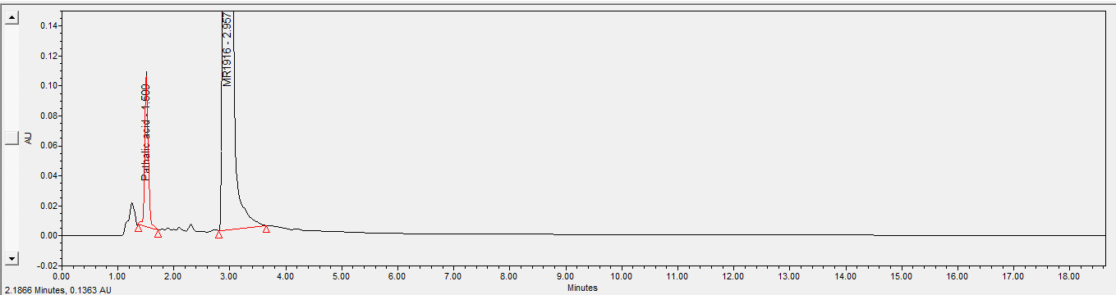
Conclusion:
Upon observing the above data here concluded that the main component peaks that of phthalic acid, need to be eluted in the established run time of the phthalic acid test procedure.
Hence, further trials were taken up by changing a few instrumental parameters like mobile phase compositions and chromatographic conditions using HPLC to have better control on the methodology.
Trial-2
Experimental Refer ARNo: Experiment No. / AR No: EM-221_EM2-AMD-NB1_219118.
Experimental: Refer Trail-1 for solution preparations and mobile phase preparations.
Experimental work was initiated using the same column and flow rate, here modified the mobile phase compositions.
Modified conditions along with the chromatographic conditions are given below,
Chromatographic Conditions:
Column : Eclipsed XDB 150*4.6,3.5micron
Flow Rate : 1.0 mL/minute
Wavelength : 235 nm
Column Temperature : 30°C
Sample Temperature : 25°C
Injection Volume : 10 µL
Run time : 25 minutes
Elution : Gradient
Needle wash : Diluent
Channel-A : 70% Mobile phase-A
Channel-A : 30% Mobile phase-B
Elution : Isocratic

Sample set: 39_18062024_RS_PA

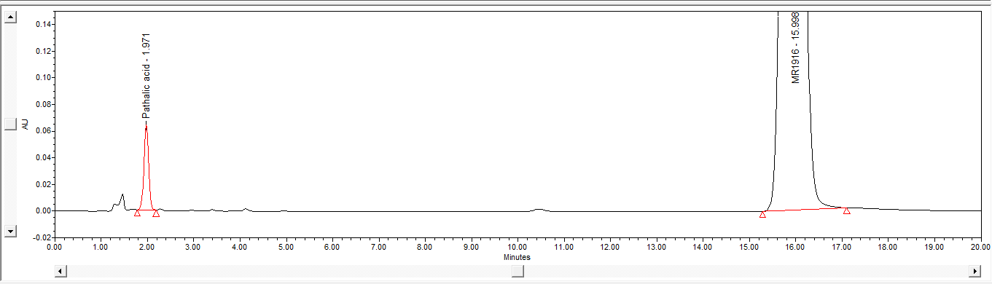
Sample chromatogram of Phthalic acid and MR1916 peaks.
Conclusion:
Upon observing the above data here concluded that the retention times of the phthalic acid peak eluted in void volume and MR1916 peaks eluted late with isocratic elution, so need to be optimized gradient elution. Hence further trial was taken up by changing the mobile phase compositions by gradient elution using HPLC.
Trial-3
Experiment No. / AR No: Experiment No. / AR No: EM-221 Capsules 1mg, 2mg, 3mg, 4mg and 7mg- EM2-AMD-NB1-219118.
Experimental: Refer Trail-2 for solution preparations and mobile phase preparations.
Experimental work was initiated using the same column and flow rate, here modified the gradient program.
Modified conditions along with the existing chromatographic conditions are given below,
Chromatographic Conditions:
Column : Eclipsed XDB 150*4.6,3.5micron
Flow Rate : 1.0 mL/minute
Wavelength : 235 nm
Column Temperature : 30°C
Sample Temperature : 25°C
Injection Volume : 10 µL
Run time : 20 minutes
Elution : Gradient
Needle wash : Diluent
Gradient program
Time | 0.01 | 8 | 10 | 15 | 16 | 20
Mobile Phase A (%) | 80 | 80 | 50 | 50 | 80 | 80
Mobile Phase B (%) | 20 | 20 | 50 | 50 | 20 | 20

Procedure:
Injected sample solution in single into the above chromatographic conditions.
Observation:
- In the sample chromatogram, the phthalic acid component peak and main component MR1916 peaks are eluted at the retention time of 3.080 and 13.185.
- The retention times of the components are not satisfactory, and the peak shape of the phthalic acid was not good.
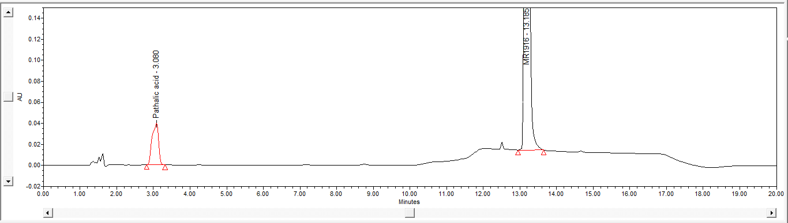
Sample chromatogram of Phthalic acid and MR1916 peaks.
Conclusion:
Based on the above observations, it is concluded that peak shapes of phthalic acid & MR1916 peaks are not good. Therefore, it should optimize the gradient program for better peak shapes of phthalic acid & MR1916.
It is proposed to taken up further trails by changing the gradient program with Inertsil ODS-3V 5µ, 4.6 X 250 mm column.

Trial-4
Experiment No. / AR No: EM-221_ EM2-AMD-NB1_219118.
Sample set:41_19062024_RS_PA
Experimental: Refer Trail-1 for solution preparations and mobile phase preparations.
Experimental work was initiated using the Inertsil ODS-3V 5µ, 4.6 X 250 mm column, with modified gradient composition.
Chromatographic Conditions:
Column : Inertsil ODS 3V 250*4.6mm, 5micron
Flow Rate : 1.0 mL/minute
Wavelength : 235 nm
Column Temperature : 30°C
Sample Temperature : 25°C
Injection Volume : 10 µL
Run time : 25 minutes
Elution : Gradient
Needle wash : Diluent
Gradient program
Time | 0.01 | 6 | 10 | 15 | 16 | 25
Mobile Phase A (%) | 75 | 75 | 50 | 50 | 75 | 75
Mobile Phase B (%) | 25 | 25 | 50 | 50 | 25 | 25

Procedure:
Injected sample solution in single into the above chromatographic conditions.
Observation:
- In the sample chromatogram the phthalic acid component peak and Main component MR1916 peaks are eluted at the retention time of 5.446 and 15.436.
- The retention times of the components are satisfied, and peak response and peak shape are also good.
- In the system suitability parameters, USP plate count & tailing factor was found satisfactory.

System Suitability | Obtained results | Accptance criteria
USP tailing | 1.00 | 0.8 to 1.8
USP Plate count | 3608 | NLT 2000

Typical chromatogram of Blank.
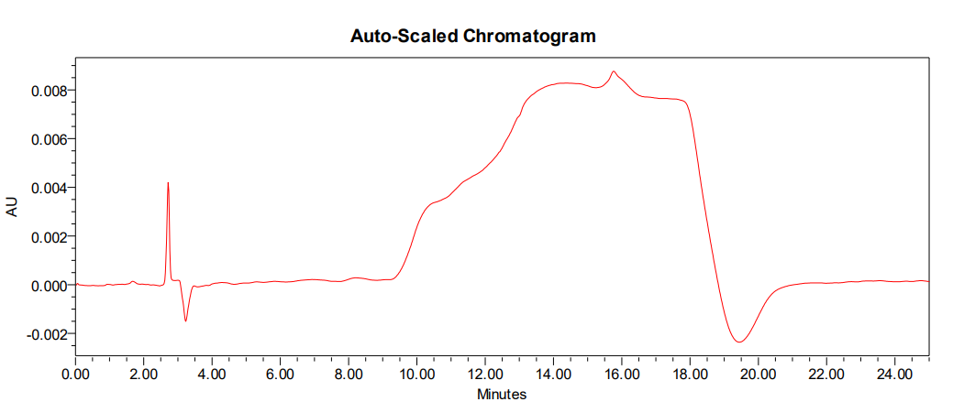
Typical chromatogram of Standard.
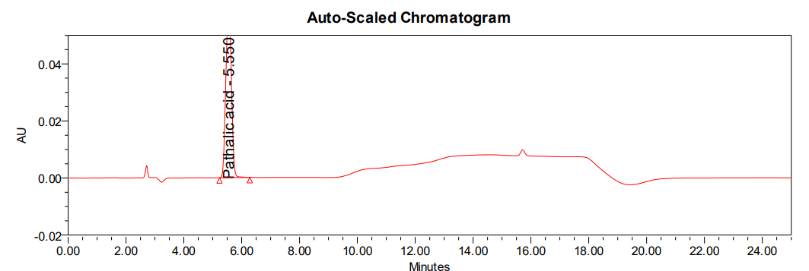
Typical chromatogram of Sample.
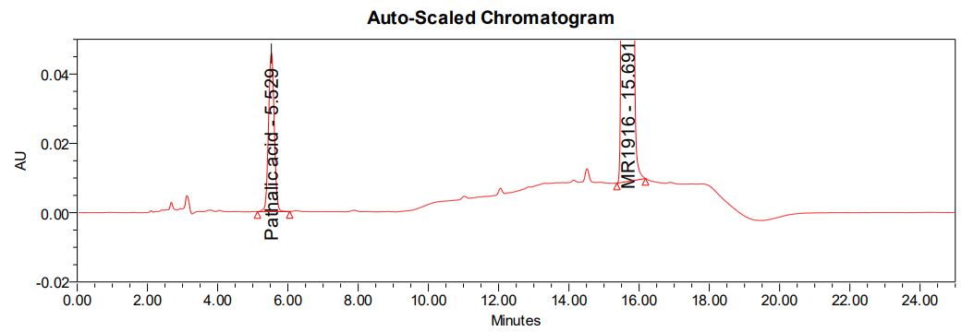
Conclusion:
Based on the above observations, chromatographic conditions and mobile phase composition was good and satisfactory and method was finalised for the method verification.
Establishment of standard and sample concentration:
The concentration of the phthalic acid standard solution is about 30 ppm (0.030 mg/mL-1% with respect to the sample concentration) and HPMCP sample solution 3000 ppm (3.0 mg/mL) fixed. The concentrations have been found to be optimum and have resulted in producing optimum peak height, tailing factor and plate count.
Diluent Selection
The diluent chosen [ i.e., water : acetonitrile (10 : 90) with 0.05% of TFA] for extracting the drug, basis to the solubility of the drug.
Hence the chromatographic conditions established in the above trials are finalized and method verification was planned.

Verification of Parameters with Finalized Method Conditions
Finalized test procedure for Phthalic acid content:
Mobile phase preparations:
Mobile phase-A:
Transferred 1.0 mL of TFA into 2000mL of 100% Water and mixed well.
Mobile phase-B:
Transferred 1.0 mL of TFA into 2000mL of 100% Acetonitrile and mixed well.
Diluent preparation:
Mix Acetonitrile : water and Trifluoro acetic acid in the ratio of 90 : 10 : 0.05 v/v. and degas.
Blank preparation: Use diluent as blank.
Chromatographic Conditions:
Column : Inertsil ODS 3V 250*4.6mm, 5µm
Flow Rate : 1.0 mL/minute
Wavelength : 235 nm
Column Temperature : 30°C
Sample Temperature : 25°C
Injection Volume : 10 µL
Run time : 25 minutes
Elution : Gradient
Needle wash : Diluent
Gradient program
Time | 0.01 | 6 | 10 | 15 | 16 | 25
Mobile Phase A (%) | 75 | 75 | 50 | 50 | 75 | 75
Mobile Phase B (%) | 25 | 25 | 50 | 50 | 25 | 25

Standard solution preparation for SDD (0.03mg/ml):
Weigh and transfer 20 mg of phthalic acid into 50 ml of volumetric flask and add about 30 ml of diluent and sonicate to dissolve then dilute volume upto the mark with diluent and mix well.
Further transfer 4mL above solution into 50mL volumetric, then dilute volume upto the mark with diluent and mix well.
Sample solution for 1mg Strength:
Weigh 20 capsules. Open each capsule and collect the powder. Weigh the empty shells to determine the average fill weight as follows.

Average fill weight

Accurately weigh powder equivalent to about 75 mg of HPMCP and transfer into 25 volumetric flasks, add 15 mL of diluent, keep in sonication for 30 minutes, and make up to volume with diluent, mix well. Centrifuged the solution for 10 minutes at 4000 RPM. Use the supernatant solution for analysis.
Sample solution for 2mg Strength:
Weigh 20 capsules. Open each capsule and collect the powder. Weigh the empty shells to determine the average fill weight as follows.

Average fill weight

Accurately weigh powder equivalent to about 78 mg of HPMCP and transfer into 25 volumetric flasks, add 15mL of diluent, keep in sonication for 30minutes, and make up to volume with diluent, mix well. Centrifuged the solution for 10 minutes at 4000RPM. Use the supernatant solution for analysis.
Sample solution for 4mg Strength:
Weigh 20 capsules. Open each capsule and collect the powder. Weigh the empty shells to determine the average fill weight as follows.

Average fill weight

Accurately weigh powder equivalent to about 156 mg of HPMCP and transfer into 50 volumetric flasks, add 30mL of diluent, keep in sonication for 30 minutes, and make up to volume with diluent, mix well. Centrifuged the solution for 10 minutes at 4000RPM. Use the supernatant solution for analysis.
Sample solution for 7mg Strength:
Weigh 20 capsules. Open each capsule and collect the powder. Weigh the empty shells to determine the average fill weight as follows.

Average fill weight

Accurately weigh powder equivalent to about 315 mg of HPMCP and transfer into 100 volumetric flasks, add 70mL of diluent, keep in sonication for 30 minutes, and make up to volume with diluent, mix well. Centrifuged the solution for 10 minutes at 4000RPM. Use the supernatant solution for analysis.
Sample solution for 2.5 mg Strength:
Take and weigh the 20 capsules. Open and transfer the powder from each capsule into a clean petri plate of suitable size. Take the total weight of empty capsule shells and calculate the average fill weight. Accurately weigh the sample powder (about 1200 mg) equivalent to 72 mg of HPMCP into a 25 mL volumetric flask, add 15 mL of diluent, and sonicate for 30 minutes with intermittent shaking of the volumetric flask. Make up the volume with diluent and mix well. Centrifuge a portion of the solution at 3000 RPM for about 10 minutes and filter the solution through 0.45μm PVDF or 0.45μm Nylon syringe filter, discarding the first 3 mL of sample prior to filling the HPLC vial for injection.
Sample solution for 5 mg Strength:
Take and weigh the 20 capsules. Open and transfer the powder from each capsule into a clean petri plate of suitable size. Take the total weight of empty capsule shells and calculate the average fill weight. Accurately weigh the sample powder (about 2400 mg) equivalent to 144 mg of HPMCP into a 50 mL volumetric flask, add 30 mL of diluent, and sonicate for 30 minutes with intermittent shaking of the volumetric flask. Make up the volume with diluent and mix well. Centrifuge a portion of the solution at 3000 RPM for about 10 minutes and filter the solution through 0.45μm PVDF or 0.45μm Nylon syringe filter, discarding the first 3 mL of sample prior to filling the HPLC vial for injection.

Note : 2.5 mg & 5 mg sample correction experiment was not conducted separately as sample preparation was optimized based on established sample preparation of 2 mg & 4 mg strengths. Because there is no difference in sample weights & volumetric flask between 2 mg, 4 mg and 2.5 mg 5 mg strengths. Detailed weights are tabulated below.

The equivalent weights for the 2mg and 4mg strengths, as mentioned below, were proposed based on the volume correction experiment to align with the sample concentration of 3mg/ml.

Label claim | Capsule size | Theoretical Avg Wt | Equivalent Weight | Sample Wt | Flask Size | Volume correction
2 mg | Size “3” | 100 mg | 72 mg | 1200 mg | 25 mL | 24 mL
2.5 mg | Size “0” | 125 mg | 72 mg | 1200 mg | 25 mL | 24 mL
4 mg | Size “0” | 200 mg | 144 mg | 2400 mg | 50 mL | 48 mL
5 mg | Size “0” | 250 mg | 144 mg | 2400 mg | 50 mL | 48 mL

Even though the capsule size is different for 2 mg & 2.5 mg it does not impact sample preparation & volume correction. This is because the sample is prepare based on the equivalent weight of API and capsules are not added at that time.

Procedure:
Equilibrate the chromatographic system with the mobile phase. Inject diluent as blank, standard solution in 6 replicates, sample solutions into the chromatograph.
System Suitability:
- No peak shall be detected at the retention time of peaks of analyte peak from blank injection.
- The tailing factor from the first standard injection shall be not less than 0.8 and not more than 1.8.
- % RSD of peak responses from standard replicate injections shall be not more than 10.0%.
- Inject bracketing standard after every six sample injections and calculate the cumulative %RSD from standard replicate injections under system suitability with each bracketing standard and the same shall be not more than 10.0%.
Calculation:

% of Phthalic acid content for 1mg Strength (3mg of HPMCP)

$$=\frac{A_{T}}{A_{S}}×\frac{W_{S}}{\text{50}}×\frac{\text{4}}{50}×\frac{\text{25}}{W_{T}}×\frac{\text{P}}{100}×\frac{AVG Wt}{\text{LC}}×\text{100}$$

% of Phthalic acid content for 2mg Strength (6mg of HPMCP)

$$=\frac{A_{T}}{A_{S}}×\frac{W_{S}}{\text{50}}×\frac{\text{4}}{50}×\frac{\text{25}}{W_{T}}×\frac{\text{P}}{100}×\frac{AVG Wt}{\text{LC}}×\text{100}$$

% of Phthalic acid content for 2.5mg Strength (7.5mg of HPMCP)

$$=\frac{A_{T}}{A_{S}}×\frac{W_{S}}{\text{50}}×\frac{\text{4}}{50}×\frac{\text{25}}{W_{T}}×\frac{\text{P}}{100}×\frac{AVG Wt}{\text{LC}}×\text{100}$$

% of Phthalic acid content for 4mg Strength (12mg of HPMCP)

$$=\frac{A_{T}}{A_{S}}×\frac{W_{S}}{\text{50}}×\frac{\text{4}}{50}×\frac{\text{50}}{W_{T}}×\frac{\text{P}}{100}×\frac{AVG Wt}{\text{LC}}×\text{100}$$

% of Phthalic acid content for 5mg Strength (15mg of HPMCP)

$$=\frac{A_{T}}{A_{S}}×\frac{W_{S}}{\text{50}}×\frac{\text{4}}{50}×\frac{\text{50}}{W_{T}}×\frac{\text{P}}{100}×\frac{AVG Wt}{\text{LC}}×\text{100}$$

% of Phthalic acid content for 7mg Strength (21mg of HPMCP)

$$=\frac{A_{T}}{A_{S}}×\frac{W_{S}}{\text{50}}×\frac{\text{4}}{50}×\frac{\text{100}}{W_{T}}×\frac{\text{P}}{100}×\frac{AVG Wt}{\text{LC}}×\text{100}$$

A_{T} = Peak area of Phthalic acid in the sample solution.
A_{S} = Average peak area of Phthalic acid from six replicate injections of standard solution injected under system suitability.
W_{S} = Weight of Phthalic acid working, or reference standard taken, in mg for the preparation of standard solution
W_{T} = Weight of sample.
P = Potency of Phthalic acid working standard or reference standard.
LC = Label claim of HPMCP in drug product.
AVG Wt = Average weight of capsule.

System Suitability:
Experiment No. / AR No: EM-221 Capsules_EM2-AMD-NB1_219129.
Experimental
System suitability was performed based on the above finalized conditions. Injected diluent as blank, and standard in six replicate injections into the chromatographic system by using reverse phase HPLC.
Table 2: System Suitability Criteria
Parameter | Acceptance Criteria
Blank Interference | No peak shall be observed in the blank chromatogram at the retention time of the phthalic acid peak.
% RSD from six replicate injections of standard solution | NMT 10.0%
Tailing factor from the first standard injection of phthalic acid peak. | NLT 0.8 and NMT 1.8

Results
Results of system suitability are summarized below (data was collected from the specificity parameter).
Table 3: System Suitability Results
Parameter | Results | Acceptance Criteria
Blank Interference | No interference observed | No peak shall be observed in the blank chromatogram at the retention time of peaks of interest.
% RSD from 6 replicate injections of standard solution | 0.44% | NMT 10.0%
Tailing factor from the first standard injection | 0.9 | NLT 0.8 and NMT 1.8

Conclusion
The method meets the requirements of system suitability.

Specificity

Blank Interference & Placebo
Experiment No. / AR No: EM-221 Capsules_EM2-AMD-NB1-219129.
Experimental
To establish non-interference, blank & placebo (API+Rest of the excipients without HPMCP) solutions were prepared and injected into HPLC.
Acceptance Criteria
No peak shall be detected in the blank & placebo (API+Rest of the excipients without HPMCP) chromatogram at the retention time of phthalic acid peak.
Results
No peak was detected in the blank & placebo (API+Rest of the excipients without HPMCP) chromatogram at the retention time of phthalic acid peak.
Table 4: Peak Information Table
Name of the solution | Peak Name | Retention Time
Blank | Phthalic acid | Not detected
Placebo | Phthalic acid | Not detected
Standard | Phthalic acid | 5.662
As such sample | Phthalic acid | 5.676
Conclusion
The method meets the requirements of blank & placebo (API ) interference.

Method Precision
Experimental: EM-221 1 mg, 2 mg, 4 mg & 7 mg capsules
Experiment No. / AR No: EM-221 Capsules_EM2-AMD-NB1-219129, 219819 & 219825.
Experimental
Prepared six sample solutions as per the test method and analyzed. Method precision was carried by spiking phthalic acid solution (1%) on the control sample. % RSD was calculated for phthalic acid content from six preparations.
Experimental: EM-221 2.5 mg & 5 mg capsules
Experiment No. / AR No: EM-221 Capsules 2.5mg and 5mg - 219819 & 219825.
Method precision for the 2.5 mg and 5 mg strengths was performed using three replicate samples, without spiking phthalic acid, as the product itself contains approximately 0.5% phthalic acid. However, in earlier development method precision was established with 1% phthalic acid spiking for the 1 mg, 2 mg, 4 mg and 7 mg strengths and validation studies performed on 1 mg & 7 mg strengths.
Acceptance Criteria
The relative standard deviation of six replicate content results should be NMT 5.0%
Results
The results were found to be within the acceptance criteria and summarized in Table 5 to 10.
Table 5: Results of Method Precision for 1mg strength
Sample No. | Retention Time | % Content of Phthalic acid
1 | 5.666 | 1.6544822
2 | 5.680 | 1.6376908
3 | 5.671 | 1.6647855
4 | 5.680 | 1.6558513
5 | 5.672 | 1.6494700
6 | 5.681 | 1.6487622
Average |  | 1.6518403
% RSD |  | 0.55

Table 6: Results of Method Precision for 2mg strength
Sample No. | Retention Time | % Content of Phthalic acid
1 | 5.681 | 1.5325582
2 | 5.678 | 1.5307092
3 | 5.679 | 1.5329121
4 | 5.692 | 1.5425297
5 | 5.694 | 1.5277249
6 | 5.690 | 1.5276003
Average |  | 1.5323390
% RSD |  | 0.36

Table 7: Results of Method Precision for 4mg strength
Sample No. | Retention Time | % Content of Phthalic acid
1 | 5.688 | 1.5300519
2 | 5.698 | 1.5384721
3 | 5.704 | 1.5332807
4 | 5.710 | 1.5337578
5 | 5.700 | 1.5269540
6 | 5.712 | 1.5322979
Average |  | 1.5324690
% RSD |  | 0.25

Table 8: Results of Method Precision for 7mg strength
Sample No. | Retention Time | % Content of Phthalic acid
1 | 5.671 | 1.5359666
2 | 5.664 | 1.5438244
3 | 5.670 | 1.5397907
4 | 5.662 | 1.5121880
5 | 5.668 | 1.5150985
6 | 5.669 | 1.5314432
Average |  | 1.5297186
% RSD |  | 0.86

Table 9: Results of Method Precision for 2.5 mg strength
Sample No. | Retention Time | % Content of Phthalic acid
1 | 5.496 | 0.54597
2 | 5.496 | 0.52156
3 | 5.499 | 0.52874
Average |  | 0.53209
% RSD |  | 2.36

Table 10: Results of Method Precision for 5 mg strength
Sample No. | Retention Time | % Content of Phthalic acid
1 | 5.492 | 0.54456
2 | 5.483 | 0.55136
3 | 5.490 | 0.54876
Average |  | 0.54822
% RSD |  | 0.63

Conclusion
The method is precise as the results meet the acceptance criteria.

Linearity
Experiment No. / AR No: EM-221 Capsules_EM2-AMD-NB1-219129.
Experimental
Linearity of detector response for phthalic acid was established by analyzing serial dilutions of stock solution of the standard in the diluent. Six concentrations ranging from 25% (About 8ppm) to 150% (About 49ppm) of the target concentration were prepared and analyzed.
The final concentration of each solution in mg per mL was plotted against peak area response. Slope, y-intercept, and correlation coefficient (R) were calculated.
Acceptance Criteria
The correlation coefficient should be not less than 0.99.
The bias at 100% response should not be more than ± 5%.
Report the intercept and slope.
Results
The correlation coefficient for phthalic acid is 1.0000 and Bias at 100% level is 0.18. The results of the experiment are summarized in Table 9. Linearity plot is shown in Figure 1.

Table 11: Linearity of phthalic acid

S. No. | % Level | Concentration (mg per mL) | Area
1 | 25 | 0.008 | 191879.1744840
2 | 50 | 0.016 | 381171.6019001
3 | 75 | 0.024 | 569294.9702388
4 | 100 | 0.033 | 761198.4750603
5 | 125 | 0.041 | 956826.4153634
6 | 150 | 0.049 | 1146495.9259716
Slope |  |  | 23445979.0047
y-intercept |  |  | -1384.07643
Correlation Coefficient |  |  | 1.0000
Bias at 100% response |  |  | -0.18

Figure 1. Linearity Curve of phthalic acid.
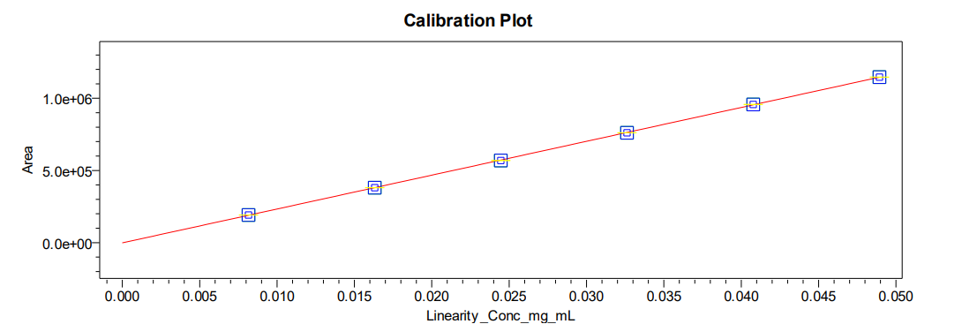
Conclusion
The results reveal that method is linear for quantification of phthalic acid in the proposed range.

Accuracy
Experiment No. / AR No: EM-221 Capsules_ EM2-AMD-NB1_219129.
Experimental
A recovery study was conducted by spiking phthalic acid stock solution on control sample from about 50% to 100% of target specification (for 100% Accuracy preparations considered from method precision for all strength) of 1% (30 ppm or 0.03 mg/ml) to the test concentration (3000 ppm or 3 mg/ml of HPMCP). Phthalic acid content recovery samples were prepared in triplicates at all levels and analyzed as per the test method. The amount spiked, the amount recovered, the percent recovery, and its mean were calculated. All the results were found to be within the limits.
Acceptance Criteria
The individual % recovery of phthalic acid should be between 85.0% to 115.0%.
Results
The individual recoveries at each level are found to be well within the acceptance criteria.

Table 12: Results of Accuracy for phthalic acid for 1mg Strength
S.No. | Accuracy level | ‘mg/mL’ added | ‘mg/mL’ found (recovered) | % Recovery | Mean  % Recovery
1 | 50% | 16.06780 | 16.08247 | 100.1 | 98.9
2 | 50% | 16.06780 | 15.75202 | 98.0 | 98.9
3 | 50% | 16.06780 | 15.85914 | 98.7 | 98.9
1 | 100% | 32.13560 | 31.50998 | 98.1 | 97.9
2 | 100% | 32.13560 | 31.00624 | 96.5 | 97.9
3 | 100% | 32.13560 | 31.81908 | 99.0 | 97.9

Table 13: Results of Accuracy for phthalic acid for 2mg Strength
S.No. | Accuracy level | ‘mg/mL’ added | ‘mg/mL’ found (recovered) | % Recovery | Mean  % Recovery
1 | 100% | 32.13560 | 30.25214 | 94.1 | 94.1
2 | 100% | 32.13560 | 30.19667 | 94.0 | 94.1
3 | 100% | 32.13560 | 30.26276 | 94.2 | 94.1

Table 14: Results of Accuracy for phthalic acid for 4mg Strength
S.No. | Accuracy level | ‘mg/mL’ added | ‘mg/mL’ found (recovered) | % Recovery | Mean  % Recovery
1 | 100% | 32.13560 | 30.24542 | 94.1 | 94.5
2 | 100% | 32.13560 | 30.49803 | 94.9 | 94.5
3 | 100% | 32.13560 | 30.34229 | 94.4 | 94.5

Table 15: Results of Accuracy for phthalic acid for 7mg Strength
S.No. | Accuracy level | ‘mg/mL’ added | ‘mg/mL’ found (recovered) | % Recovery | Mean  % Recovery
1 | 100% | 32.13560 | 29.87463 | 93.0 | 93.3
2 | 100% | 32.13560 | 30.11036 | 93.7 | 93.3
3 | 100% | 32.13560 | 29.98935 | 93.3 | 93.3

Conclusion
The results reveal that the method is accurate for all levels studied.

Ruggedness:

Solutions Stability at Room Temperature (RT)
Experiment No. / AR No: EM-221 Capsules_EM2-AMD-NB1-219129.
The stability of standard and sample solutions was established at room temperature for a period of 2 days. The standard solution was prepared per the test method, and sample solutions were prepared in duplicate and analyzed.
The final preparations of the standard and sample solutions were then stored on the bench top at controlled room temperature in tightly closed glass containers and analyzed after day 1 and day 2.
For standard solutions, the ratio of the specific response (similarity factor) of the stored standard solution to the specific response of the initial injected standard solution was calculated for each time point. For sample solutions, % content and the per cent content relative difference between the initial and each day were calculated.

Table 16: Results of Room Temperature (RT) Stability of Control Test Solution
Time in days | Test sample | % of phthalic acid | Relative Difference from Initial  % of phthalic acid
Initial | Control sample 1 | 0.54015 | NA
Initial | Control sample 2 | 0.52378 | NA
Day-1 | Control sample 1 | 0.54519 | -0.93
Day-1 | Control sample 2 | 0.53612 | -2.36
Day-2 | Control sample 1 | 0.55453 | -2.66
Day-2 | Control sample 2 | 0.54387 | -3.84

Table 17: Results of Room Temperature (RT) Stability of Spiked Test Solution
Time in days | Test sample | % of phthalic acid | Relative Difference from Initial  % of phthalic acid
Initial | Spiked sample 1 | 1.5359666 | NA
Initial | Spiked sample 2 | 1.5438244 | NA
Day-1 | Spiked sample 1 | 1.5580360 | -1.44
Day-1 | Spiked sample 2 | 1.5488556 | -0.33
Day-2 | Spiked sample 1 | 1.5738851 | -2.47
Day-2 | Spiked sample 2 | 1.5714385 | -1.79

Table 18: Results of Room Temperature (RT) Stability of Standard Solution
Time in days | Similarity Factor
Time in days | Standard Stability at Room Temperature
Initial | NA
Day-1 | 1.00
Day-2 | 1.00

Solution Stability at Refrigeration Condition (2-8°C)
The stability of standard and sample solutions was established at refrigerator for a period of 2 days. The standard solution was prepared per the test method, and sample solutions were prepared in duplicate and analyzed.
The final preparations of the standard and sample solutions were then stored on the refrigerator in tightly closed glass containers and analyzed after day 1 and day 2.
For standard solutions, the ratio of the specific response (similarity factor) of the stored standard solution to the specific response of the initial injected standard solution was calculated for each time point. For sample solutions, % content and the per cent content relative difference between the initial and each day were calculated.
Note: A precipitate was formed in the test solution in HPLC vial after 24 hours in refrigerate condition, but there is no impact on results, however, it may impact on column performance, therefore is no need for the test solution stored in the refrigerator condition.
Table 19: Results of Refrigerator (2 - 8°C) Stability of Control Test Solution
Time in days | Test sample | % of phthalic acid | Relative Difference from Initial  % of phthalic acid
Initial | Control sample 1 | 0.54015 | NA
Initial | Control sample 2 | 0.52378 | NA
Day-1 | Control sample 1 | 0.54331 | -0.59
Day-1 | Control sample 2 | 0.53118 | -1.41
Day-2 | Control sample 1 | 0.54562 | -1.01
Day-2 | Control sample 2 | 0.53917 | -2.94
Table 20: Results of Results of Refrigerator (2 - 8°C) Stability of Spiked Test Solution
Time in days | Test sample | % of phthalic acid | Relative Difference from Initial  % of phthalic acid
Initial | Spiked sample 1 | 1.5359666 | NA
Initial | Spiked sample 2 | 1.5438244 | NA
Day-1 | Spiked sample 1 | 1.5525174 | -1.08
Day-1 | Spiked sample 2 | 1.5405139 | 0.21
Day-2 | Spiked sample 1 | 1.5621407 | -1.70
Day-2 | Spiked sample 2 | 1.5364231 | 0.48

Table 21: Results of Refrigerator (2 - 8°C) Stability of Standard Solution

Time in days | Similarity Factor
Time in days | Standard Stability at Refrigerator
Initial | NA
Day-1 | 0.99
Day-2 | 1.00

Acceptance Criteria:
- For the standard solution, the similarity factor should be in the range of 0.95 to 1.05.
- For sample solution, the difference in % phthalic acid results from initial to stability should be not more than ± 10.0.

Conclusion:
Results of standard and test solutions were within the acceptance criteria till day 2. From the study, it was established that the standard and test solutions were stable on bench top & refrigerator condition for 2 days.

Mobile Phase Stability at Room Temperature (RT):
A study was conducted to establish bench top stability of the mobile phase at initial and after two days. Prepared the mobile phase as per the test method and kept it on the bench top in well-closed condition. The standard solution was prepared as per the test method and injected into the HPLC system. The system suitability parameters were evaluated as per the test method and found within the limits. From the study, it was established that the mobile phase is stable for a period of 2 days on the bench top.
Note : The final bracketing standard was calculated against the initial 5 replicate standard injections and considered for the same mobile phase stability purpose.
Table 22: Results of Mobile Phase stability at Room Temperature (RT)
System Suitability Parameters | Observed value
System Suitability Parameters | Initial | Day-2
Percent of interference at phthalic acid peak in Blank | Nil | NA
Tailing factor of the phthalic acid peak from first standard injection | 0.90 | 0.95
% RSD for analyte peak areas of six replicate standard injections | 0.58% | NA
% RSD of bracketing standard for analyte peak areas of six replicate standard injections | NA | 0.95

Acceptance Criteria:
- No peak shall be detected in the blank at the retention time of the phthalic acid peak.
- The tailing factor for the phthalic acid peak from the first injection of the standard chromatogram should be not less than 0.8 and not more than 1.8.
- The % RSD of peak area response of phthalic acid from six replicate injections of standard solution injected under system suitability shall be not more than 10.0.

Conclusion:
Method verification for Assay of MR1916 in EM-221 capsules 1 mg, 2 mg, 2.5 mg, 4 mg, 5 mg & 7 mg meets all established acceptance criteria. Results of sample and standard solution stability data generated up to 2 days shows that the standard and sample solutions are stable for 2 days at RT, when stored in a tightly closed glass container. Mobile Phase is stable up to 2 days when stored in a tightly closed glass container at room temperature. 0.45µm PVDF & Nylon filters can be used for sample filtration.

For Sample solution stability study was not established as sample was getting recrystallizing when stored in refrigerator (2-8°C). Therefore, it is recommended that standard and samples solutions are not stored in a refrigerator (2-8°C).
Based on the obtained above results of different method verification parameters, the chromatographic conditions were finalized and shall be used for regular analysis.

FINALIZED METHOD CONDITIONS
Apparatus
HPLC: Equipped with a UV-Visible detector capable of operating at 235 nm or PDA detector capable of operating in the range of 200 nm to 400 nm.
Column: Inertsil ODS-3V, 250 x 4.6mm, 5µm
Analytical Balance: Accurate to 0.1 mg
Ultrasonic Bath
Centrifuge
Membrane Filters: 0.45µm Nylon membrane filter or equivalent for mobile phase filtration or equivalent.
Volumetric Flasks: 25 mL, 50 mL and 100 mL Class A
Volumetric Pipette:4mL Class A
Chemicals
Phthalic Acid working or reference standard: Of known purity.
Acetonitrile (CH₃CN): HPLC grade or equivalent
Trifluoro acetic acid (C₂HF₃O₂): HPLC grade or equivalent

Reagent Solutions Preparation
Note:
- The volume of these solutions may be scaled up or down as appropriate for testing.
- Mobile phase is stable for a period of 2 days on bench top when stored appropriately in tightly closed glass containers.

Mobile phase A: Add 0.5 mL of trifluoro acetic acid in 1000 mL of water. Degas the mobile phase by sonication for 10 minutes.
Mobile Phase B: Add 0.5 mL of trifluoro acetic acid in 1000 mL of acetonitrile. Degas the mobile phase by sonication for 10 minutes.
Diluent: Add 0.5 mL of trifluoro acetic acid into the 900mL of acetonitrile and 100 mL of water. Degas the diluent by sonication for 10 minutes.
Blank Solution: Use diluent as blank solution.
Standard Solution Preparation
Standard solutions is stable up to 2 days when stored appropriately in bench top & refrigerator (2 - 8°C) in tightly closed glass containers.
Weigh and transfer 20 mg of phthalic acid into 50 ml of volumetric flask and add about 30 ml of diluent and sonicate to dissolve then dilute volume upto the mark with diluent and mix well.
Further transfer 4mL above solution into 50mL volumetric, then dilute volume upto the mark with diluent and mix well.
Sample Solution Preparation
Note:
- Sonicator temperature should be maintained at 20ºC-25ºC.
- Sample solutions is stable up to 2 days when stored appropriately in bench top & refrigerator (2 - 8°C) in tightly closed glass containers.

For 1mg strength: (1mg strength capsule contain 3 mg of HPMCP)
Weigh 30 capsules. Open and transfer the powder from each capsule into a clean petri plate of suitable size. Take the total weight of powder and calculate the average fill weight. Accurately weigh the powder (about 1200 mg) equivalent to 72 mg of HPMCP into a 25 mL volumetric flask, add 15 mL of diluent, and sonicate for 30 minutes with intermittent shaking of the volumetric flask. Make up the volume with diluent and mix well. Centrifuge a portion of the solution at 3000 RPM for about 10 minutes and take an aliquot of the supernatant for analysis.

For 2mg strength: (2mg strength capsule contain 6 mg of HPMCP)
Weigh 20 capsules. Open and transfer the powder from each capsule into a clean petri plate of suitable size. Take the total weight of powder and calculate the average fill weight. Accurately weigh the powder (about 1200 mg) equivalent to 72 mg of HPMCP into a 25 mL volumetric flask, add 15 mL of diluent, and sonicate for 30 minutes with intermittent shaking of the volumetric flask. Make up the volume with diluent and mix well. Centrifuge a portion of the solution at 3000 RPM for about 10 minutes and take an aliquot of the supernatant for analysis.

For 2.5 mg Strength: (2.5mg strength capsule contain 7.5 mg of HPMCP)
Take and weigh the 20 capsules. Open and transfer the powder from each capsule into a clean petri plate of suitable size. Take the total weight of empty capsule shells and calculate the average fill weight. Accurately weigh the sample powder (about 1200 mg) equivalent to 72 mg of HPMCP into a 25 mL volumetric flask, add 15 mL of diluent, and sonicate for 30 minutes with intermittent shaking of the volumetric flask. Make up the volume with diluent and mix well. Centrifuge a portion of the solution at 3000 RPM for about 10 minutes and filter the solution through 0.45μm PVDF or 0.45μm Nylon syringe filter, discarding the first 3 mL of sample prior to filling the HPLC vial for injection.

For 4mg strength: (4mg strength capsule contain 12 mg of HPMCP)
Weigh 20 capsules. Open and transfer the powder from each capsule into a clean petri plate of suitable size. Take the total weight of powder and calculate the average fill weight. Accurately weigh the powder (about 2400 mg) equivalent to 144 mg of HPMCP into a 50 mL volumetric flask, add 35 mL of diluent, and sonicate for 30 minutes with intermittent shaking of the volumetric flask. Make up the volume with diluent and mix well. Centrifuge a portion of the solution at 3000 RPM for about 10 minutes and take an aliquot of the supernatant for analysis.

For 5 mg Strength: (5mg strength capsule contain 15 mg of HPMCP)
Take and weigh the 20 capsules. Open and transfer the powder from each capsule into a clean petri plate of suitable size. Take the total weight of empty capsule shells and calculate the average fill weight. Accurately weigh the sample powder (about 2400 mg) equivalent to 144 mg of HPMCP into a 50 mL volumetric flask, add 30 mL of diluent, and sonicate for 30 minutes with intermittent shaking of the volumetric flask. Make up the volume with diluent and mix well. Centrifuge a portion of the solution at 3000 RPM for about 10 minutes and filter the solution through 0.45μm PVDF or 0.45μm Nylon syringe filter, discarding the first 3 mL of sample prior to filling the HPLC vial for injection.

For 7mg strength: (7mg strength capsule contain 21 mg of HPMCP)
Weigh 20 capsules. Open and transfer the powder from each capsule into a clean petri plate of suitable size. Take the total weight of powder and calculate the average fill weight. Accurately weigh the powder (about 4850 mg) equivalent to 290 mg of HPMCP into a 100 mL volumetric flask, add 70 mL of diluent, and sonicate for 30 minutes with intermittent shaking of the volumetric flask. Make up the volume with diluent and mix well. Centrifuge a portion of the solution at 3000 RPM for about 10 minutes and take an aliquot of the supernatant for analysis.
Chromatographic Conditions:
Column : Inertsil ODS 3V 250*4.6mm, 5micron
Flow Rate : 1.0 mL/minute
Wavelength : 235 nm
Column Temperature : 30°C
Sample Temperature : 25°C
Injection Volume : 10 µL
Run time : 25 minutes
Elution : Gradient
Needle wash : Diluent
Gradient program
Time | Mobile Phase A (%) | Mobile Phase B (%)
0.01 | 75 | 25
6 | 75 | 25
10 | 50 | 50
15 | 50 | 50
16 | 75 | 25
25 | 75 | 25

Note:
- Condition the column with the above gradient program till a stable baseline is attained.
- After completion of each sample set column washing is mandatory with 95:5 Acetonitrile & Water minimum 3 hours and 80:20 Water & Acetonitrile with minimum 1 hour.

Procedure
Follow the following order of injection for sample set sequence:
S. No. | Description | No. of injections
1 | Diluent (Blank) | 1 (Minimum)
2 | Standard solution | 6
3 | Sample solution | 1
4 | Bracketing standard (Standard solution ) | 1

System Suitability
No peak greater than 0.02% in blank shall be detected in the blank at the retention time of Phthalic acid.
Note: % Interference shall be calculated by using blank peak area against standard peak area and standard concentration and use below calculation formula
$$\frac{A_{T}}{A_{S}}×\frac{Std Wt}{\text{5}\text{0}}×\frac{4}{\text{5}\text{0}}×\frac{P}{\text{100}}× 100$$

Where,
A_{T} is the individual peak area of Phthalic acid in the blank solution.
A_{S} is the average peak area of Phthalic acid from six replicate injections of standard solution injected under system suitability.
W_{S} is the weight of Phthalic acid working or reference standard taken, in mg
P is the potency of Phthalic acid working standard or reference standard on as is basis.
- The percent relative standard deviation of the average peak area response of Phthalic acid shall be NMT 5.0%.
- The Tailing factor of phthalic acid peak from the first standard chromatogram shall be between 0.8 to 1.8.
- For the bracketing standard, the cumulative % RSD of areas of phthalic acid from six replicate injections of the standard solution obtained under system suitability and specific bracketing standard area response shall be NMT 5.0%.

Calculations

% of Phthalic acid content for 1mg Strength (3mg of HPMCP)

$$\frac{A_{T}}{A_{S}}×\frac{W_{S}}{\text{50}}×\frac{\text{4}}{50}×\frac{\text{V}}{W_{T}}×\frac{\text{P}}{100}×\frac{AVG Wt}{\text{LC}}×\text{100}$$

% of Phthalic acid content for 2mg Strength (6mg of HPMCP)

$$\frac{A_{T}}{A_{S}}×\frac{W_{S}}{\text{50}}×\frac{\text{4}}{50}×\frac{\text{V}}{W_{T}}×\frac{\text{P}}{100}×\frac{AVG Wt}{\text{LC}}×\text{100}$$

% of Phthalic acid content for 2.5mg Strength (7.5mg of HPMCP)

$$=\frac{A_{T}}{A_{S}}×\frac{W_{S}}{\text{50}}×\frac{\text{4}}{50}×\frac{\text{V}}{W_{T}}×\frac{\text{P}}{100}×\frac{AVG Wt}{\text{LC}}×\text{100}$$

% of Phthalic acid content for 4mg Strength (12mg of HPMCP)

$$\frac{A_{T}}{A_{S}}×\frac{W_{S}}{\text{50}}×\frac{\text{4}}{50}×\frac{\text{V}}{W_{T}}×\frac{\text{P}}{100}×\frac{AVG Wt}{\text{LC}}×\text{100}$$

% of Phthalic acid content for 5mg Strength (15mg of HPMCP)

$$=\frac{A_{T}}{A_{S}}×\frac{W_{S}}{\text{50}}×\frac{\text{4}}{50}×\frac{\text{V}}{W_{T}}×\frac{\text{P}}{100}×\frac{AVG Wt}{\text{LC}}×\text{100}$$

% of Phthalic acid content for 7mg Strength (21mg of HPMCP)

$$\frac{A_{T}}{A_{S}}×\frac{W_{S}}{\text{50}}×\frac{\text{4}}{50}×\frac{\text{V}}{W_{T}}×\frac{\text{P}}{100}×\frac{AVG Wt}{\text{LC}}×\text{100}$$

A_{T} = Peak area of Phthalic acid in the sample solution.
A_{S} = Average peak area of Phthalic acid from six replicate injections of standard solution injected under system suitability.
W_{S} = Weight of Phthalic acid working, or reference standard taken, in mg for the preparation of standard solution
W_{T} = Weight of sample.
V is for 1mg strength is 24.0
for 2 mg strength is 24.0
for 2.5 mg strength is 24.0
for 4mg strength is 47.9
for 5 mg strength is 47.9
for 7mg strength is 96.5
P = Potency of Phthalic acid working standard or reference standard.
LC = Label claim of HPMCP in drug product
= 1mg strength capsule contain 3 mg of HPMCP
= 2mg strength capsule contain 6 mg of HPMCP
= 2.5mg strength capsule contain 7.5 mg of HPMCP
= 4mg strength capsule contain 12 mg of HPMCP
= 5mg strength capsule contain 15 mg of HPMCP
= 7mg strength capsule contain 21 mg of HPMCP
AVG Wt = Average fill weight of EM-221 capsule.

Chromatograms
Specimen Chromatogram of blank Chromatogram
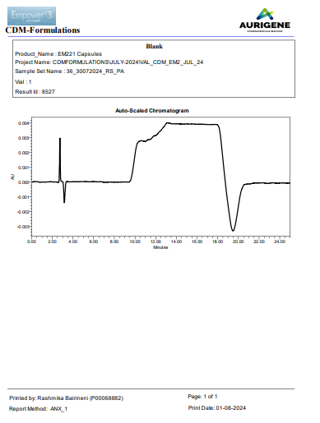

Specimen Chromatogram of Standard Chromatogram of phthalic acid
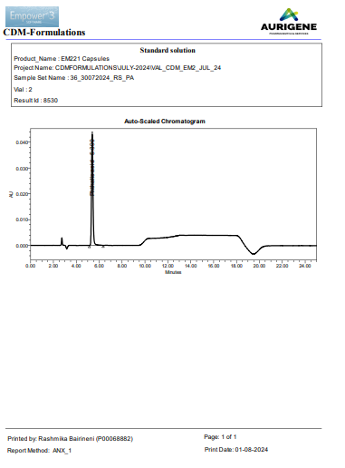

Specimen Chromatogram of Placebo Chromatogram of phthalic acid
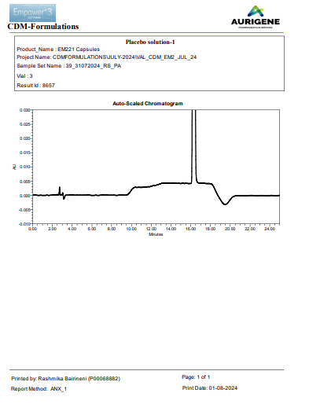
Specimen Chromatogram of Sample Chromatogram of phthalic acid
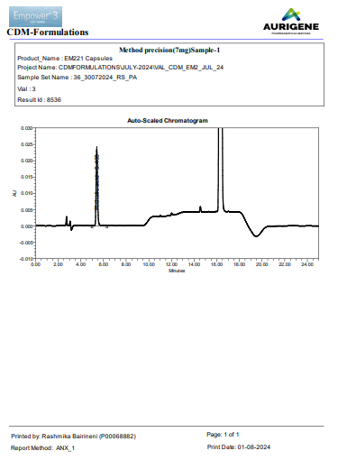

Change History
Version | Description of the Changes made
1.0 | New Analytical Method Development & Verification Report for Determination Phthalic acid content by HPLC for EM-221 Capsules 1 mg, 2 mg, 4 mg & 7mg.
2.0 | In bench top sample solution stability mentioned as 24 hrs stable instead of 2 days. Hence, the same has been corrected and report revised.
3.0 | The Analytical Method Development & Verification Report for Determination Phthalic acid content by HPLC for EM-221 Capsules 1 mg, 2 mg, 4 mg & 7mg.has been revised to include the new strengths of 2.5 mg and 5 mg, along with the optimization of test concentrations and sample preparation, followed by the performance of the precision study.

