\Department | Analytical Research & Development

ISMS Class: Internal

- Objective

The objective of this report is to draw conclusions based on the verification conducted on the Test procedure (STP-16-001313) for related substances of Lenalidomide Hemihydrate API using HPLC. Based on the verification parameters, the method is found to be Precise, Specific and shall be adopted for routine testing.
Limited parameters have been studied as the analytical method was validated.

- Responsibility
Scientist/Team Member AR&D is responsible for execution method verification and preparation of method verification report.
Team Leader/Group Leader AR&D or designee shall review and ensure the compliance.
DQA/QA is responsible to approve the method verification report.

- References
Analytical Method validation SOP: SOP-GLB-AR&D-0004, Version*
Work instruction on Validation of Analytical Test Procedure for Related substance by Liquid Chromatography: WI-GLB-AR&D-0021*
Documenting the Research data in E-Lab Notebook (ELN) SOP: SOP-CDM-RD-0061*
Test Method Reference No: STP-16-001313
Specification No : 1035-13004743, Version 5.0,
* Current Versions

- Method Verification Parameters Executed
- System Suitability
- Batch Analysis
- Method Precision
- Linearity
- LOQ Precision
Note :
- Specificity was not performed in method verification as there is no known impurities in method. However, this parameter was performed during the validation.
- Solution stability also not performed in method verification as per the validation report sample should be prepare freshly.
- Selection of Batch
The analytical method verification was conducted on the drug substance batch number IWC230107. The CoA for the same was obtained from the supplier/vendor for the study.
- Instrument & Solvent Details
Following instruments were used for method verification activities
Name of the Instrument | ID | Make | Calibration Due date
Micro balance | CDM-AR&D-MB-0182 | Sartorius | 22-04-2025
Ultrasonic water batch | CDM-AR&D-SON-0321 | Powersonic | 05-08-2025
HPLC | CDM-AR&D-HPLC- 0010 | Agilent | 20-08-2025
HPLC | CDM-AR&D-HPLC- 0172 | Waters | 02-09-2025

Following solvents/chemicals were used for method verification.
Name of the Solvent | Make | Grade | Batch No. | Valid Up to
Ortho phosphoric acid | Merck | Emparta | DL1D711501 | 02-07-2025
Acetonitrile | Honeywell | LC-MS | M272M | 03-08-2025

Following standard were used for method verification

S. No. | Standard /Impurity/ Sample Name | Batch number | Valid up to | Potency
1 | Lenalidomide Hemihydrate Standard | CFWS-0280-00 | 30-11-2025 | 96.5%

- Test Procedure

Related Substances by HPLC:
Chromatographic conditions:
Equipment :A liquid chromatograph is equipped with variable wavelength UV- Detector. (Agilent 1200/1260 series or equivalent)
Column : lnertsustainC18 (250 x 4.6 mm, 5 ~) (or Equivalent)
(Part No.5020-07346)
Flow Rate : 1.0 mL/minute
Wavelength : 218 nm
Column Temperature : 30°C
Injection Volume : 10 µL
Run time : 45 minutes
Elution : Gradient
Preparation of Mobile phase A: Transfer 1.0ml of Ortho-Phosphoric acid in to 1000ml water and mix. Filter and degas.
Mobile phase B : Acetonitrile.
Preparation of Diluent: Mix 70 volumes of water and 30 volumes of Acetonitrile. (v/v)
Gradient program
Time | Mobile Phase A (%) | Mobile Phase B (%)
0.01 | 90 | 10
2.00 | 90 | 10
12.00 | 85 | 15
35.00 | 25 | 75
35.10 | 90 | 10
45.00 | 90 | 10

Preparation of Reference Solution: Weigh accurately about 10 mg Lenalidomide hemihydrate test standard and transfer into a 200 ml volumetric fiask. Add about 100 ml of diluent, sonicate to dissolve and dilute to volume with diluent and mix. Further dilute 1.0 ml of above solution to 100 ml with diluent.
Preparation of Sample Solution: Weigh accurately about 25 mg of sample and transfer into a 50 ml volumetric flask. Add about 35 ml of diluent, sonicate to dissolve and dilute up to volume with diluent and mix (Prepare and inject sample immediately).
Note: Prepare Sample solution and Reference solution in duplicate.
Procedure: Separately inject equal volumes of Reference solution and Sample solution into the chromatograph and record the peak area responses for the major peaks and check for the System suitability requirement.
Acceptance criteria for System suitability requierments:
- The similarity factor between reference solution A (6 replicates) and reference solution B (separately prepared & injected) should be between 0.95 to1.05.
- The column efficiency and tailing factor for the peak of Lenalidomide obtained in the chromatogram of individual Reference solution A injected in replicate (including bracketing standard ) and of Reference solution B should not be less than 2000 theoretical plates and should not be more than 2 .0 respectively. (Report the value obtained from first injection of replicate of Reference solution A as well as last bracketing standard).
- The relative standard deviation for peak area response for the peak of Lenalidomide for replicate injections of Reference solution A and replicate injections of Reference solut ion A including bracketing standard should not be more than 5.0% each and the relative standard deviation for the retention time for the peak of Lenalidomide for replicate injections of Reference solution A and replicate injections of Reference solution A including bracketing standard should not be more than 1.00 % and 2.00% respectively.

Calculate the amount of impurities by area percentage by using the following formula.

$$\% Individual impurity=\frac{A}{B}×\frac{W1}{200}×\frac{1}{100}×\frac{50}{W2}×\frac{50}{5}×\frac{P}{100}×100$$
$$\% Total Unknown impurities=\frac{C}{B}×\frac{W1}{200}×\frac{1}{100}×\frac{50}{W2}×\frac{50}{5}×\frac{P}{100}×100$$

Total impurities=% Total Unknown Impurities.

Where,
A= Peak area response of unspecified impurity obtained in the chromatogram of Sample solution.
B= Average peak area response of Lenalidomide peak obtained in the chromatogram of
Reference solution A
C= Sum of area of all unknown peaks obtained in the chromatogram of Sample solution.
W1= Weight of Lenalidomide standard for preparation of reference solution A
W2= Weight of sample.
P=Purity of Lenalidomide Standard on as such basis.

- Method Verification Data

  - System Suitability:
The System suitability solution was prepared by using Lenalidomide Hemihydrate standard and injected into the HPLC system. The system suitability parameters were evaluated and found to be within the limits.
For Blank, System suitability and reference standard chromatograms refer Annexure.
Table 1A: Results of System Suitability
System suitability parameters | Observed value
Blank interference from blank preparation at the retention of Lenalidomide peak. | ND
The similarity factor between reference solution A and reference solution B. | 1.01
Theoretical plates of Lenalidomide peak standard solution | 8513
Tailing factor for Lenalidomide peak from standard solution | 1.02
%RSD of the average peak area response of Lenalidomide peak from standard replicate injections | 0.75

Reference: ARNo 221172
Acceptance Criteria:
- The similarity factor between reference solution A (6 replicates) and reference solution B (separately prepared & injected) should be between 0.95 to1.05.
- The column efficiency and tailing factor for the peak of Lenalidomide obtained in the chromatogram of individual Reference solution A injected in replicate (including bracketing standard ) and of Reference solution B should not be less than 2000 theoretical plates and should not be more than 2.0 respectively. (Report the value obtained from first injection of replicate of Reference solution A as well as last bracketing standard).
- The relative standard deviation for peak area response for the peak of Lenalidomide for replicate injections of Reference solution A and replicate injections of Reference solution A including bracketing standard should not be more than 5.0% each and the relative standard deviation for the retention time for the peak of Lenalidomide for replicate injections of Reference solution A and replicate injections of Reference solution A including bracketing standard should not be more than 1.00 % and 2.00% respectively.
Inference:

The system suitability results met the acceptance criteria set forth for the method and hence column, system, and method were considered suitable for analysis.
  - Batch Analysis:
The batch chosen for the study was prepared in duplicates as per the test procedure and evaluated for the Related substances of Lenalidomide by analysing using HPLC.

Table 3A: Results from Batch Analysis
Batch Analysis
Impurity Name | Preparation-1  (% Impurity) | Preparation-2  (% Impurity) | Acceptance criteria
Single Maximum Unknown | 0.01 | 0.01 | Not more than 0.10%
Total Impurities | 0.02 | 0.02 | Not more than 0.5%

Reference: ARNo 221172
Inference:
The results obtained are within the acceptance limits.

  - Method Precision:
Repeatability

Precision of the method was demonstrated by prepared six replicate samples and injected into HPLC system. Calculated % unspecified impurity, % Relative standard deviation.
Table 4: Results of Method Precisions

Sample No. | Single maximum  Unknown impurity | Total Impurities
1 | 0.01 | 0.02
2 | 0.01 | 0.02
3 | 0.01 | 0.02
4 | 0.01 | 0.02
5 | 0.01 | 0.02
6 | 0.01 | 0.02
Average | 0.01 | 0.02
% RSD | 0.00 | 0.00

Reference: ARNo 221172.
Acceptance Criteria:
- The relative standard deviation for individual Lenalidomide related impurities from the
six sample preparations should be not more than 15.0%

Inference:

The results obtained are within the acceptance limits. Hence the method is precise. % Impurities were found to be well within the Limit of quantification, however the actual results obtained were presented in the above table.

  - LOQ Precision:
Precision at about Limit of Quantification (LOQ) was evaluated by preparing the Lenalidomide in six replicates. The solutions were prepared and analysed using HPLC. Calculated the area of Lenalidomide Hemihydrate and % RSD.
Table 5: Results of LOQ Precision
Sample No. | Lenalidomide
1 | 5426
2 | 5710
3 | 5542
4 | 5546
5 | 5298
6 | 5225
Average | 5458
% RSD | 3.27

Reference: ARNo 221172
Acceptance Criteria:
The RSD of Lenalidomide from six preparations should be not more than 15.0%.
The results obtained are within the acceptance limits.

  - Linearity:
Linearity of detector response of Lenalidomide Hemihydrate was established by analyzing serial dilutions from Lenalidomide standard stock solutions from LOQ level to 200% of 0.1% for unknown impurity (Lenalidomide Hemihydrate).
Calculated the final concentration of Lenalidomide in each solution in mg per mL and plotted against area response. Calculated and reported the slope, Y-intercept, correlation coefficient (R), bias at 100% level and residual sum of squares.

Results for Linearity of Detector Response of Lenalidomide

S. No. | % Linearity Level | Concentration (mg/mL) | Area Response
1 | LOQ (0.02%) | 0.0000973 | 5750.0985723
2 | 50% | 0.0002433 | 13031.8373576
3 | 80% | 0.0003893 | 20089.1617417
4 | 100% | 0.0004866 | 25257.4657680
5 | 130% | 0.0006326 | 32717.0701116
6 | 150% | 0.0007299 | 37517.2354163
Coefficient of correlation |  |  | 0.9999
Slope |  |  | 50351672.4104
Y-Intercept |  |  | 751.09655
Bias at 100% response |  |  | 2.97
Residual Sum of Squares |  |  | 93098.87148

Figure 1: Linearity Plot for Detector Response of Lenalidomide
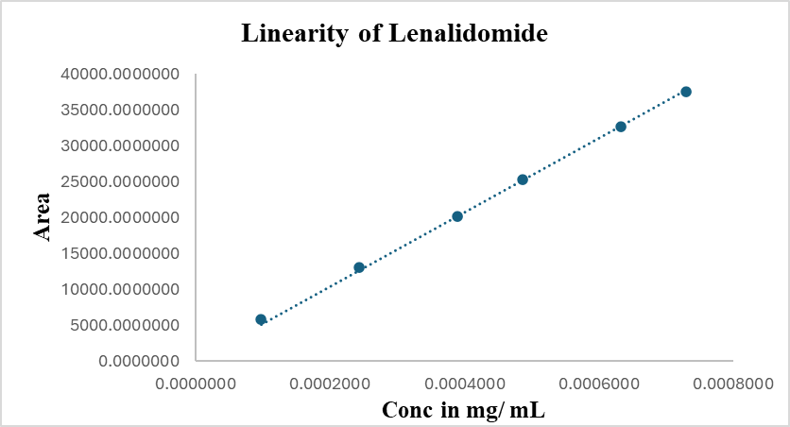

Reference: ARNo 221089

Acceptance Criteria:
- The correlation coefficient should be not less than 0.997
- Y-Intercept should not be more than ±5% of the response at 100% level.
- Report the intercept, slope and residual sum of squares value.
Inference:

Correlation coefficient and Y-intercept value at 100 % response results are found to be
within the limits. Intercept, Slope value and Residual sum of squares results were
reported. Results are tabulated in the above Table. Linearity plot is shown in Figures 1.

Conclusion
All the attributes evaluated under the analytical method verification for the related substance of Lenalidomide Hemihydrate API were found satisfactory.

- Annexure (Chromatograms)

Annexure – 1 Chromatogram of Blank
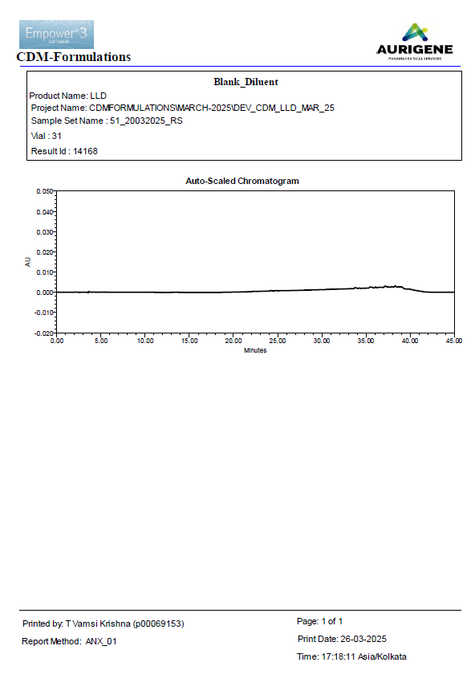

Annexure – 2 Chromatogram of Standard
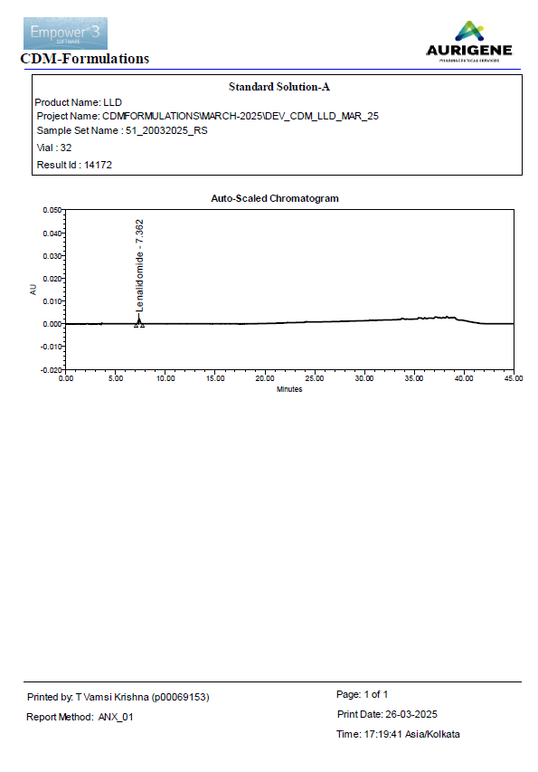

Annexure-3 Chromatogram of Sample
